Multimedia Application Project Report

Mazarin Cyril

Furnemont Nicolas

Ponton Grégoire

Perrin Julien

Duriez Thomas

Courbon Corentin

Table des matières

I) Introduction 2

II) Main program structure 2

III) Features: 3

1) Canny edge detection 3

2) Brightness and Contrast 4

3) Crop 5

4) Erosion 6

5) Rotation 7

# Introduction

The objective of the project is to develop a small image editor (like GIMP) with C++ language. The final program must be adaptable and a new feature has to be easily to had. In addition to C++ we use the OpenCv library, which is a powerful tool for image processing.

For this project we work on team, each member was in charge of the development of a feature of the program. Our work is centralize on a GitHub repository to be more efficient on the development of the project.

The list of developed functionalities is the following :

* Dilatation / erosion
* Resizing and cropping
* Brightness and contrast
* Panorama
* Canny edge detection

# Main program structure

Our image editor has to be used in command line. When launching the main program, you enter in the menu. You can select from the menu the the tool you want to use. On tool selection, a new window is opened and you can start to editing your image. The user can at any time save the new rendered image by pressing the “s” key.

We decided to put all the tools in different fonction to make the code more readable.

# Features:

## Canny edge detection

This tool is used to detect the edge of an image. When the tool is selected, you can set the minimun threshold value. If the threshold value is low, the program will detect more edge, if you put the threshold higher, you detect only the main edge of the image.

**Original image**

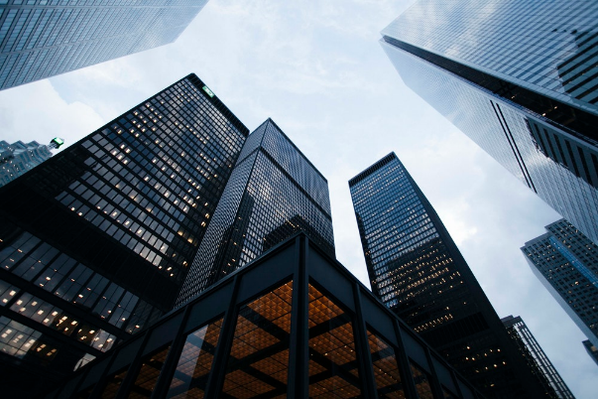

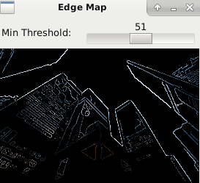

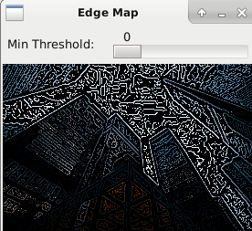

**Image with a low threshold Image with a high threshold**

## Brightness and Contrast

This tool is used to render an image with a different contrast or/and to render a different illumination from the original image. With the sliders, the user can select with precision the value of brightness or contrast wanted.

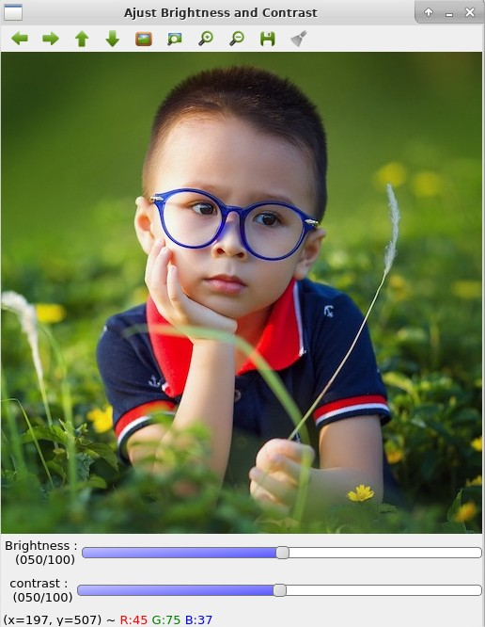

**Original image**

|  |  |
| --- | --- |
| **Low Brightness** | **High Brightness** |
| **Low Contrast** | **High Contrast** |

## Crop

This tool allows you to select and crop a region of the image by dragging the cursor on the area wanted

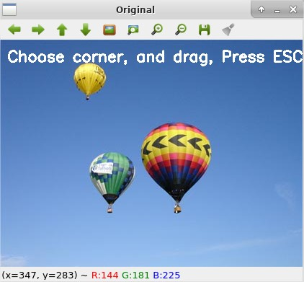

**Original**

|  |  |
| --- | --- |
|  |  |

## Erosion

Permit the user to erode the image

|  |  |
| --- | --- |
| The original | Image with erosion |

|  |  |
| --- | --- |
|  |  |

## Rotation

The user can rotate the image by adjusting the slider value.

|  |  |
| --- | --- |
| Original Image | Rotated Image |