Multimedia Application Project Report

Mazarin Cyril
Furnemont Nicolas
Ponton Grégoire
Perret Julien
Duriez Thomas
Courbon Corentin

Introduction

The objective of the project is to develop a small image editor (like GIMP) with C++ language. The final program must be adaptable and a new feature has to be easily to had. In addition to C++ we use the OpenCv library, which is a powerful tool for image processing.
For this project we work on team, each member was in charge of the development of a feature of the program. Our work is centralize on a GitHub repository to be more efficient on the development of the project.
The list of developed functionalities is the following :
- Dilatation / erosion
- Resizing and cropping
- Brightness and contrast
- Panorama
- Canny edge detection

Main program structure

Our image editor has to be use in command line. When launching the main program, you enter in the menu. The menu ask you which tool you want to use and which key you have to it to start the tool. When a tool is started, a new window is open and you can start to edit your image. When you made a ll your modification, you can can press the « s » key to save your modifications.


Let’s now focus on the code it self. We decided to put all the tools in different fonction to make the code more readable.
Canny edge detection

This tool is used to detect the edge of an image. When the tool is selected, you can set the minimun threshold value. If the threshold value is low, the program will detect more edge, if you put the threshold higher, you detect only the main edge of the image.
Here an illustration of the tool :

Original image
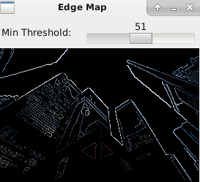
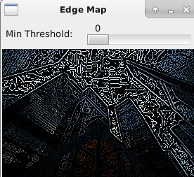

Image with a low threshold Image with a high threshold

