Technical Brief

DSP Library Module API
(Prepared for Greenwaves Technologies)

Document # W1139_001

March 19, 2018

All written and illustrative text contained within this document are the property of VOCAL Technologies, Ltd., 520 Lee Entrance, Suite 202, Buffalo, New York 14228, unless otherwise stated. No unauthorized use, whether in its direct form or reprint, is permitted without the expressed written approval of the corresponding officer at VOCAL Technologies, Ltd.

Techniques, designs, algorithms and implementations described contained herein are included in one or more US patents, patent applications and/or provisional patents submitted by VOCAL Technologies, Ltd.

All pages are marked proprietary and confidential and therefore relate directly to assets covered under the non-disclosure.

Table of Contents Page

1 Introduction 3
2 Data Types and Declarations 4
2.1 fract 4
3 Library entry points 4
3.1 void init_dsp_process (void); 4
3.2 int dsp_process_block(fract *input_mics, fract *input_spk, fract *output, int mics, int samples); 4

Introduction

This document defines the API used for the VOCAL's DSP IP, which includes Adaptive Beamforming, Acoustic Echo Cancellation (AEC), Noise Reduction and Voice Activity Detection (VAD).

The figure below shows the block diagram of the DSP module.

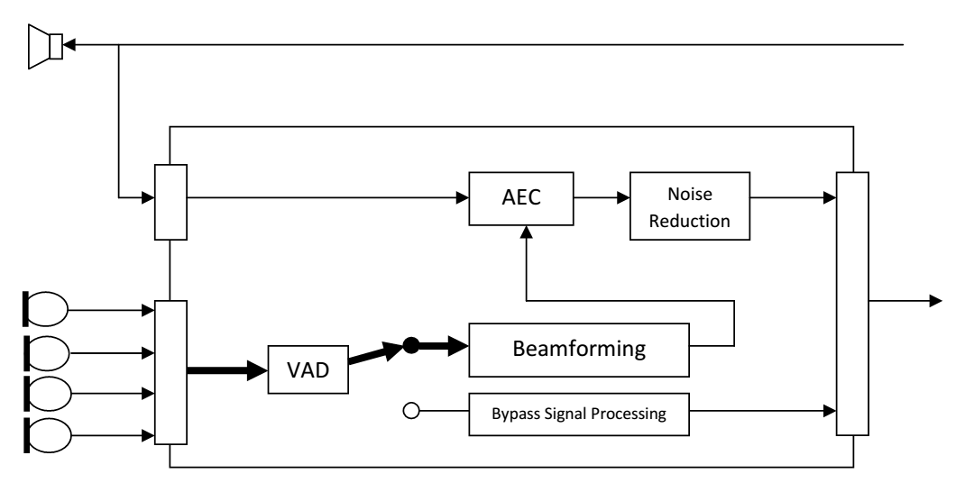

Signal processing is bypassed if the VAD has determined speech is not active.

Data Types and Declarations

There is one data type defined for this library. The declaration can be found in the dsp.h header file provided by VOCAL.

fract

This typedef is used to transfer signed 16 bit sample data in and out of the canceller, as well as configuration settings. It should be a signed 16 bit integer data type. It is typically declared as:

typedef signed short fract;

Library entry points

The VOCAL's DSP library contains the following entry points:

void init_dsp_process (void);

This function initializes the DSP module. This function MUST be called before calling the dsp_process_block() routine.

int dsp_process_block(fract *input_mics, fract *input_spk, fract *output, int mics, int samples);

Argument | Input Output | Description
*input_mics | Input | This input buffer pointer points to the buffer which contains the microphone sample data. It is assumed when there is more than one microphone, that the input samples will be interleaved. [mic0-0, mic1-0, mic2-0, mic3-0, mic0-1, mic1-1,...]. The total number in the samples in the input mic buffer will be the 'mics' parameter multiplied by the 'samples' parameter.
*input_spk | Input | This input buffer pointer points to the buffer which contains the loudspeaker sample data. It is assumed the number of loudspeaker channels is one and the number of samples is equivalent to the microphone samples. If a NULL pointer is supplied as input, the AEC module will be bypassed.
*output | Output | This output buffer pointer points to the buffer to store the output samples. The output is a single channel of data. The output buffer will be zero'ed when speech is inactive and will contain processed sp
mics | Input | This input parameter specifies the number of microphones in the input mic buffer.
samples | Input | This input parameter specifies the number of samples instances in the input mic buffer.
Return value | Output | The return value will indicate whether speech is active (value 1) or not (value 0).

