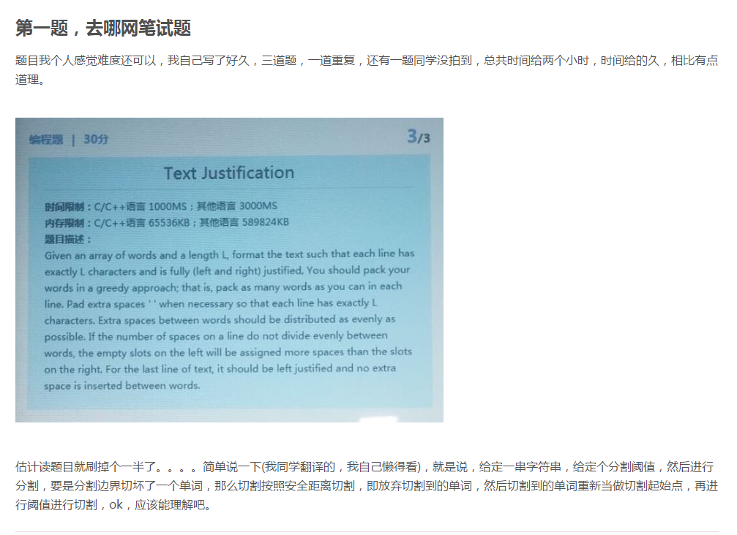

import math

part1=[]

def test(str1,n):

str1 = str1+' '*((len(str1)/n+1)*n-len(str1))

#先找到切割会碰到单词的片，确定为第几片段

k =1

while 1:

try:

if str1[(k)*n-1] !=' ' and str1[(k)*n]!=' ' :

break

else:

k = k+1

except:

part1.append(str1[(k-1)*n:].strip())

break

# 遇到切到单词的片段，之前的片段都可直接分割

for i in range(k-1):

part1.append(str1[(i)*n:(i+1)*n].strip())

# 从切割遇到问题的片段开始，专门处理片段

try:

j = 2

while 1:

# 找出问题的单词边界在哪

if str1[(k)*n-j] ==' ':

part1.append(str1[(k-1)*n:(k)*n-j].strip())

str1 = str1[(k)*n-j+1:] #分割点创建新的字符串

str1 = str1.strip() #去掉边界空格

if len(str1.strip())>=n:

str1 = str1+' '*(int(math.ceil(float(len(str1))/7))-(len(str1)/7))

test(str1,n) #递归

else:

#如果到了尾巴，结尾

part1.append(str1)

break

break

else:

j = j+1

except:

print 'Oops!'

return part1

strings = raw_input("enter the strings you want to split:")

blank = input("enter the between-segment distance:")

part = test(strings,blank)

result = []

#去除多余空格

for i in range(len(part)):

if part[i]=='':

pass

else:

result.append(part[i])

print result





