I chose to do my project in Haskell using the Blank Canvas library to make a “Breakout” type game, where the player controls a Paddle with his mouse and uses it to hit a Ball into some Bricks.
I decided to do my project in Haskell because I thought it would more challenging to do a visual project in that language than in JavaScript and more useful in the long term since I don’t plan on using Scheme over Haskell in many applications.
My project relied on a recursive looping function called “loop” to draw the “Canvas” every frame, keeping an updated version of the game as parameters that it passes to itself. I got a lot of information on how to use Blank Canvas and looping from the Blank Canvas examples provided on the Github Wiki page.
My project contains modular functions to create Brick layouts with differing colors and toughness of Brick, so that the user can make interesting levels just by concatenating several “createBrick” statements together (they return lists of Bricks).
I found the most challenging part of the project deciding the way in which the ball bounces off of the Paddle and I finally decided on modeling the Paddle’s face as the face of an ellipse and making the ball reflect over the Normal vector on the face of the flattened ellipse.
The second most challenging part of the project was using the Blank Canvas library since it was a brand new library with a staggering amount of options.
Things I would improve on my project include adding winning and losing conditions, putting in a life counter and a point system including something that keeps highs cores between Game Overs. I’d also like to add sound, background and texture images, and multiple level layouts, however I’m not sure how to do any of those things yet, but they will make a great Winter project!

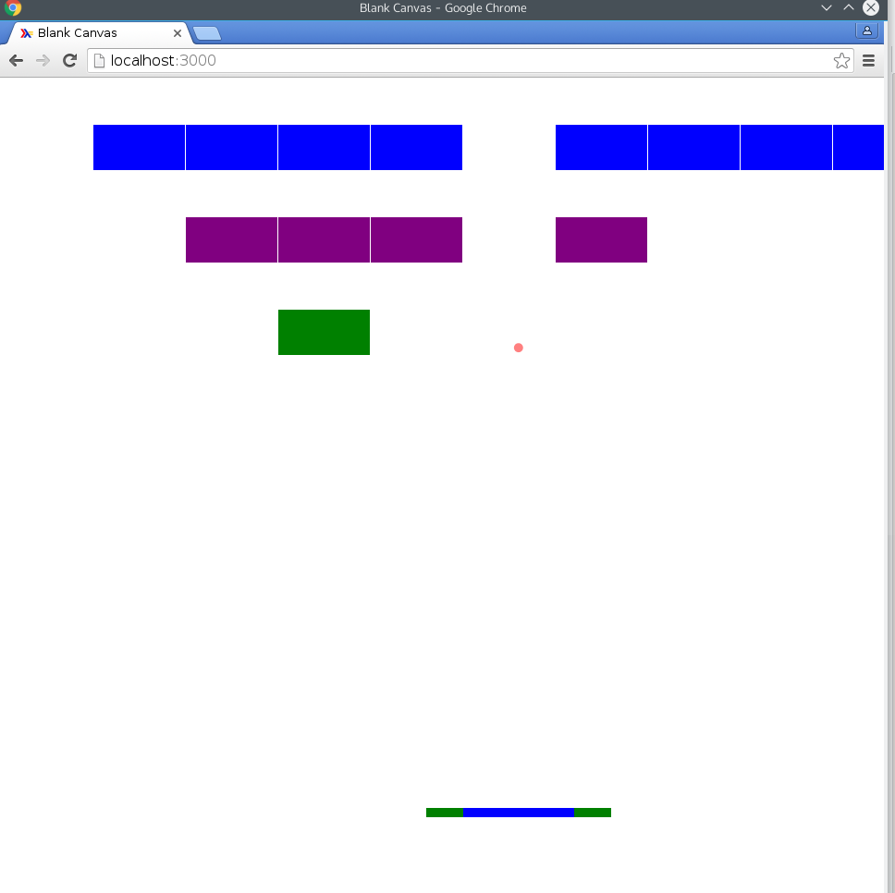
Screenshot of my program running on Chrome on a Linux machine

