2/18/2024

Greenery.Development: FiatOnramp

# | Platform | API link: | Status
1 | AlchemyPay: | https://alchemypay.org/
2 | Banxa: | https://banxacontact.typeform.com/to/Lrljrq
3 | ChangeNow: | https://changenow.io/for-partners
4 | Coinify: | https://www.coinify.com/contact-sales-wallet/
5 | Finchpay: | https://finchpay.io/business
6 | Invity: | https://invity.io/partners
7 | Kado: | https://www.kado.money/
8 | Kriptomat | https://kriptomat.io/
9 | Mercuryo: | https://mercuryo.io/business/widget/
10 | Moonpay: | https://onboarding.moonpay.io/
11 | Onramp: | https://onramp.money/
12 | Paxful: | https://paxful.com/vendors
13 | Ramp | https://docs.ramp.network/
14 | Sardine | https://www.sardine.ai/contact
15 | Simplex: | https://www.simplex.com/partners | Signing up
16 | Transak: | https://transak.com/integrate | Implemented
17 | Wert: | https://wert.io/ | Implemented
18 | ZKP2P | https://zkp2p.xyz/
19
20

Coinbase https://github.com/coinbase/cbpay-js

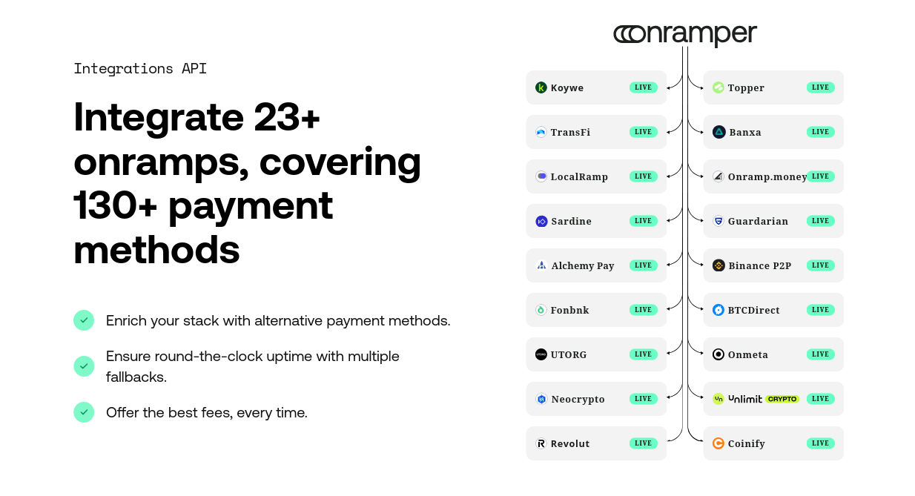

# | Platform | API link: | Status
1 |  | Alchemy Pay,
2 |  | Binance P2P,
3 |  | Fonbnk/Fonbank,
4 |  | BTCDirect,
5 |  | UTORG,
6 |  | Onmeta,
7 |  | Neocrypto,
8 |  | Unlimitcrypto
9 |  | , Revolut,
10 |  | Coinify
11
12
13
14
15
16
17
18
19
20 |  | Banxa,
 |  | Guardarian,
 |  | Koywe,
 |  | LocalRamp,
 |  | Onramp.Money,
 |  | Sardine,
 |  | Topper,
 |  | TransFi,

Koywe LIVE TransFi LIVE LocalRamp LIVE Sardine LIVE Alchemy Pay LIVE Fonbnk LIVE UTORG LIVE Neocrypto LIVE Revolut LIVE Topper LIVE Banxa LIVE Onramp.money LIVE Guardarian LIVE Binance P2P LIVE BTCDirect LIVE Onmeta LIVE LIVE Coinify LIVE

Prompts (Cursor):
# | P/R | Prompt / Response
1 | P | Organize All the onramps and append their API links and documentation as well
2 | R
3 | P
4 | R
5 | P
6 | R
7 | P
8 | R
9 | P
10 | R

 | Question: | Using the APIs from the following fiat onramps, create a vueJS website that allows a user to put in a stacked text field, a price or an amount of a currency they want, and the results show the prices and fees from each of the exchanges at the same time for the user to properly choose:  AlchemyPay, Banxa, ChangeNow, Coinify, Finchpay, Invity, Kado, Kriptomat, Mercuryo, Moonpay, Onramp, Paxful, Ramp, Sardine, Simplex, Transak, Wert, ZKP2P
# | AI | Answer
1 | ChatGPT
2 | Claude
3 | DeepSeek
4 | Gemini
5 | Grok
6 | Meta
7 | Perplexity

 | Question:
# | AI | Answer
1 | ChatGPT
2 | Claude
3 | DeepSeek
4 | Gemini
5 | Grok
6 | Meta
7 | Perplexity

 | Question:
# | AI | Answer
1 | ChatGPT
2 | Claude
3 | DeepSeek
4 | Gemini
5 | Grok
6 | Meta
7 | Perplexity

Prompts (ChatGPT):
# | P/R | Prompt / Response
1 | P
2 | R
3 | P
4 | R
5 | P
6 | R
7 | P
8 | R
9 | P
10 | R

Prompts (Claude):
# | P/R | Prompt / Response
1 | P
2 | R
3 | P
4 | R
5 | P
6 | R
7 | P
8 | R
9 | P
10 | R

Prompts (DeepSeek):
# | P/R | Prompt / Response
1 | P
2 | R
3 | P
4 | R
5 | P
6 | R
7 | P
8 | R
9 | P
10 | R

Prompts (Gemini):
# | P/R | Prompt / Response
1 | P
2 | R
3 | P
4 | R
5 | P
6 | R
7 | P
8 | R
9 | P
10 | R

Prompts (Grok):
# | P/R | Prompt / Response
1 | P
2 | R
3 | P
4 | R
5 | P
6 | R
7 | P
8 | R
9 | P
10 | R

Prompts (Meta):
# | P/R | Prompt / Response
1 | P
2 | R
3 | P
4 | R
5 | P
6 | R
7 | P
8 | R
9 | P
10 | R

Prompts (Perplexity):
# | P/R | Prompt / Response
1 | P
2 | R
3 | P
4 | R
5 | P
6 | R
7 | P
8 | R
9 | P
10 | R

# | Prompt
1
2
3
4
5
6
7
8
9
10

Prompts:
# | P/R | Prompt / Response
1 | P
2 | R
3 | P
4 | R
5 | P
6 | R
7 | P
8 | R
9 | P
10 | R
11 | P
12 | R
13 | P
14 | R
15 | P
16 | R
17 | P
18 | R
19 | P
20 | R

Prompts:
# | P/R | Prompt / Response
1 | P
2 | R
3 | P
4 | R
5 | P
6 | R
7 | P
8 | R
9 | P
10 | R
11 | P
12 | R
13 | P
14 | R
15 | P
16 | R
17 | P
18 | R
19 | P
20 | R

Prompts:
# | P/R | Prompt / Response
1 | P
2 | R
3 | P
4 | R
5 | P
6 | R
7 | P
8 | R
9 | P
10 | R
11 | P
12 | R
13 | P
14 | R
15 | P
16 | R
17 | P
18 | R
19 | P
20 | R

Links:
# | D/L | Description/Link
1 | D
2 | L
3 | D
4 | L
5 | D
6 | L
7 | D
8 | L
9 | D
10 | L
11 | D
12 | L
13 | D
14 | L
15 | D
16 | L
17 | D
18 | L
19 | D
20 | L
# | D/L | Description/Link

Links:
# | D/L | Description/Link
1 | D
2 | L
3 | D
4 | L
5 | D
6 | L
7 | D
8 | L
9 | D
10 | L
11 | D
12 | L
13 | D
14 | L
15 | D
16 | L
17 | D
18 | L
19 | D
20 | L
# | D/L | Description/Link

####################Other:

12/7/2020

Research.Cryptocurrency: PurchasingDirectlyWithDebitCreditCards

Objective:

Curate a list of Fiat Onramps to integrate into cryptocurrency wallets and websites

Information Generally needed to sign up for integration:

# |  | Description | Status
1 | EIN | The employer identification issued by the IRS
2 | Website with SSL | All domains having SSL certificate enabled
3 | Business Address | Where the busniess receives mail
4 | Officers information | Name, DOB, Address, Role
5 | Certificate of incorporation | Certifacte issued by Delaware
6 | LEI | Bloomberg number
7 | DUNS | Dun and Brad street number
8 | Privacy Policy
9 | EULA
10

# | Platform | Onboarding link:
1 | AlchemyPay: | https://alchemypay.org/
2 | Banxa: | https://banxacontact.typeform.com/to/Lrljrq
3 | ChangeNow: | https://changenow.io/for-partners
4 | Coinify: | https://www.coinify.com/contact-sales-wallet/
5 | Finchpay: | https://finchpay.io/business
6 | Invity: | https://invity.io/partners
7 | Kado: | https://www.kado.money/
8 | Kriptomat | https://kriptomat.io/
9 | Mercuryo: | https://mercuryo.io/business/widget/
10 | Moonpay: | https://onboarding.moonpay.io/
11 | Onramp: | https://onramp.money/
12 | Paxful: | https://paxful.com/vendors
13 | Ramp
14 | Sardine
15 | Simplex: | https://www.simplex.com/partners
16 | Transak: | https://transak.com/integrate
17 | Wert: | https://wert.io/
18 | Wyre
19 | ZKP2P | https://zkp2p.xyz/
20

Links:
# | D/L | Description/Link
1 | D
2 | L | https://invity.io/partners/integrator/sign-up
3 | D
4 | L | https://www.coindesk.com/abra-crypto-global-marketplace-partnerships
5 | D
6 | L | https://changenow.io/for-partners
7 | D
8 | L | https://changenow.io/api/docs
9 | D
10 | L | https://www.bestchange.com/partner/

Links:
# | D/L | Description/Link
1 | D
2 | L | https://safello.com
3 | D
4 | L | https://bity.com/products/crypto-exchange-api/
5 | D
6 | L | https://www.notion.so/Coverage-Payment-Methods-Fees-Limits-30c0954fbdf04beca68622d9734c59f9
7 | D
8 | L | https://www.notion.so/Integrate-Transak-f43cbb5dc7fa4d068a044ef9589879bf
9 | D
10 | L | https://docs.ramp.network/getting-started

https://support.ramp.network/en/articles/431-transaction-fees

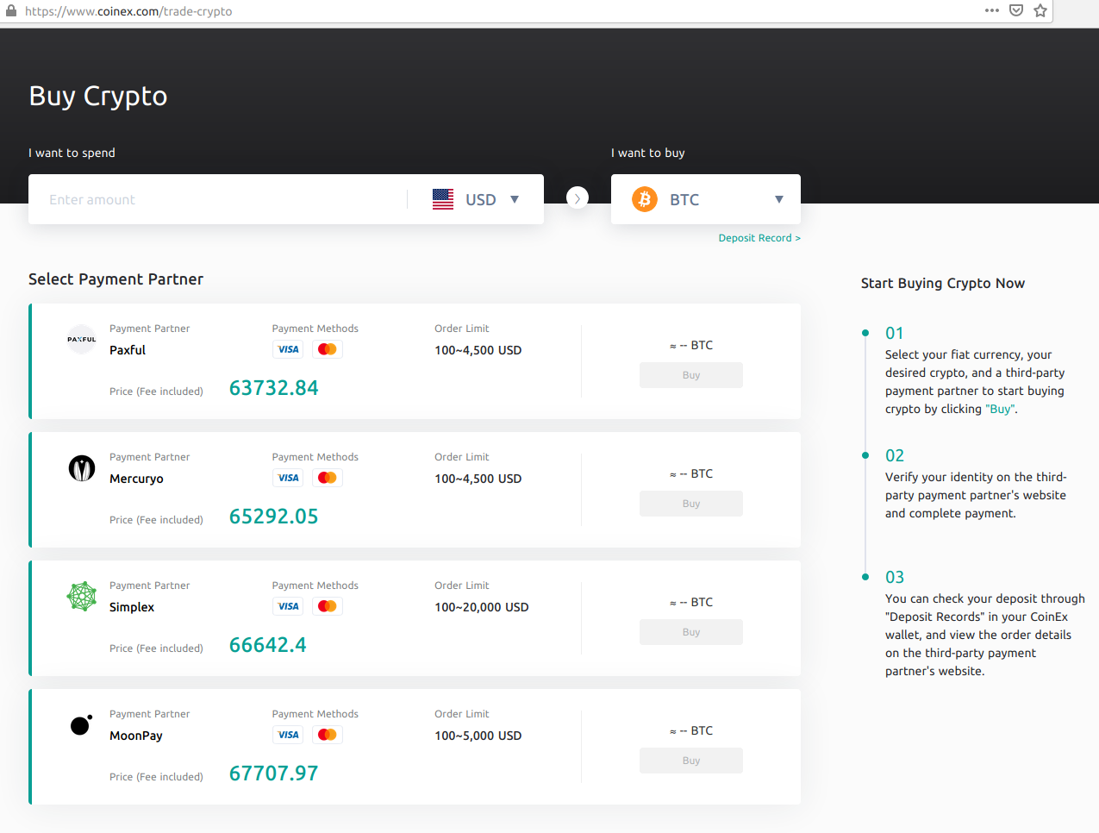



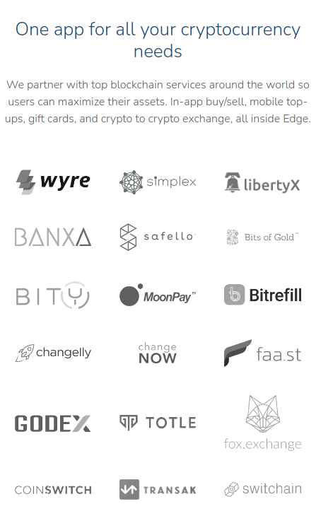

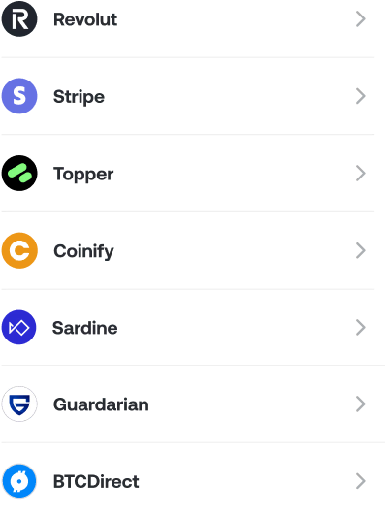
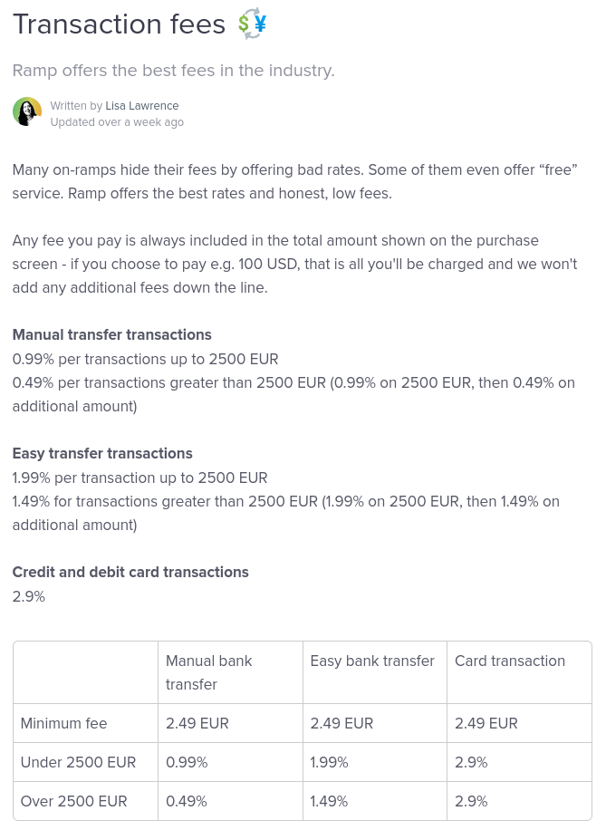

Links:
# | D/L | Description/Link
1 | D
2 | L | https://developer.kriptomat.io/docs/getting-started/kripto-ramp-widget-and-kripto-white-label-get-started
3 | D
4 | L | https://sourceforge.net/software/fiat-onramp/
5 | D
6 | L | https://sourceforge.net/software/product/Swapin/
7 | D
8 | L | https://sourceforge.net/software/product/Paxful/
9 | D
10 | L | https://sourceforge.net/software/product/Bisq/
11 | D
12 | L | https://sourceforge.net/software/product/Mercuryo/
13 | D
14 | L | https://slashdot.org/software/fiat-onramp/
15 | D
16 | L | https://stripe.com/en-ca/blog/crypto-onramp
# | D/L | Description/Link

Links:
# | D/L | Description/Link
1 | D
2 | L | https://stripe.com/en-ca/use-cases/crypto#request-invite
3 | D
4 | L
5 | D
6 | L
7 | D
8 | L
9 | D
10 | L
11 | D
12 | L
13 | D
14 | L
15 | D
16 | L
17 | D
18 | L
19 | D
20 | L

