Nature-based Solutions
Opportunity Mapping
Methodology
Prepared for: Severn Trent Water
Project: NbS Opportunity Mapping — Severn Trent operating area
Author: Jack Beard — Green in Blue
Date: July 2026


Contents
Document control — version history 3
Executive Summary 4
1. Introduction 6
1.1 Background 6
1.2 Study area 6
1.3 Nature-based solutions mapped 7
1.5 What the solutions deliver – benefits and funding routes 11
2. Methodology 13
2.1 Overall approach 13
2.2 Input datasets 13
2.3 Constraints 17
2.4 Supplementary data and prioritisation 17
3. Results 21
3.1 Result outputs 21
3.2 What the outputs can and cannot be used for 23
3.3 Example use cases in Severn Trent 23
4. Next Steps 25
4.1 Assumptions, limitations and coverage 25
4.2 How Severn Trent can take this forward 25
4.3 Reproducibility, delivery and future phases 26
Appendix A. Per-layer creation methodology 27
Generic constraints layer 27
Pond, pool and scrape 27
Leaky barriers 28
Bunds / catchment storage areas 29
Floodplain restoration / reconnection 30
Riparian buffer strips 30
Woodland and tree planting 31
Peat restoration (experimental) 31
Shared stages — supplementary and prioritisation 32
Appendix B. Technical and pipeline notes 33
Appendix C. Data access and licensing notes 34
Appendix D. Data sources and links 34
Appendix E. Extending the mapping to Wales 35
What would be needed 35
England-only inputs, GB inputs, and Welsh alternatives 36

Document control — version history
Version | Date | Author | Status | Summary of changes
0.1 | 15 Jun 2026 | Green in Blue (J. Beard) | Draft | Initial consolidated methodology draft.
0.2 | 18 Jun 2026 | Green in Blue (J. Beard) | Draft | Expanded detail: NbS photos and flow diagrams, full dataset inventory, scoring lookups, per-layer appendix.
0.3 | 08 Jul 2026 | Severn Trent (M. Palmer, M. Tallis, A. Freer) | Client review | Review comments returned on the draft.
0.4 | 10 Jul 2026 | Green in Blue (J. Beard) | Draft | Quick fixes applied as tracked changes; added appendices on data sources and links, suggestions on how to run for Wales,
0.5 | 10 Jul 2026 | Green in Blue (J. Beard) | Draft | Added Appendix D (data sources and links), Appendix E (extending mapping to Wales).
0.6 | 23 Jul 2026 | Green in Blue (J. Beard) | Draft | Restructured into Introduction / Methodology / Results; added benefits and PES-scheme content, OIE data audit, results interpretation, use cases and a provenance appendix.
0.7 | 30 Jul 2026 | Green in Blue (J. Beard) | Final | Final accuracy pass against the delivered Python pipeline methodology and the 20260730 output set.

Executive Summary
This document sets out the methodology for mapping nature-based solution (NbS) opportunities across the Severn Trent area. The key aim of this work is to identify, using openly available datasets, where NbS could feasibly be implemented in any given catchment based on simple biophysical characteristics (e.g. place leaky barriers on known flow accumulation pathways or ditches in headwater areas).
For each solution type the method produces a map of potential areas where the intervention could feasibly be placed, removes land where it would not be viable or appropriate (e.g. in heavily urbanised areas), and generates a priority score for the final output so the most promising areas for implementation can be made evident. Used together, this mapping allows for an approximation of the total potential for NbS delivery across Severn Trent areas.

What this work delivers. A reproducible spatial evidence base for catchment planning, delivering high-resolution mapping of NbS opportunities as GIS (GeoPackage) outputs. Every output traces back to a named open dataset and a documented methodology so the analysis can be re-run as the underlying data is updated. Results are delivered at water-body level so they line up with how the Water Framework Directive and catchment planning are organised, and because opportunities are mapped at fine granularity they can also be aggregated to other catchment definitions such as water resource zones or wastewater catchments. The workflow re-implements a proven method — first developed for the Warwickshire Avon under the Nature for Water Facility — as an open Python pipeline, allowing for more flexibility to swap in different datasets and extend to different NbS types.
What is mapped. Seven solution types: pond, pool and scrape creation; leaky barriers; bunds and catchment storage areas; floodplain restoration and reconnection; riparian buffer strips; woodland and tree planting; and — added for this commission — peat restoration (Figure 1). The first six are carried over faithfully from the original method; peat restoration is new, reflecting Severn Trent's peatland interests and built on the England Peat Map published in 2025.
How to use the results. Outputs should be used for screening and targeting of potential projects for delivery, they are not a substitute for site survey or scheme design. They show where each solution type is plausible and promising on the available national evidence, but local verification including land-ownership checks and ground-truthing remain necessary before any intervention.
Scope and status. Phase 1 covers the English part of the operating area; the Welsh (Hafren Dyfrdwy) could be generated using alternative datasets in a later stage.

Figure 1. Final outputs - opportunity mapped per-NbS type, delivered for the Full Severn Trent Area.

1. Introduction

1.1 Background
Severn Trent commissioned this work to extend an established NbS opportunity-mapping approach across its operating area. The method originates in work conducted by the Nature for Water Facility which was first applied at catchment scale to the Warwickshire Avon, in a series of scripts written in R programming language. This project extends that work to the full (England-based) Severn Trent operational area and translates that method to Python for reproducibility and transparency.
The aims of the work are to:
- Map opportunities consistently for seven nature-based solution types across the Severn Trent operating area.
- Use open, national data so that every result is transparent and can be reproduced and extended in future (e.g. by including more datasets, different opportunity creation approaches).
- Make the workflow repeatable — a python-based methodology that re-runs as data is updated, rather than a manual GIS exercise.
- Deliver at water-body level so outputs align with Water Framework Directive catchment planning.
- Provide a sound evidence base for targeting, prioritisation and stakeholder engagement — representing a catchment-level planning tool, not a design tool.
This document gives an overview of the methodologies used to generate final maps. Sections 1.3 and 1.4 give a non-technical overview of the study area and the nature-based solutions mapped; Section 2 sets out the methods and Section 3 the results; the appendices give the full per-layer detail and data inventory for technical readers, including those working on the Python code.
Table 1. Distinctions between this methodology and the original Warwickshire Avon work.
 | Original (Warwickshire Avon) | This project (Severn Trent)
Method | Nature for Water opportunity mapping | Same methodological basis, recreated and expanded
Language | R | Python (vector-based)
Data | Mix of open data and manual GIS steps | Open data, scripted end-to-end
Reproducibility | Partly manual | Mostly automated
Solution types | Six | Seven (adds peat restoration)

1.2 Study area
The Severn Trent operational footprint is the union of four service areas: Severn Trent Water clean-water and wastewater areas, and the Hafren Dyfrdwy (Welsh-subsidiary) clean-water and wastewater areas. Taken together the footprint is about 24,300 km², of which roughly an eighth falls within Wales (Table 2).
Table 2. Relative areas of Severn Trent operational boundaries in England and Wales.
Footprint area | km² | Share
Total operational footprint | 24,321 | 100%
England portion | 21,331 | 87.7%
Wales portion (Hafren Dyfrdwy) | 2,990 | 12.3%

1.2.1 Area of Interest
Analysis and delivery are organised at water-body level using Water Framework Directive (WFD) river water-body catchments. Because a catchment boundary rarely coincides with a service-area boundary, the AOI (area of interest — the catchments of every water body the Severn Trent region intersects or fully contains, which also creates scope to collaborate with neighbouring water companies on shared water bodies) is defined as every WFD river water-body catchment (Cycle 2) that overlaps the footprint, included whole (see Figure 2). No WFD water body is therefore only partly analysed — each is either fully inside the AOI or fully outside it. The AOI is consequently a little larger than the operational boundary to allow for per-water body delivery to occur, as agreed via conversations with Severn Trent.
Figure 2. Mapping area of interest vs. Severn Trent and Hafren Dyfrdwy operational area and the boundary of Wales.

Phase 1 is England-only
The overall scope of this piece of work is to map opportunities for NbS for the entire Severn Trent and Hafren Dyfrdwy operational region (and adjoining water bodies). This phase, however, does not map NbS within Wales due to this requiring the identification of equivalent datasets for Wales to those used in the original mapping approach for the Warwickshire Avon.

Almost all opportunity datasets are published for England, and the WFD catchment dataset used is the England product, so this restricts the AOI of outputs from this phase of work to currently being England-only. The Welsh (Hafren Dyfrdwy) portion represents a data gap: Welsh equivalents (Natural Resources Wales, DataMapWales) exist but need separate sourcing which could occur in a separate phase in the future. This has been flagged to Severn Trent.

1.3 Nature-based solutions mapped
Seven solution types are mapped. The first six are directly comparable to those generated using the original Nature for Water method; peat restoration is a seventh, added for this piece of work as Severn Trent are interested in potential avenues for peat restoration. Figure 3 shows how the solution types sit in the landscape, from the river and its floodplain up through the wider catchment.

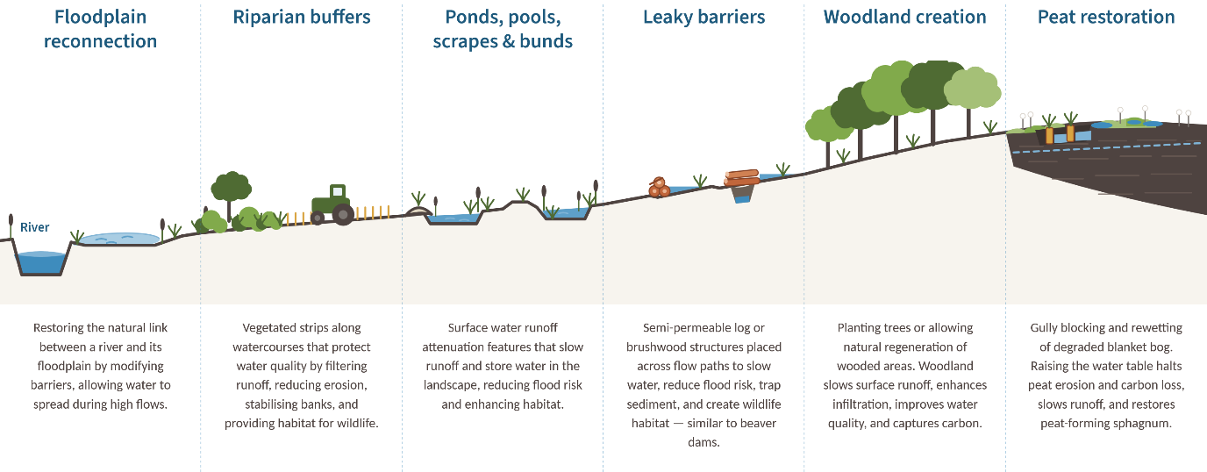
Figure 3. The shortlisted nature-based solutions and where they sit in the landscape (this diagram is an update of that produced by the Nature for Water Facility, 2024). Note that peat restoration is not included in this diagram.
Each NbS mapped is further described below: this includes its function, where it sits in the landscape, and the national dataset it is mapped from.
Section 4.8 then summarises, across all seven solution types, which water-company outcomes each one serves and how each can feed established funding and credit mechanisms such as Biodiversity Net Gain and nutrient neutrality.

1.3.1 Pond and scrape creation
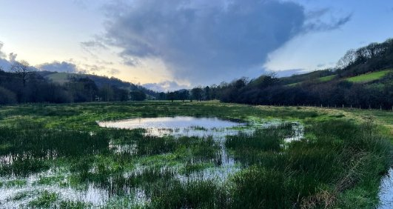 | Water-retention features of varying size (typically about 5 × 10 m) that store water and slow runoff. Ponds hold water year-round; scrapes can dry out between rainfall. They reduce downstream flood risk, trap sediment and create valuable wetland habitat. Ponds can be restored in many areas where they have been lost through drainage. These features may be linked to sub-surface hydrology depending on soil and underlying geology type.

Aspect | Detail
Function | Creating or restoring ponds helps store surface water, slow runoff and creates extremely valuable wetland habitat
Typical form | ~5 × 10 m features; 10–20 m buffer of marginal planting to protect from agricultural inputs
Landscape position | Located in areas where surface water naturally accumulates; this could be on flow pathways or in floodplain areas
Mapped from | WWNP Runoff Attenuation Features (1% annual exceedance probability)

1.3.2 Leaky barriers
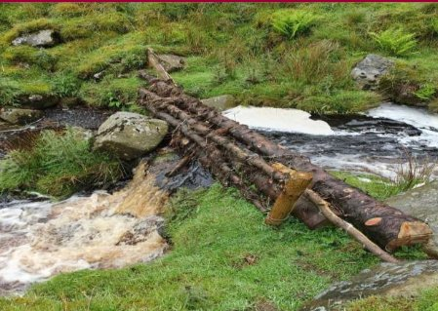 | Constructed, semi-permeable large wood structures placed across flow paths to intercept and attenuate overland and in-channel flows during high exceedance probability events — similar in effect to beaver dams. They slow water, reduce flood risk, trap sediment and create habitat. Best constructed in sequence to maximise impact.

Aspect | Detail
Function | Creating in-channel storage areas slows in-river flows, reduces peak runoff and traps sediment
Typical form | Semi-permeable log / brushwood structures placed perpendicularly across the channel; these may need to include gaps at the bottom of structures to let low flows pass
Landscape position | Along smaller (local) watercourses — ditches and drainage features — within the surface-water flood extent
Mapped from | OS Zoomstack Waterlines (Local, 100 m points) within the EA surface-water flood extent, excluding the mapped fluvial floodplain (EA Flood Zone 3) so barriers stay in headwaters

1.3.3 Bunds / runoff attenuation features
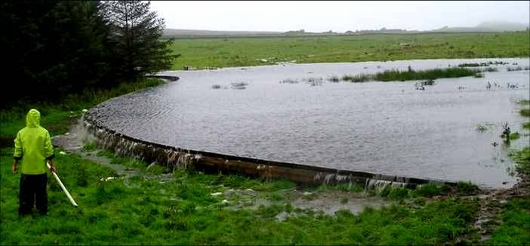 | Earth or timber embankments or excavated storage areas (sometimes in combination) built across slopes or flow pathways to store and slow overland water (typically about 0.5 m depth). They reduce peak runoff, promote infiltration and trap sediment and nutrients, and are most effective in moderate-to-steep landscapes with concentrated surface flows.

Aspect | Detail
Function | Creating water storage areas slows overland flow, reduces peak runoff and traps sediment
Typical form | Earth or timber embankments perpendicular to runoff pathways or excavated large water storage areas / wetlands. These are offline (not in-channel) and are activated during heavy rainfall.
Landscape position | Moderate-to-steep landscapes with concentrated flows; within the flood extent, away from watercourse corridors
Mapped from | EA surface-water flood extent, minus WWNP runoff attenuation features, OS watercourse buffers

1.3.4 Floodplain reconnection and restoration
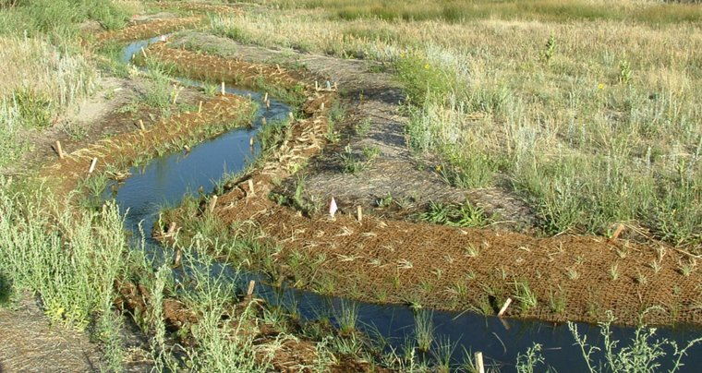 | Re-establishing the natural link between a river and its floodplain so water can spread out during high flows. This increases water-storage capacity and delivers significant flood risk benefits alongside habitat, reduced soil erosion and improved water quality. This activates valuable floodplain wetland habitats.

Aspect | Detail
Function | Reconnecting rivers to floodplains and increasing the function of existing floodplain areas; creating floodplain storage decreases downstream flood risk, increases infiltration, stores carbon and improves water quality
Typical form | Modifying barriers / levees to allow floodplain inundation; may also include channel bed raising to improve river connectivity with floodplain
Landscape position | Along rivers and their floodplains
Mapped from | WWNP Floodplain Reconnection Potential and Floodplain Woodland Potential

1.3.5 Riparian buffers
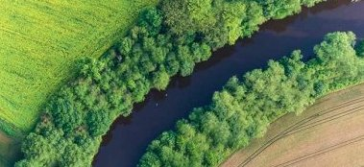 | Vegetated strips along watercourses that intercept agricultural pollution from atmospheric, surface and subsurface pathways, stabilise banks, reduce erosion and provide habitat. Strips can be anywhere between 10 and 100m from the river. These can include the planting of trees or the restoration of species-rich grassland.

Aspect | Detail
Function | Creating vegetated buffer areas along river corridors; having a buffer area intercepts pollution, stabilises banks, reduces erosion and creates valuable habitat corridors
Typical form | Planted / managed vegetative (trees or grassland) strips alongside watercourses
Landscape position | Riparian margins along watercourses
Mapped from | WWNP Riparian Woodland Potential

1.3.6 Woodland creation
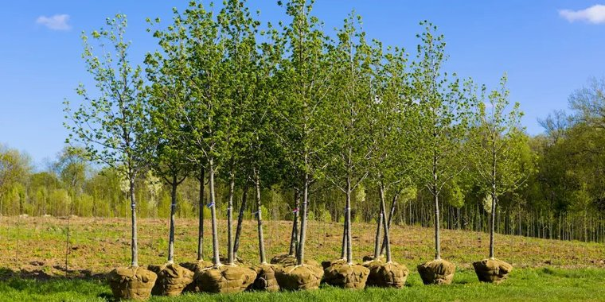 | Increasing tree cover in suitable areas of the catchment to reduce flood risk and surface runoff by promoting infiltration, intercepting rainfall and increasing ground roughness, while enhancing biodiversity and storing carbon. This can be achieved by new planting or targeting existing native areas of woodland for expansion through natural regeneration.

Aspect | Detail
Function | Planting trees and encouraging natural regeneration; changes in land use toward woodland reduces runoff and enhances infiltration whilst storing carbon and creating habitat
Typical form | New native woodland / tree planting; allowance for the natural regeneration of existing woodland areas
Landscape position | Plantable areas across the wider catchment; conifer plantations are conversion targets
Mapped from | England Woodland Creation Sensitivity and WWNP Wider Catchment Woodland Potential

1.3.7 Peat restoration
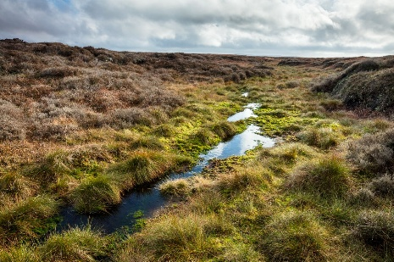 | Degraded but restorable peatland, identified for rewetting and revegetation to re-establish peat-forming conditions. Restored peat stores carbon, improves water quality and supports natural flood management. The layer reflects Severn Trent's role in upland peatland programmes (such as Moor Resilience 2030) and is built on Natural England's England Peat Map, published in 2025 — data that did not exist when the original method was designed.

Aspect | Detail
Function | Restore degraded peat; storing water and reducing runoff in upland areas yields carbon, water quality and flood management benefits
Typical form | Blocking / rewetting of upland grips (drainage ditches) and gullies (erosion channels)
Landscape position | Upland peat showing artificial drainage or erosion — mapped from Upland Grips and Upland Gullies within the peat extent
Status | Experimental — new layer, based on the 2025 England Peat Map; see Appendix A
Mapped from | England Peat Map — Upland Grips + Upland Gullies (Natural England, 2025)

1.5 What the solutions deliver – benefits and funding routes
Every solution type has a primary hydrological function, but each also delivers a spread of co-benefits and could potentially contribute to established funding and credit mechanisms. This section summarises both, so the mapping can be read across to the outcomes Severn Trent and its partners prioritise.
Table 3 shows the relative potential for each NbS type tp contribute to addressing key water-management outcomes and other co-benefits. It should be noted that in many situations, trade-offs may be encountered relating to NbS deliver – for example, woodland creation in the watershed of a reservoir may have adverse effects in terms of water resources due to increased attenuation of water and evapotranspiration in the upper catchment.
Table 3. Benefits delivered by each solution type. ✓✓ = primary benefit; ✓ = meaningful co-benefit; – = limited or situational.
Solution type | Water quality | Water resources | Flood risk | Biodiversity | Carbon
Pond, pool & scrape | ✓ | ✓ | ✓✓ | ✓✓ | ✓
Leaky barriers | ✓ | ✓ | ✓✓ | ✓ | –
Bunds / runoff attenuation | ✓✓ | ✓✓ | ✓✓ | – | –
Floodplain reconnection | ✓ | ✓ | ✓✓ | ✓✓ | ✓
Riparian buffer strips | ✓✓ | – | ✓ | ✓✓ | ✓
Woodland creation | ✓ | – | ✓✓ | ✓✓ | ✓✓
Peat restoration | ✓✓ | ✓ | ✓ | ✓✓ | ✓✓

NbS opportunities can often be delivered through, or help satisfy, wider environmental markets and grant schemes. Table 4 maps each solution against the main payments for ecosystem services (PES) approaches – Biodiversity Net Gain, nutrient neutrality and carbon codes – giving the nearest equivalent term from that scheme’s guidance (for example the statutory biodiversity metric broad-habitat classes for BNG, and the nutrient-budget methodology for nutrient neutrality).
These are indicative equivalences intended to suggest where NbS delivery could match up with market or grant opportunities. Eligibility in every case depends on a site-specific assessment – for example, the statutory biodiversity metric for BNG or the relevant catchment nutrient calculator for nutrient neutrality. The mapping identifies where the opportunity exists; it does not confirm that a given parcel will qualify for credits or grant.
Table 4. How each solution can be delivered through payment-for-ecosystem-services schemes. The text in each box gives the nearest equivalent term used in that scheme’s guidance.
✓ recognised route ~ partial or situational – limited / not typically applicable.
Nature-based solution | Biodiversity Net Gain | Nutrient neutrality | Carbon codes
Pond, pool & scrape | ✓ Lakes / ponds — area units | ~ Attenuation / interception wetland | – Minor wetland carbon
Leaky barriers | ~ Watercourse condition uplift | – Sediment-bound P only | – Not typically applicable
Bunds / runoff attenuation | ~ Created wetland / marginal habitat | ~ Attenuation wetland (P & sediment) | – Not typically applicable
Floodplain reconnection | ✓ Wetland area + watercourse units | ✓ Created-wetland mitigation | ~ Floodplain / wetland carbon
Riparian buffer strips | ✓ Watercourse units + buffer habitat – area units | ✓ Diffuse-pollution mitigation | ~ Riparian woodland carbon
Woodland creation | ✓ Woodland & forest — area units | ✓ Land-use-change mitigation | ✓ Woodland Carbon Code
Peat restoration | ✓ Bog — high-distinctiveness units | – Usually outside NN catchments | ✓ Peatland Code

2. Methodology

2.1 Overall approach
The general approach employed in this mapping is to start with a dataset that represents an opportunity (e.g. a dataset that shows where water naturally accumulates), clip it by another that represents a constraint (e.g. roads or railways), and finally prioritise each feature based on supplementary datasets (e.g. agricultural land grade). Every solution type is mapped using the same three-stage logic, shown in Figure 4. The constraints layer and the supplementary and scoring stages are generated once and shared across all types, so the only thing that differs between types is the opportunity definition. This shared structure is what makes the seven outputs directly comparable.
Three general principles guide this methodology:
- Open data — results are reproducible by others using only openly available data.
- Vector-based — every intermediate step is inspectable in standard GIS.
- AOI-driven — the same code runs over a given area of interest.

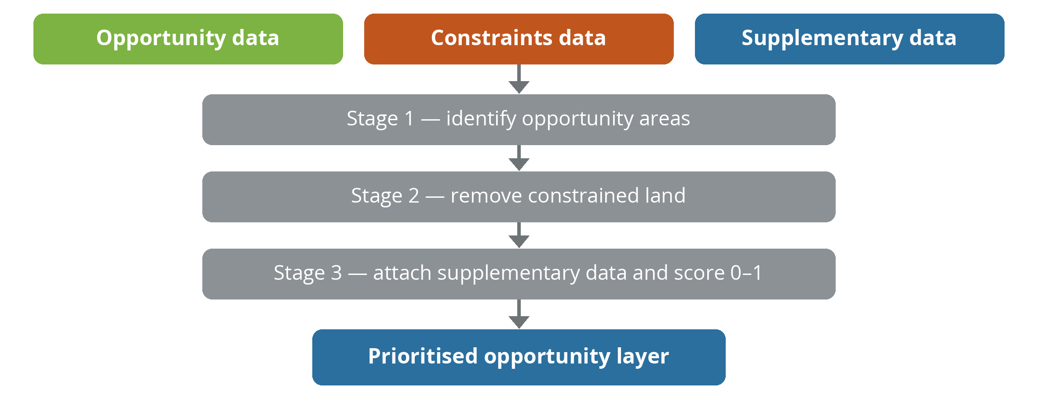
Figure 4. The generic three-stage approach applied to every solution type (adapted from the Nature for Water Facility, 2024).

2.2 Input datasets
The workflow draws on publicly available national datasets, accessed wherever possible through live open web services (EA/Defra OGC API Features, OGC WFS or ArcGIS feature services) so current data can be re-fetched, with a few larger datasets downloaded and saved locally as files. The inventory in Table 5 lists every input, its role, the NbS layer(s) it feeds, its source and access route, and its coverage.
Table 5. Full input-dataset inventory. Coverage: England = England only; GB = covers England and Wales.
Dataset | Category | Feeds (NbS layer / use) | Source & access | Cover
Opportunity inputs — define where each solution could apply
WWNP Runoff Attenuation Features (1% AEP) | Opportunity | Pond/Pool/Scrape (source); subtracted in Leaky Barriers & Bunds | Environment Agency — DEFRA DSP, OGC API | England
OS Open Zoomstack — Waterlines | Opportunity | Leaky Barriers (Local, 100 m points); Bunds (type-keyed buffers) | Ordnance Survey (OGL), staged GeoPackage | GB
NaFRA2 Risk of Flooding from Surface Water (Hazard; 1-in-100, High+Medium) | Opportunity | Bunds (extent); Leaky Barriers (intersect) | Environment Agency, OGC API / WFS | England
EA Flood Map for Planning — Flood Zone 3 (fluvial floodplain, 1-in-100) | Opportunity filter | Leaky Barriers (FZ3 points removed) | Environment Agency, OGC API | England
WWNP Floodplain Reconnection Potential | Opportunity | Floodplain Reconnection | Environment Agency, OGC API / WFS | England
WWNP Floodplain Woodland Potential | Opportunity | Floodplain Reconnection (unioned) | Environment Agency, OGC API / WFS | England
WWNP Riparian Woodland Potential | Opportunity | Riparian Buffer Strips | Environment Agency, OGC API / WFS | England
WWNP Wider Catchment Woodland Potential | Opportunity | Woodland Planting | Environment Agency, OGC API / WFS | England
England Woodland Creation Sensitivity (v4) | Opportunity | Woodland Planting (High-sensitivity retained; label only) | Forestry Commission, ArcGIS | England
England Peat Map — Upland Grips + Upland Gullies | Opportunity | Peat Restoration (grips + gullies) | Natural England, ArcGIS | England
Constraint inputs — remove land where intervention is not viable or appropriate
UKCEH Land Cover Map 2023 | Constraint + Supplementary | All layers (mask: urban 20, suburban 21, bog/peat 11, broadleaf 1) + land-use score | UKCEH (EIDC login), staged GeoPackage | GB
Source Protection Zones (No-Infiltration Area) | Constraint | All layers | Environment Agency, OGC API / WFS | England
OS Open Zoomstack — Roads | Constraint (10 m buffer) | All layers | Ordnance Survey (OGL), staged | GB
OS Open Zoomstack — Railways | Constraint (20 m buffer) | All layers | Ordnance Survey (OGL), staged | GB
OS Open Zoomstack — Surface water | Constraint | All layers | Ordnance Survey (OGL), staged | GB
WWNP Woodland Constraints | Constraint | Leaky Barriers; Woodland Planting | Environment Agency, OGC API / WFS | England
Supplementary inputs — attach context and drive the priority score
Agricultural Land Classification (national Provisional) | Supplementary | All layers (alc_grade score) | Natural England, OGC API / WFS | England
Priority Habitat Networks | Supplementary | All layers (habitat score) | Natural England, OGC API / WFS | England
BGS Soil Parent Material Model (1 km) | Supplementary | All layers (soil-group score) | British Geological Survey, staged | GB
Recharge Prioritisation (HML) | Supplementary | All layers (recharge score) | Natural England, ArcGIS | England
Analytical structure — the delivery unit
WFD River Waterbody Catchments (Cycle 2) | Structure | All layers — water-body ID, AOI definition, delivery unit | Environment Agency — DEFRA DSP, OGC API | England

A note on access and licensing. Most datasets are fetched live from open web services; the larger ones (OS Open Zoomstack, the UKCEH Land Cover Map and the BGS soil model) are downloaded and saved as local files. The UKCEH Land Cover Map requires a free account to download.

2.3.1 Data audit – availability, quality and usability
Input datasets used in this approach were audited using Severn Trent’s Overall Information Effectiveness (OIE) approach. This approach scores a dataset on three measures and multiplies them: Availability (A), Quality (Q) and Usability (U), so that OIE = A x Q x U.
Availability asks whether the data is accessible for the area and period needed; Quality whether it follows business and technical rules; and Usability whether it is documented well enough to understand and use. If a dataset is accessible, deemed of sufficient quality, and is usable for the intended purpose, it can be taken forward in this approach. Table 5 sets out the first-pass questions Severn Trent applies to external datasets and how each is addressed in this work.
Applying this as a first pass across the principal inputs gives the assessment in Table 6, which records, for each dataset, how it performs against Availability, Quality and Usability.
Table 6. The Severn Trent AQU / OIE data-assessment framework applied to the mapping’s input datasets.
Measure | What it asks (Severn Trent AQU first-pass) | How it is addressed in this work
Availability (A) | Is the dataset accessible for the area and period we need? Baselines: expected coverage, update frequency, required fields, and positional accuracy / resolution – then the actual values and the share of expected they meet. | Expected coverage is the English operating area plus adjoining WFD water bodies. Each input’s actual coverage (England-only or GB) is recorded in the dataset inventory and Appendix D; the live-fetch design records the source version at run time; resolution is noted per dataset (e.g. 1 km BGS soil, ~1:250,000 national Provisional ALC, national-scale WWNP).
Quality (Q) | Does the data follow business and technical rules? Completeness (mandatory fields not null), uniqueness (unique IDs), and validity (locations within the expected range; field values matching documented lookups). | The fetch layer checks the returned feature count against the server’s reported total and stops rather than proceed on a truncated download; geometries are validated and repaired; the CRS is forced to EPSG:27700; and attribute values are checked against the documented lookups (ALC grade, land-cover class, HML High/Medium/Low, peat classes) before they drive the score.
Usability (U) | Is the dataset documented well enough to understand its structure and use? Human-readable documentation and machine-readable metadata covering structure, purpose and the rules applied. | Every input carries an entry in the project data registry (source, endpoint, layer name, licence, access method); the methodology and per-layer build sheets document each dataset’s purpose and treatment; provenance is retained in Appendix B.

Table 7. AQU / OIE assessment of the principal input datasets.
Dataset | Availability (A) | Quality (Q) | Usability (U)
WWNP opportunity layers (RAF; floodplain reconnection & woodland; riparian; wider-catchment woodland) | Environment Agency, fetched live via the EA open API (OGC API Features) for the whole AOI. England-only, so no coverage of the Welsh 12% — a documented gap (Section 3.4). | Vetted national Working-with-Natural-Processes layers; geometries validated and clipped to the AOI; the returned feature count is reconciled against the server total on fetch so no features are silently dropped. | Documented on the Defra Data Services Platform and data.gov.uk with metadata; each layer’s role and treatment are recorded in the project data registry.
OS Open Zoomstack (waterlines, roads, rail, surface water) | GB coverage (includes Wales); downloaded and staged locally as a GeoPackage; refreshed on OS release. | Ordnance Survey national product with a consistent schema; type-keyed attributes (watercourse and road class) used directly; geometry is clean. | Open Government Licence; full OS product documentation and data dictionary; the staged copy is versioned in the project.
NaFRA2 Risk of Flooding from Surface Water | England-wide (EA National Flood Risk Assessment 2, published December 2024), fetched via the EA OGC API and filtered to the 1-in-100 (high + medium) surface-water band used here. | A large modelled hazard dataset; the paged fetch reconciles the returned count against the server total to prevent truncation, and hazard bands are checked against the documented classes. NaFRA2 uses improved modelling and higher resolution than the legacy RoFSW product, so its extents differ from older maps — noted in Section 3.4. | Published with EA methodology and metadata; supersedes RoFSW; return-period bands and their meaning are documented.
UKCEH Land Cover Map 2023 | GB coverage; a single download (free EIDC account) serves both the constraint mask and the land-use score; annual product. | Standard UKCEH classified product with a published per-class accuracy statement; the classes used (urban 20, suburban 21, bog 11, broadleaf 1, plus the land-use groups) are taken directly from the documented class list. | Full UKCEH documentation and metadata; class definitions and accuracy statement are published; the licence covers this use.
England Peat Map suite (extent, depth, condition, vegetation) | England-wide (Natural England, May 2025) at 10 m resolution, fetched per tile via ArcGIS; England-only. | Machine-learning modelled (gradient boosting and image segmentation) from ~300,000 ground points plus satellite and LiDAR; NE reports >95% accuracy for peaty-soil extent and 94% for vegetation. Known weaknesses: lowland agricultural peat is under-mapped and some artefacts are reported (improved grassland or rocky ground mis-classified, straight-line depth interpolation), so it is treated as experimental and not used as stand-alone site justification. | Documented in Natural England Research Report NERR149 with per-layer metadata and an open code base; the two layers used here — Upland Grips and Upland Gullies — are simple polygon products taken directly from the map.
Agricultural Land Classification (national Provisional) | England-only. Uses the national Provisional ALC (Natural England, ~1:250,000), which covers effectively the whole operating area (~99% non-null); a few coastal / urban-edge features may be null. This replaced the earlier Post-1988 Survey product, which was a sparse patchwork (~2% of the area). | Grades 1–5 taken directly from the documented grade field; urban / non-agricultural and unsurveyed land are handled explicitly in the scoring lookup. | Published on the Natural England geoportal with metadata; grade definitions are well documented — the coarse (~1:250,000) resolution of the national Provisional product is the main usability caveat.
Recharge Prioritisation (HML) | England-only, and an interim substitute for the EA NbS Infiltration Class, which is not openly available and which Severn Trent does not hold. Supplied only as a coarse High / Medium / Low categorisation joined at water-body scale. | A three-class categorical layer used as documented; its coarseness means it carries less weight in the score than a true infiltration surface would. | Limited public documentation; flagged for replacement with the higher-resolution EA infiltration data in a future phase (Section 3.5).
BGS Soil Parent Material Model (1 km) | GB coverage; staged locally; 1 km resolution — coarse but national and complete. | British Geological Survey product; soil group, texture and depth fields used directly from the documented schema. | BGS documentation and metadata; used as open data (any BGS commercial-use terms confirmed under the contract).

The assessment confirms that the opportunity, constraint and supplementary inputs are, in the main, well covered, current and documented. The two items carrying the largest caveats – the interim recharge substitute (in place of the unavailable EA infiltration class) and the experimental peat inputs – are already carried into the assumptions and limitations (Section 3.4) with their mitigations. We recommend a formal, scored per-dataset OIE pass with Severn Trent as a next step, so the external evidence base can be benchmarked and its health tracked over time in line with the OIE approach, and so that any Severn Trent internal datasets added later are held to the same standard.

2.3 Constraints
The constraints layer defines areas on which NbS are not to be implemented – these are areas in which it is physically impossible to create NbS (e.g. a major road already exists) rather than simply representing sub-optimal conditions (e.g. because a landowner may not be engaged or willing).
Functionally, areas identified as constraints these are removed from every opportunity type. The inputs are combined once, clipped to the AOI and dissolved into a single layer (Figure 5), then subtracted from every NbS opportunity area. Building it once and sharing it keeps the seven layers consistent and the processing efficient.
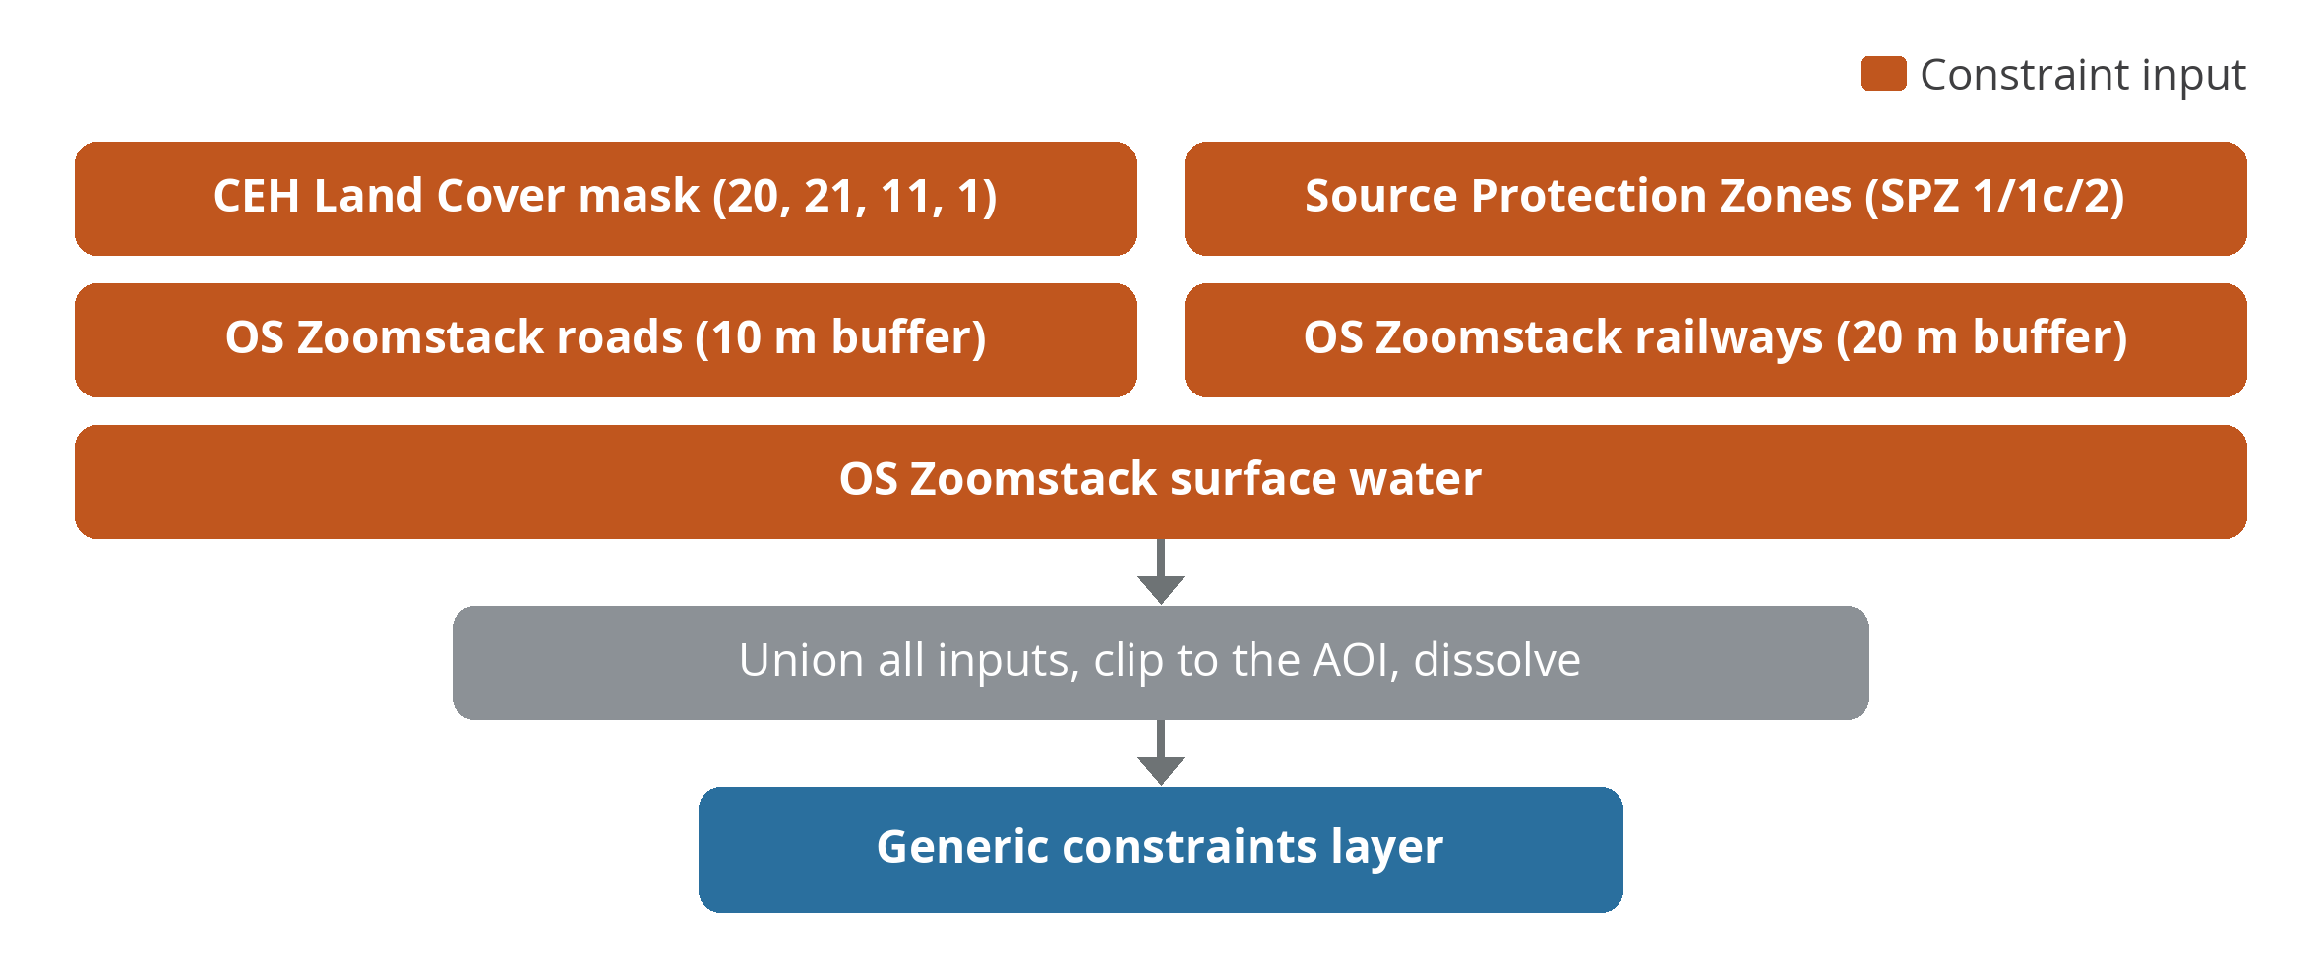
Figure 5. Combining datasets into the generic constraints layer (adapted from the Nature for Water Facility, 2024).
Table 8. Constraints inputs, datasets and treatment.
Constraint input | Dataset | Treatment
Urban & suburban land | UKCEH Land Cover Map (classes 20, 21) | Removed — construction not viable
Existing bog / peat | UKCEH Land Cover Map (class 11) | Removed — protect existing peat
Broadleaved woodland | UKCEH Land Cover Map (class 1) | Removed — protect native woodland
Source Protection Zones | EA SPZ (No-Infiltration Area) | Removed — drinking-water protection (filtered to zones SPZ1/1c/2, the No-Infiltration area; SPZ3 total catchment is retained as opportunity)
Roads | OS Open Zoomstack | Removed with a 10 m buffer
Railways | OS Open Zoomstack | Removed with a 20 m buffer
Surface water | OS Open Zoomstack | Removed

Two deliberate choices
Existing broadleaved woodland is considered by this methodology to be a constraint (protecting native woodland), but coniferous plantation is not — it is instead considered a target for conversion to native broadleaved woodland. Separately, the peat constraint (“do not build here”) is kept distinct from peat-restoration mapping (“this degraded peat could be restored”).

2.4 Supplementary data and prioritisation
Once NbS opportunity areas have been defined and constrained, every layer then passes through two further stages: attaching supplementary information, and combining that information into a single priority score. These stages add additional context to each mapped NbS feature in terms of what its current underlying conditions are and how much of a priority it is for implementation – hence increasing the use of the layers in decision making and catchment planning.
It should be noted that at present, priority scores are not tied to Severn Trent specific water-resilience drivers but to the characteristics of the existing land use (e.g. high-grade agricultural land ranks below low-grade land or existing habitat). Further internal Severn Trent data could be added to these existing supplementary datasets to better understand and map operational priorities for the implementation of NbS.
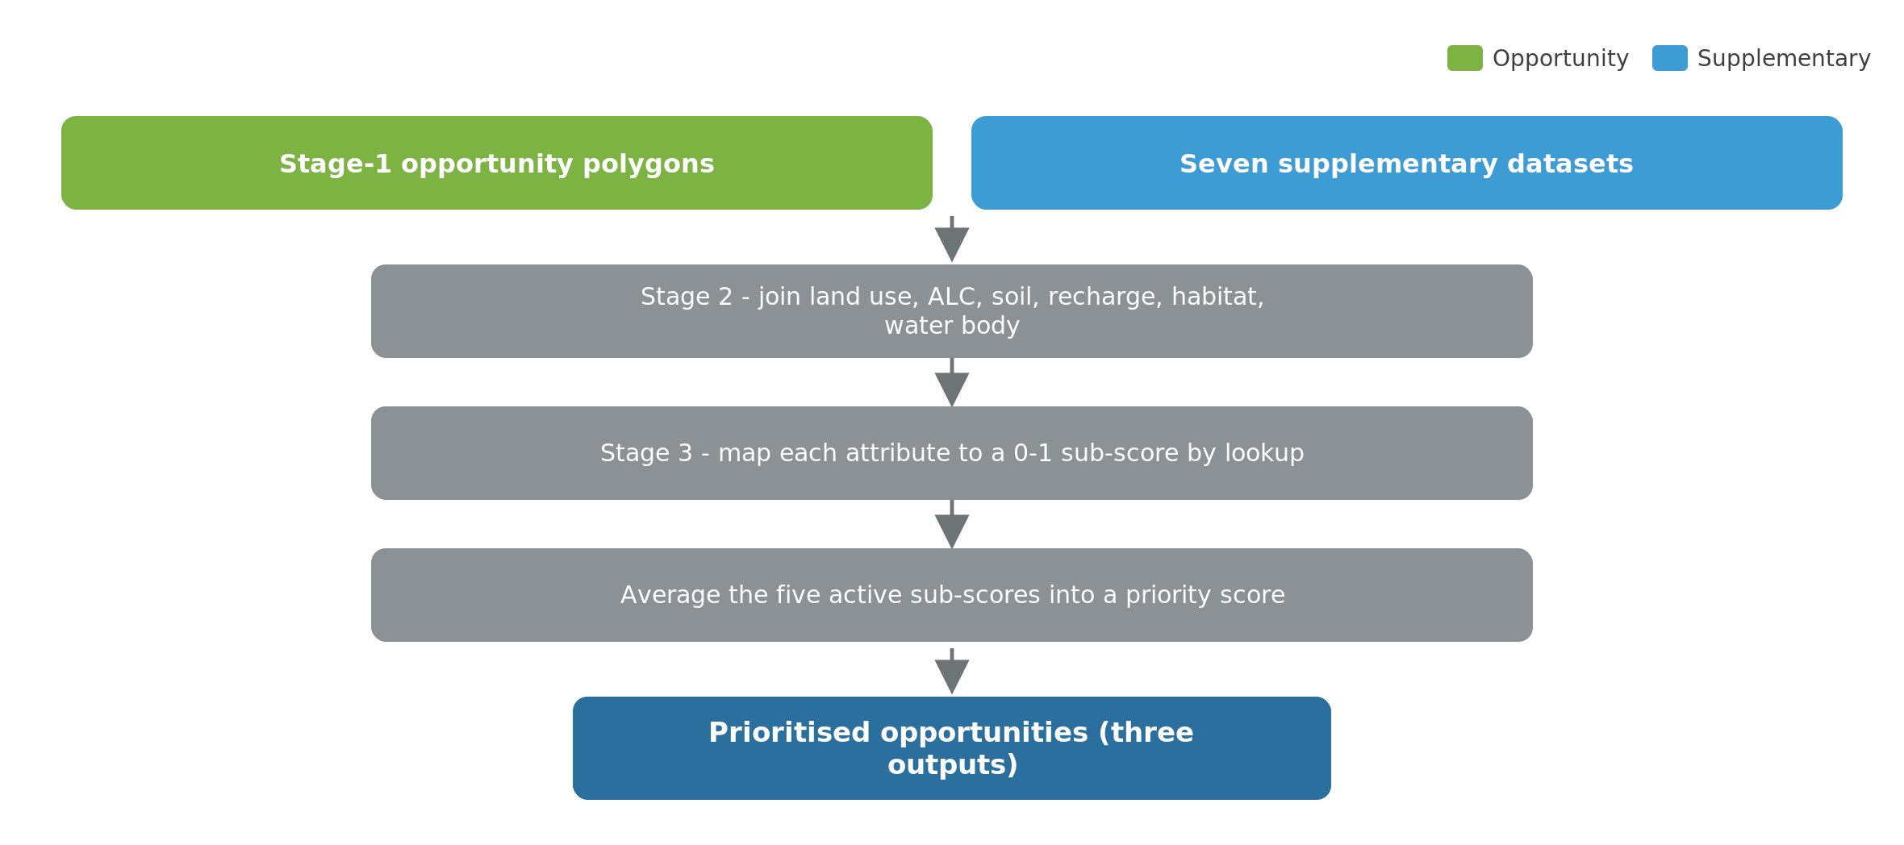
Figure 6. Supplementary-join and prioritisation stages applied to every NbS layer (adapted from the Nature for Water Facility, 2024).

2.4.1 Supplementary data
All NbS opportunity maps are given additional context by spatially joining a further set of contextual attributes coming from other layers (see Table 9). The same join sequence is applied to every layer. Most are attached by spatial intersection (taking the value of the underlying polygon with the largest overlap); the water-body and recharge layers are joined at water-body scale.
Adding supplementary data allows a user to click on a single feature (e.g. a pond), and understand the existing land use, soil type and agricultural grade of that parcel of land.
Table 9. Supplementary data layers added to opportunity maps.
Attribute attached | Source dataset | Join type
Water body — specifically water body name and ID (WB_NAME, WB_ID) | WFD River Waterbody Catchments | Intersection (largest overlap)
Land use (CEH_LU) | UKCEH Land Cover Map 2023 | Intersection (largest overlap)
Agricultural land classification (alc_grade) | Agricultural Land Classification | Intersection (largest overlap)
Soil group / texture / depth (sl_grp, sl_tex, sl_dep) | BGS Soil Parent Material Model | Intersection (largest overlap)
Recharge priority (rch_pt) | Recharge Prioritisation (HML) | Water-body join (High/Medium/Low)
Habitat-network status (prio_hb) | Priority Habitat Networks | Spatial join (intersects)
Woodland-creation sensitivity (wood_s) | England Woodland Creation Sensitivity | Intersection (largest overlap)

2.4.2 Priority scoring
All NbS features are given a single priority score between 0 (least priority) and 1 (highest priority). Five of the supplementary attributes which were attached in the previous step are converted to a 0–1 score through a documented lookup (see Table 10 for the current overview), and the five sub-scores are averaged. A higher score means a more suitable, lower-conflict location for intervention. The logic of the lookups is consistent: land that is less productive and currently low-value for nature (arable, improved grassland, poorer agricultural grades) scores highly, because it is where NbS adds most and displaces least; semi-natural habitats and the best farmland score low, to steer intervention away from them.
The score is calculated as an average across the priority scores attributed by the lookup, finally generating one priority score per-NbS feature. This can be used to plan the best locations for implementation at catchment scale.
Table 10. Scoring lookups for different supplementary datasets.
Dataset / Attribute | Sub-score | Rationale
Agricultural Land Classification
Grade 1 (best) | 0.0 | Don’t deliver on the most productive farmland
Grade 2 | 0.2
Grade 3 | 0.75
Grade 4 / 5 (poorest) | 1.0 | Lowest-conflict land for NbS
Urban / non-agricultural | 0.0
Land use (UKCEH Land Cover Map → lu_prio)
Arable; improved grassland; inland rock; freshwater; coastal rock & sediment | 1.0 | Delivering NbS on existing degraded land use types
Neutral, calcareous & acid grassland; heather; heather grassland | 0.5
Deciduous woodland; fen; bog; saltmarsh | 0.0 | Highest priority land uses for conservation
Habitat networks (prio_hb → hb_prio)
Network enhancement / expansion / fragmentation-action zones; habitat restoration-creation; rivers | 1.0 | Areas identified by this dataset as priority for habitat enhancement / restoration
Restorable habitat; wood pasture & parkland; missing value (NA) | 0.5
Existing designated / priority habitats (SSSI, ancient woodland, meadows, fens, heathland, etc.) | 0.0 | Existing areas of priority habitat
Soil group (BGS → sl_prio)
Heavy-to-medium / medium-to-heavy | 1.0 | Delivering NbS on heavy soils will help attenuate water in more flood-prone areas
Medium | 0.75
Most other named groups (mixed / lighter textures); unknown or unmapped is excluded from the score | 0.5
Recharge (HML → rch_prio)
High | 1.0 | Delivering on areas which can maximise groundwater-recharge benefits
Medium | 0.5
Low / missing | 0.0

A flexible approach to prioritisation
The lookup table shown above is easily editable in the mapping process using a plain-text YAML configuration file (config/prioritisation_scores.yaml), meaning that different prioritisation can be implemented and re-run where necessary. This allows for differing prioritisations for different outcomes (e.g. maximising flood risk reduction may prioritise slightly differently).

3. Results

3.1 Result outputs
The full-area run was completed in July 2026, generating prioritised opportunity layers for all of the NbS types across the entire area of interest (Figure 7). Each layer is delivered as opportunity, supplemented and prioritised outputs (see Figure 8 for an example of prioritised outputs). Headline results are summarised below.
Table 11. Headline results by solution type (full-area run, July 2026). Figures are totals across the AOI.
Solution type | Mapped extent | Features
Pond, pool and scrape creation | 7,987 ha | 537,042
Leaky barriers | ~4,220 km of watercourse (candidate points at 100 m) | 42,200
Bunds / runoff attenuation | 40,622 ha | 816,722
Floodplain reconnection | 175,570 ha | 127,180
Riparian buffer strips | 244,146 ha | 120,958
Woodland creation | 502,245 ha | 195,816
Peat restoration (experimental) | 11,251 ha | 17,667
All area-based layers | ≈982,000 ha | ~1.86 million

Taken together, the seven mapped layers identify approximately 982,000 ha of potential NbS opportunity across the region — around two-fifths of the operating area — before any field assessments. Individual layers overlap (the same field may host woodland or bunds, for example), so per-layer extents are not additive as land take; they rather describe the potential for each solution type independently. Leaky barriers are mapped as candidate points every 100 m along suitable smaller watercourses rather than as areas.

3.1.3 Results by solution type
The headline totals above describe the whole area of interest; the notes below summarise where each solution’s opportunity shows up across the Severn Trent area.
Pond, pool and scrape (7,987 ha; 718 water bodies). Opportunity is widespread but made up of many small features, concentrated on natural flow-accumulation pathways and floodplain margins across mixed-farming lowlands. It is the most evenly distributed layer, reflecting how readily small water-retention features fit into the agricultural landscape.
Leaky barriers (~4,220 km of watercourse; 651 water bodies). Candidate points cluster along smaller headwater watercourses that fall within the surface-water flood extent – the upper-catchment fringes of the Peak District, the Staffordshire and Shropshire hills and the Welsh Marches, where fast-responding ditches and streams dominate.
Bunds / runoff attenuation (40,622 ha; 735 water bodies). Reaching the widest set of water bodies of any layer, opportunity follows moderate-to-steep slopes with concentrated surface flow and is spread across the whole operating area, strongest in rolling farmland areas above the main valleys.
Floodplain reconnection and restoration (175,570 ha; 730 water bodies). This is dominated by the Severn and Trent main floodplain areas and their major tributaries (e.g. Avon, Soar, Tame, Teme). The extent is large and should be read as strategic, blue-sky potential: some of it coincides with developed floodplain around Nottingham, Derby, Shrewsbury and Worcester, where reconnection would conflict with existing urban land. Even after allowing for that, a substantial genuine opportunity remains on rural reaches for large-scale river and floodplain restoration.
Riparian buffer strips (244,146 ha; 732 water bodies). Opportunity is near-ubiquitous along the dense watercourse network, greatest where intensive agriculture runs up to the water’s edge and buffers would intercept the most diffuse pollution.
Woodland creation (502,245 ha; 528 water bodies). The largest layer by area, with two clear concentrations. In the west – the Shropshire Hills, Welsh Marches and the Staffordshire / Peak uplands – marginal grazing land on steeper slopes scores highly for runoff reduction. In the east – Leicestershire, Rutland and the Nottinghamshire / Lincolnshire fringe – large blocks of low-sensitivity land appear in one of the least-wooded parts of England. This distribution is driven by the two source datasets used to map this solution type – the England Woodland Creation Sensitivity map flags land with few planting constraints (abundant in the sparsely-wooded East Midlands), while the WWNP Wider-Catchment Woodland Potential layer flags wider-catchment land where new woodland would cut runoff (the western uplands).
Peat restoration (experimental). Opportunity is confined to the upland deep-peat “water tower” areas – principally the Peak District and Staffordshire Moorlands headwaters – where the England Peat Map shows large areas of degraded or bare peat. These are a priority for Severn Trent’s upland programmes; the layer is delivered as an experimental screening layer (17,667 candidate features, 11,251 ha); specialist and QGIS validation is recommended before operational use.
As set out above, these extents describe each solution’s option space independently and are not additive; the same parcel of land may appear under more than one layer.
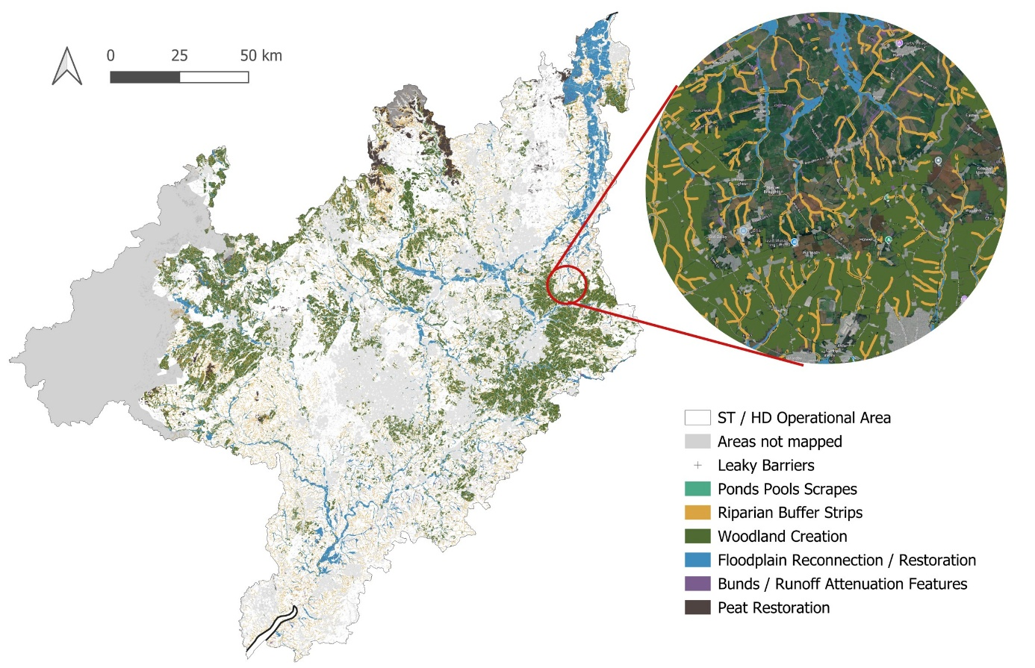
Figure 7. Mapped NbS opportunities across the Severn Trent operating area, with local detail inset.
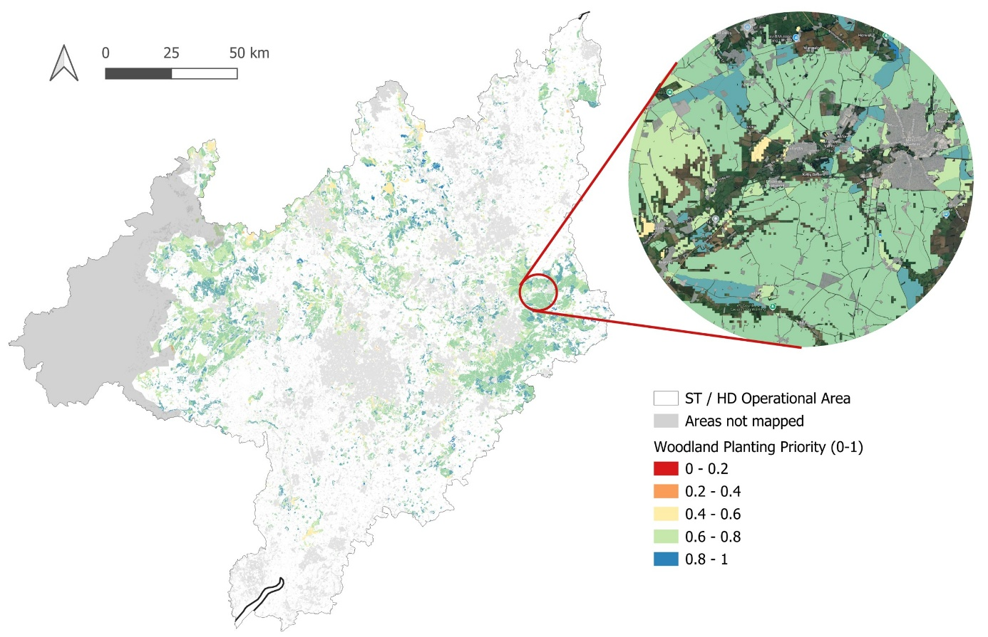
Figure 8. Example prioritised output — woodland planting priority (0–1), with local detail inset.

3.2 What the outputs can and cannot be used for
It is important to note that these outputs are a catchment-scale screening and targeting tool. They are built from national datasets at national resolution and as such are best suited for catchment-scale optioneering rather than site-level accuracy. Moreover they describe opportunity rather than deliverability – there is still a very large amount of engagement and scoping needed to progress potential opportunities identified by this mapping exercise.
Table 12. Most effective use cases for opportunity mapping.
What these maps should / can be used for | What they shouldn’t / can’t
Catchment-scale screening and targeting | Site-level design or final scheme decisions
Prioritising areas for further investigation | Confirming feasibility without survey
Comparing solution types across a water body | Welsh (Hafren Dyfrdwy) areas
Supporting stakeholder and landowner conversations | Treating the priority score as an absolute value

3.3 Example use cases in Severn Trent
The mapping is designed to feed a range of Severn Trent workflows. The uses below were discussed with Severn Trent teams during the review process in July 2026; several cut across more than one team.
Table 13. Example ways of using the mapping within Severn Trent.
Team / area | How the mapping is used
Catchment & environment teams | Opportunity scoping and landowner engagement – ready-made maps to open conversations about specific farms and reaches.
Water resources & modelling | Quantify catchment-scale NbS potential – total feasible area per water body as an input to flow and water-quality models.
WINEP & AMP planning | Screen and long-list candidate schemes with one consistent, open evidence base that reads the same in every catchment.
Peatland programme | Target restoration using the new peat layer, built on the 2025 England Peat Map.
Partnerships & catchment groups | A shareable, open-data evidence base for CaBA partnerships and neighbouring water companies – the AOI already includes shared water bodies.
Biodiversity & land teams | Find habitat-creation opportunities that stack with flood and water-quality benefits – ponds, buffers and woodland in the right places.

Together these support more joined-up planning of NbS across teams in the Severn Trent region. The methodology contains three points where Severn Trent data can be added – new opportunity layers, local constraints, and additional prioritisation criteria. These uses can therefore be sharpened further as operational data is plugged in.

4. Next Steps

4.1 Assumptions, limitations and coverage
The method makes a number of assumptions and carries known limitations that any reader should bear in mind when using the outputs. The most significant are set out in Table 14.
Table 14. Assumptions and limitations of the methodology.
Item | What it means
England-only coverage | No opportunity outputs for the Welsh portion; GB-wide datasets extend into Wales but other datasets are England-only
Dataset age | Outputs reflect dataset versions at run time; the live-fetch design allows re-running as data is revised but links may need to be checked to see if newer versions exist
Surface-water flood extent | Uses current NaFRA2 data filtered to the 1-in-100-year band, replacing the older RoFSW legacy product; same return periods but extent differences are present
Peat restoration is experimental | New layer, no original equivalent; depends on the 2025 England Peat Map; should be treated as experimental until Severn Trent review with specialists
Parity with the original model | Validated against the R outputs; geometry aligns closely, scores differ by design (added recharge signal)

4.2 How Severn Trent can take this forward
The workflow is currently held as a private repository on Github. A single method produces all seven solution types over any input area given by the user, downloading the open datasets and writing three outputs per layer (opportunity, supplemented, prioritised) plus a review note. The full technical design is summarised in Appendix A and described throughout using markdown documents delivered within the repository.
This mapping is built to be owned and run by Severn Trent, not to sit as a one-off piece of work that produces output layers. Two things make that possible: the analysis is fully reproducible, and the methodology is left deliberately open at the points where Severn Trent’s own data and priorities can be plugged in.
As part of this deliverable everything needed to run and maintain the mapping in-house is handed over together. The steps toward this being handed over and owned by Severn Trent going forward are therefore as such:
- Handover to the Data Science team — the GitHub repository, this methodology report and a step-by-step run guide together contain everything needed to repeat the analysis in-house.
- Re-run as data updates — the live-fetch design means a re-run automatically picks up new releases of the national datasets, so maps will be kept up to date.
- Swap in different datasets — the full data registry means new or better inputs, including different or updated opportunity or constraint layers can slot in easily.
- Add prioritisation layers — Severn Trent-specific spatial datasets on e.g. asset risk, WINEP obligations and biodiversity targets can be layered in to update and improve priority scoring.
The full methodology pipeline is deliberately open at three points where Severn Trent data can enter new datasets without changing the method, each mapping onto one of the shared stages (see Figure 9).
Figure 9. Where Severn Trent plugs in — three points where local data can enter the pipeline without changing the method.
1 · Opportunity | 2 · Constraints | 3 · Supplementary | 4 · Prioritise
↑ | ↑ | ↑ | ↑
New opportunity layers  An emerging NbS type — or a better source dataset — could feed in as a new map layer with one entry in the data registry. | Additional constraints  Severn Trent assets, land holdings and known no-go areas can be subtracted from every layer, exactly like the national constraint datasets. | Additional prioritisation data  For example asset risk, WINEP obligations, biodiversity net-gain targets: any spatial layer that will help Severn Trent better prioritise delivery can be attached to the output dataset and scored into the 0–1 priority which is constructed for each feature.

4.3 Potential future phases
Several additional pieces of work have been identified for future phases, beyond the Phase 1 scope agreed for this delivery:
- Welsh coverage. Sourcing Natural Resources Wales / DataMapWales equivalents so opportunities can be generated for the Hafren Dyfrdwy service area. A description of what would be needed to extend the mapping can be found in Appendix E.
- Higher-resolution watercourses. Optionally replacing the open OS Zoomstack waterlines with the richer OS MasterMap Water Network where licensing allows.
- EA infiltration data. Replacing the interim water-body level prioritised recharge areas with a more high-resolution alternative.

Appendix A. Per-layer creation methodology

Generic constraints layer
Built once and reused by every layer. The five inputs are constructed as polygons, unioned, clipped to the AOI and dissolved to a single layer.
Figure A.1. Generic constraints layer (approach adapted from the Nature for Water Facility, 2024).
Input | Treatment
UKCEH Land Cover Map 2023 (classes 20, 21, 11, 1) | Selected and dissolved (class 2 coniferous excluded)
Source Protection Zones (No-Infiltration Area) | Filtered to SPZ 1/1c/2 (No-Infiltration area), then added whole
OS Zoomstack roads (local + regional + national) | Buffered 10 m
OS Zoomstack railways | Buffered 20 m
OS Zoomstack surface water | Added whole

Output: a single dissolved constraints layer, subtracted from each NbS opportunity area.

Pond, pool and scrape
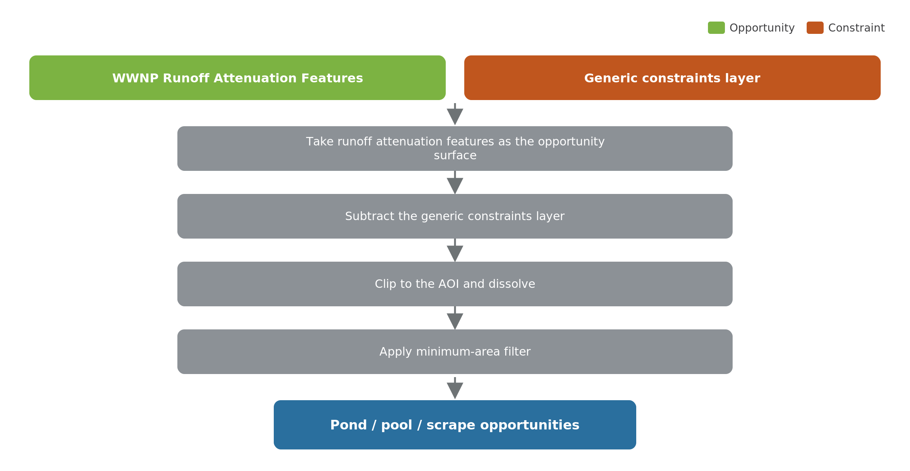
Figure A.2. Pond / pool / scrape — creation method.
Inputs | Role
WWNP Runoff Attenuation Features (1% AEP) | Opportunity source
Generic constraints layer | Subtracted

Method:
- Take the WWNP runoff attenuation features as the opportunity surface.
- Subtract the generic constraints layer.
- Clip to the AOI and dissolve.
- Apply a minimum-area filter to remove slivers.
Output: pond/pool/scrape opportunity polygons.

Leaky barriers
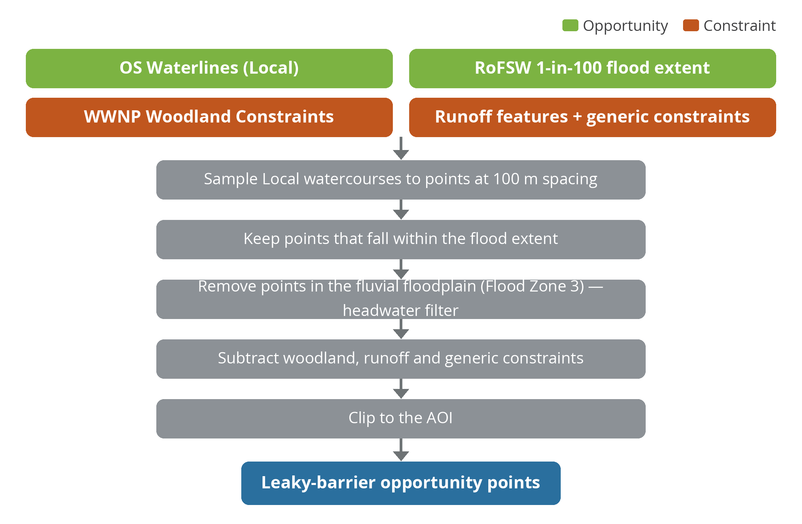
Figure A.3. Leaky barriers — creation method.
Inputs | Role
OS Zoomstack Waterlines (Local), 100 m points | Opportunity source
NaFRA2 surface-water flood extent (1-in-100) | Opportunity filter
WWNP Woodland Constraints; WWNP RAF; EA Flood Zone 3 (fluvial floodplain); generic constraints | Subtracted

Method:
- Sample the Local watercourse network to points at 100 m spacing.
- Keep points that fall within the surface-water flood extent.
- Remove points within WWNP Woodland Constraints, runoff features, the EA Flood Zone 3 fluvial floodplain (headwater filter) and the generic constraints layer.
- Clip to the AOI.
Output: candidate leaky-barrier points (already point geometry — no centroid step needed).

Bunds / catchment storage areas
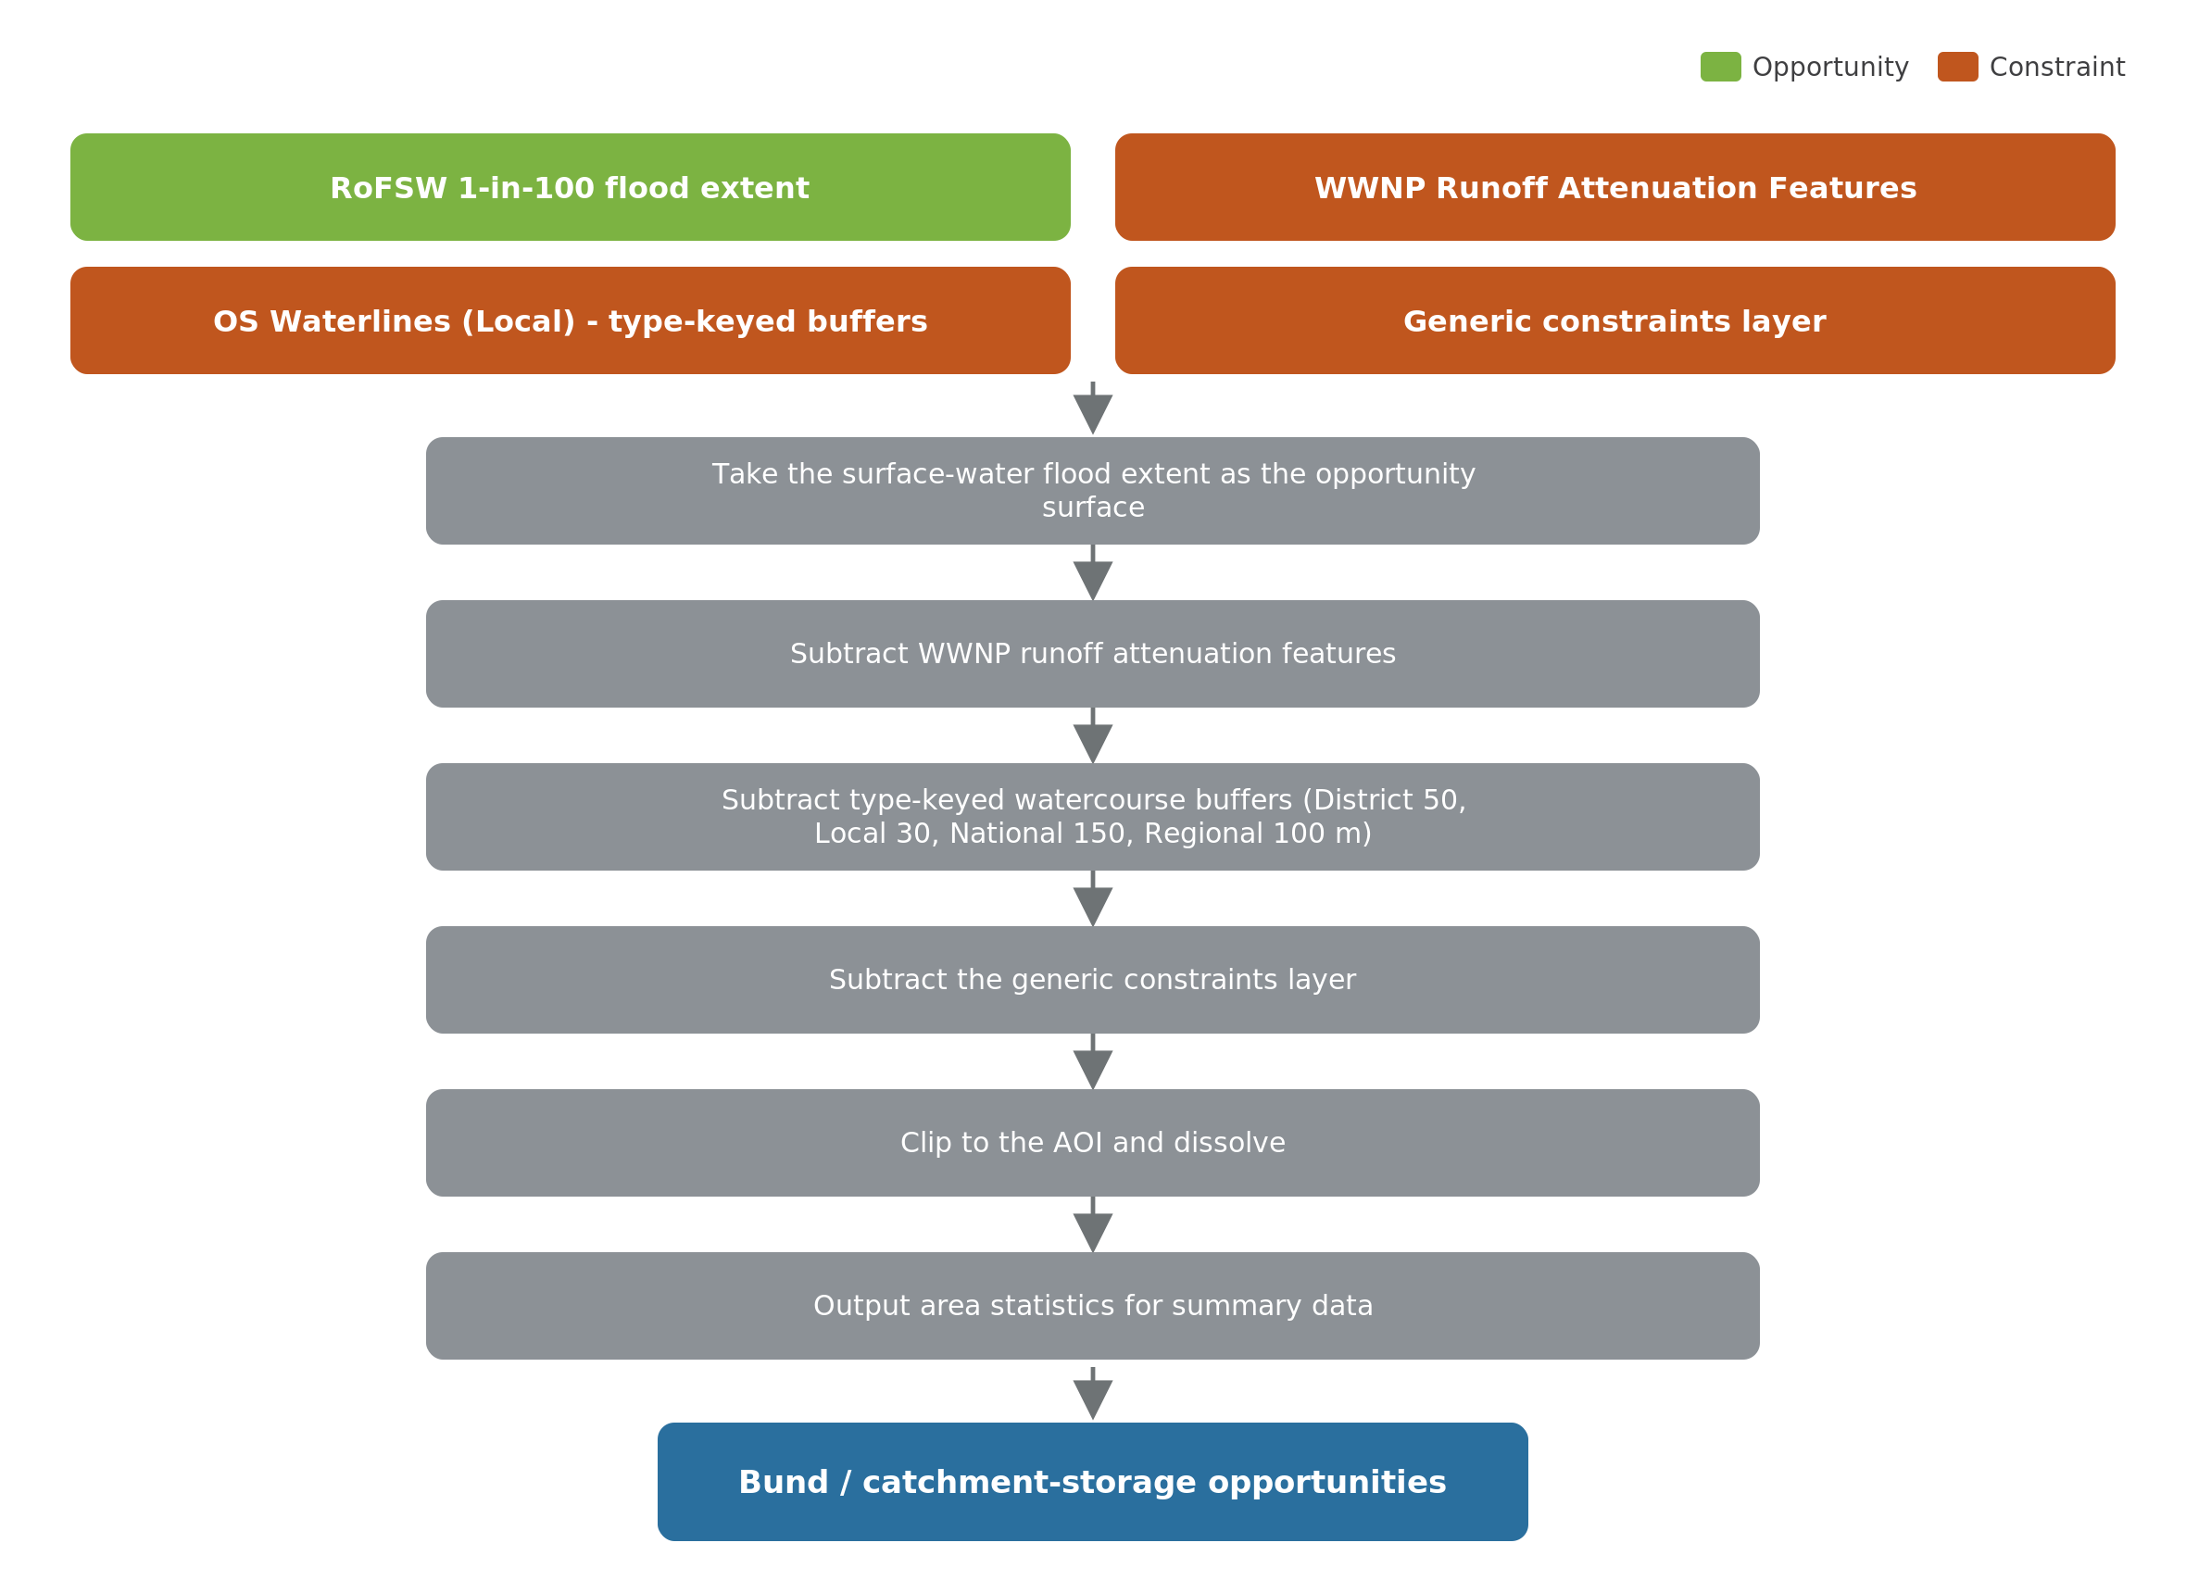
Figure A.4. Bunds — GIS methodology (Nature for Water Facility, 2024).
Inputs | Role
NaFRA2 surface-water flood extent (1-in-100) | Opportunity source
WWNP RAF; type-keyed watercourse buffers; generic constraints | Subtracted

Method:
- Take the surface-water flood extent as the opportunity surface.
- Subtract WWNP runoff attenuation features.
- Subtract watercourse corridors — Zoomstack waterlines buffered by size (District 50 m, Local 30 m, National 150 m, Regional 100 m).
- Subtract the generic constraints layer; clip to the AOI and dissolve.
Output: bund / catchment-storage opportunity polygons.

Floodplain restoration / reconnection
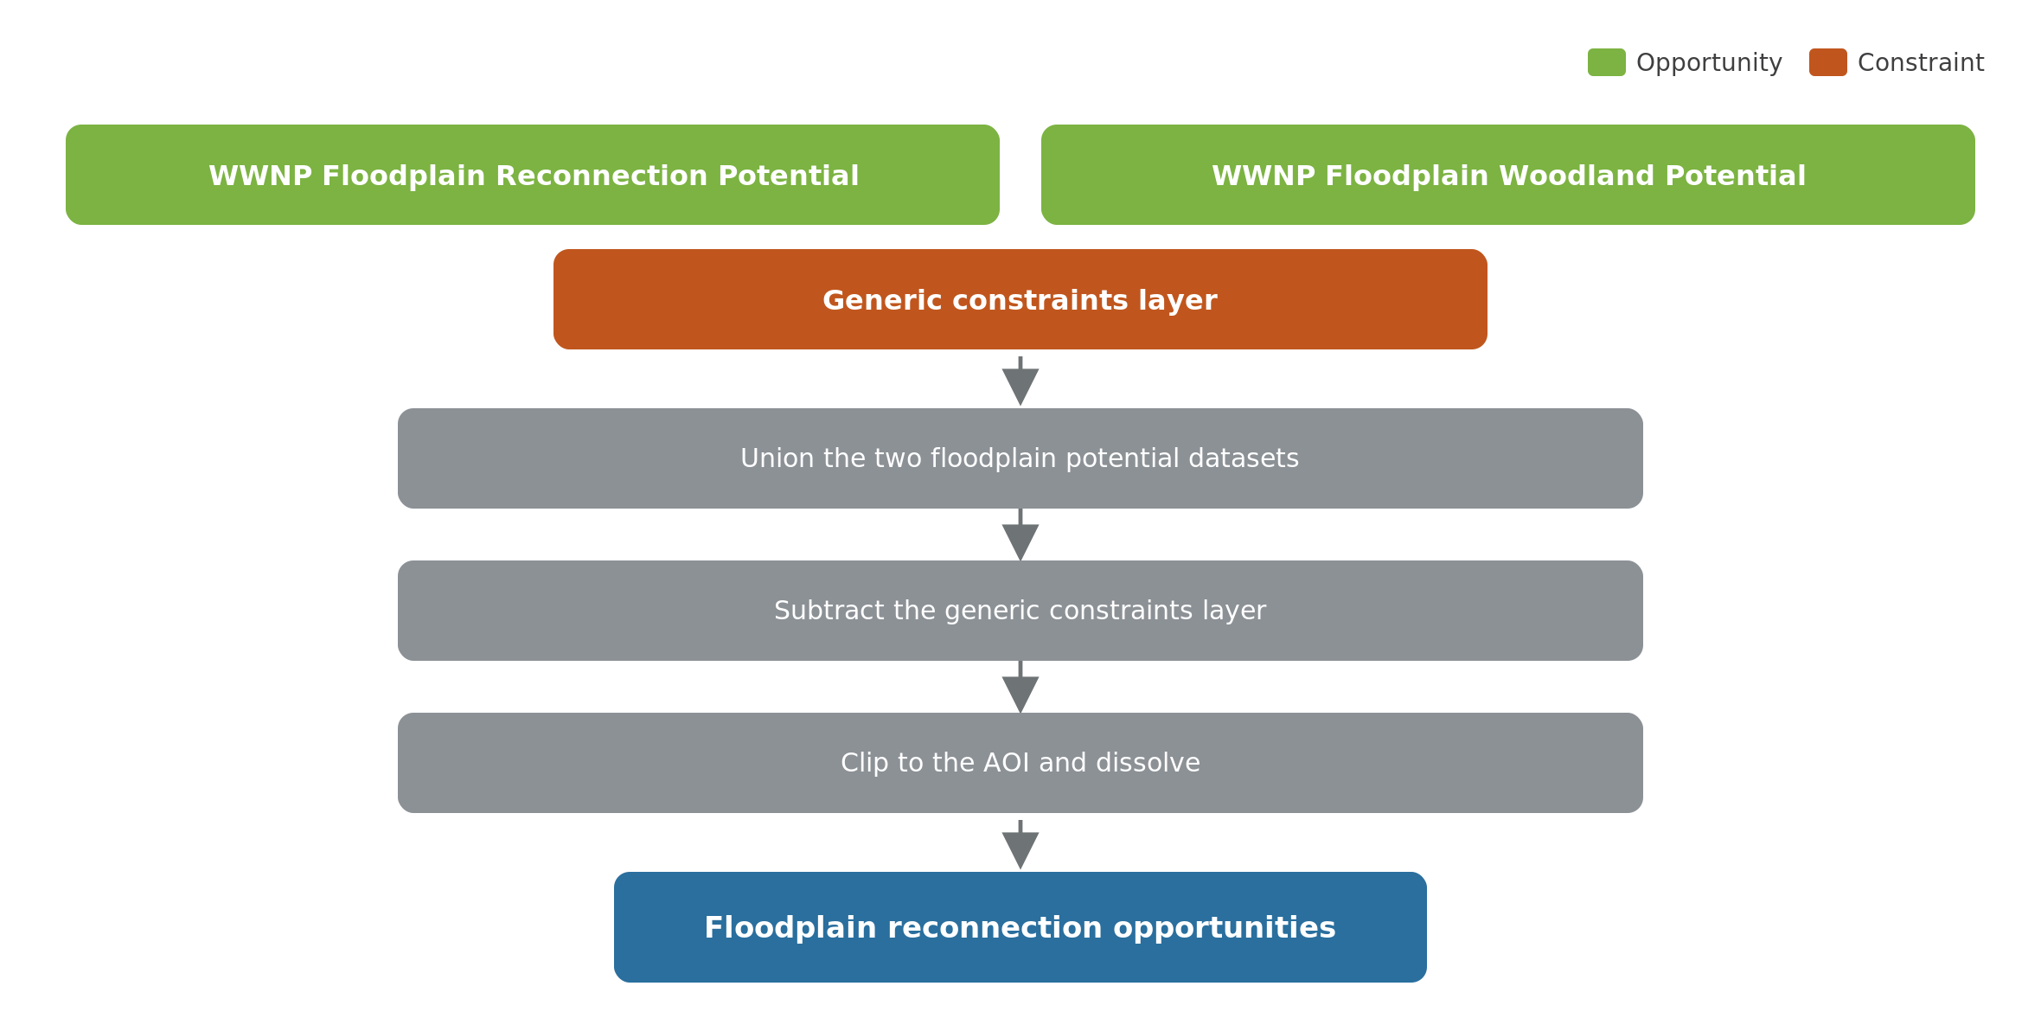
Figure A.5. Floodplain reconnection — creation method.
Inputs | Role
WWNP Floodplain Reconnection Potential | Opportunity source
WWNP Floodplain Woodland Potential | Opportunity source (unioned)
Generic constraints layer | Subtracted

Method:
- Union the floodplain reconnection and floodplain woodland potential datasets.
- Subtract the generic constraints layer.
- Clip to the AOI and dissolve.
Output: floodplain reconnection opportunity polygons.

Riparian buffer strips
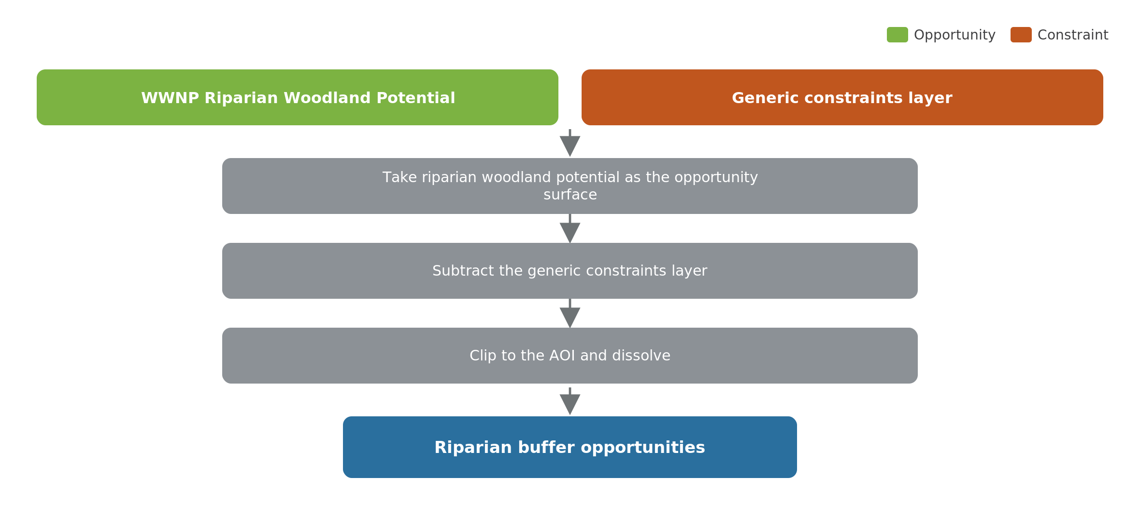
Figure A.6. Riparian buffers — creation method.
Inputs | Role
WWNP Riparian Woodland Potential | Opportunity source
Generic constraints layer | Subtracted

Method:
- Take the WWNP riparian woodland potential as the opportunity surface.
- Subtract the generic constraints layer.
- Clip to the AOI and dissolve.
Output: riparian buffer opportunity polygons. (No reference output exists in the original model, so parity reports ‘no reference’.)

Woodland and tree planting
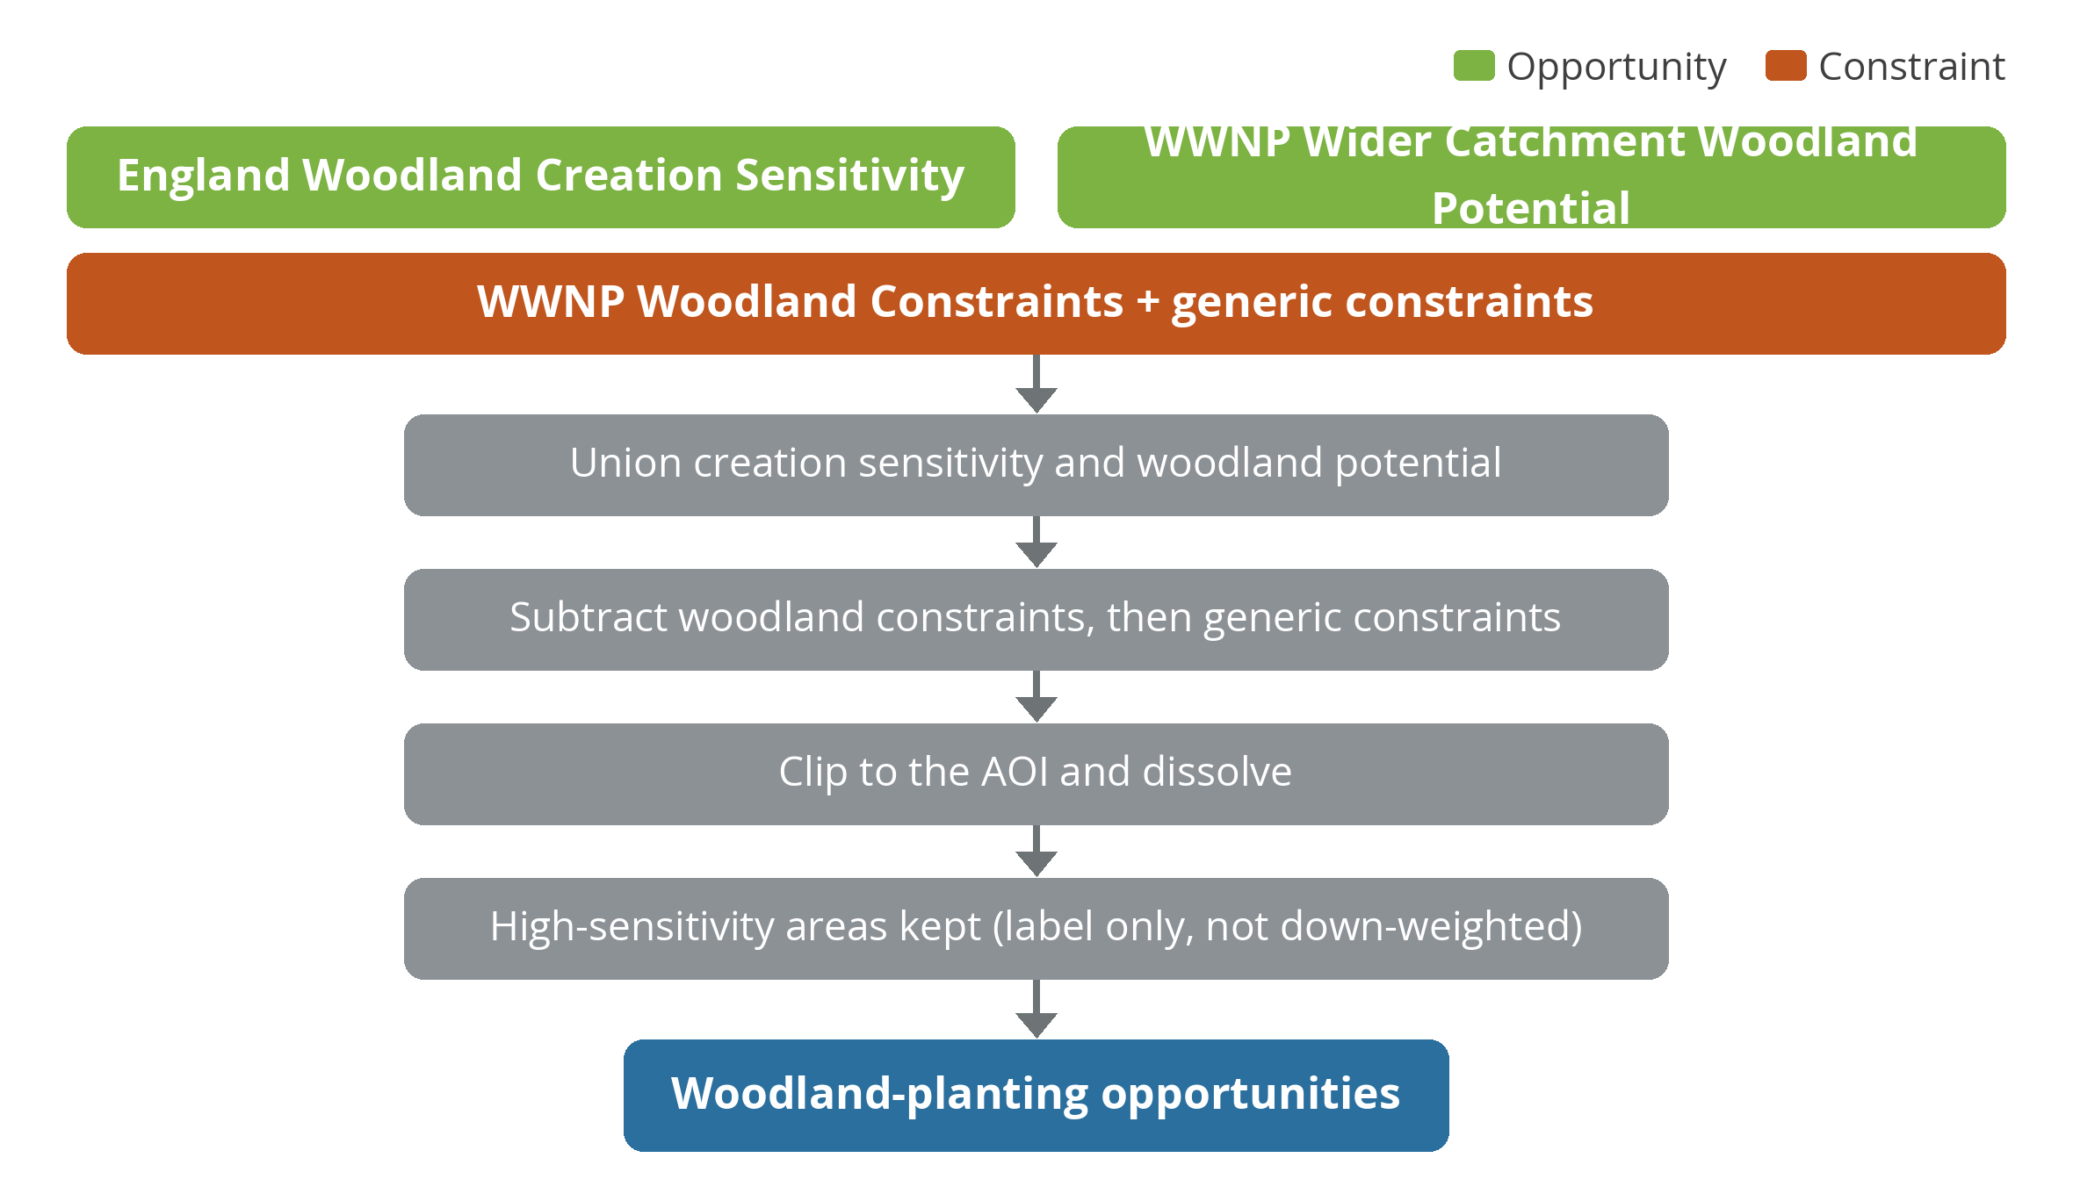
Figure A.7. Woodland planting — creation method.
Inputs | Role
England Woodland Creation Sensitivity | Opportunity source
WWNP Wider Catchment Woodland Potential | Opportunity source (unioned)
WWNP Woodland Constraints; generic constraints | Subtracted

Method:
- Union the woodland creation sensitivity and wider-catchment woodland potential datasets (High-sensitivity areas retained).
- Subtract WWNP Woodland Constraints, then the generic constraints layer.
- Clip to the AOI and dissolve.
Output: woodland-planting opportunity polygons; High-sensitivity areas are kept and carried as a label only — they are not down-weighted in the priority score (matching the original R method).

Peat restoration (experimental)
New for this commission. An initial vegetation- and depth-based approach (following the NERR149 framework) was trialled but, on GIS review, over-selected across the Peak District; the delivered method is a focused erosion / drainage screen built from two England Peat Map layers — Upland Grips (artificial drainage ditches) and Upland Gullies (peat erosion channels). The steps below follow that delivered method.
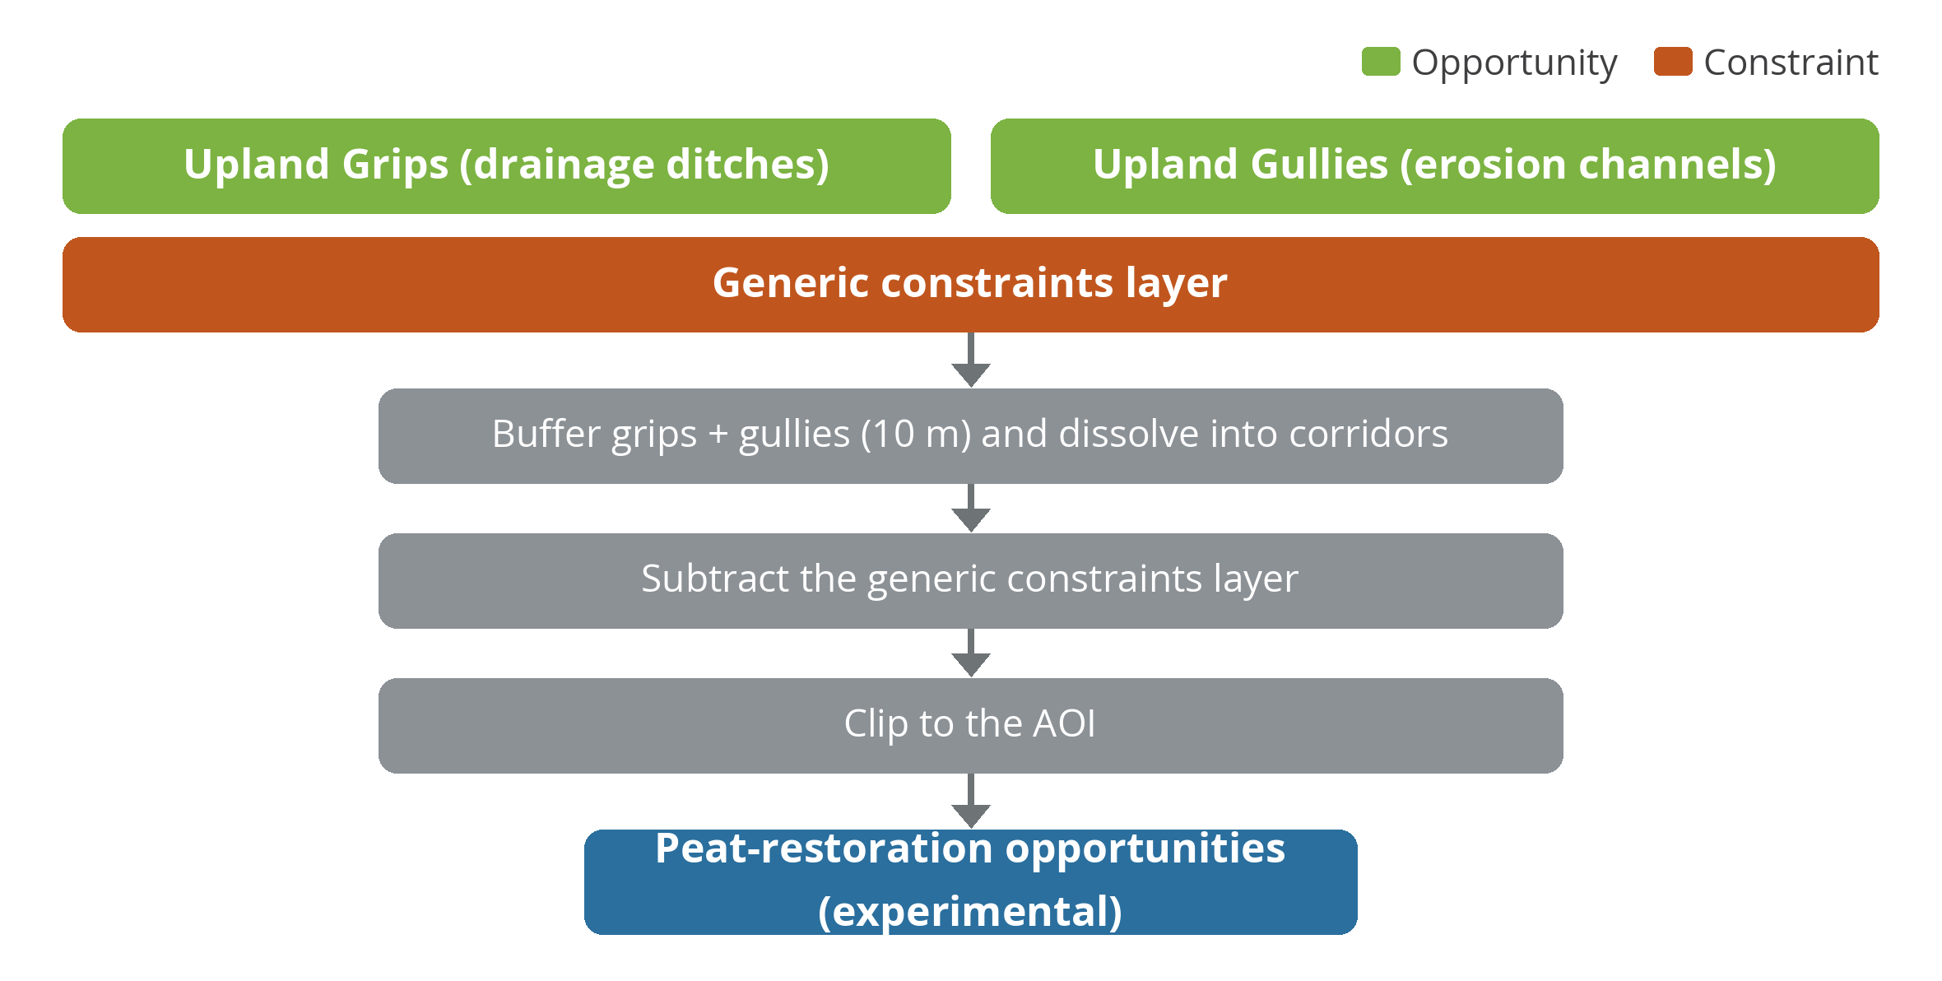
Figure A.8. Peat restoration — grip / gully erosion-screening method.
Step | Logic | Inputs
1 — Buffer | Buffer the two erosion / drainage signals | Upland Grips + Upland Gullies, buffered 10 m
2 — Dissolve + constrain | Dissolve buffered corridors, then remove constraints | Generic constraints layer (roads, rail, surface water, urban, SPZ)
3 — Clip | Clip to the water-body AOI | (no depth or vegetation gate applied)
Output: peat-restoration opportunity polygons — buffered, dissolved grip / gully corridors. Delivered as an experimental screening layer with no depth refinement applied, so site-level validation is recommended.

Shared stages — supplementary and prioritisation
After Stage 1, every layer passes through the two shared stages described in Section 2.5 and diagrammed in Figure 7: a supplementary join attaching land use, agricultural grade, soil group, recharge priority, habitat status and water body to each opportunity area; and a prioritisation step combining the five scoring sub-scores into a single priority value. Each layer is written as three GeoPackage outputs — opportunity, supplemented and prioritised — mirroring the original model's three output stages.
Figure A.9. Shared supplementary-join and prioritisation stages.

Appendix B. Technical and pipeline notes
This appendix records the engineering decisions behind the pipeline, for readers working on the code. They do not change the methodology but explain how it is implemented.

Vector-only architecture
The original R workflow rasterised features, applied an inverse mask with the constraints raster, then vectorised the result. The Python pipeline works in vector throughout: the constraints inverse-mask becomes a geometric difference, masking to the AOI becomes a clip/intersection, and there is no raster approach used in the core modules. This keeps every intermediate step inspectable in standard GIS and preserves a one-to-one correspondence with the original scripts. Any raster pre-processing that is ever needed is confined to standalone scripts that emit vectors. All geometry is held in British National Grid (EPSG:27700).

Data retrieval and scaling
Some national datasets — notably the surface-water flood extent — are very large, and some web-service requests return truncated data. The fetch layer therefore pages through web-feature-service results and checks the returned count against the server's reported total, raising an error rather than proceeding on a partial download. Pages are cached and resumable, with gentle pacing to avoid overloading the source servers, and the densest layers use smaller page sizes. At full-operating-area scale the analysis can be processed one water-body catchment at a time and merged, which matches the delivery unit and makes the run resumable and reviewable.

Provenance of the original method
The pipeline builds on the Warwickshire Avon R model (Jack Beard / Corjan Nolet, 2024). The R reference scripts and their outputs are retained unchanged as the methodological source of truth. Two manual steps in the original — sampling 100 m points along local watercourses, and applying type-keyed buffers to watercourses for bunds — were previously done by hand in desktop GIS and have been rebuilt as scripted pre-processing, so the full chain from raw data to output is reproducible.

Origin, authorship and provenance of this work
The origin of this methodology is recorded here so that the authorship and lineage of the work are unambiguous.
- The approach originates in the Nature for Water Facility opportunity mapping for the Warwickshire Avon (March 2024). That analysis was delivered as a set of bespoke R scripts, authored by Jack Beard with Corjan Nolet, with the methodology recorded at the time only as presentation slides.
- Green in Blue (Jack Beard) was commissioned by Severn Trent to extend that approach across the Severn Trent operating area and to re-platform it as an open, reproducible Python pipeline. This report and the pipeline are original work produced by Green in Blue under that commission, building on the author’s own earlier Warwickshire Avon work. The seventh layer, peat restoration, was developed new for this commission using the 2025 England Peat Map and the NERR149 framework.
- The original R reference scripts and their outputs are retained unchanged in the project repository as the methodological source of truth, and the Python pipeline is written to maintain a one-to-one correspondence with them. The commission, scope and review history are documented in the project correspondence, the Technical Annex (Opportunity Mapping Methodology) and the version history in this document.
- All input datasets are third-party national / open data. Each is attributed to its provider with its source, licence and access route in Appendix D and, authoritatively, in the project data registry. No third-party data is redistributed beyond its licence terms; the PSGA-licensed OS MasterMap Water Network is deliberately excluded from any public repository.

Appendix C. Data access and licensing notes
Practical notes on obtaining and using the input datasets, for anyone re-running or extending the work.
Dataset / item | Access note
UKCEH Land Cover Map 2023 | Requires a free EIDC account to download; one download covers both the constraint mask and the land-use score
EA NbS Infiltration Class | Not openly available; must be requested directly from the Environment Agency. Severn Trent does not hold it. Interim substitute: Recharge Prioritisation (HML)
BGS datasets | Soil Parent Material Model is used as open data; any BGS commercial-use terms (e.g. Groundwater Vulnerability) require confirmation under the contract
OS MasterMap Water Network | PSGA-licensed; held out of Phase 1 (which uses open OS Zoomstack) and not committed to any public repository
England Peat Map | Open (Natural England, 2025); some services are tiled by biogeographical zone and fetched per tile then combined
Welsh equivalents | Natural Resources Wales / DataMapWales datasets would be needed for Hafren Dyfrdwy coverage; some may require a data-sharing agreement

Appendix D. Data sources and links
This appendix lists the source and access point for every dataset used in the methodology. Links are given to the dataset landing page where one exists, and otherwise to the service endpoint recorded in the project dataset registry. The data registry in the project code remains the authoritative record of URLs, layer names, access methods and licensing for each dataset.
Dataset | Provider | Source / link
WWNP Runoff Attenuation Features (1% AEP) | Environment Agency | https://environment.data.gov.uk/dataset/fc69965f-684f-463d-b7c9-2471a5d49741
WWNP Floodplain Reconnection Potential | Environment Agency | https://environment.data.gov.uk/dataset/e92e50e6-d2c5-4ae7-b824-138e0da0b554
WWNP Floodplain Woodland Potential | Environment Agency | https://environment.data.gov.uk/dataset/d1b028b8-6090-4621-8645-034f01b32403
WWNP Riparian Woodland Potential | Environment Agency | https://environment.data.gov.uk/dataset/960926b5-84e7-45f0-a38f-8ef58004820e
WWNP Wider Catchment Woodland Potential | Environment Agency | https://www.data.gov.uk/dataset/abe0c86f-4088-4d3a-8517-c6e70e2a57a3/wwnp-wider-catchment-woodland-potential
WWNP Woodland Constraints | Environment Agency | https://www.data.gov.uk/dataset/8e5fc315-a3cc-4659-b444-44bc72f4d6f7/wwnp-woodland-constraints
Risk of Flooding from Surface Water — Hazard (NaFRA2) | Environment Agency | https://environment.data.gov.uk/dataset/4e51df30-8437-4a56-92c2-ab14ff6e565b
Source Protection Zones (merged; no-infiltration) | Environment Agency | https://environment.data.gov.uk/dataset/6fd0120f-d465-11e4-abee-f0def148f590
WFD River Waterbody Catchments (Cycle 2) | Environment Agency | https://environment.data.gov.uk/dataset/7846354f-d465-11e4-89d9-f0def148f590
Agricultural Land Classification (national Provisional) | Natural England | https://environment.data.gov.uk/dataset/af1b847b-037b-4772-9c31-7edf584522aa
Priority Habitat Networks (combined habitats) | Natural England | https://environment.data.gov.uk/dataset/5e614b67-ccd0-4673-8ad8-adddf538125e
England Woodland Creation Sensitivity (v4) | Forestry Commission | services2.arcgis.com/mHXjwgl3OARRqqD4/arcgis/rest/services/England_Woodland_Creation_Full_Sensitivity_Map_v4/FeatureServer
Recharge Prioritisation (HML) | Natural England | services.arcgis.com/JJzESW51TqeY9uat/ArcGIS/rest/services
England Peat Map (extent, depth, condition) | Natural England | www.arcgis.com/sharing/rest/content/items/bc4527cbbc0c4acc92b44e85528c975e/data
England Peat Map — Peaty Soil Depth Confidence | Natural England | www.arcgis.com/sharing/rest/content/items/edb3acca28db43c99af414062ad3c928/data
UKCEH Land Cover Map 2023 | UKCEH | www.ceh.ac.uk/data/ukceh-land-cover-maps (free EIDC account required)
OS Open Zoomstack (waterlines, roads, rail, surface water) | Ordnance Survey | www.ordnancesurvey.co.uk/products/os-open-zoomstack
BGS Soil Parent Material Model (1 km) | British Geological Survey | www.bgs.ac.uk/datasets/soil-parent-material-model/
EA NbS Infiltration Class (not yet obtained) | Environment Agency | environment.maps.arcgis.com/apps/webappviewer/index.html?id=91202d8f6e3947689dc1c74b9fdd078f

Appendix E. Extending the mapping to Wales
The area of interest already includes the Welsh (Hafren Dyfrdwy) part of the Severn Trent business — about 2,990 km², or 12% of the operational footprint. Phase 1 produces no nature-based solution outputs there, because the opportunity layers are published for England only. This appendix sets out what extending the mapping to Wales would require and identifies the Welsh datasets that could replace each England-only input.

What would be needed
Extension would largely require supplementing and merging existing datasets rather than a change of method. In summary:
- Most inputs now have identified Welsh equivalents on DataMapWales and the Natural Resources Wales portal — agricultural land classification, priority habitats, peat, woodland opportunity, surface-water flood extent and WFD catchments.
- Three GB-wide datasets already cover Wales (UKCEH Land Cover Map, OS Open Zoomstack, BGS soil), so no substitution is needed for the shared constraint and supplementary layers.
- The main development effort is the runoff and floodplain opportunity layers (the Working with Natural Processes datasets are used in the creation of ponds, bunds, leaky barriers and floodplain reconnection). Wales has no direct equivalent, so these would need to be derived — for example from the NRW surface-water flood extent and watercourses — or sourced from NRW natural-flood-management work.
- Two key points: the WFD cycle differs (England uses Cycle 2, Wales publishes Cycle 3), and each Welsh dataset's attribute scoring lookups would need remapping to match the English ones. Licensing should also be confirmed per dataset.
With these substitutions in place, the same three-stage pipeline could generate Welsh outputs. We would recommend a short scoping exercise to confirm dataset availability, licensing and schema mapping before committing to a Phase 2.

England-only inputs, GB inputs, and Welsh alternatives
English input dataset | Coverage | Welsh alternative / approach | Source (DataMapWales / NRW)
Analytical structure
WFD River Waterbody Catchments (Cycle 2) — defines the AOI | England only | NRW WFD River Waterbody Catchments (Cycle 3) — note cycle difference to harmonise | datamap.gov.wales/layers/geonode:nrw_wfd_river_waterbody_catchments_c3_baseline_classification
Opportunity inputs (the main gap)
WWNP Runoff Attenuation Features; Floodplain Reconnection & Woodland Potential | England only | No direct equivalent — derive from the NRW surface-water flood extent and watercourses, or source NRW natural-flood-management / Opportunity Catchments work | NA
NaFRA2 Risk of Flooding from Surface Water (bunds, leaky barriers) | England only | NRW Flood Map for Planning — Surface Water & Small Watercourses (Flood Zone 3 = 1-in-100); or Flood Risk Assessment Wales (High/Medium/Low) | datamap.gov.wales/layers/inspire-nrw:NRW_FLOODZONE_SURFACE_WATER_AND_SMALL_WATERCOURSES
England Woodland Creation Sensitivity | England only | Welsh Government Woodland Opportunity Map 2025 (Woodland Creation Score) | datamap.gov.wales/maps/woodland-opportunity-map-2025
England Peat Map suite (peat restoration) | England only | Unified Peat Map of Wales (2019) / Peatlands of Wales Maps (2022, 50 m, peat thickness); NRW Peatland Data Portal | datamap.gov.wales/layers/inspire-wg:wg_unified_peat_2019
Constraint inputs
Source Protection Zones (No-Infiltration) | England only | NRW Source Protection Zones — confirm availability via the NRW data portal | naturalresources.wales/evidence-and-data/accessing-our-data
WWNP Woodland Constraints | England only | Woodland Opportunity Map — Priority Habitat (High Sensitivity), Section 7 — serves the same exclusion role | datamap.gov.wales/layers/geonode:wom_priority_habitat_high_sensitivity
UKCEH Land Cover Map 2023 | GB — covers Wales | Already covers Wales — no substitute needed | (as Phase 1)
OS Open Zoomstack (waterlines, roads, rail, surface water) | GB — covers Wales | Already covers Wales — no substitute needed | (as Phase 1)
Supplementary inputs
Agricultural Land Classification (national Provisional) | England only | Predictive ALC Map 2 (Wales) — 50 m grid, MAFF 1988 basis | datamap.gov.wales/layers/inspire-wg:wg_predictive_alc2
Priority Habitat Networks | England only | Section 7 Priority Habitats (Environment (Wales) Act 2016) | datamap.gov.wales/layers/geonode:wom_priority_habitat_high_sensitivity
BGS Soil Parent Material Model (1 km) | GB — covers Wales | Already covers Wales — no substitute needed | (as Phase 1)
Recharge Prioritisation (HML) | England only | No direct equivalent — approximate from NRW WFD groundwater bodies / status, or the GB BGS data | NA

