Exploring the Tradeoff Between Compression Efficiency and Energy Consumption in Modern Video Codecs
Tania Pouli
Greening of Streaming / Vivid Manta
Benjamin Schwarz
Greening of Streaming / CTO Innovation Consulting
Simon Jones
Greening of Streaming

Abstract (~100 words, self-contained — SMPTE Journal style)
[TODO — condense the 300–400 word conference abstract into a ~100 word self-contained abstract per the SMPTE Journal style guide (objective + outline of contents). Draft after Results/Discussion are stable so numbers quoted here match the final dataset, not the preliminary one.]

1. Introduction
Video codec evaluation has traditionally relied on rate-distortion (RD) analysis: bitrate savings measured against objective quality metrics such as PSNR, SSIM, or VMAF. This approach has been effective for comparing coding performance, but it omits the energy cost of achieving that performance. As sustainability becomes an operational concern for broadcasters, streaming platforms, and technology vendors, estimating or calculating the energy required to reach a given quality target becomes more critical.
This paper extends traditional bitrate–quality evaluation with directly measured wall-power encoding energy, for H.264/AVC, H.265/HEVC, and AV1, across CPU and GPU implementations.
[CLAUDE TODO: take the following points as well as the key findings we produced and complete the introduction]
- In addition: We explore the impact of different choices by evaluating codecs across comparaible bitrate ranges (iso-bitrate) as well as comparable quality levels (iso-quality, using VMAF as a proxy)
- We consider different contents covering different levels of complexity
Central message: better compression efficiency does not automatically translate into better energy efficiency on the encoding side, and hardware implementation choices can affect sustainability outcomes as much as codec selection.
- State the three research questions from the extended abstract (criterion-dependent ranking; iso-bitrate/iso-quality codec ranking; hardware & content dependence).
- State the paper's contribution relative to prior energy-focused codec studies — sharpen once related work is in.
[TODO — expand introduction once related work is drafted, so the contribution statement is framed explicitly against what's already been published (see Section 2).]

2. Related Work
Editorial note: First-pass literature search complete (Aug 2026) — candidate references below, organized into the four sub-areas. Each still needs: (1) a read of the full text, not just abstract/snippet, to confirm relevance and pull accurate figures; (2) final BibTeX-quality bibliographic details; (3) trimming to the set that actually earns a citation once the section is written in prose. Treat the numbering here as provisional — final numbering follows first appearance in text per SMPTE style.

2.1 Rate–Distortion Evaluation of Video Codecs
Rate-distortion (RD) comparison remains the dominant framework for evaluating codecs, typically summarized via Bjøntegaard-delta bitrate/quality (BD-rate) computed from PSNR, SSIM, or VMAF curves [1,7]. Recent multi-codec comparisons extend this to H.266/VVC alongside AV1, HEVC, and AVC across a range of resolutions up to 8K, generally finding VVC delivering the largest bitrate savings, with AV1 and HEVC trading position depending on the VMAF operating point [8,9]. Large-scale subjective studies (36,000+ ratings across five codecs) corroborate the ordering seen in objective RD comparisons and evaluate which objective metrics best predict perceived quality at high resolution [10]. Comparative studies specifically pairing AV1 against HEVC report bitrate savings in the 13-29% range depending on content and encoder maturity [11,12]. This body of work establishes the RD baseline this paper extends with energy — codec ranking under RD alone is well characterized; what's underexamined is whether that ranking survives once encoding energy is added as a criterion (this is exactly what the preliminary OWL data in Section 4 already suggests it does not).

2.2 Energy and Power Measurement of Video Encoding
A growing body of work measures encoding energy directly rather than inferring it from RD curves alone. Closest in spirit to this paper is Katsenou, Mao, and Mavromatis's comparison of energy-rate-quality tradeoffs across SVT-AV1, VVenC/VVdeC, VP9, and x265, which found SVT-AV1 offering the best energy-quality tradeoff among the codecs tested [13]. The same group's later comparative study of hardware versus software power-measurement techniques for video compression is directly relevant to OWL's own measurement methodology and calibration claims, and is a natural companion citation alongside the OWL platform paper itself [14]. Chachou et al. measured energy consumption and CO2 emissions across five open-source encoders (x264, x265, VVenC, libvpx-vp9, SVT-AV1) at multiple presets, finding x264 and SVT-AV1 the most energy-efficient at fast presets [15]. Several papers build predictive energy models rather than pure measurement studies — for SVT-AV1 based on video complexity [16], for hardware encoders based on high-level features such as resolution [17], and for HEVC decoding [18] — which is useful context for arguing why direct measurement (as opposed to modeled estimation) is still necessary at the encoder-implementation and hardware level this paper targets. On the hardware-acceleration side specifically, recent evaluations of GPU-based hardware encoders report substantially lower power draw than CPU software encoders (tens of watts versus 100+ W) but with RD performance that trails tuned software encoders, and show that per-codec power draw on GPU hardware does not scale uniformly (AV1 draws modestly more than HEVC on the same silicon) [19,20,21] — this lines up closely with the GPU-benefit-is-codec-dependent finding already in the preliminary OWL results.
A second cluster of closely related work, largely from the AAU Klagenfurt ATHENA group, treats encoding energy as an explicit optimization target within adaptive-streaming bitrate-ladder construction rather than as a post-hoc measurement — Amirpour et al. evaluate energy consumption and compression efficiency across x265 presets for 500 sequences and select presets per bitrate-ladder rung to trade off energy against quality loss [28]; follow-on work extends this to joint spatial/temporal resolution selection [29] and to ML-driven encoding-parameter selection for combined quality and energy optimization [30]. This line of work is complementary rather than overlapping with the present paper: it optimizes within a single codec/implementation, whereas this paper compares across codecs and hardware implementations at fixed operating points — but it is useful both as evidence that per-title/per-segment energy optimization is an active adjacent research direction, and as a possible reference point for future work extending OWL-based measurement into an optimization loop.
Separately, the reliability of the underlying power-measurement instrumentation is itself an active research question. Comparative evaluations of software-based power meters (RAPL, NVML, and toolkits built on them such as Scaphandre and PowerAPI/SmartWatts) generally find RAPL-derived CPU/DRAM estimates highly correlated with wall-socket measurements, though coverage gaps remain for full-platform power (peripherals, PSU losses) that only a hardware wattmeter captures [25,14]. This is directly relevant to OWL's own measurement-integrity claims and worth citing explicitly in the companion methodology paper as well as here. On the hardware-implementation side of encoding specifically, FPGA-based HEVC encoders have been shown to cut encoding energy by 76-86% versus software encoding on the same edge-server class of hardware [27], which is a useful data point for framing GPU acceleration as one point on a broader hardware-implementation spectrum (software CPU → GPU-embedded ASIC blocks → dedicated FPGA/ASIC) rather than the only alternative to CPU encoding worth discussing in the paper's framing.

2.3 Sustainability and Green Streaming
At the systemic level, the DIMPACT/Carbon Trust white paper is the most widely cited estimate of the carbon footprint of streaming video, putting it at roughly 55 gCO2e per hour in Europe circa 2020 and identifying the viewing device as the largest single contributor — encoding/data-center energy is a comparatively small share of the total footprint in that lifecycle accounting [22]. The IEA's fact-checking commentary on streaming's carbon footprint makes a similar point using different assumptions, and is useful as a counterweight to inflated public claims about streaming's climate impact [23]. A recent review in ACM's Journal (2024) surveys the energy-consumption and environmental-impact literature across the full streaming pipeline, covering encoding, delivery, and decoding/display, and is a strong anchor citation for framing where this paper's encoder-focused contribution sits within the broader picture [24]. [CLAUDE TODO: I HATE this last paragraph, it’s too claudish, re-write with less linkedin article statements tone] Together, this sub-area supports a framing point worth making explicitly in the paper: encoding energy is only one segment of the end-to-end footprint, but it is the segment most directly under the control of codec and hardware choices made by broadcasters and streaming platforms — which is the operational decision this paper is aimed at.

2.4 Positioning of This Work
Comparatively little of the above work evaluates codecs under practical, iso-bitrate, and iso-quality operating conditions simultaneously while also varying hardware implementation (CPU vs GPU) and content class within the same measurement framework. Three prior threads come closest, and each stops short in a specific, nameable way. Katsenou et al.'s energy-rate-quality study [13] is the closest antecedent in intent — comparing SVT-AV1, VVenC/VVdeC, VP9, and x265 on energy and quality jointly — but it is software-encoder-only (no GPU-hardware implementations) and does not structure the comparison around iso-bitrate/iso-quality operating points. The AAU Klagenfurt per-title/preset-optimization thread [28,29,30] treats energy as an optimization target and is the most active adjacent body of work, but it optimizes parameters within a single codec (x265) rather than comparing across codecs and hardware implementations, and its unit of analysis is the bitrate-ladder rung rather than a fixed practical/iso-bitrate/iso-quality operating point. The GPU/hardware-encoder evaluations [19,20,21] measure power directly and do vary hardware implementation, but report RD and throughput rather than a joint bitrate-quality-energy-time framing, and do not include the software CPU encoders needed to quantify the size of the hardware-acceleration effect.
This paper's contribution is to combine what none of these three threads combine: practical, iso-bitrate, and iso-quality operating points; directly measured wall-power energy; both CPU and GPU implementations of the same three mainstream codecs; and more than one content class within a single measurement framework. In doing so it connects the codec-RD literature (Section 2.1), the codec-energy-measurement and per-title-optimization literature (Section 2.2), and the systemic sustainability literature (Section 2.3) around a single operational question: for a broadcaster or streaming platform choosing a codec and hardware path today, what does the RD-optimal choice cost in energy, and does that cost hold across bitrate and quality targets, not just at one operating point.
[TODO — re-check this gap statement once full texts of [13],[28],[29],[30] are read (not just abstracts/snippets) — confirm the 'x265-only' and 'ladder-rung unit of analysis' claims about the AAU Klagenfurt thread are accurate before submission, since a reviewer from that group is a plausible referee for this paper.]

3. Methodology

3.1 Measurement Platform
Measurements are performed using OWL (Online WattLab), a Greening of Streaming platform for reproducible wall-power measurement of media-processing workloads. Full platform description, calibration procedure, and measurement-integrity framework are in the companion paper (Schwarz et al., under submission). OWL differs from an ad hoc measurement (running ffmpeg on a laptop against a wall meter) in four respects. First, every task is bounded by a freshly measured idle baseline: two daisy-chained Tapo P110 smart plugs are polled at 1 s intervals immediately before the task, and reported energy is the task-window mean power minus that baseline, so thermal and operational drift are subtracted per run rather than assumed constant across a session. Second, a focus mode suppresses background system tasks (cron, apt, fwupd, man-db and related housekeeping) for the measurement's duration. Third, the platform waits for wall power to reconverge to the measured idle floor between runs rather than sleeping a fixed interval. Fourth, every result persists its full raw poll series (baseline and task), not just the derived summary, so outlier treatment and confidence can be recomputed after the fact. All reported figures use wall power measured at the plug, capturing PSU and system-level overhead rather than only CPU/GPU component draw.

3.2 Test Content
Three sequences are used, chosen to span a practical range of spatial and temporal complexity while holding format constant (3840×2160, 16:9, 60 fps) so that bitrate/energy/quality comparisons are not confounded by resolution, aspect-ratio or frame-rate differences between clips:
- Meridian (natural, cinematic content), 120 s clip.
- Big Buck Bunny (animated content), 120 s clip.
- ReadySetGo (horse-racing starting-gate footage, Ultra Video Group dataset, Tampere University), added as a third, format-matched sequence — 3840×2160 (16:9), 60 fps, same resolution, aspect ratio and frame rate as Meridian/Big Buck Bunny (confirmed via ffprobe) — to extend the comparison to a high-motion ‘sport’ content tier without confounding it with a format difference.
- Content complexity measured independently (ITU-T P.910 SI/TI) and cross-validated against the campaign's own values: Meridian SI≈13/TI≈2 (low), Big Buck Bunny SI≈33–47/TI≈6 (moderate, animated), ReadySetGo SI≈38–66/TI≈40 (high-motion ‘sport’ tier). SI is analysis-resolution-dependent (native vs. 1080p-downscaled values differ — state which is used); TI is not.

3.3 Codecs and Implementations
All three codecs are evaluated in both a CPU (software) and a GPU (hardware-accelerated) implementation. Encode parameters are normalized across every codec/implementation pair (CR-029 §2): GOP length, profile and B-frame configuration are pinned identically wherever the encoder exposes the knob, so the encoder and hardware path are the isolated variables rather than incidental parameter drift.
- H.264/AVC — CPU: libx264, ABR rate control (-b:v target bitrate), GOP fixed at 120 frames (-g 120) with closed-GOP scene-cut detection disabled (-x264-params scenecut=0:open_gop=0) so cadence is exact rather than content-adaptive, High profile (-profile:v high), 2 B-frames (-bf 2). GPU: h264_nvenc, full hardware pipeline (-hwaccel cuda -hwaccel_output_format cuda, scale_cuda for resize), -rc cbr (NVENC's constant-bitrate mode, the ABR-equivalent matching the CPU target-bitrate approach), same GOP, profile and B-frame settings as CPU.
- H.265/HEVC — CPU: libx265, the same GOP-pinning approach as H.264 (-x265-params scenecut=0:open-gop=0), Main profile (-profile:v main), 2 B-frames (-bf 2). GPU: hevc_nvenc, -rc cbr, Main profile, 2 B-frames, same GOP as CPU.
- AV1 — CPU: libsvtav1 (SVT-AV1), scene-change detection disabled (-svtav1-params scd=0), Main profile (-profile:v main); AV1 uses native alt-ref frames rather than H.26x-style B-frames, so no -bf flag applies. GPU: av1_nvenc, -rc cbr, same GOP as CPU; NVENC's AV1 encoder exposes no profile knob, so no -profile:v is set, and no B-frames at baseline (added only in the 'tuned' variant below).
Every configuration encodes to 1080p (scale=-2:1080 CPU / scale_cuda=-2:1080 GPU) with AAC audio fixed at 128 kbps, so codec and hardware implementation are the only varied factors. A supplementary NVENC 'tuned' variant is additionally measured for all three GPU codecs — appending a quality-knob bundle (-preset p7 -tune hq -multipass 2 -spatial-aq 1 -temporal-aq 1 -aq-strength 8 -rc-lookahead 32, plus B-frame referencing -b_ref_mode middle, and -bf 2 for AV1 specifically) at the same target bitrate, to measure the VMAF this buys and its energy cost against the 'GPU baseline' configuration OWL's live page actually ships. This gives nine measured codec×profile combinations per clip: {H.264, H.265, AV1} × {CPU, GPU baseline, GPU tuned}.

3.4 Experimental Design
Three complementary experiment types are measured for every sequence and codec × hardware-profile combination (CPU, GPU baseline, GPU tuned), per the accepted abstract's structure:
- Practical operating points. A fixed ABR-ladder sweep at per-resolution bitrates representative of current industry deployment — 720p/540p/480p/360p lower rungs (H.264-referenced bitrates, H.265/AV1 scaled to roughly 0.6×/0.5× of the H.264 value) plus a 1080p top rung — measured directly for the CPU and GPU-baseline profiles (the lower rungs are not measured on GPU-tuned).
- Iso-bitrate. Codecs are compared at a matched delivery bitrate: 7 target bitrates are swept for H.264, 7 for H.265 and 6 for AV1, per clip × codec × hardware profile. Every iso-bitrate point used in Section 4 is one of these directly measured sweep bitrates, not an interpolated one.
- Iso-quality. Codecs are compared at a matched VMAF target, read from the same bitrate sweep via linear interpolation between the two nearest measured (bitrate, VMAF) points for that clip × codec × profile — never extrapolated beyond the measured range.
- [TODO — write up the Section 4 normalization treatment for energy and encoding time (per-1,000-encoded-frames vs. per-measurement-row, and how the harness's ~20 s minimum-measurement-window repeat-loop count is handled) once finalized in the local analysis pass.]

3.5 Measurement Integrity and Statistical Treatment
- IQR-based outlier filtering per (source, codec, implementation), applied to delta-energy and duration, with a practical-deviation guard to avoid filtering normal measurement scatter.
- Multiple repeated measurements per configuration.
- Descriptive, not inferential: the bitrate sweep is a single measurement per (clip, codec, profile, bitrate) point (n=1); any variance decomposition or fitted model in Section 4 reports how variance splits across the measured design (effect size), not repeat-to-repeat statistical significance.
Run order is fixed rather than randomized: campaign recipes are generated by nested iteration over clip → codec → bitrate → hardware profile → repeat, so every measurement for a given source clip runs consecutively before the harness moves to the next clip. A wait-for-idle cooldown (not a fixed sleep) runs between measurements and removes thermal-drift confounds by holding each run to a freshly reconverged idle floor, but no explicit OS page-cache drop is performed between runs — repeated sequential reads of the same source file are not deliberately mitigated, and this remains an open limitation (Section 5.1) rather than a resolved one.
Accordingly, the final dataset does not use randomized run order or a predefined statistical test plan; Section 4's claims are worded per-content and per-configuration (“in these measurements…”) rather than as generalized inferential statistics, consistent with the descriptive framing stated above.

4. Results

4.1 Practical Operating Points

[CLAUDE TODO:
Content-specific means, post outlier-filtering (preliminary dataset):
Codec/HW | Bitrate (kbps) | VMAF | Energy (Wh) | Time (s)
H.264 CPU | — | — | — | —
H.264 GPU | — | — | — | —
H.265 CPU | — | — | — | —
H.265 GPU | — | — | — | —
AV1 CPU | — | — | — | —
AV1 GPU | — | — | — | —
Status: Table 1 (literature-typical ABR points, 10 repeated measurements/config) currently covers Meridian and Big Buck Bunny only. The equivalent repeated-trial run for ReadySetGo has not been executed; a single-measurement ABR-ladder sweep exists for all three clips (Section 3.4) but has not been reduced to this table's format. The bullets and figure below use the matched-bitrate sweep instead, which does cover all three clips.
Table 1. Placeholder — per-content, per-codec/implementation means. Populate from paper_table_content_configurations.csv for each content source in the final set; repeat one table per sequence.
Findings from the matched-bitrate sweep (Section 3.4), all three clips, replacing the preliminary 2-clip findings below:
- At a representative matched bitrate (≈4.4 Mbps CPU / ≈4.6 Mbps GPU-baseline — see Section 4.2), VMAF ranks Meridian > Big Buck Bunny > ReadySetGo consistently on both CPU and GPU.
- Codec ranking depends on the criterion: AV1 or H.265 usually reach the highest VMAF at a given bitrate, but H.265 on CPU is consistently the most energy-expensive of the three codecs, on every content tested (Section 4.2).
- GPU acceleration reduces energy roughly 2.3–5.6× versus CPU depending on codec/content, with H.265 benefiting the most (Meridian H.265 at VMAF 92: 0.174→0.036 Wh/1000 frames, a 4.9× reduction — Section 4.3).

4.2 Iso-Bitrate Comparison
- VMAF ranks Meridian > Big Buck Bunny > ReadySetGo consistently across CPU, GPU-baseline and GPU-tuned profiles, tracking each sequence's measured SI/TI complexity (Section 3.2).
- Energy at matched bitrate is set far more by hardware profile than by codec: at ≈4.4–4.6 Mbps, GPU-baseline cuts energy 2.3–5.6× versus CPU depending on codec/content (e.g. ReadySetGo H.265: 0.292→0.052 Wh/1000 frames, a 5.6× reduction).
- On CPU, H.265 is the most energy-expensive of the three codecs at every matched bitrate and every content, despite not always delivering the highest VMAF — AV1 frequently matches or exceeds H.265's VMAF at the same bitrate for 1.4–2.8× less CPU energy.
- ReadySetGo is the most energy-expensive content to encode at matched bitrate, on every hardware profile (CPU H.265: 0.292 Wh/1000 frames vs 0.213/0.183 for Meridian/BBB) — a clean, hardware-consistent pattern that only emerged after replacing the format-mismatched Kranjska sequence with ReadySetGo (Section 3.2).
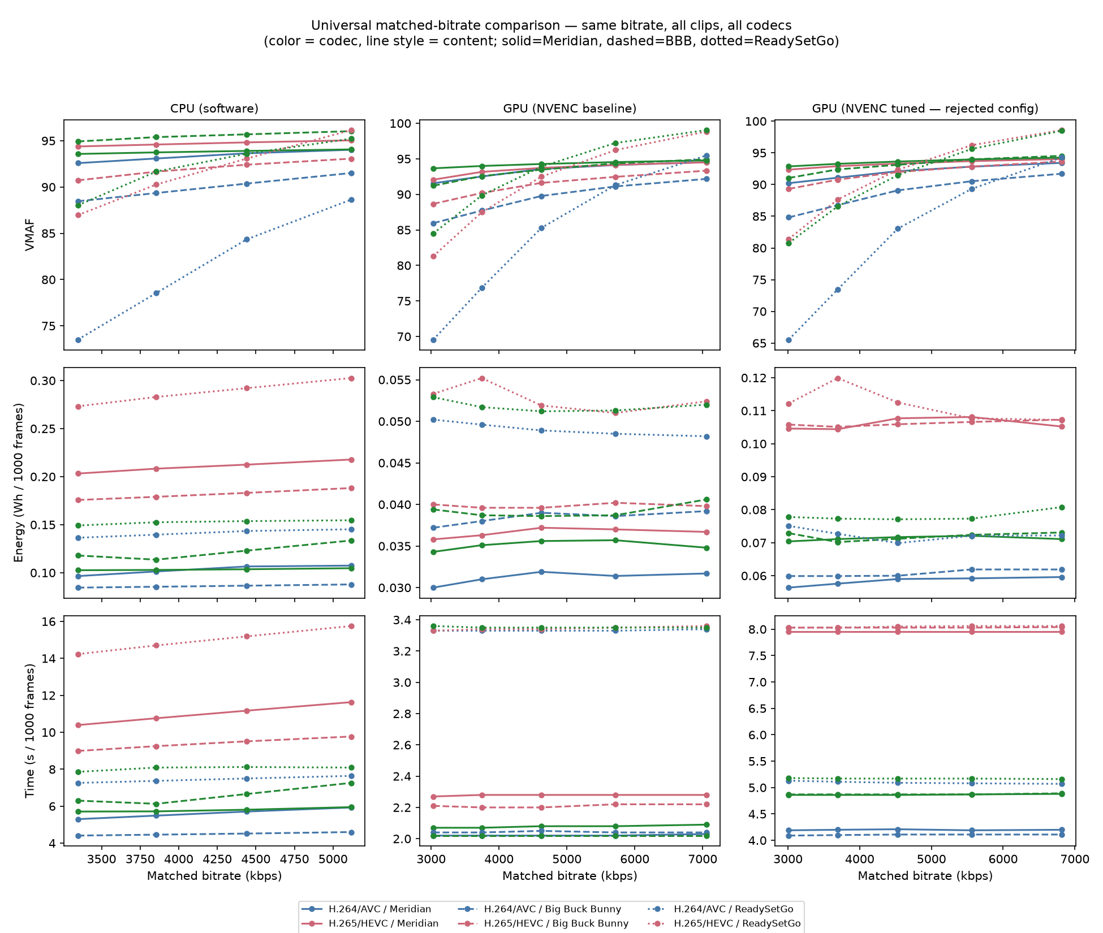
Fig. 2. Universal matched-bitrate comparison — VMAF, energy and time vs. matched bitrate, all three clips, all three codecs, CPU/GPU-baseline/GPU-tuned.
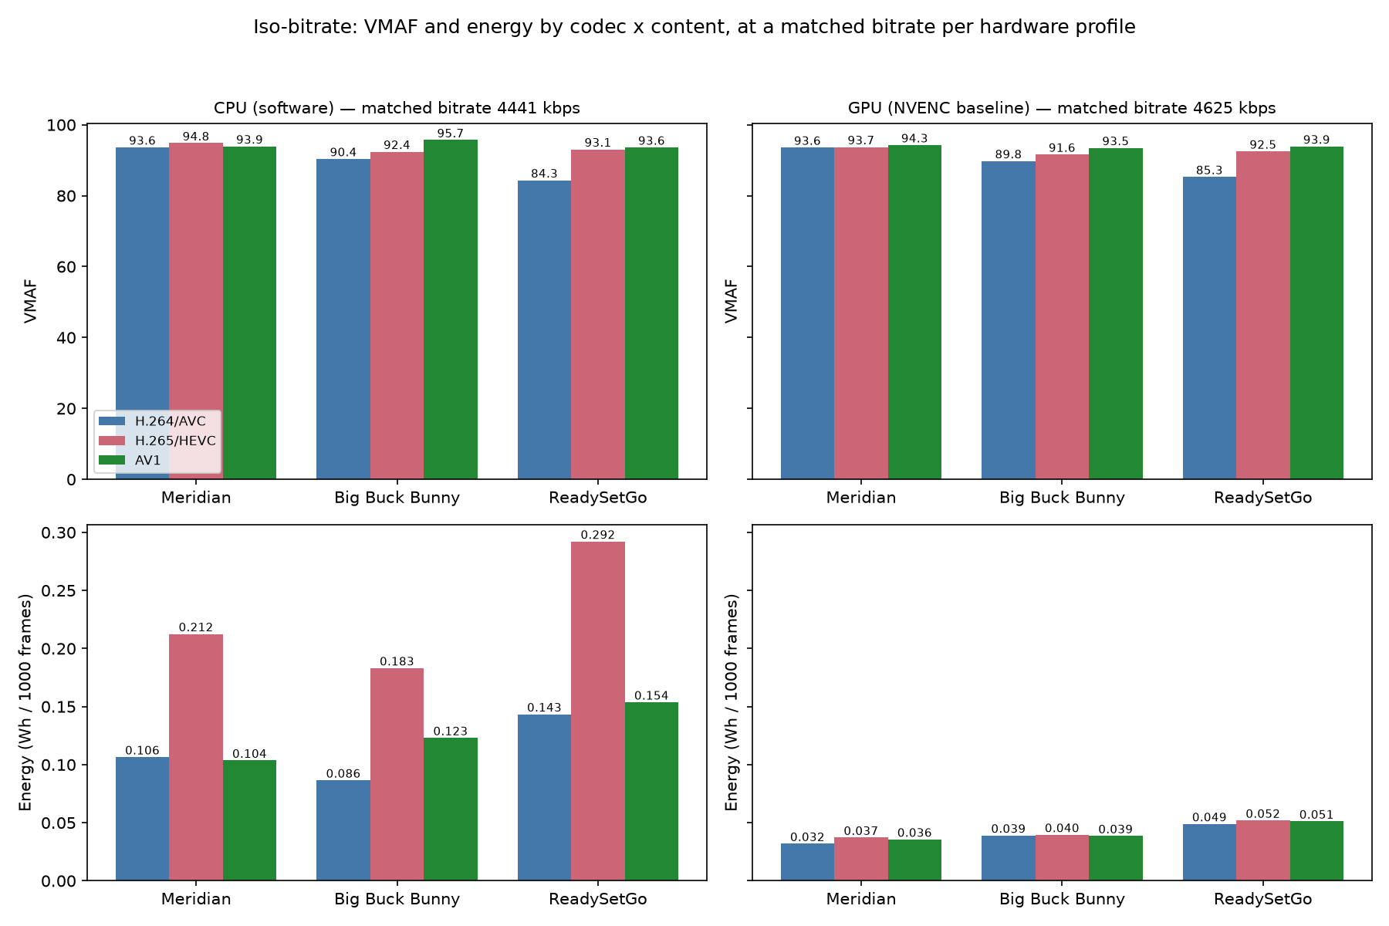
Fig. 3. Iso-bitrate summary — VMAF and energy by codec x content, at a matched bitrate per hardware profile (bar chart).

4.3 Iso-Quality Comparison
- At matched quality (VMAF 92 — reached by all 9 codec×profile combinations per content with zero interpolation gaps), H.265 needs roughly half the bitrate of H.264 across all three sequences (Meridian: 2928→1481 kbps; BBB: 5658→4041 kbps; ReadySetGo: 5718→4218 kbps).
- That bitrate saving does not translate into energy savings on CPU: H.265 needs ≈1.9–2.0× the CPU energy of H.264 to reach VMAF 92, consistently across all three sequences (e.g. Meridian: 0.093→0.174 Wh/1000 frames).
- On GPU, the codec energy gap at matched quality almost disappears — all three codecs land within ≈15% of each other in Wh/1000 frames for the same VMAF 92 target.
- Bitrate needed to reach VMAF 92 is highest for ReadySetGo on every codec (up to ≈2× Meridian's for H.264/AV1), consistent with its higher measured complexity.
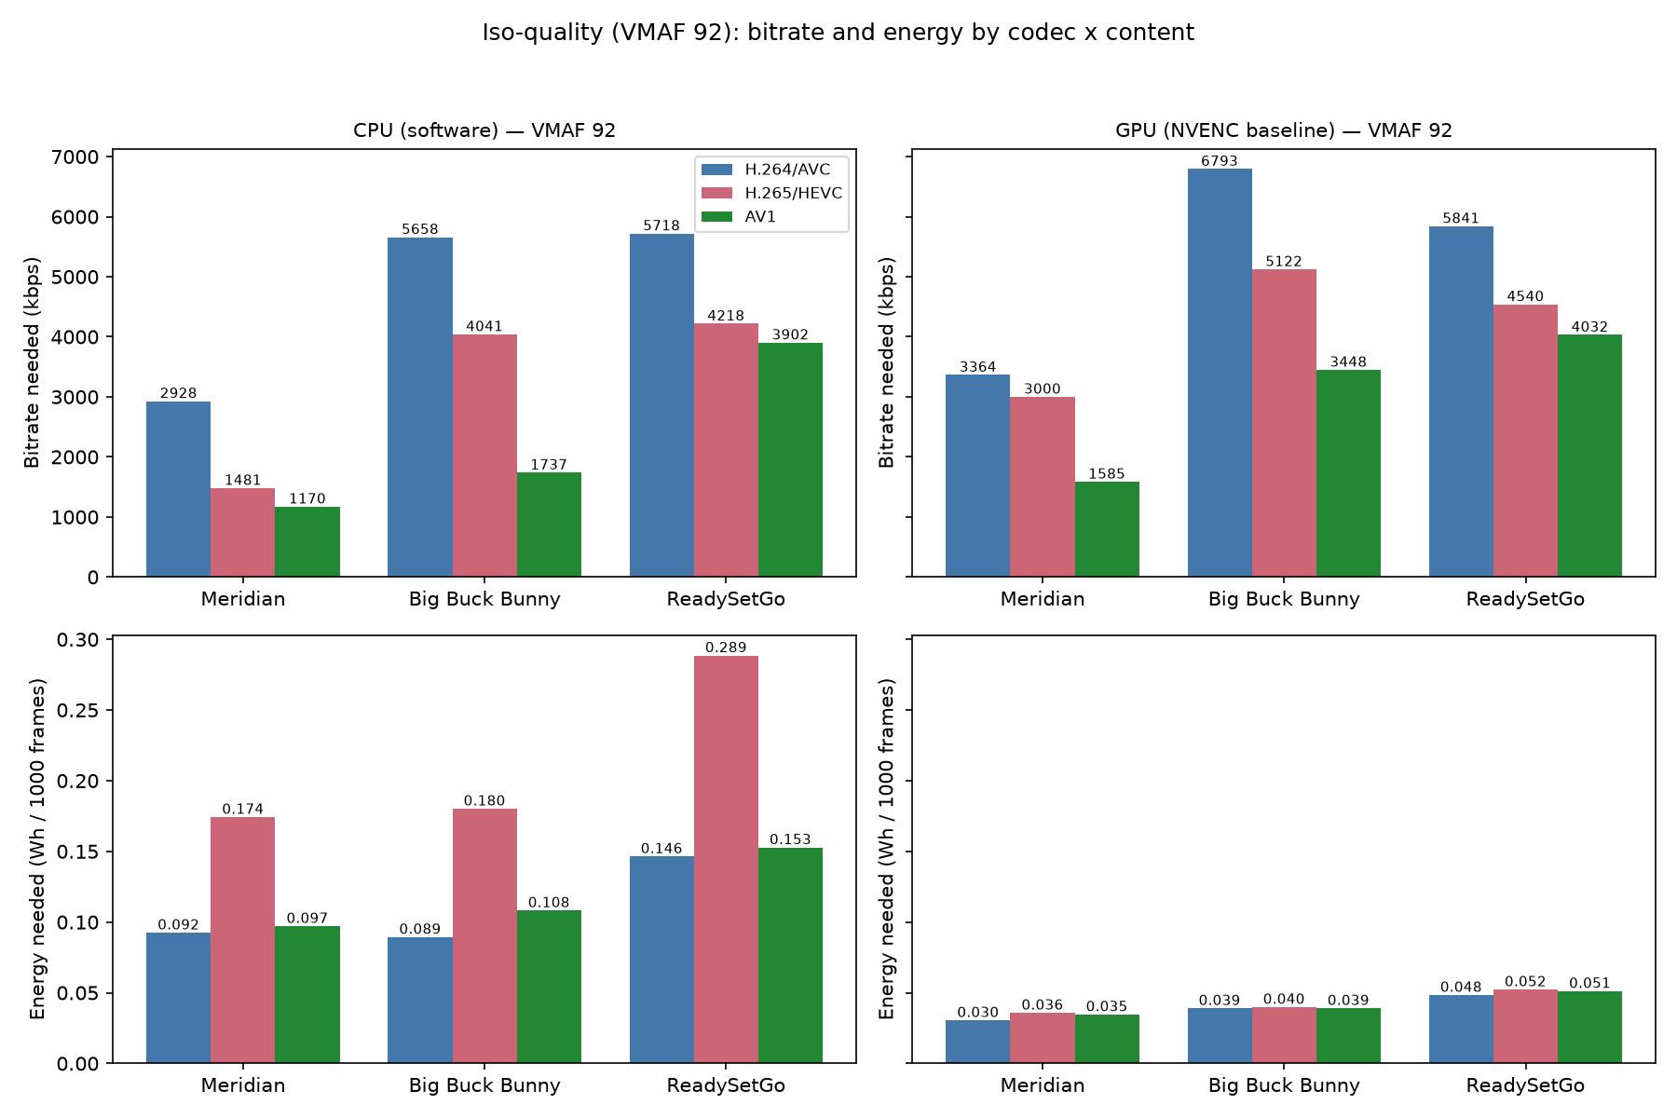
Fig. 4. Iso-quality summary (VMAF 92) — bitrate and energy needed by codec x content, under CPU and GPU.
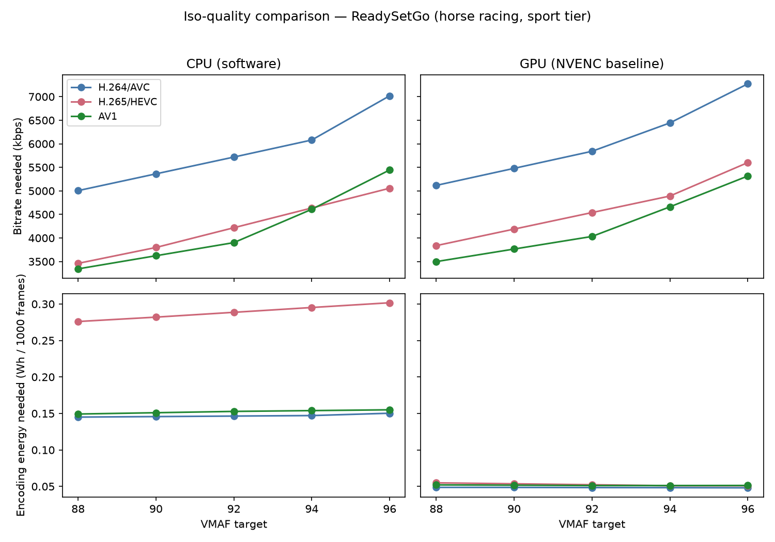
Fig. 5. Iso-quality detail for ReadySetGo — bitrate and energy needed vs. VMAF target, CPU vs. GPU-baseline (Meridian/BBB equivalents also produced).

4.4 Cross-Content Generalization
- A designed-grid variance decomposition (ANOVA-style, 168 measured 1080p sweep points; descriptive effect sizes, not inferential — Section 3.5) attributes: bitrate ≈45% and content ≈8% of VMAF variance; hardware profile ≈55% and content ≈5% of energy variance; hardware ≈32% and content ≈9% of encoding-time variance. Hardware choice dominates energy/time; content is real but secondary (Table 2).
- Codec ranking by VMAF at matched bitrate is stable across all three sequences (Meridian > BBB > ReadySetGo order preserved on CPU, GPU-baseline and GPU-tuned), but the size of the gap between codecs is content-dependent (Codec×Content interaction ≈4% of VMAF variance).
- Not every pattern is monotonic in measured complexity: Big Buck Bunny has higher spatial complexity than Meridian (SI≈33–47 vs 13) yet consistently lower encoding energy on both CPU and GPU — content type (e.g. animated vs. natural) appears to matter beyond what SI/TI alone capture.
- Content complexity was validated, not assumed: independently measured SI/TI matched the campaign's own values closely once compared at the same analysis resolution — temporal information matched almost exactly regardless of resolution; spatial information required a native-resolution comparison (worth a methodology footnote).
Factor | VMAF | Energy | Time
Bitrate | 44.7% | 0.3% | 0.2%
Codec | 3.8% | 1.5% | 6.0%
Hardware (CPU/GPU/tuned) | 0.9% | 54.7% | 31.8%
Content | 8.1% | 4.6% | 9.1%
Codec x Hardware | 0.4% | 5.2% | 9.3%
Codec x Content | 4.4% | 1.7% | 3.5%
Unexplained (residual) | 37.8% | 32.1% | 40.3%
Model R² | 61.0% | 67.9% | 59.7%
Table 2. Variance explained by factor (%), from the ANOVA-style decomposition described above.
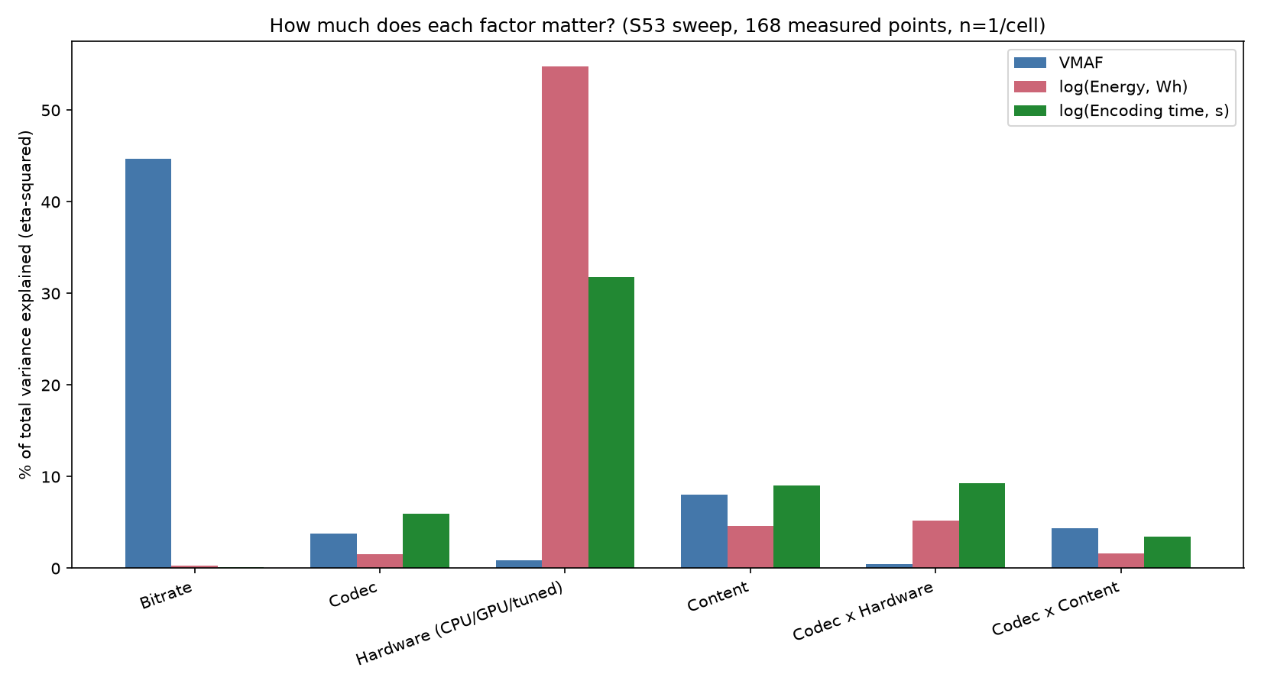
Fig. 6. Variance explained per factor, per response (bar-chart form of Table 2).
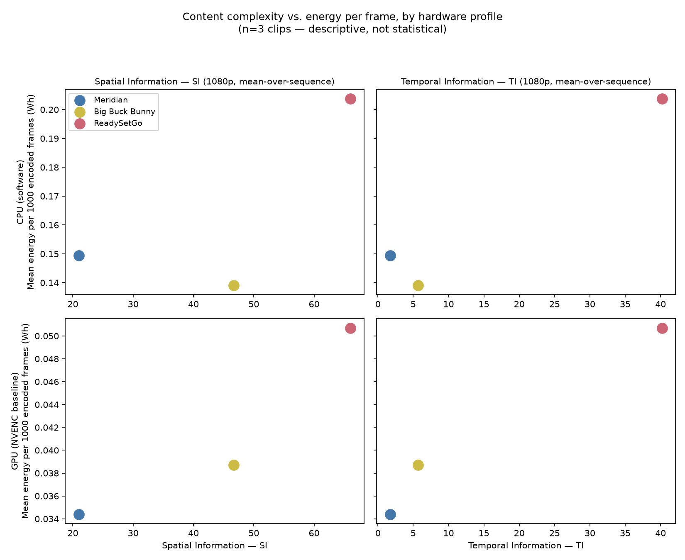
Fig. 7. Content complexity (SI/TI) vs. energy per encoded frame, CPU vs. GPU-baseline, all three clips.

5. Discussion
These results indicate that adding directly measured energy to codec evaluation changes the interpretation of rate-distortion results: a codec or implementation that is attractive from a bitrate-quality perspective may be unattractive once energy and encoding time are included.
- Sustainability implications for encoder/hardware selection in production and streaming pipelines.
- Hardware implementation choice can matter as much as codec choice — practical guidance for deployment decisions.
- Content dependence means single-content conclusions should not be generalized.

5.1 Limitations
- Decode/playback-side energy (TV power measurements) is out of scope for this paper — encoding-side focus only. Device-side carbon/energy accounting is a distinct and non-trivial problem in its own right, addressed directly by Le Gargasson et al.'s life-cycle carbon analysis of a video streaming/playback device [31]; flagged here as future work rather than omitted silently.
[TODO — confirm phrasing on excluding TV decode power against [31] and [18] once both are fully read — one or two sentences noting the decode-side dataset exists and is left to future work, to preempt reviewer questions about the "full pipeline" energy picture.]
- OS page-cache warm-start bias between sequential D/E/T runs on the same source file (Section 3.5): not mitigated in the current dataset — acknowledged here as an open limitation rather than a resolved one.
- Statistical claims scoped to "in these measurements / for this content" wording unless full statistical rigor (randomized order, predefined tests, uncertainty treatment) is documented.

6. Conclusion
These findings support energy-aware codec evaluation as a multi-objective problem in which bitrate, quality, encoding energy, and encoding time must be considered jointly, and where both hardware implementation and content characteristics materially affect the observed tradeoffs.
[TODO — add 2-3 sentences of forward-looking future work: decode-side energy, additional content classes, additional codecs (VVC?), larger statistical sample.]

References
Editorial note: Superscript-numbered, in order of first appearance in text, per SMPTE reference guidelines. Numbering below is provisional (grouped by topic for review, not yet reordered by first appearance) — renumber once Section 2 prose is final. Entries 1-6 are from the original abstract; 7-24 are candidates from the Aug 2026 literature search and still need full-text verification and precise page/DOI details before submission.
1. G. Bjøntegaard, "Calculation of Average PSNR Differences between RD-Curves," ITU-T Q.6/SG16, 2001.
2. Z. Li et al., "Toward A Practical Perceptual Video Quality Metric," Netflix Tech Blog, 2016.
3. Netflix, VMAF Development Project. https://github.com/Netflix/vmaf
4. A. C. Begen et al., "Greening Video Distribution: Opportunities and Challenges," IEEE MultiMedia, 2022.
5. M. Zakaria et al., "Energy Consumption Analysis of Modern Video Coding Technologies," IEEE Access, 2023.
6. B. Schwarz et al., "A Dual-Track Measurement Framework for Streaming Energy: Real-World and Lab-Reproducible Approaches" (companion paper, under submission).
7. X. Li, M. Wien, and J.-R. Ohm, "Rate-Complexity-Distortion Evaluation for Hybrid Video Coding," IEEE Int'l Conf. on Multimedia and Expo (ICME), 2010.
8. [Author(s) TBD], "Performance Comparison of VVC, AV1, HEVC, and AVC for High Resolutions," 2024 (verify venue/authors from full text).
9. [Author(s) TBD], "The Efficiency of HEVC/H.265, AV1, and VVC/H.266 in Terms of Performance Compression and Video Content," 2024 (verify venue/authors from full text).
10. H. Wang et al., "AVC, HEVC, VP9, AVS2 or AV1? — A Comparative Study of State-of-the-Art Video Encoders on 4K Videos," Int'l Conf. on Image Analysis and Recognition (ICIAR), 2019.
11. T. Laude et al., "A Comparison of JEM and AV1 with HEVC: Coding Tools, Coding Efficiency and Complexity," Picture Coding Symposium (PCS), 2018.
12. I. Bender et al., "Compression Efficiency and Computational Cost Comparison between AV1 and HEVC Encoders," European Signal Processing Conf. (EUSIPCO), 2019.
13. A. Katsenou, J. Mao, and I. Mavromatis, "Energy-Rate-Quality Tradeoffs of State-of-the-Art Video Codecs," Picture Coding Symposium (PCS), 2022, pp. 265-269.
14. A. Katsenou, X. Wang, D. Schien, and D. Bull, "Comparative Study of Hardware and Software Power Measurements in Video Compression," 2024.
15. T. Chachou, W. Hamidouche, S. A. Fezza, and G. Belalem, "Energy Consumption and Carbon Emissions of Modern Software Video Encoders," IEEE Consumer Electronics Magazine, vol. 13, no. 6, pp. 73-91, 2024.
16. [Author(s) TBD], "Encoding Time and Energy Model for SVT-AV1 Based on Video Complexity," IEEE ICASSP, 2024.
17. D. R. Kadagathur Lakshmana Reddy et al., "A High-Level Feature Model to Predict the Encoding Energy of a Hardware Video Encoder," arXiv:2510.12754, 2025.
18. M. Kränzler, C. Herglotz, and A. Kaup, "A Comprehensive Review of Software and Hardware Energy Efficiency of Video Decoders," arXiv:2402.09001, 2024.
19. [Arunruangsirilert et al.], "Evaluation of Hardware-Based Video Encoders on Modern GPUs for UHD Live-Streaming," arXiv:2511.18686, 2025.
20. [Arunruangsirilert et al.], "Evaluation of NVENC Split-Frame Encoding (SFE) for UHD Video Transcoding," arXiv:2511.18687, 2025.
21. [Author(s) TBD], "Performance Analysis of Hardware-Accelerated 10-Bit 4:2:2 Encoding with Split-Frame Encoding for High-Fidelity V-PCC Streaming," arXiv:2606.29179, 2026.
22. Carbon Trust, "Carbon Impact of Video Streaming," white paper developed with DIMPACT, 2021.
23. G. Kamiya, "The Carbon Footprint of Streaming Video: Fact-Checking the Headlines," IEA Commentary, Dec. 2020.
24. S. Afzal, N. Mehran, Z. Azimi Ourimi, F. Tashtarian, H. Amirpour, R. Prodan, and C. Timmerer, "A Survey on Energy Consumption and Environmental Impact of Video Streaming," arXiv:2401.09854, 2024.
25. C. Ostapenco, M. Jay, and L. Lefèvre, "An Experimental Comparison of Software-Based Power Meters: Focus on CPU and GPU," IEEE/ACM Int'l Symposium on Cluster, Cloud and Internet Computing (CCGRID), 2023.
26. [Author(s) TBD], "An Empirical Study of Reducing AV1 Decoder Complexity and Energy Consumption via Encoder Parameter Tuning," arXiv:2510.12380, 2025 (decode-side; candidate for Limitations/future-work citation rather than Section 2.2).
27. P. Sjövall, A. Mercat, and J. Vanne, "FPGA-Accelerated HEVC Encoder for Energy-Efficient Multi-Access Edge Computing," IEEE conference, 2023 (verify exact venue from full text).
28. H. Amirpour, V. V. Menon, S. Afzal, R. Prodan, and C. Timmerer, "Optimizing Video Streaming for Sustainability and Quality: The Role of Preset Selection in Per-Title Encoding," IEEE Int'l Conf. on Multimedia and Expo (ICME), 2023, pp. 1679-1684.
29. M. Ghasempour, H. Amirpour, M. Ghanbari, and C. Timmerer, "Energy-Aware Spatial and Temporal Resolution Selection for Per-Title Encoding," 2024 (verify exact venue from full text).
30. Z. Azimi Ourimi, R. Farahani, V. V. Menon, C. Timmerer, and R. Prodan, "Towards ML-Driven Video Encoding Parameter Selection for Quality and Energy Optimization," Int'l Conf. on Quality of Multimedia Experience (QoMEX), 2024.
31. P. Le Gargasson, O. Weppe, T. Marty, M. Pelcat, D. Ménard, and C. Herglotz, "Use or Produce - Carbon Impact of a Video Streaming Device," IEEE Int'l Symposium on Circuits and Systems (ISCAS), 2025, DOI: 10.1109/ISCAS56072.2025.11043750.
[TODO — next pass: (a) open each [Author(s) TBD] entry and fill in exact authors/venue from the full paper, not just the search snippet; (b) verify DOIs; (c) decide which of these candidates actually get cited once Section 2 prose is finalized — not all of them need to survive into the submitted reference list; (d) renumber in order of first appearance in text per SMPTE style once section numbering is locked; (e) entry 26 (AV1 decode-side encoder tuning) probably belongs in the Limitations/future-work discussion about decode energy rather than in Related Work proper — decide on final placement.]

Figure Captions
Fig. 1. Energy–quality tradeoff by content. Left panel: [Sequence A]. Right panel: [Sequence B]. X-axis: VMAF. Y-axis: encoding energy per clip (Wh). One ellipse per codec/implementation pair; color = codec, line style = CPU/GPU, ellipse width proportional to bitrate.
Fig. 2–7 captions are inline with Section 4 above (Figs. 2–3: iso-bitrate; Figs. 4–5: iso-quality; Figs. 6–7: cross-content / variance decomposition).

