Exploring the Tradeoff Between Compression Efficiency and Energy Consumption in Modern Video Codecs
Tania Pouli
Greening of Streaming / Vivid Manta
Benjamin Schwarz
Greening of Streaming / CTO Innovation Consulting
Simon Jones
Greening of Streaming

Abstract
Video codec evaluation typically relies on rate-distortion analysis, which omits the energy cost of reaching a given quality target. This paper extends bitrate-quality evaluation with directly measured wall-power encoding energy for H.264/AVC, H.265/HEVC, and AV1, on CPU and GPU, using OWL (Online WattLab). We compare codecs at matched bitrate and matched quality points, across four sequences spanning natural, animated, and sport content (horse racing and football broadcast footage). Lower bitrate does not imply lower energy: H.265 needs up to half H.264's bitrate for equal quality, but that saving shrinks with content complexity while its CPU energy cost grows in inverse proportion, from 1.8x on the simplest content to 2.6x on the most complex. GPU acceleration cuts energy 2.2-6.6x depending on codec and content. Hardware implementation explains more energy/time variance than codec choice.

Introduction
Video codec evaluation has traditionally relied on rate-distortion (RD) analysis: bitrate savings measured against objective quality metrics such as PSNR, SSIM, or VMAF. This approach is effective for comparing coding performance but omits the energy cost of achieving it. As broadcasters, streaming platforms, and technology vendors treat sustainability as a deployment requirement, that energy cost needs to be measured directly rather than inferred from bitrate.
This paper extends traditional bitrate–quality evaluation with directly measured wall-power encoding energy, for H.264/AVC, H.265/HEVC, and AV1, across CPU and GPU implementations. We evaluate these codecs and implementations under two complementary conditions: matched bitrate (iso-bitrate), and matched perceptual quality (iso-quality, using VMAF as a proxy). We consider four different sequences, spanning a range of spatial and temporal complexity and exemplifying different content types, including two sport-tier sequences of differing complexity. Our results suggest that better compression efficiency does not automatically translate into better energy efficiency on the encoding side, and hardware implementation choices can affect sustainability outcomes as much as codec selection. Notably, we find that this energy penalty is not fixed but scales with content complexity, and is largest precisely on the content type where software encoding is most likely to still be used in production: live sport.
This raises three questions this paper aims to answer: Does codec ranking vary depending on the evaluation criterion (bitrate, quality, energy, or time)? Does a ranking that holds at matched bitrate also hold at matched quality? And how much do hardware implementation and content complexity change the answer? Relative to prior energy-focused codec studies, which typically fix hardware implementation or evaluate a single content class (see Section 2), this paper combines iso-bitrate, and iso-quality operating points with directly measured wall-power energy, both CPU and GPU implementations of the same three codecs, and multiple content classes within a single measurement framework.

Related Work

Rate–Distortion Evaluation of Video Codecs
Rate-distortion (RD) comparison remains the dominant framework for evaluating encoding solutions, typically summarized via Bjøntegaard-delta bitrate/quality (BD-rate) computed from PSNR, SSIM, or VMAF curves [1], [2]. Recent multi-codec comparisons extend this to H.266/VVC alongside AV1, HEVC, and AVC, generally finding VVC delivering the largest bitrate savings, with AV1 and HEVC trading position depending on the VMAF operating point, and with results showing a high dependence on resolution [3], [4]. Studies comparing AV1 against HEVC report bitrate savings in the 13-29% range depending on content and encoder maturity [5], [6].
The above works, although not exhaustive, help establish the RD baseline of recent codecs and show that different codecs but also different content characteristics have an important impact on bitrate and quality. Our work extends these findings with the additional consideration of energy cost. Codec ranking under RD alone is well characterized; however, whether that ranking survives once encoding energy is added as a criterion is underexamined.

Energy and Power Measurement of Video Encoding
A growing body of work measures encoding energy directly rather than inferring it from RD curves alone. Closest in spirit to our work is the study of Katsenou et al., comparing the energy-rate-quality tradeoffs across AV1, VVC, VP9, and HEVC, which found AV1 offering the best energy-quality tradeoff among the codecs tested [7]. Chachou et al. measured energy consumption and CO2 emissions across five open-source encoders (AVC, HEVC, VVC, VP9 and SVT-AV1) at multiple presets, finding AVC and AV1 the most energy-efficient at fast presets [8]. A similar ranking was found in the study of Uitto et al. when comparing both compression and energy efficiency between AVC, HEVC and VP9 codecs [9].
Other works aim at building predictive energy models rather than measuring directly: for SVT-AV1 based on video complexity [10] or for hardware encoders based on high-level features such as resolution or codec presets [11]. Although such models can be useful for guiding encoding decisions, they focus on single codecs. Instead, we opt for real measurements across codecs and hardware implementations, since that interaction is less well studied and harder to model.
Focusing on hardware considerations, recent evaluations compare GPU-based hardware encoders against software counterparts. Arunruangsirilert et al. find that modern GPU hardware encoders can match the RD performance of software encoders in real-time scenarios across HEVC, VP9, AV1, and VVC, with only marginal RD gains between successive hardware generations [12]. Closer to our study, the work of Salcedo-Navarro et al. compares encoding performance and quality across codecs in both CPU and GPU implementations, finding that GPU implementations require over 20% less bitrate than CPU for AVC and AV1, but around 7.5% more bitrate than CPU for HEVC [13]. Neither study measures power or energy however.
A related study of NVENC's split-frame encoding reports comparable RD performance at considerably lower power draw than software encoding [14]. Beyond GPUs, migrating the Kvazaar HEVC encoder from software to an FPGA was shown to reduce encoding energy by 76% on a Xeon-based cloud server and 86% on an embedded ARM board [15]. This pattern is not specific to video coding: CPU/GPU/FPGA energy comparisons for other workloads consistently find important efficiency differences across the three implementation classes [16], and recent work synthesizes this comparative literature into application-specific guidance for choosing between them [17].
A separate cluster of work treats encoding energy as an explicit optimization target in the construction of an adaptive-streaming bitrate-ladder. Amirpour et al. optimize HEVC presets per bitrate-ladder rung across a large set of video sequences, finding that significant energy gains could be achieved with moderately small quality losses [18]. Ghasempour et al. extend this to joint spatial and temporal resolution selection [19], and Azimi Ourimi et al. use a lightweight ML model considering content complexity and encoding parameters to find optimal configurations [20].
The reliability of the underlying power-measurement instrumentation is itself an active research question. Katsenou et al. compare hardware and software power meters directly for video compression and find high correlation between the two approaches across two codecs and multiple resolutions, with software-based measurement carrying lower computational overhead [21]. More broadly, software-based power meters are found to produce energy estimates highly correlated with wall-socket measurements across general computing workloads, though full-platform power (peripherals, PSU losses) is only captured by a hardware wattmeter [22].

Sustainability and Green Streaming
At the systemic level, several studies estimate the carbon footprint of streaming video. The DIMPACT/Carbon Trust white paper estimates roughly 55 gCO2e per hour in Europe, with the viewing device the largest contributor and encoding/data-center energy a comparatively small share of the total [23]. The IEA study arrives at a similar figure of approximately 36 gCO2e per hour [24]. In contrast, the Shift Project's estimate is approximately 400 gCO2e per hour [25]. A more exhaustive survey of the environmental impact literature across the full streaming pipeline can be found in [26]. Estimates at this scale necessarily rely on modeling assumptions, collapsing device mix, network paths, and data-center energy intensity into averaged parameters. This paper instead relies on direct measurement under real operating conditions: lower generalization power across the full streaming ecosystem, but higher ecological validity for the specific codec, hardware, and content configurations measured.
Encoding is a small share of streaming's total footprint, but it is the share that a broadcaster's codec and hardware choices directly control, which is what this paper measures. Further, as discussed in our companion paper by Schwarz et al. [27], encoding choices can have an impact on the decoding power at the other end of the line, and ideally both should be considered in conjunction.
Our work considers the impact of both bitrate and quality on the directly measured wall-power energy; both CPU and GPU implementations of the same three mainstream codecs and different content classes are measured within a single framework. In doing so it connects the codec-RD literature (Section 2.1), the codec-energy measurement and hardware comparison work (Section 2.2), and the systemic sustainability literature (Section 2.3) around one key question: what does the RD-optimal choice cost in energy for a broadcaster or streaming platform choosing a codec and hardware path today, and does that cost hold across bitrate and quality targets.

Methodology
This section describes the measurement approach used to answer the questions outlined in Section 2. We first briefly introduce the OWL platform and how it isolates task-level wall power from baseline and drift. The test content details, codec and hardware implementation combinations and their operating points are discussed respectively in Sections 3.2, 3.3 and 3.4. Finally, Section 3.5 presents the statistical treatment applied to the resulting measurements.

Measurement Platform
Measurements are performed using OWL (Online WattLab), a Greening of Streaming platform for reproducible wall-power measurement of media-processing workloads. Full platform description, calibration procedure, and measurement-integrity framework can be found in the companion paper by Schwarz et al. [26]. OWL differs from an ad hoc measurement in four respects. First, every task is bounded by a freshly measured idle baseline: two daisy-chained Tapo P110 smart plugs are polled at 1 s intervals immediately before the task, and reported energy is the task-window mean power minus that baseline, so thermal and operational drift are subtracted per run rather than assumed constant across a session. Second, a focus mode suppresses background system tasks for the measurement's duration. Third, the platform waits for wall power to reconverge to the measured idle floor between runs rather than sleeping a fixed interval. Fourth, every result persists its full raw poll series (baseline and task), not just the derived summary, so outlier treatment and confidence can be recomputed after the fact. All reported figures use wall power measured at the plug, capturing PSU and system-level overhead rather than only CPU/GPU component draw.

Test Content
Four sequences are used, spanning a range of spatial and temporal complexity while holding format constant (3840×2160, 16:9, 60 fps). Spatial and temporal complexity (SI/TI) are measured for each sequence, per ITU-T P.910 [28]. For each frame, SI is computed as the standard deviation of a Sobel-filtered luma frame and TI as the standard deviation of the frame-to-frame luma difference, aggregated as the mean over the full sequence at native resolution. Table 1 summarizes the characteristics of the four evaluated sequences.
Table 1: Test content characteristics.
Sequence | Content | Resolution | FPS | Duration (frames) | SI | TI | Source / License
Football | Broadcast football match | 3840×2160 | 60 | 35 s | 48.3 | 10.3 | Panasonic “Barcelona Football” 4K Demo  https://www.youtube.com/watch?v=-gXGcLDIjPI
Meridian | Natural, live-action | 3840×2160 | 59.94 | 120 s | 13.1 | 1.9 | Netflix Open Content, CC BY 4.0 — opencontent.netflix.com
Big Buck Bunny | Animated (CGI) | 3840×2160 | 60 | 120 s | 35.8 | 6.1 | Blender Foundation, 2008, CC BY 3.0 — peach.blender.org
ReadySetGo | Horse racing (‘sport’ tier) | 3840×2160 | 60 (2:1 decimated from 120) | 35 s (looped from a 5 s master) | 38.5 | 40.4 | UVG dataset, Tampere University (Mercat et al., ACM MMSys 2020), CC BY-NC — ultravideo.fi/dataset.html

Codecs and Implementations
In this work, we compare AVC (H.264), HEVC (H.265) and AV1 codecs. All three are evaluated considering both a CPU and a GPU implementation. Encoding parameters are normalized across every codec and implementation pair: GOP length, profile and B-frame configuration were identical wherever possible, allowing for the codec and hardware path to be treated as isolated variables. In all cases, output resolution was set to 1080p, with AAC audio fixed at 128 kbps. This gives six measured combinations per clip, as outlined in Table 2.
Table 2: Encoding configurations by codec and hardware implementation.
Codec / Implementation | Encoder | Rate control | GOP | Profile | B-frames
AVC / CPU | libx264 | ABR (-b:v) | 120 | High | 2
AVC / GPU | h264_nvenc | CBR (-rc cbr) | 120 | High | 2
HEVC / CPU | libx265 | ABR (-b:v) | 120 | Main | 2
HEVC / GPU | hevc_nvenc | CBR (-rc cbr) | 120 | Main | 2
AV1 / CPU | libsvtav1 (SVT-AV1) | ABR (-b:v) | 120 | Main | n/a
AV1 / GPU | av1_nvenc | CBR (-rc cbr) | 120 | n/a | n/a

The following bitrate targets were used during encoding for the different codecs:
- AVC: 3000, 4500, 6000, 8000, 11000, 13000, 15000 kbps
- HEVC: 1500, 2500, 3500, 5000, 7000, 8500, 10000 kbps (Football additionally swept 12000, 14000, and 16000 kbps)
- AV1: 1000, 1800, 2800, 4000, 6000, 7500 kbps (Football additionally swept 9000, 11000, and 13000 kbps)

Bitrate targets for the Football sequence for the HEVC and AV1 tests were extended beyond the shared levels because its higher complexity meant the standard range did not reach the VMAF quality targets used in Section 4.2. It should be noted that although the above bitrates were the targets provided to the encoder, they were not always exactly achieved. The reported measurements and analysis in Section 4 rely on the real bitrate of each encoded sequence rather than the target.

Experimental Design
Codecs are compared under two matched-condition designs, applied to every clip × codec × hardware-profile combination. The iso-bitrate comparison maintains delivery bitrate constant. A sweep of target bitrates is measured for each clip × codec × hardware profile. The iso-quality comparison considers a constant VMAF, reading each codec's bitrate at a given quality target from the same sweep via linear interpolation between the two nearest measured points. Note that VMAF v0.6 was used for this analysis.
Successive measurements were decoupled by the OWL platform's wait-for-idle check (as discussed in Section 3.1) rather than by randomization or a fixed interval, ensuring that each encoding run started from the same thermal and operational baseline regardless of what ran before it.
To ensure stable power reading, the OWL platform is configured to a 20 s minimum measurement duration. As encoding speed can vary widely by codec and hardware profile, an encoding task can be completed in a fraction of that window. As such, an encoding job is repeated until the cumulative wall-clock time reaches 20 s. This, as well as to account for different framerates, means that obtained measurements need to be normalized. Specifically, throughout our analysis, the reported energy and encoding time are normalized per 1000 encoded frames.

Results
The following sections report codec and hardware-implementation comparisons under the two matched-condition designs introduced in Section 3.4. We first compare codecs at a fixed delivery bitrate (Section 4.1) and fixed quality target (Section 4.2). We then evaluate whether our findings hold across all test sequences and quantify how much of the observed variation is attributable to bitrate, codec, hardware profile, and content.

Iso-Bitrate Comparison
Error! Reference source not found. plots VMAF, measured energy and encoding time against bitrate for the four clips, three codecs and hardware options. As discussed in Section 3.3, matched bitrate points were selected for the three codecs to allow for a direct comparison. Figure 2 shows a summary of the same comparison for a single matching representative bitrate.
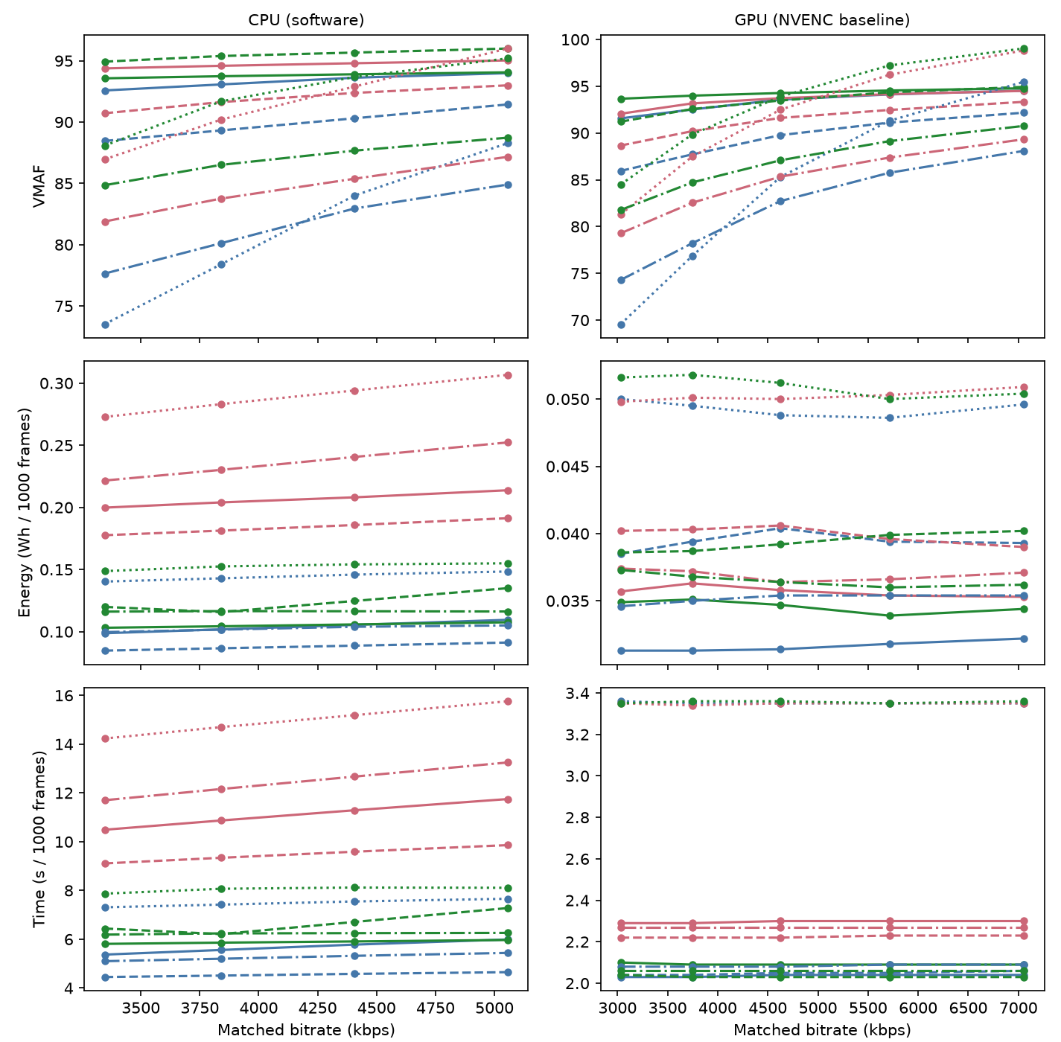
Figure 1: Matched-bitrate comparison: VMAF, energy and time vs. matched bitrate, all four clips, all three codecs, CPU vs. GPU.
Considering the quality of the encoded sequences as measured by VMAF, we observe that the relative order of the four clips remains consistent across both CPU and GPU configurations (Meridian > Big Buck Bunny > ReadySetGo > Football), broadly tracking each sequence's measured SI/TI complexity (Section 3.2). Football is an exception to a strict complexity ordering: despite lower spatial and temporal complexity than ReadySetGo, it consistently achieves the lowest VMAF of the four sequences at matched bitrate, suggesting that broadcast-sport content carries an encoding cost beyond what SI/TI alone predicts. Nevertheless, at the same bitrate, simpler sequences tend to achieve a higher quality, irrespective of codec or hardware.
Energy was found to be more strongly impacted by hardware profile than by codec choice: GPU implementations led to 2.2 - 6.6x reduction relative to CPU at the same bitrate, depending on codec and content (e.g. Football HEVC CPU: 0.241 vs. GPU: 0.036 Wh/1000 frames). Within a hardware profile, codec choice still matters, but not in the direction RD alone would suggest: on CPU, our measurements showed HEVC as the most energy-expensive of the three codecs at every matched bitrate and every content tested, despite not always delivering the highest VMAF. AV1 frequently matched or exceeded HEVC VMAF at the same bitrate for 1.5 - 2.1x less CPU energy.
Content was also found to have a measurable, albeit smaller, effect: ReadySetGo was the most energy-expensive sequence to encode at matched bitrate on every hardware profile, consistent with its higher spatial and temporal complexity. One exception was found to that pattern however: Football, despite its lower complexity, was the second most energy-expensive, consistent with the VMAF anomaly noted above.
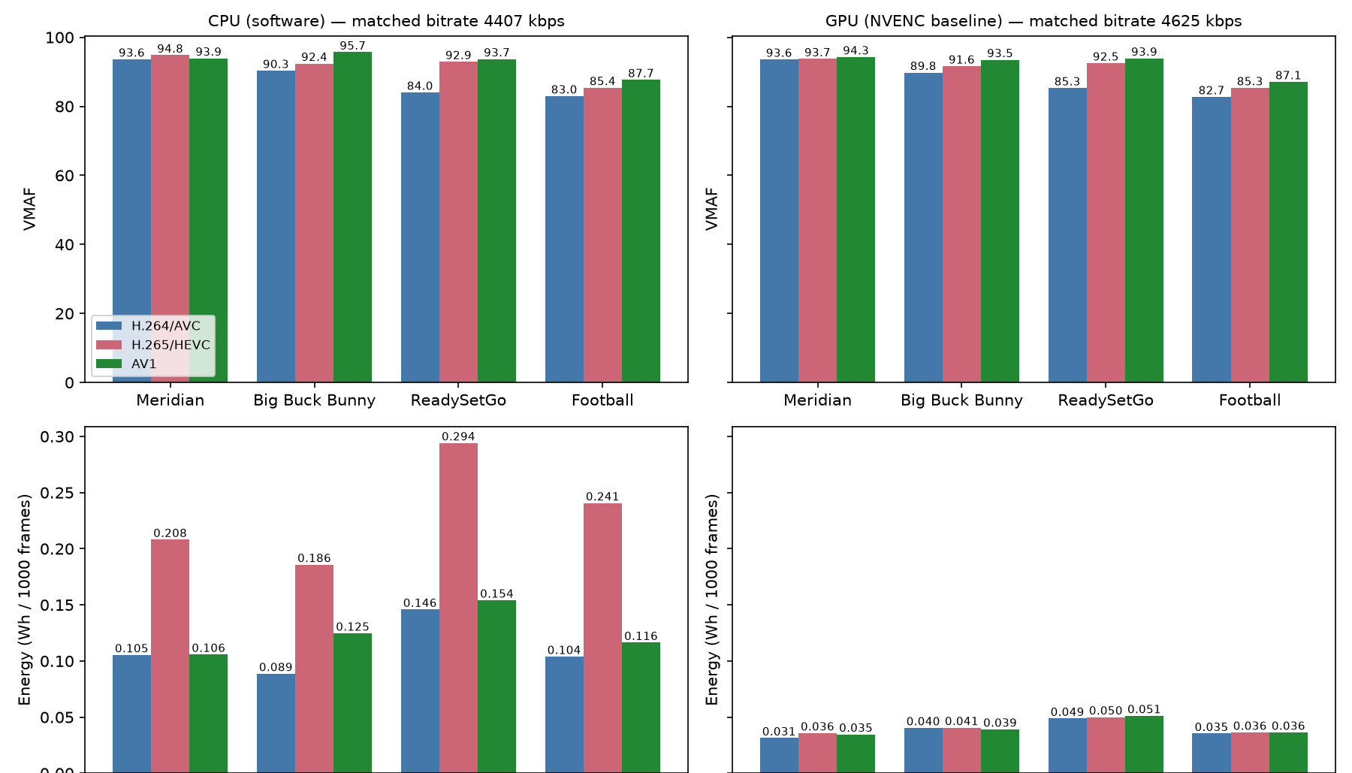
Figure 2: Iso-bitrate summary: VMAF and energy by codec x content, at a matched bitrate per hardware profile.

Iso-Quality Comparison
Figure 3 shows bitrate and energy needed to reach the matched-quality target, for the four clips, three codecs and hardware options. VMAF 92 was selected as the matched-quality target because it is the highest quality level reached by every codec and profile combination without necessitating interpolation.
Considering the bitrate needed to reach VMAF 92, HEVC required less bitrate than AVC across all four sequences, but the size of that saving varied sharply with content complexity: from roughly half on the simplest content (Meridian: 2928 1481 kbps, a 49% reduction) down to under 10% on the most complex (Football: 10497 9581 kbps, a 9% reduction). Big Buck Bunny (5658 4041 kbps, 29%) and ReadySetGo (5718 4218 kbps, 26%) fell between these extremes.
That bitrate saving, however, was not found to carry over into energy savings on CPU, and the relationship inverted: the sequence with the smallest bitrate saving had the largest energy penalty. HEVC required 1.8x the CPU energy of AVC on Meridian, the content where it saved the most bitrate, rising to 2.6x on Football, the content where it saved the least (Meridian: 0.096 0.170 Wh/1000 frames; Football: 0.119 0.314 Wh/1000 frames). In other words, the codec that looked most efficient on a bitrate basis was the most energy-expensive to actually produce, and that gap widened rather than narrowed for the hardest content. Football therefore represents the worst case for codec-only optimization on CPU: it offers the smallest bitrate incentive to move to HEVC (9%) while incurring the largest energy penalty for doing so (2.6x), the opposite of what a purely RD-driven decision would predict. On GPU however, this gap was found to largely disappear, with all three codecs landing within approximately 15% of each other in Wh/1000 frames at the same quality target for every content tested, suggesting the CPU-side energy penalty is more a software-implementation effect than an inherent property of the codec.
Content was also found to have a measurable effect on the bitrate needed to reach a given quality: Football required by far the most bitrate of the four sequences to reach VMAF 92 across every codec (3.6-6.9x Meridian's, depending on codec), followed by ReadySetGo and Big Buck Bunny, consistent with Football's high measured complexity despite the VMAF ranking anomaly noted in Section 4.1.
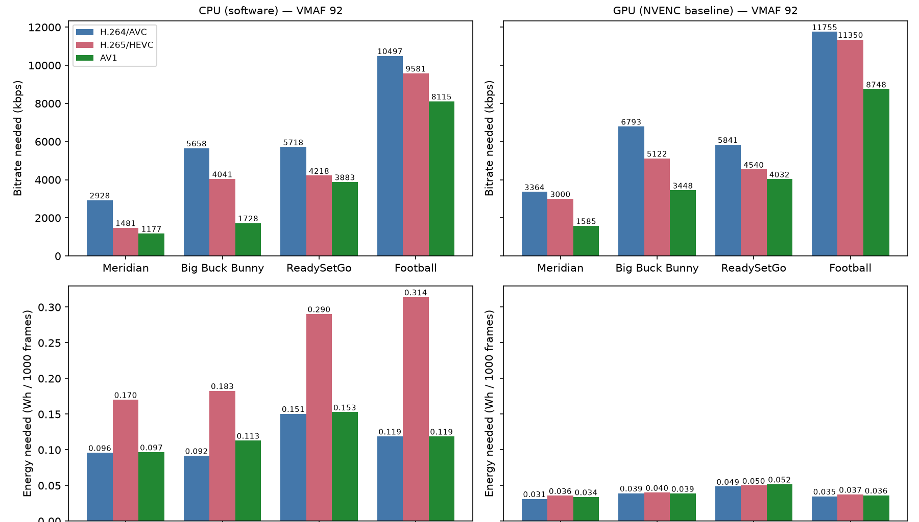
Figure 3: Iso-quality summary (VMAF 92): bitrate and energy needed by codec x content, under CPU and GPU.

Cross-Content Generalization
Table 3 and Figure 4 show how much of the variation in VMAF, energy, and encoding time across the full set of conditions measured is attributable to each factor (bitrate, codec, hardware profile, and content) using the variance-decomposition method described in Section 3.4.
Factor | VMAF | Energy | Time
Bitrate | 49.2% | 0.5% | 0.6%
Codec | 3.2% | 5.9% | 7.4%
Hardware (CPU/GPU) | 0.6% | 83.5% | 79.8%
Content | 18.1% | 3.2% | 5.2%
Codec x Hardware | 0.3% | 4.8% | 4.7%
Codec x Content | 3.3% | 0.3% | 0.4%
Residual (unexplained) | 25.2% | 1.8% | 1.9%
Model R-squared | 71.9% | 98.2% | 98.1%
Table 3: Variance explained by factor (%), from the ANOVA-style decomposition described above.

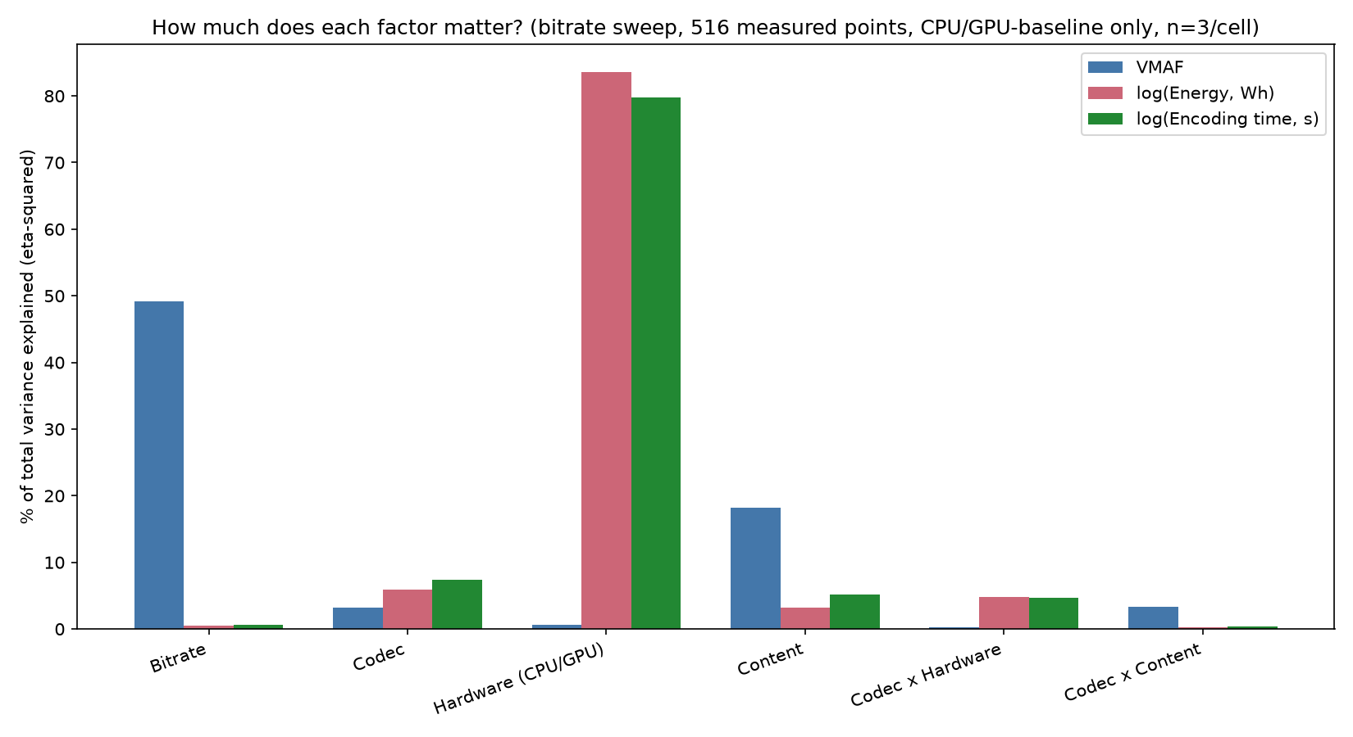
Figure 4: Variance explained per factor, for quality, energy and encoding time.
Consistent with the pattern observed in Sections 4.1 and 4.2, hardware profile was found to explain far more of the variation in energy (~84%) and encoding time (~80%) than codec choice, while content contributed a smaller but still measurable share (~3% and ~5% respectively). VMAF variance, by contrast, was dominated by bitrate (~49%), with content contributing ~18%, several times its share of energy or time variance, reflecting Football's markedly lower VMAF at matched bitrate relative to the other three sequences.
Content ordering by VMAF at matched bitrate was found to be stable across the four sequences when averaged across codecs, but some inconsistencies can be observed when evaluating each codec separately. Notably, although the content ordering was stable across AVC and HEVC bitrate ladders, some reversals are observed in the case of AV1. Further, Football's low VMAF at matched bitrate breaks the strict complexity-based ordering established by the other three sequences. The size of the gap between codecs was also found to be content-dependent, with codec x content interaction accounting for 3.3% of VMAF variance, suggesting that while the ranking generalizes on average, the magnitude of any codec's advantage, and in Football's case the ranking itself, is content-specific rather than universal.
Not every pattern was found to be monotonic relative to the measured content complexity. Figure 5 plots content complexity against energy per encoded frame. Although Big Buck Bunny has higher measured spatial complexity (SI) than Meridian, it leads to consistently lower encoding energy on both CPU and GPU. This is plausible given the characteristics of the two sequences: Big Buck Bunny is flat-shaded CG animation with large areas of static background, content that a Sobel-based SI measure scores as spatially complex due to sharp edges, but that compresses efficiently once temporal redundancy is exploited. Meridian, by contrast, is natural live-action footage with film grain, high-frequency noise that inflates encoding cost without necessarily registering as high SI/TI. This suggests that such complexity metrics, while they provide useful information, do not fully capture the complexity dimensions that drive encoding energy, and that content type (e.g., animated vs. natural, grained vs. clean) should be treated as a factor in its own right.
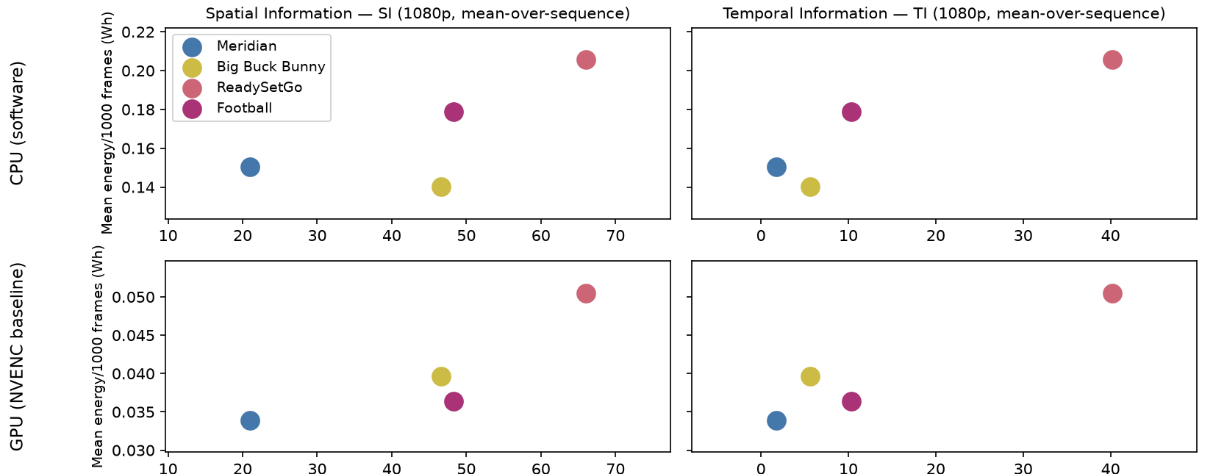
Figure 5: Content complexity (SI/TI) vs. energy per encoded frame, CPU vs. GPU-baseline for all four clips.

Discussion
The core premise of this work was three questions: whether codec ranking depends on the evaluation criterion, whether a ranking established at matched bitrate holds at matched quality, and how much hardware implementation and content complexity change the answer. The results presented in the previous section answer all three, and in each case the answer argues against evaluating codecs on rate-distortion grounds alone.
Codec ranking does depend on the criterion. When considering quality as measured by VMAF, HEVC and AV1 are the strongest performers at a given bitrate; by energy on CPU in contrast, HEVC is consistently the most expensive of the three codecs, on every content and at every matched bitrate or quality target tested. A codec that looks best on the metric conventionally used to evaluate it, bitrate for a given quality, can be the worst choice once energy is the criterion instead.
That reversal is not an artifact of how the comparison was framed: the same pattern holds whether codecs are compared at matched bitrate (Section 4.1) or matched quality (Section 4.2). HEVC requires roughly half AVC's bitrate to achieve a comparable VMAF, but close to double the CPU energy for the same, so the ranking established under one condition transfers to the other rather than being an artifact of the comparison itself.
Hardware implementation and content complexity both impact the answer, but not equally. Hardware profile explains far more of the variance in energy and encoding time than codec or content does, as seen in Section 4.3, and the two interact: HEVC's CPU energy penalty largely disappears on GPU, so it behaves less like an inherent property of the codec and more like a cost specific to the software encoder path. This effect is hardest to avoid on exactly the content where it matters most: live and broadcast-sport encoding. In this case, the energy penalty of a compression-efficient codec choice was found to be largest, but it is also the case most often run on CPU in production, where GPU acceleration, the one lever shown here to neutralize the penalty (Section 4.2), is not always available or used.
Content complexity has a real but smaller effect, and one not fully captured by standard SI/TI metrics: Big Buck Bunny, despite higher measured spatial complexity than Meridian, was consistently cheaper to encode on both hardware profiles. Practically, this means the encoding-energy decision is a joint one, where codec, hardware path, and content type together should be considered, rather than a codec choice made on rate-distortion grounds alone.

Limitations
The scope of this paper is limited to encoding-side energy; decode/playback-side energy is not measured here. Several works address device-side carbon and energy accounting [29], [30]. Our companion paper (Schwarz et al. [26]) demonstrates that the OWL platform used here can also measure decode and playback power. Future work will extend the present findings by measuring the corresponding decoding costs, to give a more complete picture of how encoding choices affect energy at both ends of the video chain.
Although our findings strongly suggest that content characteristics play a non-negligeable role for all the measured dimensions (quality, energy, and encoding time), more content for each type would be needed to draw more extensive content related conclusions, particularly in terms of the correlation with content complexity.
It should also be noted that all measurements were performed on a single machine. Although specific strategies were employed to ensure that measurements are repeatable and reliable as discussed in Section 3, absolute energy values and encoding times would likely change if using different hardware. Nevertheless, preliminary tests using an AMD GPU on the same server suggest that the relative ordering and observations remain unchanged. Similarly, limited tests performed using different GPU settings and clock optimizations did not seem to change overall conclusions, albeit affecting the absolute measurements slightly.

Conclusion
This paper measured the wall-power encoding energy of three mainstream codecs across CPU and GPU implementations, at matched bitrate and matched quality conditions, over four content sequences spanning a range of complexity. The findings support energy-aware codec evaluation as a multi-objective problem in which bitrate, quality, encoding energy, and encoding time must be considered jointly, rather than one where compression efficiency is treated as a stand-in for energy efficiency. Both hardware implementation and content characteristics materially affect the observed tradeoffs, and neither can be safely factored out of a codec selection decision.
The clearest evidence for this is content-dependent: the energy premium of optimizing compression efficiency on CPU was most pronounced for the more complex content tested. On the simplest sequence, HEVC's roughly 50% bitrate saving over AVC came with the smallest energy premium (1.8x); on the most complex, a bitrate saving of under 10% came with the largest (2.6x). This suggests that codec selection guidance for encoding pipelines should be content and hardware-aware rather than focusing on bitrate savings alone.
Future work should extend measurements to decode-side energy, given that encoding and decoding choices interact across the full delivery chain [26], and to a wider range of codecs (including VVC and VP9) and content classes, particularly additional high-complexity live and sport sequences, to establish whether the pattern observed here generalizes beyond the specific content tested.

References
[1] G. Bjøntegaard, “Calculation of average PSNR differences between RD-curves,” ITU-T, Q.6/SG16, 2001.
[2] X. Li, M. Wien, and J.-R. Ohm, “Rate-complexity-distortion evaluation for hybrid video coding,” in IEEE int’l conf. on multimedia and expo (ICME), 2010.
[3] M. Uhrina, L. Sevcik, J. Bienik, and L. Smatanova, “Performance Comparison of VVC, AV1, HEVC, and AVC for High Resolutions,” Electronics, vol. 13, no. 5, p. 953, Jan. 2024, doi: 10.3390/electronics13050953.
[4] “The Efficiency of HEVC/H.265, AV1, and VVC/H.266 in Terms of Performance Compression and Video Content | Boumehrez | Indonesian Journal of Electrical Engineering and Informatics (IJEEI).” Accessed: Sep. 01, 2026. [Online]. Available: https://section.iaesonline.com/index.php/IJEEI/article/view/5336
[5] T. Laude, Y. G. Adhisantoso, J. Voges, M. Munderloh, and J. Ostermann, “A Comparison of JEM and AV1 with HEVC: Coding Tools, Coding Efficiency and Complexity,” in 2018 Picture Coding Symposium (PCS), Jun. 2018, pp. 36–40. doi: 10.1109/PCS.2018.8456291.
[6] I. Bender, D. Palomino, L. Agostini, G. Correa, and M. Porto, “Compression Efficiency and Computational Cost Comparison between AV1 and HEVC Encoders,” in 2019 27th European Signal Processing Conference (EUSIPCO), Sep. 2019, pp. 1–5. doi: 10.23919/EUSIPCO.2019.8903006.
[7] A. Katsenou, J. Mao, and I. Mavromatis, “Energy-Rate-Quality Tradeoffs of State-of-the-Art Video Codecs,” in 2022 Picture Coding Symposium (PCS), Dec. 2022, pp. 265–269. doi: 10.1109/PCS56426.2022.10017999.
[8] T. Chachou, W. Hamidouche, S. A. Fezza, and G. Belalem, “Energy Consumption and Carbon Emissions of Modern Software Video Encoders,” IEEE Consumer Electronics Magazine, vol. 13, no. 6, pp. 73–91, Nov. 2024, doi: 10.1109/MCE.2023.3347714.
[9] M. Uitto, “Energy consumption evaluation of H.264 and HEVC video encoders in high-resolution live streaming,” in 2016 IEEE 12th International Conference on Wireless and Mobile Computing, Networking and Communications (WiMob), Oct. 2016, pp. 1–7. doi: 10.1109/WiMOB.2016.7763234.
[10] L. Eichermüller et al., “Encoding Time and Energy Model for SVT-AV1 Based on Video Complexity,” in ICASSP 2024 - 2024 IEEE International Conference on Acoustics, Speech and Signal Processing (ICASSP), Apr. 2024, pp. 3370–3374. doi: 10.1109/ICASSP48485.2024.10446602.
[11] D. R. Kadagathur Lakshmana Reddy and others, “A high-level feature model to predict the encoding energy of a hardware video encoder.” 2025.
[12] K. Arunruangsirilert and J. Katto, “Evaluation of Hardware-based Video Encoders on Modern GPUs for UHD Live-Streaming,” in 2024 33rd International Conference on Computer Communications and Networks (ICCCN), Jul. 2024, pp. 1–9. doi: 10.1109/ICCCN61486.2024.10637525.
[13] A. Salcedo-Navarro, J. Gutiérrez-Aguado, and M. Garcia-Pineda, “UHD Video Encoding in CPU Versus GPU: Quality and Performance Trade-Offs,” IEEE Access, vol. 13, pp. 55115–55129, 2025, doi: 10.1109/ACCESS.2025.3553634.
[14] K. Arunruangsirilert and J. Katto, “Evaluation of NVENC Split-Frame Encoding (SFE) for UHD Video Transcoding,” Nov. 24, 2025, arXiv: arXiv:2511.18687. doi: 10.48550/arXiv.2511.18687.
[15] P. Sjövall, A. Mercat, and J. Vanne, “FPGA-Accelerated HEVC Encoder for Energy-Efficient Multi-Access Edge Computing,” in 2023 IEEE International Conference on Image Processing (ICIP), Oct. 2023, pp. 2215–2219. doi: 10.1109/ICIP49359.2023.10222671.
[16] M. Qasaimeh, K. Denolf, J. Lo, K. Vissers, J. Zambreno, and P. H. Jones, “Comparing Energy Efficiency of CPU, GPU and FPGA Implementations for Vision Kernels,” in 2019 IEEE International Conference on Embedded Software and Systems (ICESS), Jun. 2019, pp. 1–8. doi: 10.1109/ICESS.2019.8782524.
[17] A. A. Purkayastha, J. Tharwani, and S. Aggarwal, “FPGA or GPU? Analyzing Comparative Research for Application-Specific Guidance,” in SoutheastCon 2025, Mar. 2025, pp. 1258–1263. doi: 10.1109/SoutheastCon56624.2025.10971274.
[18] H. Amirpour, V. V. Menon, S. Afzal, R. Prodan, and C. Timmerer, “Optimizing Video Streaming for Sustainability and Quality: The Role of Preset Selection in Per-Title Encoding,” in 2023 IEEE International Conference on Multimedia and Expo (ICME), Jul. 2023, pp. 1679–1684. doi: 10.1109/ICME55011.2023.00289.
[19] M. Ghasempour, H. Amirpour, and C. Timmerer, “Energy-Aware Spatial and Temporal Resolution Selection for Per-Title Encoding,” IEEE Access, vol. 12, pp. 104555–104567, 2024, doi: 10.1109/ACCESS.2024.3434682.
[20] Z. Azimi, R. Farahani, V. V. Menon, C. Timmerer, and R. Prodan, “Towards ML-Driven Video Encoding Parameter Selection for Quality and Energy Optimization,” in 2024 16th International Conference on Quality of Multimedia Experience (QoMEX), Jun. 2024, pp. 80–83. doi: 10.1109/QoMEX61742.2024.10598278.
[21] A. Katsenou, X. Wang, D. Schien, and D. Bull, “Comparative Study of Hardware and Software Power Measurements in Video Compression,” in 2024 Picture Coding Symposium (PCS), Jun. 2024, pp. 1–5. doi: 10.1109/PCS60826.2024.10566286.
[22] M. Jay, V. Ostapenco, L. Lefevre, D. Trystram, A.-C. Orgerie, and B. Fichel, “An experimental comparison of software-based power meters: focus on CPU and GPU,” in 2023 IEEE/ACM 23rd International Symposium on Cluster, Cloud and Internet Computing (CCGrid), May 2023, pp. 106–118. doi: 10.1109/CCGrid57682.2023.00020.
[23] Carbon Trust, “Carbon impact of video streaming,” Carbon Trust, developed with DIMPACT, 2021.
[24] G. Kamiya, “The carbon footprint of streaming video: fact-checking the headlines,” Dec. 2020. Accessed: Sep. 01, 2026. [Online]. Available: https://www.iea.org/commentaries/the-carbon-footprint-of-streaming-video-fact-checking-the-headlines
[25] The Shift Project, “Climate Crisis: The Unsustainable Use of Online Video.” Accessed: Sep. 01, 2026. [Online]. Available: https://theshiftproject.org/app/uploads/2025/04/Press-kit_Climate-crisis_The-unsustainable-use-of-online-video.pdf
[26] S. Afzal et al., “A Survey on Energy Consumption and Environmental Impact of Video Streaming,” Jan. 18, 2024, arXiv: arXiv:2401.09854. doi: 10.48550/arXiv.2401.09854.
[27] B. Schwarz and others, “A dual-track measurement framework for streaming energy: Real-world and lab-reproducible approaches,” 2026.
[28] ITU-P.910 : Subjective video quality assessment methods for multimedia applications, 2008. Accessed: Sep. 01, 2026. [Online]. Available: https://www.itu.int/rec/t-rec-p.910
[29] M. Kränzler, C. Herglotz, and A. Kaup, “A Comprehensive Review of Software and Hardware Energy Efficiency of Video Decoders,” in 2024 Picture Coding Symposium (PCS), Jun. 2024, pp. 1–5. doi: 10.1109/PCS60826.2024.10566363.
[30] C. Herglotz, D. Springer, M. Reichenbach, B. Stabernack, and A. Kaup, “Modeling the Energy Consumption of the HEVC Decoding Process,” IEEE Transactions on Circuits and Systems for Video Technology, vol. 28, no. 1, pp. 217–229, Jan. 2018, doi: 10.1109/TCSVT.2016.2598705.

