Flutter

What is Flutter?
Flutter is a cross-platform UI toolkit that is designed to allow code reuse across operating systems such as iOS and Android, while also allowing applications to interface directly with underlying platform services.

Flutter now a days to build Mobile(Android/IOS),Desktop(Windows ,linux, Mac),Web applications.
Flutter inspired from react with respect to coding style ,Flutter is component driven(Widget) , tree model.

Flutter apps are built using dart programming language.
During development, Flutter apps run in a VM that offers stateful hot reload of changes without needing a full recompile.
For release, Flutter apps are compiled directly to machine code, whether Intel x64 or ARM instructions, or to JavaScript if targeting the web

The framework is open source, with a permissive BSD license, and has a thriving ecosystem of third-party packages that supplement the core library functionality.

Architecture: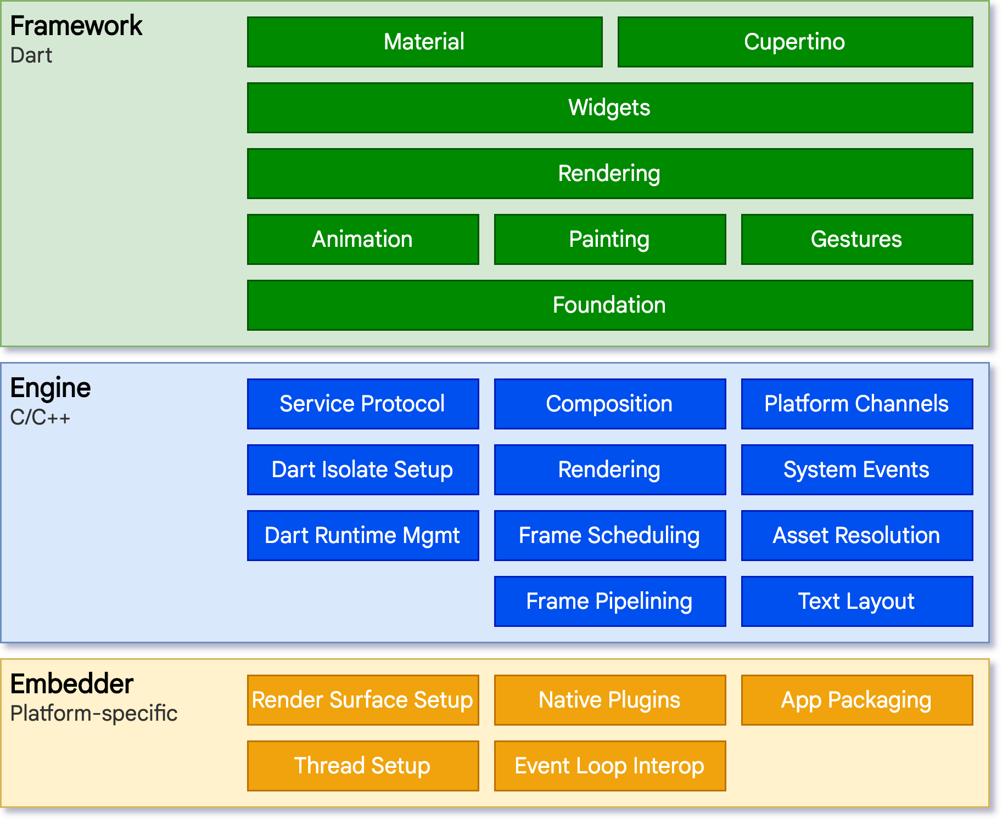

1.Flutter Framework (Written in Dart)
The Framework is the part you work with directly as a Flutter Developer.
It is a set of Dart lib that provides “widgets, Animations, navigation, state management and rendering abstractions

Responsibilities:
- Building UI using widgets

2.Flutter Engine (Written in c/c++)
The Engine is the low level runtime that executes dart code and render graphics
It acts as bridge between the framework and the operating system

3.Platform Embedder (Native Platform layer)
The Embedded is a platform specific code that hosts the flutter engine inside a native application.
Platforms
- Android
- Ios
- Windows
- Mac
- Linux
- Web host integration via browser

Flutter Setup:
https://docs.flutter.dev/platform-integration/android/setup

Steps to create and run flutter Project:
1.Device or emulator.
2.Start android emulator.
3.create flutter project using android studio template /command line
G:\CTS\2026\flutterapps>flutter create my_app
Creating project my_app...
Resolving dependencies in `my_app`... (1.1s)
Downloading packages...
Got dependencies in `my_app`.
Wrote 131 files.

All done!
You can find general documentation for Flutter at: https://docs.flutter.dev/
Detailed API documentation is available at: https://api.flutter.dev/
If you prefer video documentation, consider: https://www.youtube.com/c/flutterdev

In order to run your application, type:

$ cd my_app
$ flutter run

Your application code is in my_app\lib\main.dart.

Building user interfaces with Flutter

Flutter widgets are built using a modern framework that takes inspiration from React Native. The central idea is that you build your UI out of widgets. Widgets describe what their view should look like given their current configuration and state. When a widget's state changes, the widget rebuilds its description, which the framework diffs against the previous description in order to determine the minimal changes needed in the underlying render tree to transition from one state to the next.

In Flutter fundamental building block is "Widget" , In React and React Native fundamental building block is "Component".

What is Widget? What is Component?
- Both are same only which represents "User interface"
- Widget and Component are "Object".
- Every UI element is Object which is called "Widget".
- Widget describe what their "View" should look like given their current configuration and state.
- In Flutter Widgets are "Configurable".
- Lets say I want to display simple text on Screen...

What are the configuration is needed?

->Where to display that text - "Location" - Layout
->Size of the Text
->Style of the Text
->Color of the Text
etc.......

Native Development vs Flutter Development

eg:
Android vs Flutter Development.

In Android "the View" is foundation of every thing that shows up on the screen
"Button,toolbars,inputs every thing is view"
IN flutter the rough equivalent to a View is a "Widget"

Note:
"Widgets don’t map exactly to Android Views"

With Programming native (android) development is highly "Imperative Programming"
Where as "Flutter Programming is highly "Declarative"
Imperative Programming:

In the imperative style, you would typically go to ViewB’s owner and retrieve the instance b using selectors or with findViewById or similar, and invoke mutations on it (and implicitly invalidate it). For example:

ViewB b = findViewById("selector")
// Imperative style
b.setColor(red)
b.clearChildren()
ViewC c3 = new ViewC(...)
b.add(c3)

Declarative Programming:

// Declarative style
return ViewB(
color: red,
child: const ViewC(
color:Yellow
child: const ViewD()
),
);

Flutter vs native development

1.flutter is declarative
more readable
2.native is imperative

1.flutter widgets are immutable

2.native widgets are mutable

if you have object, if you change object properties, the same object is updated over period of time => Mutable pattern.
if you have object, if you change object properties, the same object is updated over period of time , when ever update happens , it creates new object => Immutable pattern.

Immutability is achieved by "Declarative Programming"

Helloworld
import 'package:flutter/material.dart';
void main(){
//UI starting point
var HelloWidget = Text(
"Hello Flutter",
textAlign: TextAlign.center,
textDirection: TextDirection.ltr
);
runApp(HelloWidget);
}

HelloWorld as part of runApp
import 'package:flutter/material.dart';
void main(){
runApp(Text(
"Hello Flutter",
textAlign: TextAlign.center,
textDirection: TextDirection.ltr
));
}
void main() {
- Entry point of every Dart and Flutter application.
- Execution starts here.
- void means this function does not return a value.
runApp()
- A Flutter function from the flutter/widgets.dart library.
- Starts the Flutter framework.
- Takes a widget and makes it the root of the widget tree.
- Displays that widget on the screen.
- Think of it as:
- “Render this widget and show it to the user.”

Types of Widget
Note: runApp function must take only root Widget.
1.StatelessWidget
2.Statefull Widget

Stateless widget:
- A widget does not require any mutable state(data).
- A Stateless widget describes "static User interface"

Stateful Widget
- A widget requires mutable state(data) and biz logic.
- A Stateful widget describes "Dynamic User interface"

How to create State less widget?

class App extends StatelessWidget {

}

import 'package:flutter/material.dart';

//
class App extends StatelessWidget {
const App({super.key});

@override
Widget build(BuildContext context) {
return const Center(
child: Text(
"Hello Stateless Widget!",
textDirection: TextDirection.ltr,
style: TextStyle(color: Colors.cyan),
),
);
}
}

void main() {
runApp(const App());
}

build method returns Widget which describes UI.
.....................................................................................

Tree Model of Widgets:
import 'package:flutter/material.dart';

class App extends StatelessWidget {
const App({super.key});

@override
Widget build(BuildContext context) {
return const HelloWorldWidget();
}
}

class HelloWorldWidget extends StatelessWidget {
const HelloWorldWidget({super.key});

@override
Widget build(BuildContext context) {
return const Center(
child: Text(
"Hello World",
textDirection: TextDirection.ltr,
style: TextStyle(color: Colors.cyan),
),
);
}
}

void main() {
runApp(const App());
}
................................................................................

Inside lib folder

lib/HelloWorld.dart
import 'package:flutter/material.dart';

class HelloWorldWidget extends StatelessWidget {
const HelloWorldWidget({super.key});

@override
Widget build(BuildContext context) {
return const Center(
child: Text(
"Hello World!!!",
textDirection: TextDirection.ltr,
style: TextStyle(color: Colors.cyan),
),
);
}
}

lib/App.dart
import 'package:flutter/material.dart';
import 'package:flutterapps/HelloWorld.dart';

class App extends StatelessWidget {
const App({super.key});

@override
Widget build(BuildContext context) {
return const HelloWorldWidget();
}
}

lib/main.dart
import 'package:flutter/material.dart';
import 'package:flutterapps/App.dart';

void main() {
runApp(const App());
}
Basic widgets
1. Text Widget
Text displays text on the screen.
Text(
'Hello Flutter',
style: TextStyle(
fontSize: 24,
color: Colors.blue,
),
)

2. Center Widget
Center centers its child horizontally and vertically.
Center(
child: Text('Centered Text'),
)
3. Container Widget
Container is a box that can hold one child and apply styling.
Container(
width: 200,
height: 100,
padding: EdgeInsets.all(16),
color: Colors.amber,
child: Text('Inside Container'),
)
Common uses:
- Size (width, height)
- Padding and margin
- Background color
- Borders and rounded corners

4. Padding Widget
Padding adds space around its child.
Padding(
padding: EdgeInsets.all(20),
child: Text('Padded Text'),
)

5. SizedBox Widget
SizedBox adds fixed space or constrains size.
SizedBox(
width: 100,
height: 50,
child: ElevatedButton(
onPressed: () {},
child: Text('Click'),
),
)
6. Row Widget
Row arranges children horizontally.
Row(
children: [
Icon(Icons.star),
Text('Rating'),
],
)
7. Column Widget
Column arranges children vertically.
Column(
children: [
Text('Name'),
Text('Email'),
],
)
8. Stack Widget
Stack overlays widgets on top of each other.
Stack(
children: [
Container(width: 200, height: 200, color: Colors.blue),
Text('On Top'),
],
)
9. Icon Widget
Icon displays icons.
Icon(
Icons.favorite,
size: 40,
color: Colors.red,
)
10. Image Widget
Image displays images from assets or the network.
Image.asset('assets/logo.png');
Image.network('https://example.com/image.png');

11. ElevatedButton Widget
ElevatedButton creates a raised button.
ElevatedButton(
onPressed: () {
print('Button clicked');
},
child: Text('Submit'),
)

12. TextButton Widget
TextButton creates a flat text-only button.
TextButton(
onPressed: () {},
child: Text('Cancel'),
)
13. IconButton Widget
IconButton creates a clickable icon.
IconButton(
icon: Icon(Icons.settings),
onPressed: () {},
)

14. Scaffold Widget
Scaffold provides a standard page structure.
Scaffold(
appBar: AppBar(
title: Text('Home'),
),
body: Center(
child: Text('Hello'),
),
)

15. AppBar Widget
AppBar creates a top application bar.
AppBar(
title: Text('My App'),
)

16. MaterialApp Widget
MaterialApp is the root widget for Material Design apps.
MaterialApp(
home: Scaffold(
body: Center(
child: Text('Hello'),
),
),
)

17. ListView Widget
ListView displays scrollable lists.
ListView(
children: [
ListTile(title: Text('Item 1')),
ListTile(title: Text('Item 2')),
],
)

18. Card Widget
Card displays content in a Material card.
Card(
child: Padding(
padding: EdgeInsets.all(16),
child: Text('Card Content'),
),
)

Widget Categories

Category | Widgets
Display | Text, Icon, Image
Layout | Row, Column, Stack, Expanded
Spacing | Padding, SizedBox, Container
Input | ElevatedButton, TextField
Structure | MaterialApp, Scaffold, AppBar
Scrolling | ListView, GridView
Interaction | GestureDetector

Summary
The most commonly used beginner widgets are:
- MaterialApp
- Scaffold
- AppBar
- Text
- Center
- Container
- Padding
- SizedBox
- Row
- Column
- Image
- Icon
- ElevatedButton
- ListView
Learning these widgets provides a strong foundation for building nearly any Flutter user interface.

Basic MaterialApp with Scaffold:

import 'package:flutter/material.dart';
void main() {
runApp(
MaterialApp(
home: Scaffold(
appBar: AppBar(title: const Text("Home")),
body: const Center(child: Text("Hello Material")),
),
),
);
}
Scaffold provides common properties
- Appbar – Top tool bar
- Body – Main content
- Drawer – left side drawer
- endDrawer – right side drawer
etc..
import 'package:flutter/material.dart';
void main() {
runApp(
MaterialApp(
debugShowCheckedModeBanner: false,
home: Scaffold(
backgroundColor: Colors.amber,
appBar: AppBar(title: const Text("Home")),
endDrawer: Drawer(
child: Text(
"data",
style: TextStyle(color: Colors.red, fontSize: 30),
textAlign: TextAlign.center,
)
),
drawer: Drawer(
child: Text(
"data",
style: TextStyle(color: Colors.red, fontSize: 30),
textAlign: TextAlign.center,
),
),
body: const Center(child: Text("Hello Material")),
),
),);
}
AppBar Design:

AppBar is the top application bar shown in a Scaffold. It typically contains a title, navigation controls, action buttons, and optional tabs.
import 'package:flutter/material.dart';
void main() {
runApp(
MaterialApp(
debugShowCheckedModeBanner: false,
home: Scaffold(
backgroundColor: Colors.amber,
appBar: AppBar(
leading: IconButton(
icon: Icon(Icons.menu),
onPressed: () {},
),
title: Row(
children: [
Icon(Icons.fax_rounded),
SizedBox(width: 8),
Text('My App'),
],
),
),
endDrawer: Drawer(
child: Text(
"data",
style: TextStyle(color: Colors.red, fontSize: 30),
textAlign: TextAlign.center,
),
),
drawer: Drawer(
child: Text(
"data",
style: TextStyle(color: Colors.red, fontSize: 30),
textAlign: TextAlign.center,
),
),
body: const Center(child: Text("Hello Material")),
),
),
);
}

