JVM & Memory Fundamentals & Tomcat 10.1

Understanding how the Java Virtual Machine (JVM) manages memory is the foundation of maintaining a high-performance Tomcat environment.
1. JVM Memory Structure
In modern JVMs (post-Java 8), memory is divided into several distinct areas:
- Heap Memory: Where all class instances and arrays are stored. It is divided into:
  - Young Generation: Where new objects are born (Eden space and Survivor spaces).
  - Old Generation: Where long-lived objects reside after surviving multiple GC cycles.
- Metaspace: Replaced the old "PermGen." This stores class metadata (method data, static variables). Unlike PermGen, it scales dynamically using native memory unless capped by -XX:MaxMetaspaceSize.
- Code Cache: Used for compilation and storage of native code by the JIT compiler.

Heap Memory:
Components of Young Generation
The Young Generation is divided into three spaces:
1️⃣ Eden Space
- All new objects are created here
- Most objects are short-lived
- When Eden becomes full → Minor GC happens
Garbage collection is the JVM's automatic memory management process.
GC is algorithm or code which is run by JVM to delete/destroy/remove unused objects , so that we can keep memory free.
It finds objects that are no longer reachable by the application and reclaims their memory, so the developers need not write any code to reclaim memory through code.

Types Of GC:
1.Minor GC - Eden
2.Major GC – Old Generation
3.Full GC – Entire heap + measpace
When GC runs?
When ever there is no space…
👉 Think of Eden as a nursery for newborn objects

2️⃣ Survivor Spaces (S0 & S1)
- Two survivor spaces exist: From and To
- Objects that survive Minor GC are copied from:
  - Eden → Survivor
  - Survivor → Survivor (age increases)
👉 Survivor spaces are part of the Young Generation

🔁 Object Lifecycle in Young Generation
- Object created → Eden
- Eden fills up → Minor GC
- Alive objects → Survivor space
- Object survives multiple GCs → Promoted to Old Generation

📌 Key Points to Remember
✔ Eden is part of Young Generation
✔ Survivor spaces are part of Young Generation
✔ Minor GC works only on Young Generation
✔ Most objects die in Eden (very fast & efficient GC)

🧠 One-Line Summary
Young Generation = Eden + Survivor Spaces (S0, S1), where new objects are born, tested, and either die young or grow old.

Components of Old Generation (Java Heap):
The Old Generation (also called Tenured Generation) stores long-lived objects that have survived multiple Minor GCs in the Young Generation.
Survivor Spaces (S0 & S1) — What exactly are they?
S0 and S1 are the two Survivor spaces inside the Young Generation of the JVM heap.
They are also called:
- From Space
- To Space
👉 At any point in time:
- One is active (From)
- The other is empty (To)
They swap roles after every Minor GC.
Why do we need TWO Survivor spaces?
The JVM uses a copying GC algorithm for Young Generation.
During Minor GC:
- Live objects are copied:
  - Eden → To Survivor
  - From Survivor → To Survivor
- Objects not copied are garbage
- After GC:
  - Eden = empty
  - To Survivor becomes From
  - Old From is cleared
This is why two spaces are needed — to copy safely without overwriting live objects.
How S0 and S1 work (Step-by-Step)
🔁 Minor GC Cycle
Before GC | After GC
Eden: Full | Eden: Empty
S0: From | S1: To
S1: Empty | S0: Empty

Next GC → roles swap again
Object Aging & Promotion
- Every time an object survives a Minor GC:
  - Age increases by 1
- When age reaches MaxTenuringThreshold:5
  - Object is promoted to Old Generation

GC #1 → Age 1 → S0
GC #2 → Age 2 → S1
GC #3 → Age 3 → Old Gen
Key JVM Options (Very Important)
-XX:SurvivorRatio=8 # Eden : Survivor = 8 : 1 : 1
-XX:MaxTenuringThreshold=15
✔ Larger Survivor → fewer promotions
✔ Smaller Survivor → early Old Gen pressure
Simple Analogy 🧠
- Eden = Nursery
- S0 / S1 = Kindergarten classes
- Old Gen = College 😄
Children move classes every year (GC cycle).
If they stay long enough → promoted.

🔹 Main Components of Old Generation
Unlike Young Generation, Old Generation is not split into Eden/Survivor spaces.
1️⃣ Tenured (Old) Space
- Primary area of Old Generation
- Holds objects promoted from Survivor spaces
- Objects expected to live for a long time
- Examples:
  - Caches (HashMap, Guava, Caffeine)
  - Session objects (HTTP Session)
  - Singleton beans (Spring)
  - Static data structures
2️⃣ Free Space (Implicit)
- Unused memory within Old Generation
- Used for:
  - Object promotion
  - Object allocation (in some collectors)
- Not a separate region, but important for:
  - Avoiding Full GC
  - Preventing promotion failure

🧠 What Happens in Old Generation?
- Major GC / Old GC runs here
- Slower than Minor GC
- Uses mark–sweep / mark–compact style algorithms
- Triggered when:
  - Old Gen fills up
  - Promotion from Young Gen fails
  - Explicit System.gc() (depends on GC)

📌 Important Notes
✔ Old Generation does NOT have Eden / Survivor
✔ Objects arrive here via promotion
✔ GC here is expensive
✔ Memory leaks usually occur here
✔ Large objects may be allocated directly here (GC dependent)
Old Generation mainly consists of the Tenured space, holding long-lived objects, and is managed by Major/Full GC.

GC cycle — how many times does it run?

1️⃣ Minor GC (Young GC)
- Runs many times
- Trigger: Eden space becomes full
- Scope: Young Generation only (Eden + S0 + S1)
📌 In a busy app:
- Can run hundreds or thousands of times
- Even multiple times per second
2️⃣ Major GC (Old GC)
- Runs less frequently
- Trigger: Old Generation filling up
- Scope: Old Generation
📌 Frequency:
- Depends on object promotion rate
- Ideally rare

3️⃣ Full GC
- Runs very rarely (ideally)
- Triggered by:
  - Old Gen full
  - Metaspace full
  - Promotion failure
  - Explicit System.gc()
- Scope: Entire Heap + Metaspace
⚠️ Very expensive → causes long pauses

Typical Runtime Pattern (Realistic)
GC Type | How many times
Minor GC | Many times (continuous)
Major GC | Occasionally
Full GC | Rare / should be avoided

Object Lifetime View (Key Insight)
- Most objects die in Eden
- Only few survive to Old Gen
- That’s why:
  - Minor GC → frequent & fast
  - Full GC → rare & slow
How to SEE how many times GC runs (Practically)
🔹 Using jstat
jstat -gc <pid> 1000
Key counters:
- YGC → Number of Minor GCs
- FGC → Number of Full GCs

Example:
YGC = 1245
FGC = 3
👉 JVM has run:
- 1245 Minor GCs
- 3 Full GCs
GC has no fixed count — Minor GC runs frequently, Major GC occasionally, and Full GC rarely, based entirely on memory usage and allocation behavior.

What is GC Pause?
✅ Simple Definition
GC Pause is the time during which the JVM stops application threads to perform Garbage Collection.
This is also called Stop-The-World (STW) pause.
What happens during a GC Pause?
When a GC pause starts:
- ❌ All application threads are stopped
  - HTTP requests stop
  - Background jobs stop
- 🧹 GC does its work:
  - Finds live objects
  - Removes garbage
  - Compacts memory (GC-dependent)
- ▶️ Application threads resume
⏱️ This pause can last from:
- Microseconds / milliseconds (Minor GC)
- Seconds (Full GC – very bad for production)

Types of GC Pauses
1️⃣ Minor GC Pause
- Scope: Young Generation
- Pause time: Very short
- Happens frequently
- Usually few ms
✔ Generally acceptable

2️⃣ Major / Old GC Pause
- Scope: Old Generation
- Pause time: Longer
- Happens occasionally
⚠️ Can impact performance

3️⃣ Full GC Pause
- Scope: Entire Heap + Metaspace
- Pause time: Longest
- Happens rarely (ideally)
🚨 Causes:
- Application freeze
- Timeouts
- Tomcat 503 / latency spikes

Why GC Pauses are Dangerous (Real Systems)
- Web requests wait
- Load balancers think server is down
- DB connections time out
- Users experience slowness / hangs
Pause Behavior by GC Algorithm
GC Algorithm | Pause Behavior
Serial GC | Long pauses
Parallel GC | Shorter, but still STW
CMS | Short pauses (mostly concurrent)
G1 GC | Predictable, tunable pauses
ZGC / Shenandoah | Ultra-low pauses (<10ms)

How to OBSERVE GC Pauses
🔹 GC Logs
-Xlog:gc
Sample:
Pause Young (Normal) (G1 Evacuation Pause) 12.3ms
🔹 jstat
jstat -gcutil <pid> 1000
Watch:
- Sudden CPU drop
- Application latency spikes

GC Root — what does it mean?
✅ Simple Definition
GC Roots are starting points used by the Garbage Collector to find all live (reachable) objects in memory.
If an object is reachable from a GC Root, it is alive.
If not reachable, it is eligible for GC.
How GC uses GC Roots (mark phase)
- GC starts from GC Roots
- Traverses object references (graph walk)
- Marks reachable objects as live
- Unmarked objects = garbage
Main Types of GC Roots (Very Important)
1️⃣ Local Variables (Stack References)
- Objects referenced by method local variables
- Stored in thread stacks
void process() {
Order o = new Order(); // GC Root → o
}
✔ Most common GC Root
✔ Valid only while method is executing
2️⃣ Active Java Threads
- Each running thread itself is a GC Root
- Thread → stack → objects
✔ Threads prevent their referenced objects from being collected

3️⃣ Static Variables
- Objects referenced by static fields
- Loaded by ClassLoader
static Cache cache = new Cache();
⚠️ Common cause of memory leaks

4️⃣ JNI (Native) References
- Objects referenced from native code (C/C++)
- Via JNI
✔ JVM must keep them alive

5️⃣ Class Objects & ClassLoaders
- Loaded classes
- Their metadata and static fields
✔ Important in app server leaks (Tomcat redeploy issues)

6️⃣ System ClassLoader
- Bootstrap / Platform ClassLoader references
- Always GC Roots

What is NOT a GC Root?
❌ Heap objects by themselves
❌ Unreferenced local variables
❌ Objects only referenced by other unreachable objects

GC Root Reachability Rule (Golden Rule)
Reachable from GC Root = Alive
Not reachable = Garbage

Real-World Memory Leak Example
public class CacheHolder {
public static Map<String, Object> CACHE = new HashMap<>();
}
- CACHE is static → GC Root
- Objects inside map never collected
- Leads to Old Gen memory leak

The Analogy
🌳 GC Roots = Power Stations / Tree Roots
- GC Roots are the main sources of power
- Examples:
  - Power stations
  - Main water tanks
  - Tree roots
These always stay alive.

🏢 Objects = Buildings
- Buildings need a connection to power
- If a building is connected (directly or indirectly) to a power station → it’s alive
- If a building has no connection → it’s abandoned

How GC Works (Analogy Flow)
- GC starts from power stations (GC Roots)
- Checks all connected buildings
- Marks them as occupied
- Any building not connected:
  - Power cut
  - Demolished (Garbage Collected)

Example (Static Memory Leak)
Real World
- A power station keeps supplying power to an empty warehouse
- Warehouse is never demolished
- City space wasted
JVM
static List<Object> cache = new ArrayList<>();
- static → GC Root
- Objects in list → always reachable
- Result → memory leak

Thread Stack Analogy
- A worker (thread) holding a tool (object):
  - As long as worker is working → tool stays
  - Worker stops → tool can be removed

One-Line Memory Rule 🧠
If something is reachable from a root, it lives.
If it’s disconnected, it goes.
1️⃣ Shallow Heap & 2️⃣ Retained Heap

When analyzing heap dumps (MAT / VisualVM / JProfiler), these two terms are critical for finding memory leaks.

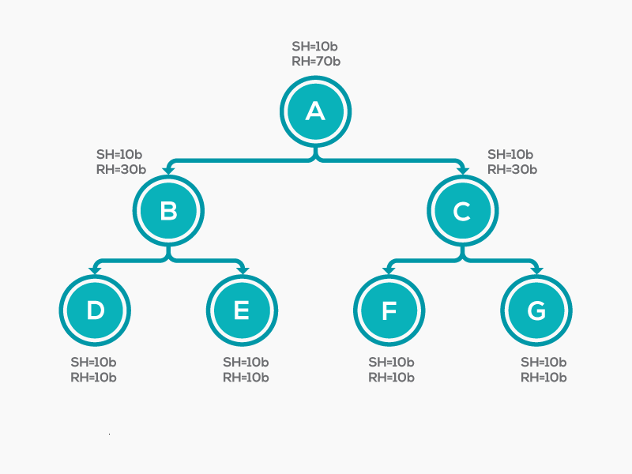
2️⃣ Retained Heap
✅ Definition
Retained Heap = total memory that would be freed if this object were garbage-collected
✔ Includes:
- The object itself
- All objects only reachable through it

Aspect | Shallow Heap | Retained Heap
What it measures | Object itself | Object + dependent objects
Size | Small | Often very large
Used for | Memory layout | Finding memory leaks
Indicates leak? | ❌ No | ✅ Yes

Real-World Analogy 🌍
🧳 Person traveling
- Shallow Heap = Person’s own body weight
- Retained Heap = Person + suitcase + bags + trolley
If the person leaves → everything goes.

Java Example (Classic Leak)
static Map<String, byte[]> cache = new HashMap<>();
- Map object:
  - Shallow heap → small
  - Retained heap → huge (all byte arrays)
⚠️ Leak analysis always focuses on retained heap

Heap Dump Tools View
In Eclipse MAT
- Sort by Retained Heap
- Top objects = memory leak suspects

One-Line Summary
Shallow heap is the memory of the object itself, while retained heap is the total memory that would be reclaimed if that object were removed.
Dominator Tree — Explained Simply (with Leak-Finding Insight)
The Dominator Tree is one of the most important tools for finding memory leaks in Java heap dumps.
What is a Dominator Tree?
✅ Simple Definition
An object A dominates object B if every path from a GC Root to B goes through A.
In plain words:
- If A is removed, B must also be removed
- So A controls the lifetime of B
Why Dominator Tree is Powerful
- Shows who is keeping memory alive
- Groups objects by retained heap
- Helps identify real leak roots, not symptoms
Real-World Analogy 🌍
🚪 Office Building
- Security Gate (A) controls access to all rooms (B, C, D)
- If gate closes → all rooms become inaccessible
👉 Gate dominates the rooms
Shallow vs Retained Heap in Dominator Tree
- Shallow Heap → size of the node itself
- Retained Heap → memory freed if node is removed
📌 Dominator Tree is usually sorted by Retained Heap
Typical Leak Example (Very Common)
public class CacheHolder {
public static Map<String, Object> CACHE = new HashMap<>();
}
Dominator Tree View
System ClassLoader
└── CacheHolder (static)
└── HashMap
└── 1,000,000 objects
- CacheHolder dominates all cached objects
- Removing it frees huge retained heap

How to Use Dominator Tree (Step-by-Step)
- Take heap dump
- jmap -dump:live,format=b,file=heap.hprof <pid>
- Open in Eclipse MAT
- Go to Dominator Tree
- Sort by Retained Heap
- Inspect top entries
- Trace path to GC Root

What Dominator Tree is NOT
❌ Not execution order
❌ Not object creation order
❌ Not GC algorithm detail
It’s a reachability & ownership view

One-Line Summary
A Dominator Tree shows which objects control the lifetime of other objects and is the fastest way to identify memory leaks using retained heap.
Demo
I am going to simulate java heap out of memory.

Steps
1.create spring boot application
package com.example.heapdump;
import org.springframework.boot.SpringApplication;
import org.springframework.boot.autoconfigure.SpringBootApplication;
import java.util.ArrayList;
import java.util.List;
@SpringBootApplication
public class HeapdumpApplication {
static List<byte[]> leak = new ArrayList<>();
public static void main(String[] args) throws InterruptedException {
SpringApplication.run(HeapdumpApplication.class, args);
long counter=1;
while (true) {
leak.add(new byte[1024 * 1024]); // 1 MB
// Thread.sleep(200);
System.out.println("adding...");
counter++;
}
}
}
How to test this code against tomcat server.

Steps:
1.we need to set heapmemory size, incase if memory is full/heap is full, we have to create a heap dump file.
Heap dump file is a file which contains the memory report.

G1 GC tuning specifically for Apache Tomcat 10 (Java 11+), practical, production-oriented, and based on GC logs, not guesswork.

🧠 Why G1 GC is ideal for Tomcat
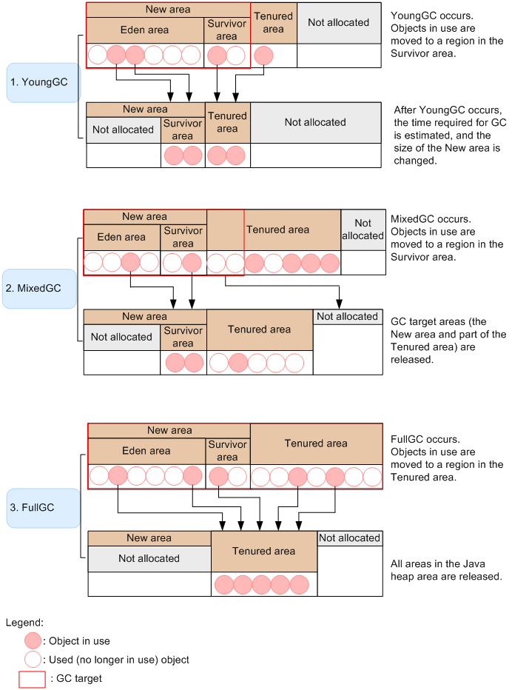
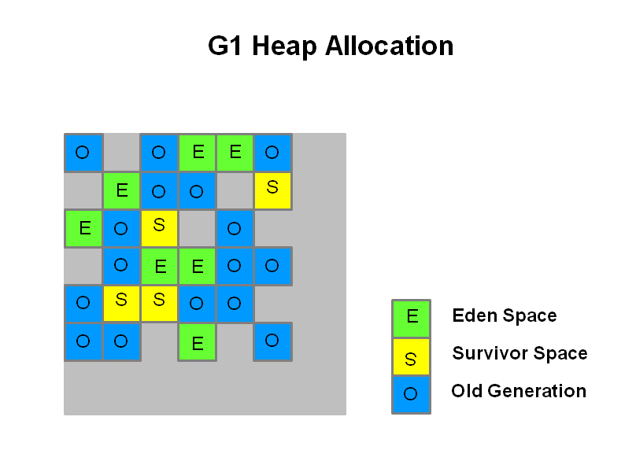

Tomcat workloads:
- Many short-lived objects (requests, JSON, buffers)
- Some medium-lived objects (sessions, caches)
- Need low latency, not max throughput
👉 G1 GC is designed exactly for this

1️⃣ Baseline (DON’T tune before this)
Before tuning, always set:
-Xms = Xmx
Why?
- Avoid heap resizing pauses
- Predictable GC behavior
Example:
-Xms4g
-Xmx4g

2️⃣ Production-Ready G1 GC Base Config (Tomcat 10)
Put this in setenv.bat:
set "JAVA_OPTS=
-Xms4g -Xmx4g
-XX:+UseG1GC
-XX:MaxGCPauseMillis=200
-XX:InitiatingHeapOccupancyPercent=45
-XX:+ParallelRefProcEnabled
-XX:+AlwaysPreTouch
-Xlog:gc*,gc+heap=info
"
This works well for 80% of Tomcat applications.

3️⃣ Key G1 GC options (WHAT & WHY)
🔹 -XX:+UseG1GC
- Enables G1 explicitly (safe even if default)

🔹 -XX:MaxGCPauseMillis=200
Soft goal, not a guarantee
- Tomcat sweet spot: 100–300 ms
- Lower value → more frequent GC
- Higher value → fewer but longer pauses

🔹 -XX:InitiatingHeapOccupancyPercent=45
When G1 starts Old Gen cleanup (Mixed GC)
Value | Effect
Too high (70) | Late cleanup → Full GC
Too low (30) | Too frequent Mixed GC
👉 45 is ideal for Tomcat

🔹 -XX:+ParallelRefProcEnabled
- Parallelizes reference processing
- Reduces pause time
- Always enable

🔹 -XX:+AlwaysPreTouch
- Touches heap at startup
- Avoids page faults during traffic
- Slightly slower startup, better runtime

4️⃣ Survivor tuning (ONLY if needed)
Symptoms in GC log:
- Objects promoted too fast
- Old Gen grows quickly
Tune:
-XX:SurvivorRatio=8
-XX:MaxTenuringThreshold=10
Use only if GC logs justify it.

5️⃣ Region size tuning (ADVANCED)
-XX:G1HeapRegionSize=8m
When?
- Heap ≥ 8 GB
- Large objects / large caches
❌ Don’t tune blindly

6️⃣ Thread & reference tuning (Tomcat-specific)
-XX:+DisableExplicitGC
Prevents:
System.gc();
Very useful if libraries call it.

7️⃣ What GOOD G1 GC logs look like (Tomcat)
Pause Young (Normal) 30ms
Pause Young (Mixed) 80ms
No Full GC
- Young GC every 1–3 sec
- Mixed GC occasionally
- No Full GC → healthy system

8️⃣ What BAD G1 GC logs look like
Log | Meaning
Frequent Mixed GC | Old Gen pressure
Pause > 1s | Latency issue
Full GC | Heap leak / undersized heap

9️⃣ Simple tuning decisions table
GC symptom | Action
Frequent Young GC | Increase heap
Long pauses | Increase MaxGCPauseMillis
Mixed GC too often | Increase heap
Full GC | Heap dump + leak analysis

🔟 Full Tomcat 10 G1 GC config
@echo off
set "JAVA_OPTS=
-Xms4g -Xmx4g
-XX:+UseG1GC
-XX:MaxGCPauseMillis=200
-XX:InitiatingHeapOccupancyPercent=45
-XX:+ParallelRefProcEnabled
-XX:+DisableExplicitGC
-XX:+AlwaysPreTouch
-Xlog:gc*,gc+heap=info:file=G:\hexaware\gclogs\gc.log:time,uptime,level,tags:filecount=5,filesize=20M
-XX:+HeapDumpOnOutOfMemoryError
-XX:HeapDumpPath=G:\hexaware\heapdump
"

