Below is a clean, beginner-friendly Maven Basic Tutorial, written step-by-step with commands, examples, folder structure, and explanations — ideal for hands-on learning.

✅ Maven Basic Tutorial (Beginner to Intermediate)
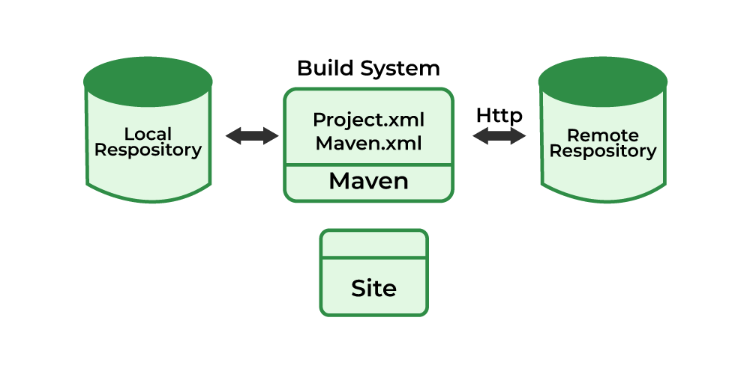
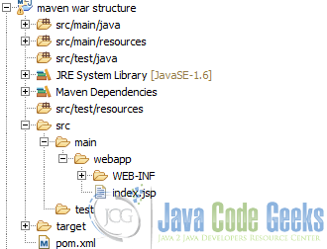
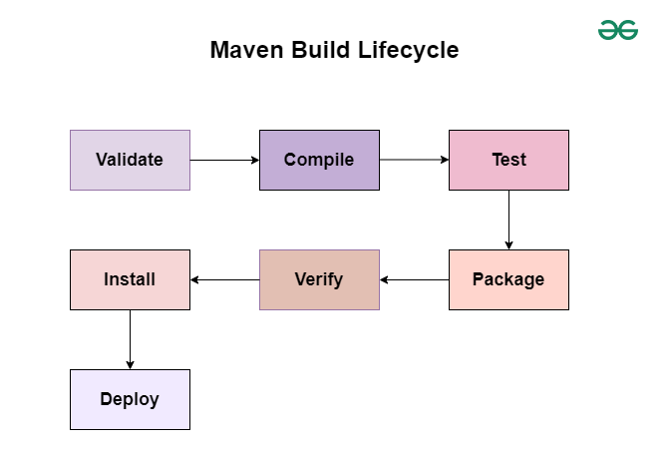

1. What is Maven?
Maven is a build automation and dependency management tool for Java projects.
🔥 Maven solves:
- Downloading and managing jars automatically
- Building Java projects with standard project structure
- Running tests
- Packaging WAR/JAR
- Using plugins (compiler, surefire, shade, etc.)

2. Install Maven
Step 1: Download
Go to Apache Maven website → Download ZIP.
Step 2: Extract & Configure
Add the bin folder to PATH.
Test installation:
mvn -version
Expected output:
Apache Maven 3.x.x
Java version: 17

3. Create Your First Maven Project
Use Maven archetype command:
mvn archetype:generate -DgroupId=com.demo \
-DartifactId=hello-maven \
-DarchetypeArtifactId=maven-archetype-quickstart \
-DinteractiveMode=false

4. Maven Project Directory Structure
hello-maven/
├── src
│ ├── main
│ │ └── java (production code)
│ └── test
│ └── java (test code)
└── pom.xml

5. Understanding pom.xml (Core of Maven)
A basic POM:
<project xmlns="http://maven.apache.org/POM/4.0.0"
xmlns:xsi="http://www.w3.org/2001/XMLSchema-instance"
xsi:schemaLocation="http://maven.apache.org/POM/4.0.0
https://maven.apache.org/xsd/maven-4.0.0.xsd">

<modelVersion>4.0.0</modelVersion>

<groupId>com.demo</groupId>
<artifactId>hello-maven</artifactId>
<version>1.0-SNAPSHOT</version>

<dependencies>
<!-- Example dependency -->
<dependency>
<groupId>org.slf4j</groupId>
<artifactId>slf4j-api</artifactId>
<version>2.0.9</version>
</dependency>
</dependencies>

</project>

6. Add Dependencies
You can add any library — Maven downloads it automatically.
Example: Add JUnit for testing:
<dependency>
<groupId>org.junit.jupiter</groupId>
<artifactId>junit-jupiter-api</artifactId>
<version>5.10.0</version>
<scope>test</scope>
</dependency>
Then run:
mvn install

7. Maven Build Lifecycle
Maven has 3 major lifecycles:
➤ clean
Deletes target/ folder.
mvn clean
➤ default (build)
Important phases:
Phase | Meaning
validate | Validates project structure
compile | Compiles source code
test | Runs unit tests
package | Creates JAR/WAR
verify | Runs integration tests
install | Saves to local repo
deploy | Uploads to remote repo
Common commands:
mvn compile
mvn test
mvn package
mvn install
➤ site
Generates project reports.

8. Build a JAR File
Run:
mvn package
Output:
target/hello-maven-1.0-SNAPSHOT.jar

9. Add a Main Class and Run with Plugin
Add plugin to POM:
<build>
<plugins>

<plugin>
<groupId>org.apache.maven.plugins</groupId>
<artifactId>maven-compiler-plugin</artifactId>
<version>3.10.1</version>
<configuration>
<source>17</source>
<target>17</target>
</configuration>
</plugin>

<plugin>
<groupId>org.codehaus.mojo</groupId>
<artifactId>exec-maven-plugin</artifactId>
<version>3.1.0</version>
<configuration>
<mainClass>com.demo.App</mainClass>
</configuration>
</plugin>

</plugins>
</build>
Run:
mvn exec:java

10. Common Maven Commands
Command | What it does
mvn clean | remove target folder
mvn compile | compile source code
mvn test | run tests
mvn package | build JAR/WAR
mvn install | save to local repo
mvn dependency:tree | view dependency tree
mvn -X | debug mode

11. Settings.xml (Optional)
Configure proxies, repositories, mirrors, credentials.
Location:
- Windows: ~/.m2/settings.xml
Example mirror (Maven Central faster):
<mirrors>
<mirror>
<id>central</id>
<url>https://repo.maven.apache.org/maven2</url>
<mirrorOf>*</mirrorOf>
</mirror>
</mirrors>

12. How Maven Downloads Jars?
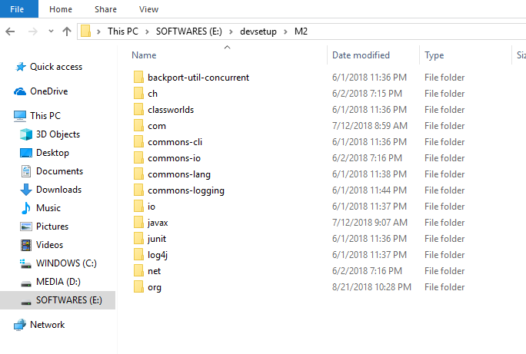
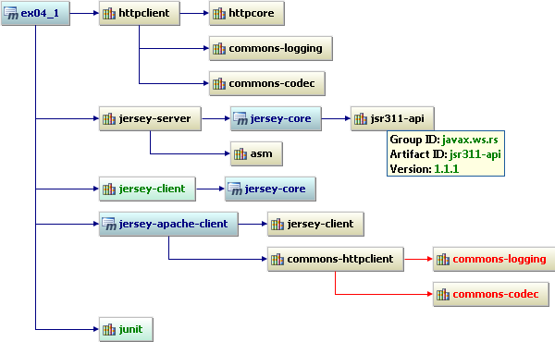
- Downloads from Maven Central → stores inside
C:\Users\<user>\.m2\repository
- No need to manually add jars
- Resolves transitive dependencies automatically

13. Simple Real-Time Example
Goal: Use Gson to convert Java object → JSON
Add dependency:
<dependency>
<groupId>com.google.code.gson</groupId>
<artifactId>gson</artifactId>
<version>2.10.1</version>
</dependency>
Code:
class Employee {
String name;
int age;
}

public class App {
public static void main(String[] args) {
Employee e = new Employee();
e.name = "John";
e.age = 30;

String json = new com.google.gson.Gson().toJson(e);
System.out.println(json);
}
}
Run:
mvn exec:java
Output:
{"name":"John","age":30}

The tags you highlighted:
<groupId>com.demo</groupId>
<artifactId>hello-maven</artifactId>
are two of the most important identifiers in a Maven project.
Here is a very simple explanation:

✅ What is groupId?
groupId = Company / Organization / Project group name
It uniquely identifies who owns the project.
Examples:
- For Google → com.google
- For Spring → org.springframework
- For your company → com.mycompany
- For your personal project → anything you choose
Example: com.demo
Think of it like:
📌 A folder name that groups your related projects.

✅ What is artifactId?
artifactId = The name of your project (your JAR/WAR file name)
It must be unique inside the groupId.
Examples:
- spring-core
- mysql-connector
- hello-maven
- employee-service
This becomes your output:
artifactId-version.jar
Example:
hello-maven-1.0-SNAPSHOT.jar

✅ Simple Example Meaning
<groupId>com.demo</groupId>
<artifactId>hello-maven</artifactId>
Means:
- The project belongs to organization/package → com.demo
- The specific project name is → hello-maven
Your final artifact becomes:
com.demo : hello-maven : 1.0-SNAPSHOT

🧠 Easy Analogy
Maven term | Real-world meaning
groupId | Company or department name
artifactId | Specific product name
version | Product version

