<http://stuiis.cms.gre.ac.uk/codezer0/>

**Testing story:** Us23

**Staff being tested:** pm253 (authorised), tm21 (not authorised)

**Student’s being tested:** Aaron Dunphy (da236), Polly Stoyanova (sp116), Andrew Tate (ta210)

**Page(s) being tested:** viewDashboards.php(1),

**Feature(s) being tested:** Admin can view all dashboards

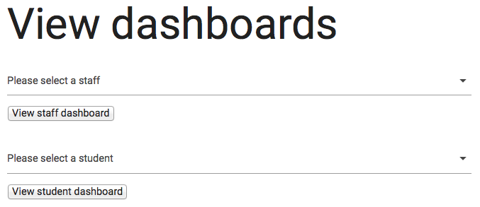**Associated images:**Admin ‘View Dashboards’ page (viewDashboards.php)-

**Steps included in test:**

**1. Admin “View dashboards” page**

View staff dashboard

* Select no staff and click “view staff dashboard”
* Should be validation telling you to select staff
* Select staff and select student and click “view staff dashboard” –Should show staff’s dashboard since “view staff dashboard” was clicked
* Select staff and click “view student dashboard”-validation should appear saying please select a student
* Select staff and click “view staff dashboard”- does the selected staff’s dashboard appear?
* Is the staff member assigned to a project student once only? - Should be (no duplicates)
* Are the links contained within the cards of the staff’s dashboard consistent? (Text which takes up two lines should be directly underneath its first line of text)
* Click “go back to view dashboards”-does it take you back?
* Are the cards on each staff’s dashboard positioned in the same way to keep the design consistent? -Should be
* Once you are on a staff dashboard, does the “view dashboards” link in the navigation disappear?- shouldn’t do

View student dashboard

* Select no student and click “view student dashboard”
* Should be validation telling you to select student
* Select student and select staff and click “view student dashboard” –Should show student’s dashboard since “view student dashboard” was clicked
* Select student and click “view staff dashboard”-validation should appear saying please select a staff
* Select student and click “view student dashboard”- does the selected student’s dashboard appear?
* Are the links contained within the cards of the students dashboard consistent? (Text which takes up two lines should be directly underneath its first line of text)
* Click “go back to view dashboards”-does it take you back?
* Are the cards on each student’s dashboard positioned in the same way to keep the design consistent? -Should be
* Are there any duplicate supervisor/second marker assigned to any of the students? – shouldn’t be
* Once you are on a student dashboard, does the “view dashboards” link in the navigation disappear?- ask Aaron if it should/shouldn’t do

**Things to note whilst following steps:**

* What happens after refreshing the page at various stages?
* Check for spelling mistakes

**Additional notes before testing**

* Log in as a student (tm112) then change the URL to the admin “view dashboards” page to see if you can access the admin page (should not be allowed to).
* Log in as an unauthorized staff (tm21) then change the URL to the admin “view dashboards” page to see if you can access the admin page (should not be allowed to).