**Design  
Student dashboard: Browser**

Table of Contents

Design guidelines 5

Palette 3

Chosen: Material design 3

CSS 3

Typography 4

Font name: Roboto 4

Font weights 4

Browser size 4

Prototypes 5

Student Dashboard 5

Meetings 8

Diary/Blog 10

Uploads 10

Design guidelines

## Palette

### Chosen: Material design

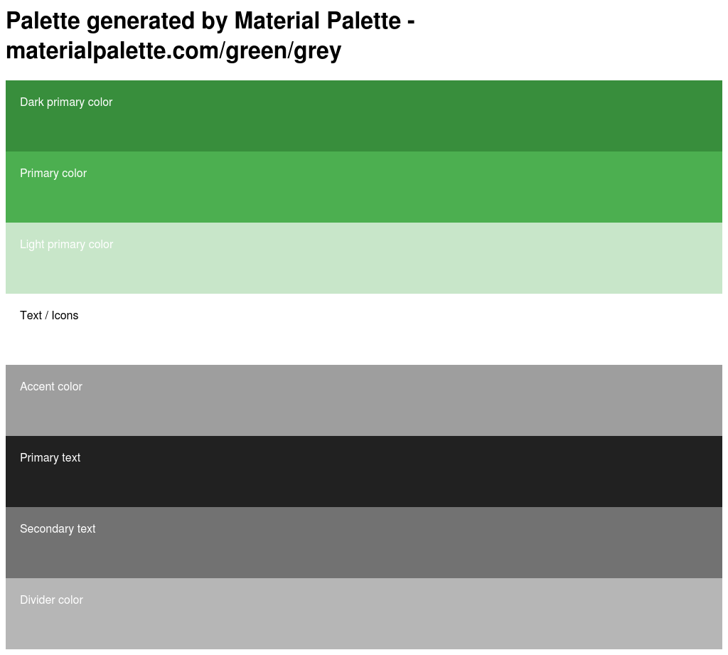Palette will be based on two colours; Green and Grey. Below are the colours to use with each element along with its CSS.  
  
  
  
  
  
  
  
  
  
  
  
  
  
  
  
  
  
  
  
  
  
  
  
  
  
  
CSS

.dark-primary-color { background: #388E3C; }

.default-primary-color { background: #4CAF50; }

.light-primary-color { background: #C8E6C9; }

.text-primary-color { color: #FFFFFF; }

.accent-color { background: #9E9E9E; }

.primary-text-color { color: #212121; }

.secondary-text-color { color: #727272; }

.divider-color { border-color: #B6B6B6; }

## Typography

### Font name: Roboto

A folder containing the font is included on GitHub: directory is: GreenwichCodeZero/Documentation>Design>Typography.

Alternatively fonts can be downloaded from:

[www.materializecss.com/typography.html](http://www.materializecss.com/typography.html)

### Font weights

Roboto has six weights: Thin, Light, Regular, Medium, Bold, and Black, these are included on GitHub (follow directory above).

# Browser size

Chosen size is **1024px by 768px**

# Prototypes

## Student Dashboard

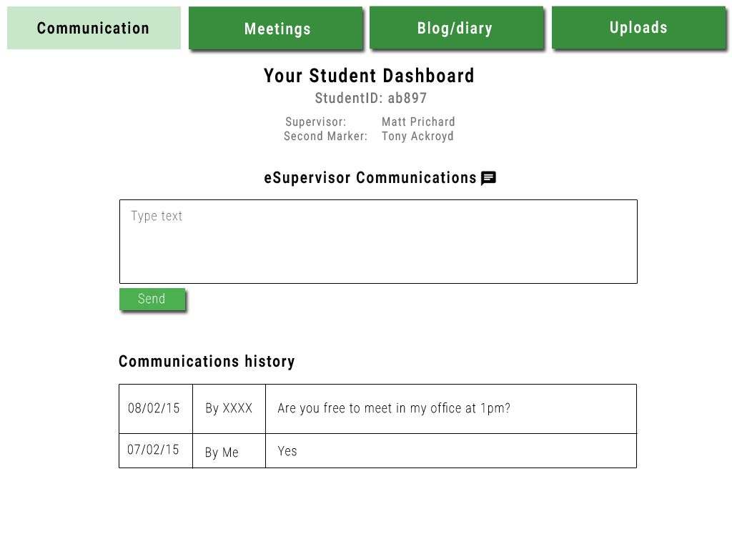

**Navigation**

The navigation consists of raised buttons to draw more attention to them. I based this on the material design guidelines. [http://www.google.co.uk/design/spec/components/buttons.html#](http://www.google.co.uk/design/spec/components/buttons.html)

Text size: 40px

Text colour: #FFFFFF

Font: Roboto bold

Button colour:#388E3C

Hovered button colour: #C8E6C9

Hovered text colour: #000000**Headings**

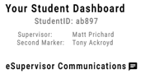

Font: Roboto Bold

Size: 48px

  
  
  
  
Font: Roboto Medium

Size: 36px  
  
  
  
  
  
  
Font: Roboto Regular

Size: 30px  
  
  
  
  
Font: Roboto Bold

:studentDashPro:snaps:home:Communicaionshist.pngSize: 40px  
  
  
  
  
Font: Roboto Bold

Size: 40px**icons/buttons**

:icons:CHAT.png:studentDashPro:snaps:home:shapes:Send.pngObtained from Material icons site: <https://google.github.io/material-design-icons/>Font: Roboto thin

Size: 32px

Text colour: #FFFFFF

Rectangle width: 92px

Rectangle height: 31px

Background colour: #4CAF50  
  
  
**Tables**

All tables/ text fields on the Communication, Blog and Uploads pages have a width as displayed below. The height will vary on how much text the student inputs. The height below is for the image below which is on the **communications** page.

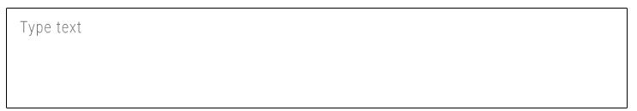  
  
  
  
  
  
  
Rectangle width: 723px

Rectangle height: 116px

Font: Roboto thin

Text size: 32px

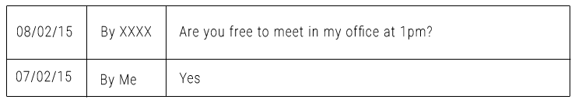Text colour: #727272

Font: Roboto thin

Text size: 32px

Text colour: #000000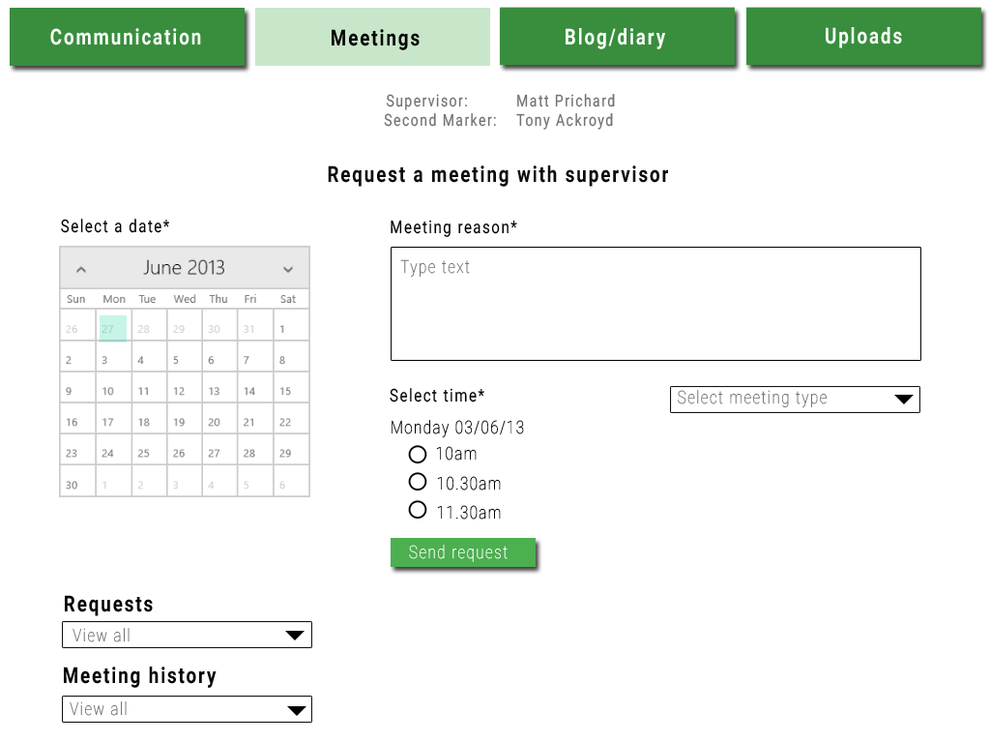Meetings  
  
  
  
  
  
  
  
  
  
  
  
  
  
  
  
  
  
  
  
  
  
  
  
  
  
  
  
**Note: Navigation, supervisor/second marker and main heading specifications can be found above.**

1. This will be a Calendar GUI.
2. Font: Roboto Regular  
   Font size: 32px  
   Colour: #000000
3. Font: Roboto thin  
   Font size: 32px  
   Colour: #727272
4. :icons:dropdown.png  
     
   Obtained from Material icons site: <https://google.github.io/material-design-icons/>
5. :icons:radioOff.png   
     
   Obtained from Material icons site: <https://google.github.io/material-design-icons/>
6. Font: Roboto thin  
   Size: 32px  
   Text colour: #FFFFFF  
   Rectangle width: 92px  
   Rectangle height: 31px  
   Background colour: #4CAF50
7. Font: Roboto Bold  
   Size: 40px  
   Text colour: #000000

## Blog/ Diary

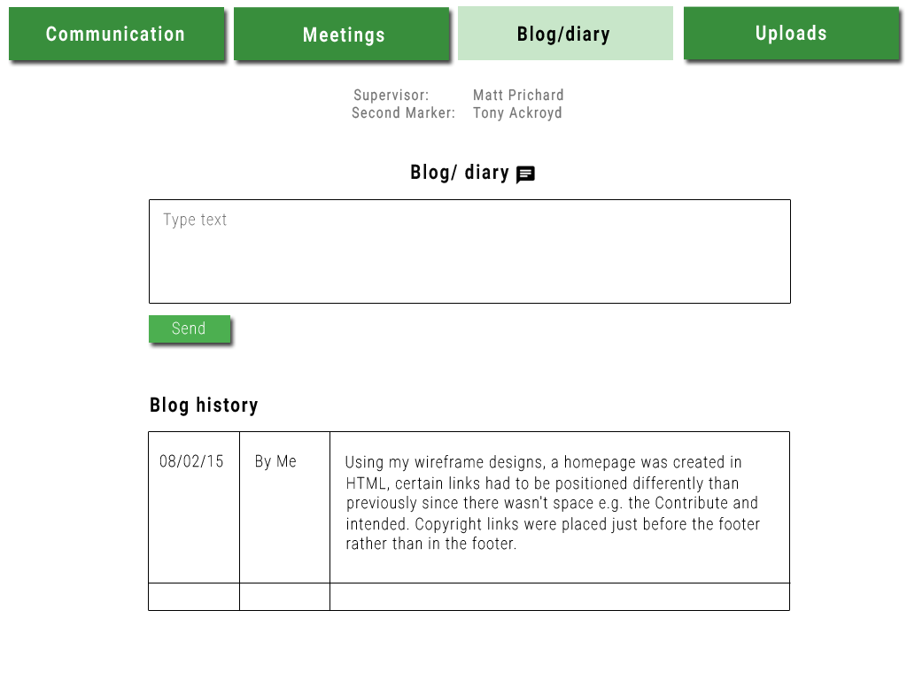

**See specification above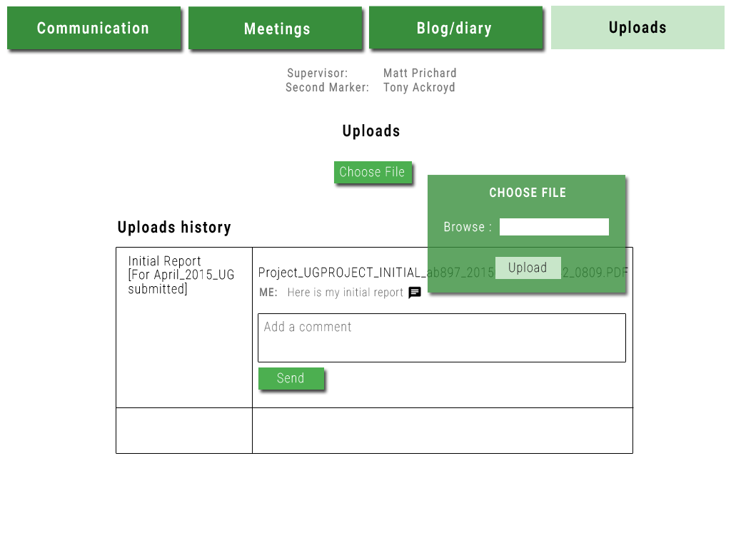**Uploads

8. Font: Roboto Thin

Font-Size: 32px  
 Colour: #FFFFFF  
 Rectangle width: 109px  
 Rectangle height: 31px  
 Background colour: #4CAF50

9. Font: Roboto Bold   
 Font size: 32px  
 Text colour: #FFFFFF

10.   
  
  
  
 Text size: 32px  
 Font: Roboto Light

Text colour: #FFFFFF

11. Rectangle width:92px  
 Rectangle height: 31px

Text colour: #000000

Font: Roboto Thin

Font size: 32px

12. Box colour: #4CAF50 Opacity: 80%  
 Box width: 277px

Box height: 165px