**Test plans and Test criteria’s**

Kinza Naseer

Table of Contents

US82- Test plan 3

US23- Test criteria 4

US23- Test plan 6

US86- Test criteria 11

US86- Test plan 15

US92 – Test plan 20

US15- Test criteria 21

US16- Test criteria 25

US16- Test plan 27

US21- Test criteria 34

# US82- Test plan

**Test:** Student can upload files when messaging.

**Description:** Test to see if a student can upload files on the messages page and that their file appears on the Staff’s “messages” page.

**System requirements:**

Student is logged in

Student has a supervisor to request a meeting with (tm112).

|  |  |  |  |  |  |  |
| --- | --- | --- | --- | --- | --- | --- |
| **Test No.** | **Page** | **Action** | **Expected Result** | **Actual Result** | **Date Tested** | **Success/Failure** |
| 1 | Login.php | Enter username and password and click log in. | Taken to their dashboard. | SAME | 21/02/2015 | SUCCESS |
| 2 | Dashboard.php | Click on ‘Messaging’ tab in top navigation bar. | User is taken to the messages page. | SAME | 21/02/2015 | SUCCESS |
| 3 | Messages.php | User clicks “New Message”. | A form appears to allow user to enter text and select a file. | SAME | 21/02/2015 | SUCCESS |
| 4 | Messages.php | User enters a message and clicks “choose file”. | A box appears allowing user to browse file. | SAME | 21/02/2015 | SUCCESS |
| 5 | Messages.php | User chooses a file other than PDF and .doc and hits “Submit”. | An error message appears saying “you can only submit PDF and .doc files”. | SAME | 21/02/2015 | SUCCESS |
| 6 | Messages.php | User chooses a PDF/.doc file and enters message. | A message confirming, “Your content was committed successfully” appears and file is added to Message History along with message. File is sent to Matt Prichard. | SAME | 21/02/2015 | SUCCESS |
| 7 | Messages.php | User refreshes page after upload. | User success message disappears and user is not prompted to upload again. | SAME | 21/02/2015 | SUCCESS |
| 8 | Messages.php | User chooses a file but enters no text. | A message saying, “Please complete all fields” appears. | SAME | 21/02/2015 | SUCCESS |
| 9 | Messages.php | User enters text but chooses no file. | Message is submitted. Message appears on staff’s “messages” page. | SAME | 21/02/2015 | SUCCESS |
| 10 | Messages.php | Student uploads a PDF/.DOC file of size 40MB. | A message appears saying cannot exceed maximum file size of 39MB. | SAME | 21/02/2015 | SUCCESS |

# US23- Test criteria

**Staff being tested:** pm253 (authorised), tm21 (not authorised)

**Student’s being tested:** Aaron Dunphy (da236), Polly Stoyanova (sp116), Andrew Tate (ta210)

**Page(s) being tested:** viewDashboards.php(1),

**Feature(s) being tested:** Admin can view all dashboards

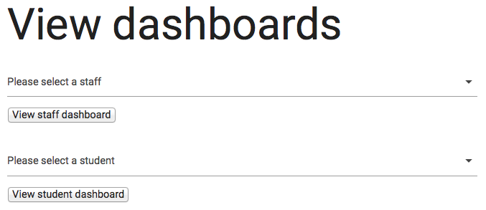**Associated images:**Admin ‘View Dashboards’ page (viewDashboards.php)-

**Steps included in test:**

**1. Admin “View dashboards” page**

View staff dashboard

* Select no staff and click “view staff dashboard”
* Should be validation telling you to select staff
* Select staff and select student and click “view staff dashboard” –Should show staff’s dashboard since “view staff dashboard” was clicked
* Select staff and click “view student dashboard”-validation should appear saying please select a student
* Select staff and click “view staff dashboard”- does the selected staff’s dashboard appear?
* Is the staff member assigned to a project student once only? - Should be (no duplicates)
* Are the links contained within the cards of the staff’s dashboard consistent? (Text which takes up two lines should be directly underneath its first line of text)
* Click “go back to view dashboards”-does it take you back?
* Are the cards on each staff’s dashboard positioned in the same way to keep the design consistent? -Should be
* Once you are on a staff dashboard, does the “view dashboards” link in the navigation disappear?- shouldn’t do

View student dashboard

* Select no student and click “view student dashboard”
* Should be validation telling you to select student
* Select student and select staff and click “view student dashboard” –Should show student’s dashboard since “view student dashboard” was clicked
* Select student and click “view staff dashboard”-validation should appear saying please select a staff
* Select student and click “view student dashboard”- does the selected student’s dashboard appear?
* Are the links contained within the cards of the students dashboard consistent? (Text which takes up two lines should be directly underneath its first line of text)
* Click “go back to view dashboards”-does it take you back?
* Are the cards on each student’s dashboard positioned in the same way to keep the design consistent? -Should be
* Are there any duplicate supervisor/second marker assigned to any of the students? – shouldn’t be
* Once you are on a student dashboard, does the “view dashboards” link in the navigation disappear?- ask Aaron if it should/shouldn’t do

**Things to note whilst following steps:**

* What happens after refreshing the page at various stages?
* Check for spelling mistakes

**Additional notes before testing**

* Log in as a student (tm112) then change the URL to the admin “view dashboards” page to see if you can access the admin page (should not be allowed to).
* Log in as an unauthorized staff (tm21) then change the URL to the admin “view dashboards” page to see if you can access the admin page (should not be allowed to).

# US23- Test plan

**Staff being tested:** pm253 (authorised), tm21 (not authorised)

**Student’s being tested:** Aaron Dunphy (da236), Polly Stoyanova (sp116), Andrew Tate (ta210)

**Page(s) being tested:** viewDashboards.php

**Feature(s) being tested:** Admin can view all dashboards

|  |  |  |  |  |  |  |  |  |  |  |  |
| --- | --- | --- | --- | --- | --- | --- | --- | --- | --- | --- | --- |
| Test No | Page | Action | | Expected Result | | Actual Result | | Date tested | | Success / Failure | |
| 1 | Index.php | Admin pm253 logs in | | Admin is taken to their dashboard | | Same as expected | | 05.03.15 | | SUCCESS | |
| 2 | Index.php | Admin navigates to “view dashboards” page | | viewDashboards.php loads up | | Same as expected | | 05.03.15 | | SUCCESS | |
| 3 | viewDashboards.php | Admin leaves “select a staff” field empty and clicks “view staff dashboard” | | Validation appears telling you to select staff | | Same as expected | | 05.03.15 | | SUCCESS | |
| 4 | viewDashboards.php | Admin selects staff “Mike unauthorized” and a student “Aaron” and clicks “view staff dashboard” | | Mike unauthorized’s dashboard should show since “view staff dashboard” was clicked | | Same as expected | | 05.03.15 | | SUCCESS | |
| 5 | viewDashboards.php | Admin selects staff “Mike unauthorized” and clicks “view student dashboard” | | Validation appears saying please select a student since “view student dashboard” was clicked | | Same as expected | | 05.03.15 | | SUCCESS | |
| 6 | viewDashboards.php | Admin selects staff “Lucy deadman” and clicks “view staff dashboard” | | Lucy Deadman’s staff dashboard should appear | | Same as expected | | 05.03.15 | | SUCCESS | |
| 7 | viewDashboards.php>Lucy Deadman | Admin scrolls down the page to view Lucy’s project students | | All project student assigned to Lucy appear, with no duplicates | | Same as expected | | 05.03.15 | | SUCCESS | |
| 8 | viewDashboards.php>Lucy Deadman | Admin navigates to Lucy’s Message summary card | | Links contained within that card should be consistent | | Same as expected | | 05.03.15 | | SUCCESS | |
| 9 | viewDashboards.php>Lucy Deadman | Admin views the cards as a whole | | All cards should be positioned the same for each staff being searched | | Same as expected | | 05.03.15 | | SUCCESS | |
| 10 | viewDashboards.php>Lucy Deadman | Admin looks at navigation | | The link for “view dashboards” should still be in the navigation bar | | Same as expected | | 05.03.15 | | SUCCESS | |
| 11 | viewDashboards.php>Lucy Deadman | Admin clicks “Go back to view dashboards” | Admin should be taken back to viewDashboards.php | | Same as expected | | 05.03.15 | | SUCCESS | |
| 12 | viewDashboards.php | Admin leaves “select a student” field empty and clicks “view student dashboard” | | Validation appears telling you to select student | | Same as expected | | 05.03.15 | | SUCCESS | |
| 13 | viewDashboards.php | Admin selects student “Andrew” and a staff “Lucy” and clicks “view student dashboard” | | Andrew’s dashboard should show since “view student dashboard” was clicked | | Same as expected | | 05.03.15 | | SUCCESS | |
| 14 | viewDashboards.php | Admin selects student “Andrew” and clicks “view staff dashboard” | | Validation appears saying please select a staff since “view staff dashboard” was clicked | | Same as expected | | 05.03.15 | | SUCCESS | |
| 15 | viewDashboards.php | Admin selects student “Andrew” and clicks “view student dashboard” | | Andrews student dashboard should appear | | Same as expected | | 05.03.15 | | SUCCESS | |
| 16 | viewDashboards.php>Andrew Tate | Admin views Andrews Supervisor and second marker | | There should be a different supervisor and different second marker | | Same as expected | | 05.03.15 | | SUCCESS | |
| 17 | viewDashboards.php>Andrew Tate | Admin looks at navigation | | The link for “view dashboards” should still be in the navigation bar | | Same as expected | | 05.03.15 | | SUCCESS | |
| 18 | viewDashboards.php>Andrew Tate | Admin clicks “Go back to view dashboards” | | Admin should be taken back to viewDashboards.php | | Same as expected | | 05.03.15 | | SUCCESS | |
| 19 | viewDashboards.php | The url is copied and staff logs out | | Index.php is displayed | | Same as expected | | 05.03.15 | | SUCCESS | |
| 20 | Index.php | Log in as student Aaron and paste the copied url from staff into browser and click enter | | You shouldn’t be able to view the staff page since you are logged in as student | | Same as expected | | 05.03.15 | | SUCCESS | |
| 21 | Index.php | Log in as an unauthorized staff member (tm21), paste in the url from the authorized staff page and click enter | | You shouldn’t be able to view the staff page since you are logged in as an unauthorized staff member | | Same as expected | | 05.03.15 | | SUCCESS | |

# US86- Test criteria

**Testing story:** Us86

**Staff being tested:** pm253 (authorised), tm21 (not authorised)

**Student’s being tested:** Aaron Dunphy (da236), Polly Stoyanova (sp116), Andrew Tate (ta210) , Mark Tickner (tm112), Amy Louise (la345), Dwayne student (BD118).

**Page(s) being tested:** index.php (1), blogs.php (2)(3)(4)(5)

**Feature(s) being tested:** Staff can add comments to their students blog.

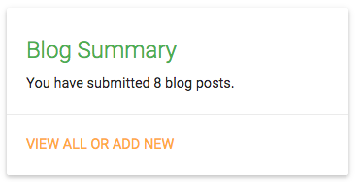**Associated images:**Students ‘Blog Summary’ page (index.php)-

Students ‘Blog history’ page and option to ‘Add Entry’ (blogs.php) -

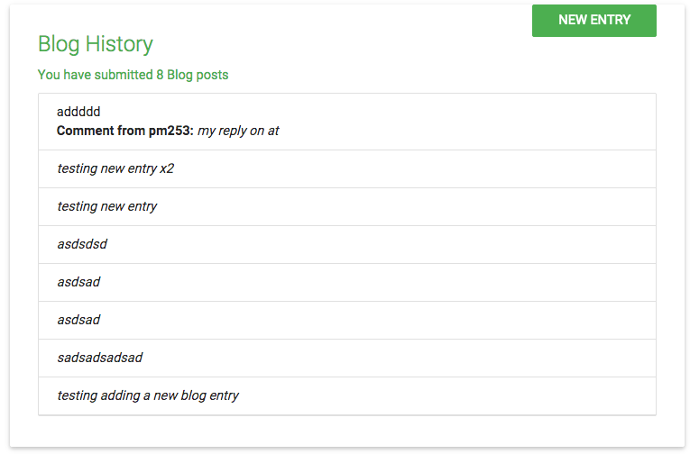

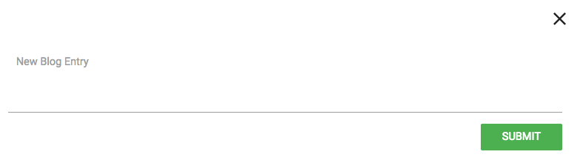

Staff’s ‘Student Blog history’ page and option to ‘Write a Comment” (blogs.php) -

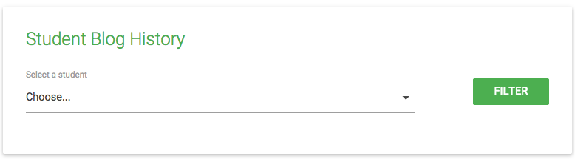

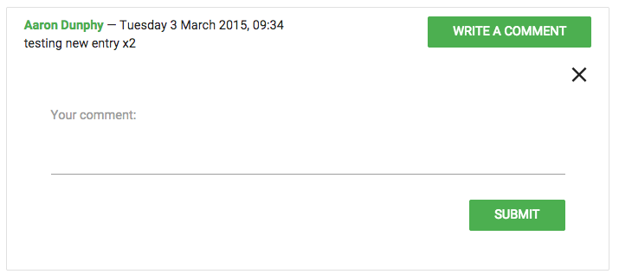

**Steps included in test:**

**1. Student’s “Blog Summary” page**

View number of submitted Blog posts on index.php

* Does the number of submitted blog posts update when submitting a message?
* Does it remain the same when page is refreshed?
* Click on “View all or add new”, do the number of submissions reflect the number of submissions on index.php?
* Should see a button; ‘new entry’ directly to supervisor
* Are you able to view comments from supervisor in the blog history?

**2. Student’s “Blog History” page**

View submitted blog posts on blogs.php

* Do the number of submissions reflect the number of submissions on index.php?
* Should see a button; ‘new entry’ directly to supervisor
* Are you able to view comments from supervisor in the blog history?

**3. Student’s “Submit New Blog Entry”**

On blogs.php

* Click on “New entry”, should open a form to add a new blog entry to supervisor
* Click “X” to Close form
* Click on “New entry” again and enter html code with inline css formatting (change text colour, font-weight) – should display all tags and styling as text and not render it
* Leave blog entry field blank and submit
* Ensure there is validation on the form (can’t send blank)
* Refresh page before clicking Submit
* Ensure you cannot inject message contents in the url
* Does the number of posts submitted to supervisor update every time you send a message?-should do

**4. Staff’s “Student Blog History” page**

Select a student to view blog posts on blogs.php

* Choose a student
* Refresh page- does the field become empty again? Should do
* Choose a student again and click “filter”
* Don’t choose a student and click “filter”
* Do the posts submitted by that student appear?
* If a student hasn’t submitted any posts does it state that?
* Is staff able to add a comment to a new post submitted by the student?
* Is staff able to comment a second time to a students post?- check with Aaron if this is allowed?

**5. Staff’s “Write a comment” to Student blog post**

Select a student to view blog posts on blogs.php

* Click on “write a comment”-should open form
* Click “write a comment” again -should close form
* Click “write a comment” and click “X”- should this delete the ability to add a comment or close the form?-ask Aaron
* Refresh page- does the button “write a comment” reappear on the students posts which originally disappeared when clicking “X”?- should this happen?-ask Aaron
* Click on “write a comment”, and enter html code with inline css formatting (change text colour, font-weight) – should display all tags and styling as text and not render it
* Refresh page before clicking Submit
* Leave all fields blank and send
* Ensure there is validation on the form (can’t send blank)
* Does the student receive the staff’s comment
* Are the dates and times displayed correctly?

**Things to note whilst following steps:**

* What happens after refreshing the page at various stages?
* Does the number of posts staff has received on blogs.php update when a student posts a blog? (Should do)
* When staff selects a student to view their blog post history, do all the posts for that student show or do posts from other students show too (should only filter posts from the student who is selected)
* Check for spelling mistakes

**Additional notes before testing**

* Access the page as a student (tm112) then change the URL to the staffs message history page to see if you can access the staff’s message history function as a student (should not be allowed to).

# US86- Test plan

**Staff being tested:** pm253 (authorised), tm21 (not authorised)

**Student’s being tested:** Aaron Dunphy (da236), Polly Stoyanova (sp116), Andrew Tate (ta210) , Mark Tickner (tm112), Amy Louise (la345), Dwayne student (BD118).

**Page(s) being tested:** index.php (1), blogs.php (2)(3)(4)(5)

**Feature(s) being tested:** Staff can add comments to their students blog.

|  |  |  |  |  |  |  |
| --- | --- | --- | --- | --- | --- | --- |
| Test No | Page | Action | Expected Result | Actual Result | Date tested | Success / Failure |
| 1 | Index.php | Authorized staff pm253 logs in | Staff is taken to their dashboard | Same as expected | 04.03.15 | SUCCESS |
| 2 | Index.php | Staff navigates to blog page | Blogs.php loads up | Same as expected | 04.03.15 | SUCCESS |
| 3 | Blogs.php | Staff chooses a student (Aaron) | Aaron’s name appears in the “select a student” field | Same as expected | 04.03.15 | SUCCESS |
| 4 | Blogs.php | Refresh page | “Choose a student field” becomes empty again | Same as expected | 04.03.15 | SUCCESS |
| 5 | Blogs.php | Staff chooses a student (Aaron) again and clicks button “Filter” | All blog posts from Aaron appear in descending order with the latest post first | Same as expected | 04.03.15 | SUCCESS |
| 6 | Blogs.php | Staff chooses another student Polly | Nothing should display since she hasn’t submitted any posts | Same as expected | 04.03.15 | SUCCESS |
| 7 | Blogs.php | Staff chooses a student (Aaron) again and clicks button “Filter” and clicks on “write a comment” | All blog posts from Aaron appear in descending order with the latest post first. A form should open when the button “write a comment” is clicked | Same as expected | 04.03.15 | SUCCESS |
| 8 | Blogs.php | Staff enters text and clicks refresh | Text disappears | Same as expected | 04.03.15 | SUCCESS |
| 9 | Blogs.php | Staff enters text and clicks submit | A message appears confirming comment has been submitted | Same as expected | 04.03.15 | SUCCESS |
| 10 | Blogs.php | Staff logs out | Index.php appears | Same as expected | 04.03.15 | SUCCESS |
| 11 | Index.php | Student Aaron logs in | Student dashboard appears | Same as expected | 04.03.15 | SUCCESS |
| 12 | Blogs.php | Student clicks on “view all or add new” button | Blog history appears and student should be able to view comments from staff with the time they commented and on what date | Same as expected | 05.03.15 | SUCCESS |
| 13 | Blogs.php | Student clicks on “new entry” | A form should appear to enter an entry | Same as expected | 04.03.15 | SUCCESS |
| 14 | Blogs.php | Student enters some html code | The code should not render and should be submitted as static text | Same as expected | 05.03.15 | SUCCESS |
| 15 | Blogs.php | Student navigates back to index.php | The number of submitted blog posts should updates under the “blog summary” card | Same as expected | 04.03.15 | SUCCESS |
| 16 | Index.php | Student navigates back to blog tab | Blogs.php opens | Same as expected | 04.03.15 | SUCCESS |
| 17 | Blogs.php | Student clicks on “new entry” and leave form empty and clicks submit | Validation should be present indicating text needs to be entered | Same as expected | 04.03.15 | SUCCESS |
| 18 | Blogs.php | Student clicks on “new entry” and enters text then refreshes page | Text should disappear and form should close | Same as expected | 04.03.15 | SUCCESS |
| 19 | Blogs.php | Student logs out | Index.php should display | Same as expected | 04.03.15 | SUCCESS |
| 20 | Index.php | Staff pm253 logs in | Staff dashboard should appear | Same as expected | 04.03.15 | SUCCESS |
| 21 | Blogs.php | Staff clicks on blog page and selects student Aaron and clicks filter | Aarons posts should show including the html rendered recent post | Same as expected | 04.03.15 | SUCCESS |
| 22 | Blogs.php | Staff clicks on “write a comment” on the recent post submitted by Aaron, then clicks on it a second time | A form should open on the first click and then close on the second click | Same as expected | 04.03.15 | SUCCESS |
| 23 | Blogs.php | Staff clicks on “write a comment” again and enters some html code then clicks “submit” | The code should not render and should be submitted as static text with the date and time of submission being shown | Same as expected | 04.03.15 | SUCCESS |
| 24 | Blogs.php | Staff navigates back to the same student post that was just commented on | There shouldn’t be an option to add another comment on the same post | Same as expected | 05.03.15 | SUCCESS |
| 25 | Blogs.php | Staff logs out | Index.php is displayed | Same as expected | 04.03.15 | SUCCESS |
| 26 | Index.php | Student Aaron logs in | Student dashboard appears | Same as expected | 04.03.15 | SUCCESS |
| 27 | Index.php | Student navigates to blog | Staffs recent comment should appear without having been rendered | Same as expected | 04.03.15 | SUCCESS |
| 28 | Blogs.php | Student logs out | Index.php should display | Same as expected | 04.03.15 | SUCCESS |
| 29 | Index.php | Staff pm253 logs in | Staff dashboard should appear | Same as expected | 04.03.15 | SUCCESS |
| 30 | Blogs.php | Staff clicks on blog page and selects student Aaron and clicks filter | Aarons posts should show | Same as expected | 04.03.15 | SUCCESS |
| 31 | Blogs.php | Staff clicks “write a comment” on one of the other posts, then clicks “X” | The ability to add a comment should disappear and reappear once the page is refreshed | Same as expected | 05.03.15 | SUCCESS |
| 32 | Blogs.php | The page is refreshed | The deleted form appears again | Same as expected | 04.03.15 | SUCCESS |
| 33 | Blogs.php | The url is copied and staff logs out | Index.php is displayed | Same as expected | 04.03.15 | SUCCESS |
| 34 | Index.php | Log in as student Aaron and paste the copied url from staff into browser and click enter | You shouldn’t be able to view the staff page since you are logged in as student | Same as expected | 05.03.15 | SUCCESS |
| 35 | Index.php | Log in as an unauthorized staff member (tm21), paste in the url from the authorized staff page and click enter | You shouldn’t be able to view the staff page since you are logged in as an unauthorized staff member | Same as expected | 05.03.15 | SUCCESS |

# US92 – Test plan

**Test:** Student can VIEW uploaded files.

**Description:** Test to see if a student can view their uploaded files from the Meetings and Messages page, on the Uploads page.

**System requirements:**

Student is logged in (tm112)

Student has uploaded a file on the Meetings page and Messages page (see test plan for “student_can_upload_files” on GitHub)

|  |  |  |  |  |  |  |
| --- | --- | --- | --- | --- | --- | --- |
| **Test No.** | **Page** | **Action** | **Expected Result** | **Actual Result** | **Date Tested** | **Success/Failure** |
| 1 | Login.php | Enter username and password and click log in. | Taken to their dashboard. | SAME | 20/02/2015 | Success |
| 2 | Dashboard.php | Click on ‘Uploads’ tab in top navigation bar. | User is taken to the Uploads page to view all uploads. | SAME | 20/02/2015 | Success |
| 3 | Uploads.php | Uploads page is displayed. | User can view uploads they submitted on ‘Meetings’ and ‘Messages’ pages. | SAME | 20/02/2015 | Success |
| 4 | Uploads.php | User clicks on “view file”. | The file is downloaded to the users desktop, and when clicked on the file is displayed. | SAME | 20/02/2015 | Success |

# US15- Test criteria

**Staff being tested:** pm253 (authorised), tm21 (not authorised)

**Student’s being tested:** Aaron Dunphy (da236), Polly Stoyanova (sp116), Andrew Tate (ta210) , Mark Tickner (tm112), Amy Louise (la345), Dwayne student (BD118).

**Page(s) being tested:** search.php (1), allocate.php (2)

**Feature(s) being tested:** Involved users are notified when supervisor/second marker is added/changed.

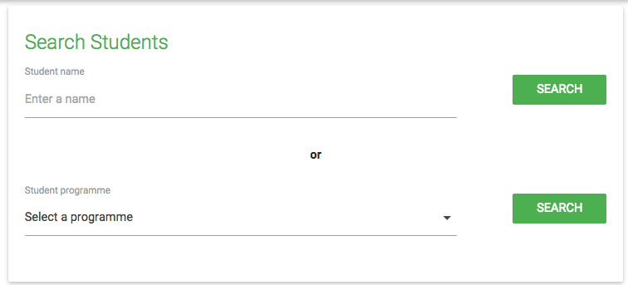**Associated images:**Staff’s Search page -

Staff Allocate page-

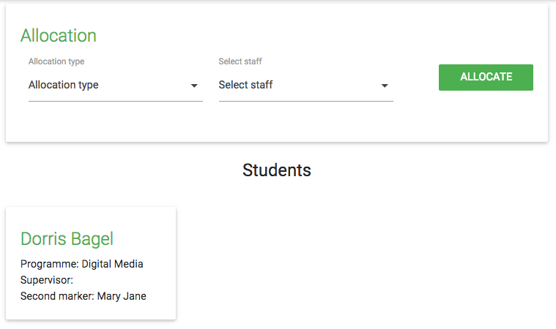

Student email-

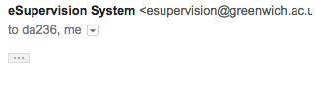

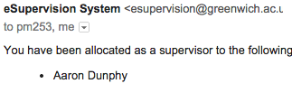Staff email-

**Steps included in test:**

**1. Staffs “search” page**

Search for a student on search.php

*Search by name*

* Leave an empty field and click “search”-is there validation?
* Enter first name of student e.g. Aaron-Do all students called Aaron display?
* Enter last name of student e.g. Dunphy-Does the student Aaron Dunphy display?
* Enter full name of student e.g. Aaron Dunphy-Does the student Aaron Dunphy display?
* Select the student- does the button change colour?- should do
* Choose the other student called Aaron- does the selection change? Or are both Aaron’s selected-check with Aaron if both students can be selected together?
* Select student
* Click “Allocate” with no student’s selected- is there validation on the search.php page or are you taken to allocate.php first THEN shown the validation?- there should really be validation on search.php
* Select student and click allocate-are you taken to allocate.php with the correct student selected?-should be

Allocate.php (2)

* Click “allocate” with nothing selected- is there validation?
* Choose a supervisor and click “allocate”-Is there validation telling you to choose staff?-should be
* Leave the “allocation type” empty and choose staff-is there validation telling you to choose an allocation type?-should be
* Choose an “allocation type” and a staff then click “allocate”- is there validation telling you that the student(s) have successfully been allocated? -should be
* Refresh the page- does the allocation get resubmitted?-(check email of both student and staff)

*Search by programme*

* Leave an empty field and click “search”-is there validation?
* Select a program and click “search”-do students for that program appear?
* Are the radio buttons consistent to the results displayed when searching by name? e.g. both should be either circle shaped OR square shaped, not both
* Select a program and click “search”
* Select the student- should the button change to a tick?- check with Aaron
* Choose another student as well- does the selection change? Or are both student’s selected-check with Aaron that both students can be selected at once
* Select student and click allocate-are you taken to allocate.php with the correct student selected?-should be
* Select multiple students and click allocate-are you taken to allocate.php with the correct students selected?-should be

Allocate.php (2)

* Click “allocate” with nothing selected- is there validation?
* Choose a supervisor and click “allocate”-Is there validation telling you to choose staff?-should be
* Leave the “allocation type” empty and choose staff-is there validation telling you to choose an allocation type?-should be
* Choose an “allocation type” and a staff then click “allocate”- is there validation telling you that the student(s) have successfully been allocated? -should be
* Refresh the page- does the allocation get resubmitted?-(check email of both student and staff)

**3. Staff ‘s email**

Alerted when changes are made

* Do staff get an email straight after an allocation has been made?
* Does the email include information on which student has been allocated/reallocated to another staff?
* Does the email include information on which student they have been assigned to?

**4. Student ‘s email and dashboard**

Alerted when allocated to supervisor/second marker

* Does the student get an email straight after an allocation has been made?
* Does the email include information on which staff they have been allocated/reallocated to?
* Does the name of the new staff update on the student dashboard?

**Things to note whilst following steps:**

* What happens after refreshing the page at various stages?
* Check for spelling mistakes

**Additional notes before testing**

* Access the page as a student (tm112) then change the URL to the staffs search.php page to see if you can access the staff’s search.php page as a student (should not be allowed to).

# US16- Test criteria

**Staff being tested:** pm253 (authorised), tm21(not authorised)

**Student’s being searched:** Mark Tickner, Andrew Tate, Aaron Dunphy, Polly Stoyanova, Brandon Tompson, Dorris Bagel, Bill Kash, Amy Louise, Louis Brown, Dwayne Student, Aaron Smith

**Page(s) being tested:** search.php (1)

**Feature(s) being tested:** only authorised staff should be able to search for a student

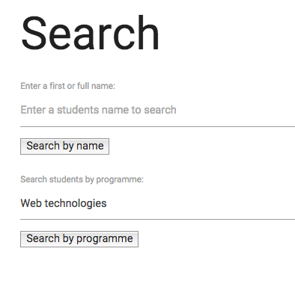**Associated images:   
  
  
  
  
  
  
  
  
  
  
  
  
Steps included in test:**

Search by **name**;

* Enter studentsfirst name -hit “search by name”
* Enter students last name-hit “search by name”
* Enter studentsfull name-hit “search by name”
* Enter part of a name (e.g. ‘aar’) -hit “search by name”
* Empty field -hit “search by name”
* Insert incorrect data -hit “search by name”

Search by **name and programme combined**;

* Enter studentsfirst name- hit “search by programme”
* Enter studentsfull name - hit “search by programme”
* Select programme 1/2/3/4/5 - hit “search by programme” hit “search by programme”
* Enter studentsfirst name + select programme 1/2/3/4/5 - hit “search by programme”
* Enter studentsfull name+ select programme 1/2/3/4/5 -hit “search by programme”
* Empty field

**Things to note whilst following steps:**

* What happens after refreshing the page at various stages?
* Does the placeholder text change after the search button is clicked?
* Check for spelling mistakes
* Is a programme selected by default? (shouldn’t be)
* When selecting a program name from the list, only students assigned to that program should appear

**Additional notes before testing**

* Access the page as a student (tm112) then change the URL to see if you can access the authorised staff’s student search function
* Login as student – check that you don’t see the search item in the menu.
* What are the expected results when filtering by both criteria – student name and programme – talk to Aaron for clarification on expected functionality.

Example:

* Search by name for Aaron
* Should see two results
* When you get the results, search for a programme name (that you know only one of the matched student results is on) – do you get only that one result for Aaron on the programme searched by or all students on the programme?

# US16- Test plan

|  |  |  |  |  |  |  |
| --- | --- | --- | --- | --- | --- | --- |
| **Test No** | **Page** | **Action** | **Expected Result** | **Actual Result** | **Date tested** | **Success / Failure** |
| 1 | index.php | Authorized staff pm253 logs in | Staff is taken to their dashboard | Same as expected | 02.03.15 | SUCCESS |
| 2 | index.php | Staff navigates to search.php page and clicks it | Search.php page opens | Same as expected | 02.03.15 | SUCCESS |
| 3 | Search.php | Staff enters student’s **last name** “dunphy” and selects the button “search by name” | Nothing happens and a message appears “no students found” since staff can only search by students first or full name | Same as expected | 02.03.15 | SUCCESS |
| 4 | Search.php | Staff enters student’s **full name** “aaron dunphy” and selects the button “search by name” | Student Aaron Dunphy appears below | Same as expected | 01.03.15 | SUCCESS |
| 5 | Search.php | Staff enters part of student’s name “aar” and selects the button “search by name” | Students whose first name is Aaron appear below | Same as expected | 01.03.15 | SUCCESS |
| 6 | Search.php | Staff leaves the student name field empty and selects the button “search by name” | An alert message appears, saying “please enter a name to search for a student” | Same as expected | 01.03.15 | SUCCESS |
| 7 | Search.php | Staff enters a name of a student which isn’t on the database e.g. Kinza and selects the button “search by name” | An alert message appears, saying “There is no student by this name” | Same as expected | 01.03.15 | SUCCESS |
| 8 | Search.php | Staff enters student’s **full name** “aaron dunphy” and selects the button “search by programme” | Nothing should happen since a program hasn’t been selected | Same as expected | 01.03.15 | SUCCESS |
| 9 | Search.php | Staff enters student’s **first name** “aaron dunphy” and selects the button “search by programme” | Nothing should happen since a program hasn’t been selected | Same as expected | 01.03.15 | SUCCESS |
| 10 | Search.php | Staff enters student’s **last name** “aaron dunphy” and selects the button “search by programme” | Nothing should happen since a program hasn’t been selected | Same as expected | 01.03.15 | SUCCESS |
| 11 | Search.php | Staff selects program “**web technologies**” (leaving student name field empty) and selects the button “search by programme” | Students assigned to **web tech** course appear | Same as expected | 01.03.15 | SUCCESS |
| 12 | Search.php | Staff selects programe “**games and multimedia**” (leaving student name field empty) and selects the button “search by programme" | Students assigned to **games and multimedia** course appear | Same as expected::::::::::Desktop:Screen Shot 2015-02-25 at 23.43.26.png | 01.03.15 | SUCCESS |
| 13 | Search.php | Staff selects programe “**Digital media**” (leaving student name field empty) and selects the button “search by programme” | Students assigned to **Digital media** course appear | Same as expected | 01.03.15 | SUCCESS |
| 14 | Search.php | Staff selects programe “**Maths**” (leaving student name field empty) and selects the button “search by programme” | Students assigned to **Maths** course appear | Same as expected | 01.03.15 | SUCCESS |
| 15 | Search.php | Staff selects programe “**Computer science**” (leaving student name field empty) and selects the button “search by programme” | Students assigned to **Computer science** course appear | Same as expected | 01.03.15 | SUCCESS |
| 16 | Search.php | Staff enters students first name, “aaron” and selects the programe “**Web tech**” and selects the button “search by programme” | The results should be based on the program chosen, since the “search by program” button was clicked. | Same as expected | 01.03.15 | SUCCESS |
| 17 | Search.php | Staff enters students first name, “aaron” and selects the programe “**games and multimedia**” and selects the button “search by programme” | The results should be based on the program chosen, since the “search by program” button was clicked. | Same as expected | 01.03.15 | SUCCESS |
| 18 | Search.php | Staff enters students last name, “dunphy” and selects the programe “**Web tech**” and selects the button “search by programme” | The results should be based on the program chosen, since the “search by program” button was clicked. | Same as expected | 01.03.15 | SUCCESS |
| 19 | Search.php | Staff enters students last name, “dunphy” and selects the programe “**games and multimedia**” and selects the button “search by programme” | The results should be based on the program chosen, since the “search by program” button was clicked. | Same as expected | 01.03.15 | SUCCESS |
| 20 | Search.php | Staff enters students full name, “aaron dunphy” and selects the programe “**Web tech**” and selects the button “search by programme” | The results should be based on the program chosen, since the “search by program” button was clicked. | Same as expected | 01.03.15 | SUCCESS |
| 21 | Search.php | Staff enters students full name, “aaron dunphy” and selects the programe “**games and multimedia**” and selects the button “search by programme” | The results should be based on the program chosen, since the “search by program” button was clicked. | Same as expected | 01.03.15 | SUCCESS |
| 22 | Search.php | Staff leaves program field empty and selects “search by program” | An alert appears saying “no students found on this program” | Same as expected | 01.03.15 | SUCCESS |
| 23 | Search.php | Copy the url, navigate to the dashboard and log out. | Login screen appears | Same as expected | 02.03.15 | SUCCESS |
| 24 | Index.php | Login in as student tm112, paste the URL copied from staff and click enter | You shouldn’t be able to view the staff page since you are logged in as student | Same as expected | 02.03.15 | SUCCESS |
| 25 | Index.php | Go back a page, to the dashboard | There should NOT be an option to search for student in the navigation bar since you are logged in as student | Same as expected | 02.03.15 | SUCCESS |
| 26 | Index.php | Log out | Log in page appears | Same as expected | 02.03.15 | SUCCESS |
| 27 | Index.php | Log in as an unauthorized staff member (tm21), paste in the url from the authorized staff page and click enter | You shouldn’t be able to view the staff page since you are logged in as an unauthorized staff member | Same as expected | 02.03.15 | SUCCESS |

# US21- Test criteria

**Staff being tested:** pm253 (authorised), tm21 (not authorised)

**Student’s being tested:** Aaron Dunphy (da236), Polly Stoyanova (sp116), Andrew Tate (ta210) , Mark Tickner (tm112), Amy Louise (la345), Dwayne student (BD118).

**Page(s) being tested:** messages.php (2)(4), index.php (1)(3)

**Feature(s) being tested:** Staff can view incoming messages from their students.

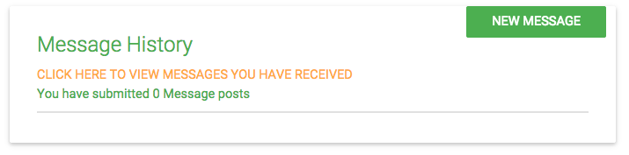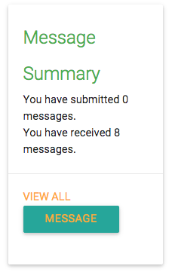**Associated images:**Student messages page -

Staff messages page-

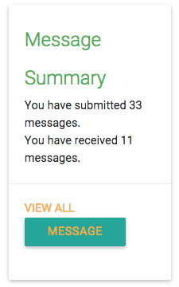

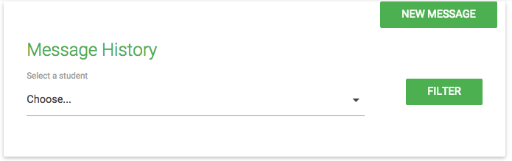

**Steps included in test:**

**1. Student “index” page-message summary**

View messages on index.php

* Select view all - should load messages.php- then go back a page
* Should see a button; ‘message’ directly to supervisor (check with Aaron)
* Click on Message button to open box and click outside of box to close box
* Enter text into new message field
* Refresh page-does the box close?-should do
* Click on message button; Enter html code with inline css formatting (change text colour, font-weight) – should display all tags and styling as text and not render it once sent to supervisor
* Leave message field blank and submit
* Ensure there is validation on the form (can’t send blank)
* Ensure you cannot inject message contents in the url (e.g. by adding communication_body=’some text’ to the url, if the text input box name is communication_body – check if it is different by inspecting the code)
* Does the number of messages submitted to supervisor update every time you send a message?-should do
* Does the number of messages received by supervisor update every time you recieve a message?-should do

**2. Student “messages” page**

Compose a new message on messages.php

* Click on the New Message button to open the form and click close icon
* Click on the New Message button to open the form
* Enter text into new message field
* Refresh page- does the form close? –Should do
* Enter html code with inline css formatting (change text colour, font-weight) – should display all tags and styling as text and not render it once sent to supervisor
* Upload a file, then click ‘choose file’ again, and click ‘cancel’- does the file get removed? –(Check with Aaron if it should do this)
* Enter text into the field and submit
* Enter text and upload a file and submit (different types and sizes – incorrect file type+correct size, incorrect file type+incorrect size, correct file type + incorrect file size, correct file type + size of 0mb, correct file type + correct size – check limits with Dwayne)-
* Upload a file and submit
* Leave both blank and submit
* Ensure there is validation on the form (can’t send blank/cant send file alone)
* Ensure you cannot inject message contents in the url (e.g. by adding communication_body=’some text’ to the url, if the text input box name is communication_body – check if it is different by inspecting the code)
* Does the number of messages submitted message posts update every time you send a message? -Should do

Compose a new message on recievedmessages.php

* Click on the New Message button to open the form and click the close icon
* Click on the New Message button to open the form
* Enter text into new message field
* Refresh page- does the form close? –Should do
* Enter html code with inline css formatting (change text colour, font-weight) – should display all tags and styling as text and not render it once sent to supervisor
* Upload a file, then click ‘choose file’ again, and click ‘cancel’- does the file get removed? –(Check with Aaron if it should do this)
* Enter text into the field and submit
* Enter text and upload a file and submit (different types and sizes – incorrect file type+correct size, incorrect file type+incorrect size, correct file type + incorrect file size, correct file type + size of 0mb, correct file type + correct size – check limits with Dwayne)
* Upload a file and submit
* Leave both blank and submit
* Ensure there is validation on the form (can’t send blank/cant send file alone)
* Refresh page while uploading – should not upload partial files
* Refresh page before clicking Send
* Ensure you cannot inject message contents in the url
* Are you able to view new messages sent to you, under ‘messages you have received’
* Does the **number** of messages received also update? -should do
* Are you able to view files sent to you by clicking ‘submit view’?

**3. Staff “index” page-message summary**

View message from student on index.php

* Select view all - what is the expected result
* Should not see button for messaging directly there-on messages.php (check with Aaron)
* Click ‘message’ on index.php- is the message meant to be directed to the supervisor?
* Click outside of the box-does the message disappear?
* Does the number of messages submitted update every time you send a message? -should do (does this include messages sent to students or supervisor or both?-check with Aaron)
* Does the number of messages received update every time you receive a message?-should do(does this include messages received by students or supervisor or both?-check with Aaron)
* Ensure there is validation on the form-cant send blank

**4. Staff “messages” page**

View message from student on messages.php

* New message- should it be there? (Check with Aaron ).
* Click on the New Message button to open the form and click the close icon
* Click on the New Message button to open the form
* Choose a student
* Refresh page-does the form reset or take you back to message history?
* Click on “New message”, don’t choose a student, enter a message, choose a file click send
* Click on “New message”, don’t choose a student, don’t enter a message, choose a file click send
* Click on “New message”, choose a student, enter a message, choose a file click send
* Click on “New message”, don’t choose a student, enter a message, don’t choose a file click send
* Leave all fields empty and click send
* Enter html code with inline css formatting
* Enter text and upload a file (different types and sizes – incorrect file type+correct size, incorrect file type+incorrect size, correct file type + incorrect file size, correct file type + size of 0mb, correct file type + correct size – check limits with Dwayne)
* Refresh page while uploading – should not upload partial files
* Refresh page before clicking Send
* Leave all fields blank and send
* Ensure there is validation on the form (can’t send blank)
* ensure you cannot inject message contents in the url

View message history

* Choose a student and filter
* Don’t choose a student and filter

**Things to note whilst following steps:**

* What happens after refreshing the page at various stages?
* Does the number of messages staff has received on index.php update when a student messages them? (Should do)
* Does the number of messages staff has received on index.php reflect the correct number of messages (check with db)
* Does the number of messages student has received on index.php update when staff (supervisor and second marker) messages them? (Should do)
* Does the number of messages student has received on index.php reflect the correct number of messages (check with db)
* When staff selects a student to view their message history, do all the messages for that student show or do messages from other students show too (should only filter messages from the student who is selected)
* When viewing messages are they listed in a descending order (latest first)
* Check for spelling mistakes
* is the sender identified (user_id)
* is message body visible
* is date visible
* are all buttons functioning
* are messages informative and non-confusing
* can uploaded files be downloaded
* can downloaded files be opened
* is the layout consistent
* [staff] what happens when you have opened the New Message form before you filter View Messages by student
* [staff] what happens after you select a student in View Messages and change the student in the New Message form, does anything not work as expected
* [staff] what happens when you already have selection in both and click the button in one
* [staff] if having selected a student in View Messages and entering a New Message for a different student, who gets the message after submitting?

**Additional notes before testing**

* Access the page as a student (tm112) then change the URL to the staffs message history page to see if you can access the staff’s message history function as a student (should not be allowed to).