**PC Wireframe for student dashboard**

The design will scale down accordingly when viewed on a Mobile & Tablet

**\*NOTE: RED UNDERLINED TEXT IN WIREFRAME SIGNIFIES A LINK\***

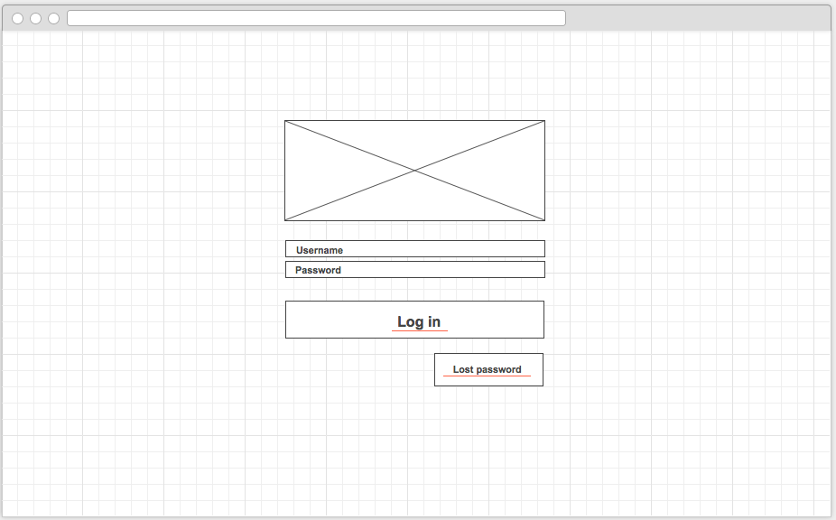**Log in**

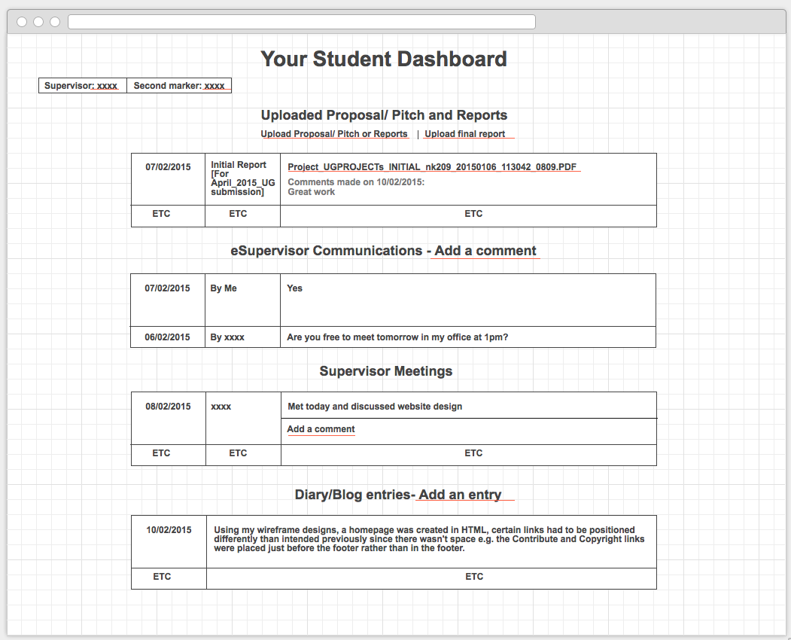**Student home**   
  
  
  
  
  
  
  
  
  
  
  
  
  
  
  
  
  
  
  
  
  
  
  
  
  
  
  
  
  
  
  
Canvas: 1034/799px**Supervisor profile**   
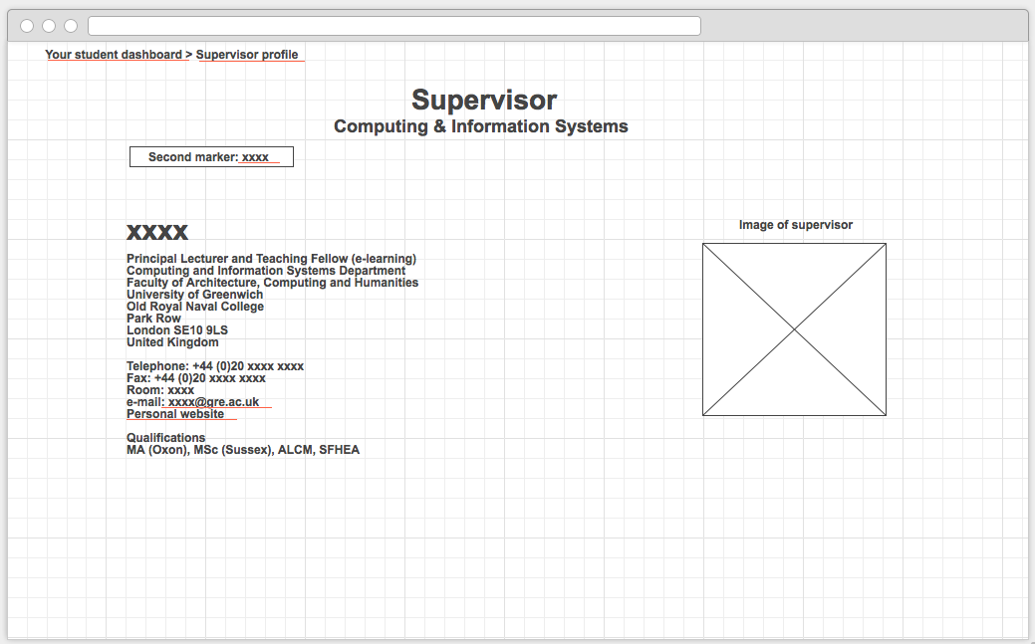  
  
  
  
  
  
  
  
  
  
  
  
  
  
  
  
  
  
  
  
Canvas: 1024/600px  
  
  
  
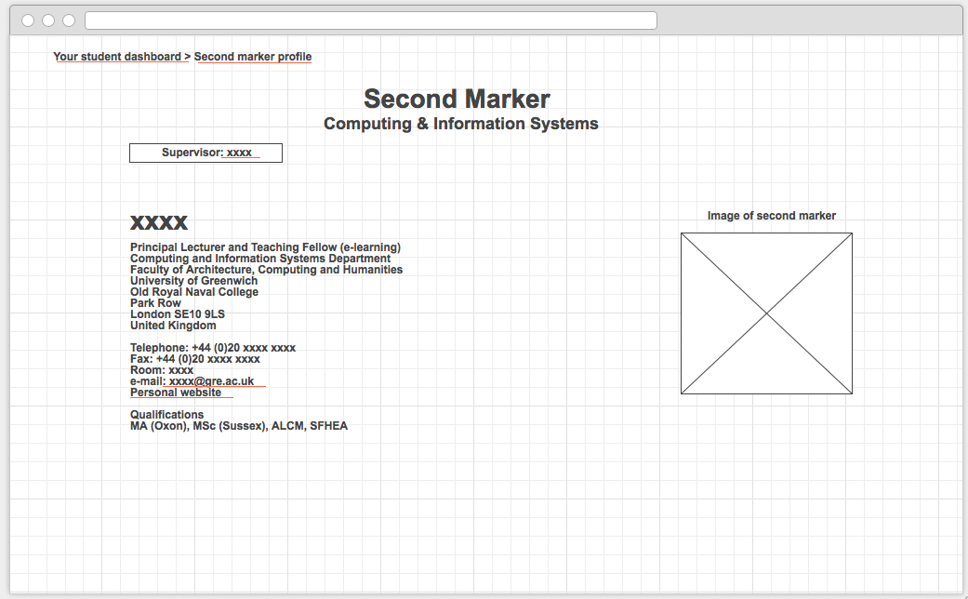**Second marker profile   
  
  
  
  
  
  
  
  
  
  
  
  
  
  
  
  
  
  
  
  
  
Canvas: 1024/600pxUpload documents**   
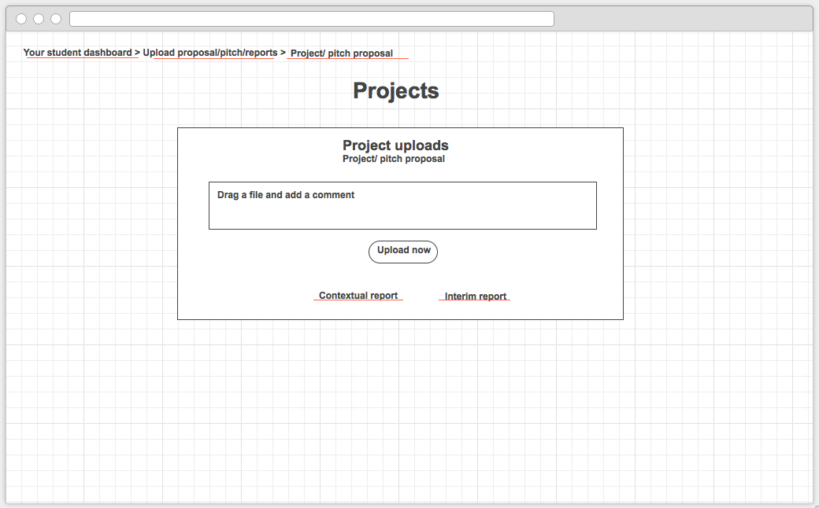  
  
  
  
  
  
  
  
  
  
  
  
  
  
  
  
  
  
  
  
  
Canvas: 1024/600px  
  
  
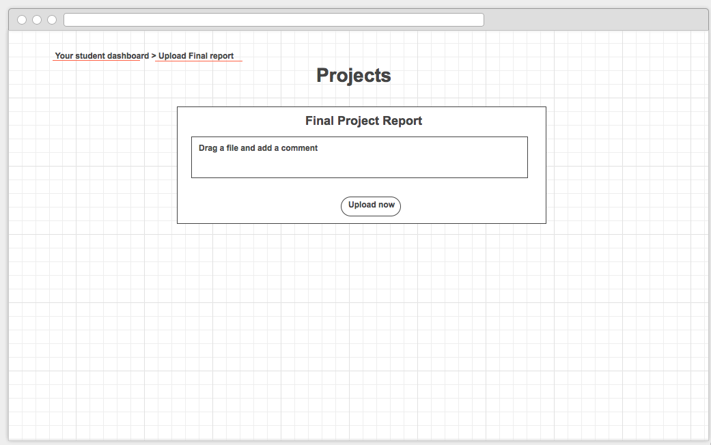  
  
  
  
  
  
  
  
  
  
  
  
  
  
  
  
  
  
  
  
  
Canvas: 1024/600px**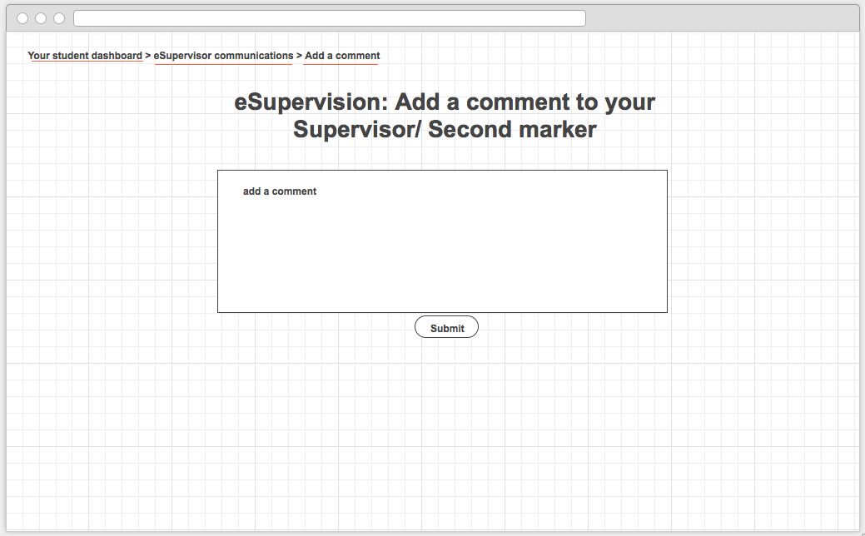E-supervisor communications**Canvas: 1024/600px



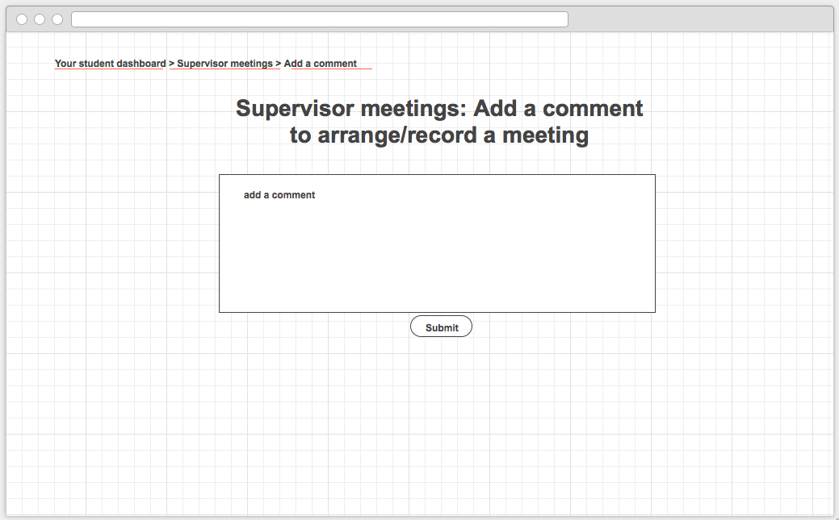**Supervisor meetings**

Canvas: 1024/600px

Diary/ blog

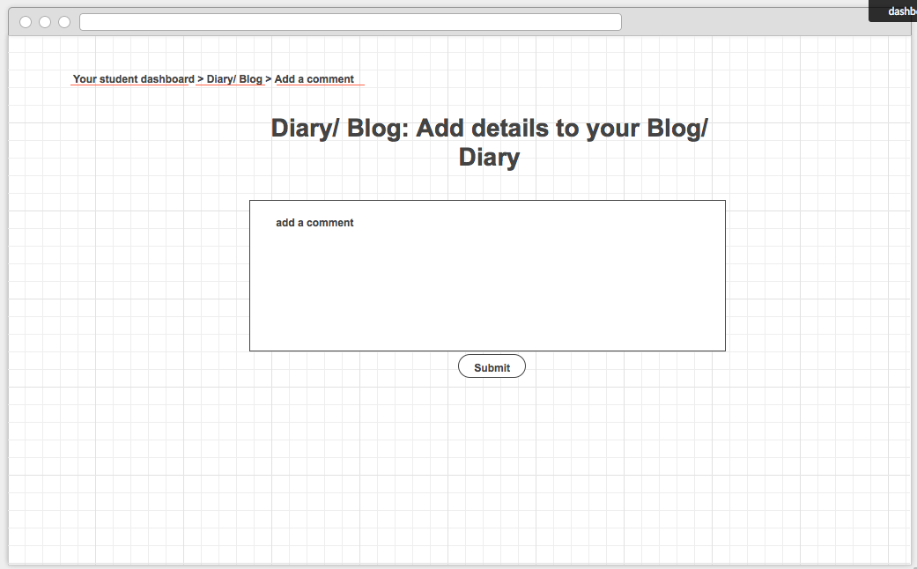

Canvas: 1024/600px