## Meeting Minutes - 21.01.15

## COMP1640 Enterprise Web Software Development

Members present:

Polina Stoyanova

Aaron Dunphy

Dwayne Brown

Laura Whitehead

Andrew Tate

Sumangalya Mohanarasa

Kinza Naseer

Members not present: Mark Tickner (assessment centre, job interview)

Agenda:

1. **Team agreements**
   1. notify in advance for absence
   2. aim to be present at all meetings
   3. use software management tool, proposed by SCRUM master
   4. post regular updates to the live feed to notify team members of progress
2. **Communication means**
   1. WhatsApp group
   2. SoftwareManagement tool - live feed and messaging
   3. receive agenda via email
3. **Roles assignment and discussion of responsibilities**
   * **Polly** - SCRUM master, User Experience
   * **Aaron** - Product Owner, User Experience
   * **Mark** - Database Administrator, Programmer (Back-end)
   * **Dwayne** - Database Administrator, Programmer (Back-end)
   * **Sumy** - Front-end developer
   * **Laura** - Front-end developer, tester
   * **Kinza**- Web designer
   * **Andrew** - Web Designer, Senior QA Manager
4. Group name selection (brainstorming)

* PeriPeri - 0 votes
* Jumper - 0 votes
* Tuna - 0 votes
* BlueFish - 0 votes
* Team - 0 votes
* E-Group - 1 votes
* E-Code - 1 votes
* Flag - 1 votes
* LightCode - 3 votes
* NLAP - 4 votes
* RaiserLeaf - 0 votes
* VineWhip - 0 votes
* E-Snorlax - 1 votes
* DietCode - 2 votes
* CodeZero – 7 votes

Team name selected: CodeZero

1. Meetings schedule

* Meetings every Tuesday from 14:00 - 15:30, SCRUM master to book a room in Stockwell Street library
* Agenda sent before meeting by SCRUM master via email
* Minutes uploaded soon after meeting by SCRUM master to software management tool
* One-week sprints
* Meetings format:
  + 15 minute stand-up (team members provide daily/weekly updates on individual progress)
  + planning (pulling tasks off the product backlog to include in the sprint) - 30min
  + retrospective - 15 min
  + show and tell (features implemented last sprint) - 30min
  + any other business

## 

## Meeting Minutes - 26.01.15

## COMP1640 Enterprise Web Software Development

Date: Tuesday 26.01.15

Location: Stockwell Streel Library, Floor 1, Group Study 10_1004

Members present:

Polina Stoyanova

Aaron Dunphy

Dwayne Brown

Laura Whitehead

Andrew Tate

Sumangalya Mohanarasa

Kinza Naseer

Mark Tickner

Agenda:

1. **Software Management Collaboration Tool (10mins)**
   1. Trello, comparison of VersionOne and Rally, short demos
   2. Team is to use Rally Dev
2. **SCRUM terminology and best practices (10mins)**
3. **View Prezi presentation on SCRUM -** <http://prezi.com/jc8ye072khry/?utm_campaign=share&utm_medium=copy&rc=ex0share>
   1. [**Sprint 0**](http://www.scrum-breakfast.com/2011/04/how-we-do-sprint-zero.html)
      1. **Identification of roles**
      2. Product backlog
      3. Estimation and prioritisation of product backlog
      4. Train Product Owner and Team on Scrum
      5. Define the sprint length
      6. Define the initial Definition of Done
         1. Implementation is reviewed
         2. Feature is fully tested
         3. Feature is clean of bugs and passes test cases
         4. All story tasks are completed as per story requirements
   2. Explanation of User Stories
   3. Epic, Story, Tasks structure
   4. T-shirt vs Card scoring models, and explanation of backlog grooming
4. **Discussion of requirements (70min)**
   1. Backlog brainstorming, product backlog documentation
   2. Writing up User Stories
5. **Sprint planning (5min)**
   1. TO DO this SPRINT:

Team divides in two sub-teams to discuss and plan

* + 1. interactions (Aaron, Mark, Dwayne, Polly)
    2. interface (Andrew, Sumy, Kinza, Laura)
  1. Produce a wireframe prototype, storyboards

1. **Team logo** (Team name selected: CodeZero) (5min)
   1. submit logo designs by Thursday midday
   2. Vote Thursday evening on Google Hangouts

* SCRUM master upload - Product Backlog and high-level documentation

To do:

* 1. Review of UML design (Kinza shared in WhatsApp)
  2. Complete Product Backlog, PO to prioritise stories
  3. Create QA test plan based on Requirements backlog

## Meeting Minutes - 03.02.15

## COMP1640 Enterprise Web Software Development

Date: Tuesday 03.02.15

Time: 14.00pm

Location: Stockwell Streel Library, Floor 1, Group Study 10_1006

Members present:

Polina Stoyanova

Aaron Dunphy

Dwayne Brown

Laura Whitehead

Andrew Tate

Sumangalya Mohanarasa

Mark Tickner

Members not present:

## Kinza Naseer

Agenda:

1. **SCRUM practices**
   1. Defining Nirvana
   2. Role-expectations matrix
   3. Backlog grooming
   4. T-shirt vs Card scoring models, and explanation of backlog grooming

**Next team meeting:**

Date: Thursday 05.02.15

Time: 10.00am

Location: Stockwell Streel Library, Floor 1, Group Study 10_2007

* 1. Team backlog management
  2. Ground rules

1. **Selection of stories for this weeks' sprint and sprint goals**
   1. Review of UML design
   2. Discussion and changes of product initial wireframe prototype and storyboards
   3. Create QA test plan based on Requirements backlog
   4. Complete Database design
   5. UX and Usability plan evaluating prototype
   6. Front-end design feature spikes (experiments and research)
   7. **Team logo**
2. **Stand-up Meeting**
3. **Retrospective meeting**
4. **Any other business**
   * TEAM upload - Wireframes and product prototype

## Meeting Agenda - 10.02.15

## COMP1640 Enterprise Web Software Development

Time: 14.00-16.00

Date: Tuesday 10.02.15

Location: Stockwell Streel Library, Floor 2, Group Study 10_2007

Members present:

Polina Stoyanova

Aaron Dunphy

Dwayne Brown

Laura Whitehead

Andrew Tate

Sumangalya Mohanarasa

Kinza Naseer

Mark Tickner

Members not present:

Agenda:

1. **Standup meeting (10min)**
2. **Retrospective (50min)**
   1. Improving team ethics
   2. Working agreements
3. **Code Standards (10min)**
   1. Front-end framework
   2. Code quality
   3. Code documentation
4. **Sprint planning (50min)**
   1. User Stories
   2. Finalise prototype
   3. Create a complete and comprehensive QA test plan based on Requirements backlog
   4. Demos:

**Polly** – product to date

**Dwayne** – functionality to date

**Laura** – design principles research, conclusions and wireframes

**Sumy** – research into staff dashboard and wireframes

**Andrew** – how to write a comprehensive test plan

* SCRUM master upload- Database design

## Meeting Agenda - 17.02.15

## COMP1640 Enterprise Web Software Development

Time: 14.00-16.00

Date: Tuesday 17.02.15

Location: Stockwell Streel Library, Floor 2, Group Study 10_2007

Members present:

Polina Stoyanova

Aaron Dunphy

Dwayne Brown

Andrew Tate

Sumangalya Mohanarasa

Kinza Naseer

Mark Tickner

Members not present:

Agenda:

1. **Standup meeting (15mins)**
2. **Retrospective (45mins)**
   1. Team exercise
   2. Improving team ethics - ground rules, processes, communication
   3. Revise working agreements

Send the whole team TWO DAILY UPDATES via email

- one **before 10am** to say what have are you working on that day, is there anything you depend on being done by someone else, is there anything blocking you from work

- one **before 10pm** on the same day - say what have you done that day, is there anything blocking you

To be send every day including weekends at any time before the stated above

Deadline times are non-negotiable, not providing an update means nothing has been done.

Assign yourself to a task you intend to start and finish

* Provide hand-overs on tasks you stop working on and remove your name from the task to make it available for other members
* Update tasks on RallyDev as you go along - **twice a day**
* Pick up any task, but only assign yourself to ones you are currently working on to enable other members to pick up tasks you may have planned on doing ensuring meeting sprint deadlines

Ask for help with tasks if you have done your best and are still strugling

* phone calls rather than chat messages for one to one quick and effective communication
* email whole team instead of spamming group chat for big messages
* pair-programming if you work better

Every team member actively contributes to the Sprint with high quality work

* a task is considered done if it brings value to the product and the team
* a task is considered done if it is of good quality
* check for spelling/grammar errors before sending for review

1. **Code Standards spreadsheet voting (5mins)**
2. **Sprint planning (30mins)**
   1. Review of Sprint progress
   2. User Stories for this Sprint - everyone should know the requirements and ask Aaron (PO) to clarify if needed:
      1. [US18](https://rally1.rallydev.com/#/29329895900u/detail/userstory/29330749275)**:** STUDENT CAN SUBMIT A MESSAGE TO SUPERVISOR (carried over from Sprint1)
      2. [US20](https://rally1.rallydev.com/#/29329895900u/detail/userstory/29330861907)**:** Student can view personal dashboard
      3. [US13](https://rally1.rallydev.com/#/29329895900u/detail/userstory/29330633205)**:** Users can access information about staff members
      4. [US19](https://rally1.rallydev.com/#/29329895900u/detail/userstory/29330859368)**:** Supervisors can message students
   3. Review comprehensive QA test plan based on Requirements backlog (whole release, starting with current stories)
3. **Demos:**

**Mark** – product to date

**Dwayne** – communication functionality

Sumy is under review due to lack of contribution in the last Sprint.

1. **Closing the meeting**

* team upload this week – Comprehensive QA test plan for the release
* individual upload this week – interim report

## Meeting Minutes - 24.02.15

## COMP1640 Enterprise Web Software Development

Time: 14.00-16.00

Date: Tuesday 24.02.15

Location: Stockwell Streel Library, Floor 1, Group Study 10_1004

Members present:

Polina Stoyanova

Aaron Dunphy

Dwayne Brown

Andrew Tate

Kinza Naseer

Mark Tickner

Members not present:

Sumangalya Mohanarasa

Agenda:

1. **Demos: (15mins) - Andrew and Kinza presented the product to date**
2. **Standup meeting (15mins)**
3. **Sprint review (15mins) - completed 100% of sprint committment**

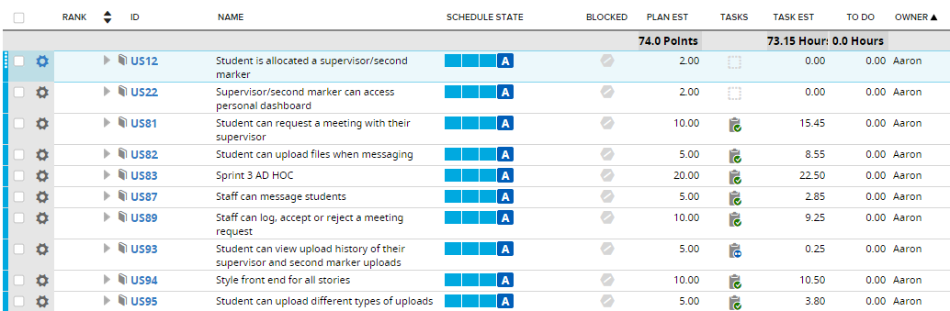

**Iteration Cumulative Flow**

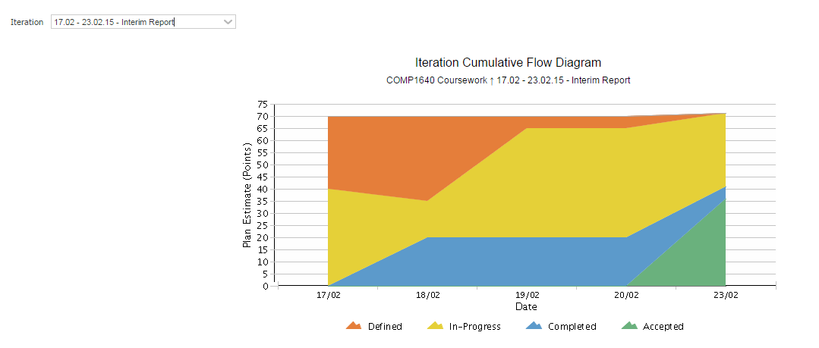

**Release Cumulative Flow**

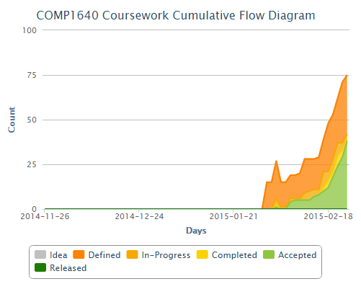

1. **Sprint planning (30mins)**
   1. User Stories for this Sprint
   2. User Stories in Backlog
   3. Overview of features to be implemented this Sprint (Aaron)
2. **Retrospective (45mins)**
   1. Team exercise - Happiness Radar
   2. Gathering Insights
   3. Generating improved agreements

The team is feeling content with the three aspects listed:

* people (collaboration in the team)
* technology (implementation practices, software, technologies - HTML5, PHP, MySQL, MaterializeCSS)
* processes (RallyDev, work methodologies, Agile)

However, there were themes that require improvement of the way we work together in order to stay on the positive side of the Happiness Radar.

As a result of the exercise the following working agreements were highlighted:

**Follow a process workflow and notify relevant members directly of a change waiting for their attention/actions**

1. When a feature is completed create a pull request for that branch on GitHub and assign to Polly (sp116)
2. Send a message to Polly to notify of the pull request.
3. Polly reviews the code and merges to master (after any conflicts between the branches are resolved).
4. Polly notifies Mark so he can add the files from master branch onto the server.
5. Mark adds the updated files onto the server and changes the date on the team site login page to reflect the last update of the site to use as a verification in testing. Mark notifies the team of this update.
6. Kinza and Andrew can start testing the features on the team server. Notify the team in the daily update email of a list of all bugs found during testing.

**If working on something that would affect others, or is related to their tasks, give a heads up in advance.**

**Merge completed features early to keep up to date with master branch and prevent large merge conflicts.**

**Keep RallyDev up to date and make use of its helpful features.**

We have identified that teamwork has improved, but there could be justifications in communication so we can make it more effective. Helping each other and not being afraid to contribute with more than expected ensures we can achieve an excellent product and learn a lot on the way

The team is happy about our choice and use of technology - PHP and the materializeCSS streamline our collaboration.

Everyone is happy with RallyDev and GitHub and we have managed to resolve issues with their use in the process.

1. **Closing the meeting**

CodeZero Working Agreements

Send the whole team a daily update via email

* What I did today and what I'll do tomorrow - by 11pm every day
* Mention any tasks you depend on or things that are blocking you and who might be able to help.
* If working on something that would affect others, or is related to their tasks, give a heads up in advance.
* Follow a process workflow and notify relevant members directly of a change waiting for their attention/actions

Assign yourself to a task you intend to start and finish

* Provide hand-overs on tasks you stop working on and remove your name from the task to make it available for other members
* Update tasks on RallyDev as you go along
* Pick up any task, but only assign yourself to ones you are currently working on
* Notify everyone when blocked
* Commit working features early for review and testing

Ask for help with tasks if you have done your best and are still strugling

* phone calls rather than chat messages for quick and effective communication
* email whole team instead of spamming group chat for big messages
* pair-programming if you work better
* SCRUM Master is available to help and coach with processes and issues
* Product Owner is available to explain vision of the product, features and requirements

Every team member actively contributes to the Sprint with high quality work

* a task is considered done if it brings value to the product and the team
* a task is considered done if it is of good quality
* check for spelling/grammar errors before sending for review

## Meeting Minutes - 03.03.15

## COMP1640 Enterprise Web Software Development

Time: 14.00-16.00

Date: Tuesday 03.03.15

Location: Stockwell Streel Library, no room could be booked

Members present:

Polina Stoyanova

Aaron Dunphy

Dwayne Brown

Andrew Tate

Kinza Naseer

Mark Tickner

Members not present:

Sumangalya Mohanarasa (on Hangouts)

Agenda:

1. **Icebreaker**
2. **Standup meeting (15mins)**
3. **Sprint review (15mins)**
4. **Sprint planning (30mins)**
   1. Review of Sprint progress
   2. User Stories for this Sprint
5. **Retrospective (45mins)**
   1. Team exercise
   2. Generating insights from the exercise

# Success criteria:

All user stories are complete

All bugs are fixed

Design looks good and consistent

All functionality is implemented, fully working complete and consistent product

All members acquired new skills

First class

Everybody knows their contribution is valued

Proud of what we have created

High quality product

Built and accepted early

Learn something new

Good understanding of Agile

Improved programming skills

New approach to tasks

Bonding as a team

Having a process in place to ensure things get done

Trust the team but be proactive

Get everything done to high quality

# Intentions:

Produce a product which satisfies the spec, that everyone can be proud of!

Present a well developed and tested product, which is implemented to high standards

Explain and demonstrate what have we learnt as part of the Agile process.

1. **Closing the meeting**

# Meeting Minutes - 10.03.15

# COMP1640 Enterprise Web Software Development

Time: 14.00-16.00

Date: Tuesday 10.03.15

Location: Stockwell Streel Library, Floor 1, Group Study 10_1006

Members present:

Polina Stoyanova

Aaron Dunphy

Dwayne Brown

Andrew Tate

Kinza Naseer

Mark Tickner

Members not present:

Sumangalya Mohanarasa

Agenda:

1. **Standup meeting**
2. **Release review**
3. **Sprint planning** 
   1. Review of Sprint progress

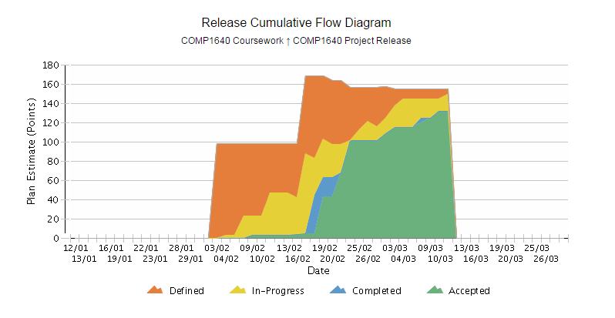

* 1. Tasks to be completed from last sprint
  2. Finishing all stories

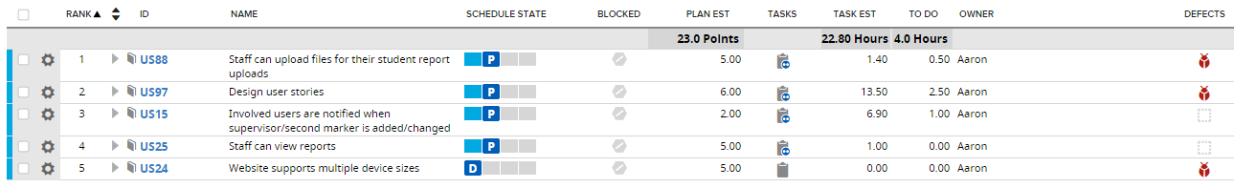

* 1. Main focus is overall testing and active bug logging for:
     1. (Desktop) Mozilla (prone to issues with HTML5 compatibility, especially on input fields that are not of type text)
     2. (Desktop) Chrome
     3. Tablet
     4. Mobile
  2. Bug fixing ( All major issues should be resolved in the weekend) and UI should be consistent

1. **Demo (Aaron)**
2. **Presentation planning**
   1. Aaron to send out outline of the presentation
   2. Everyone must contribute during the presentation
   3. USP of team
   4. USP of Product
   5. Meeting at 10.00am on Thursday 12th March to prepare for presentation
3. **Closing the meeting**

CodeZero Working Agreements

Send the whole team a daily update via email

* What I did today and what I'll do tomorrow
* Mention any tasks you depend on or things that are blocking you and who might be able to help.
* If working on something that would affect others, or is related to their tasks, give a heads up in advance.
* Follow a process workflow and notify relevant members directly of a change waiting for their attention/actions

Assign yourself to a task you intend to start and finish

* Provide hand-overs on tasks you stop working on and remove your name from the task to make it available for other members
* Update tasks on RallyDev as you go along
* Pick up any available task, but only assign yourself to ones you are currently working on
* Notify everyone when blocked
* Commit working features early for review and testing

Ask for help with tasks if you have done your best and are still strugling

* phone calls rather than chat messages for quick and effective communication
* email whole team instead of spamming group chat for big messages
* pair-programming if you work better
* SCRUM Master is available to help and coach with processes and issues
* Product Owner is available to explain vision of the product, features and requirements

Every team member actively contributes to the Sprint with high quality work

* a task is considered done if it brings value to the product and the team
* a task is considered done if it is of good quality
* check for spelling/grammar errors before sending for review

## Meeting Minutes - 17.03.15

## COMP1640 Enterprise Web Software Development

Time: 11.00-13.00 and 14.00-16.00

Date: Tuesday 17.03.15

Location: Stockwell Streel Library, Floor 1, Group Study 10_1006

Members present:

Polina Stoyanova

Aaron Dunphy

Dwayne Brown

Andrew Tate

Sumangalya Mohanarasa

Kinza Naseer

Mark Tickner

Members not present:

Agenda:

1. **Product review (15mins)**
2. **Presentation practice**
3. **Closing the meeting**