**Staff and Admin wireframe functionality**

Table of Contents

Criteria followed 3

Staff 3

Admin 3

Staff 3

Dashboard 4

Project students 5

Example student 6

ADMIN 7

Home 7

Notes-additional comments? 8

# Criteria followed

## Staff

* Staff can add a message
* Staff can view all messages from a student
* Staff can upload a file for meeting recording
* Staff can record and specify type of meeting
* Staff should be able to comment on a students blog entry
* Staff can upload a document of feedback for a student
* Staff can comment on student uploads

**\*These points are highlighted green below to show they have been implemented in the design\***  
  
  
Admin

* Admin is able to look up users
* Admin can allocate/re allocate supervisor and second marker to each student
* Admin can view all dashboards
* Admin can select multiple records at once

**\*These points are highlighted blue below to show they have been implemented in the design\***

**\*All red underlined text within designs indicates a link\***Staff

## Dashboard

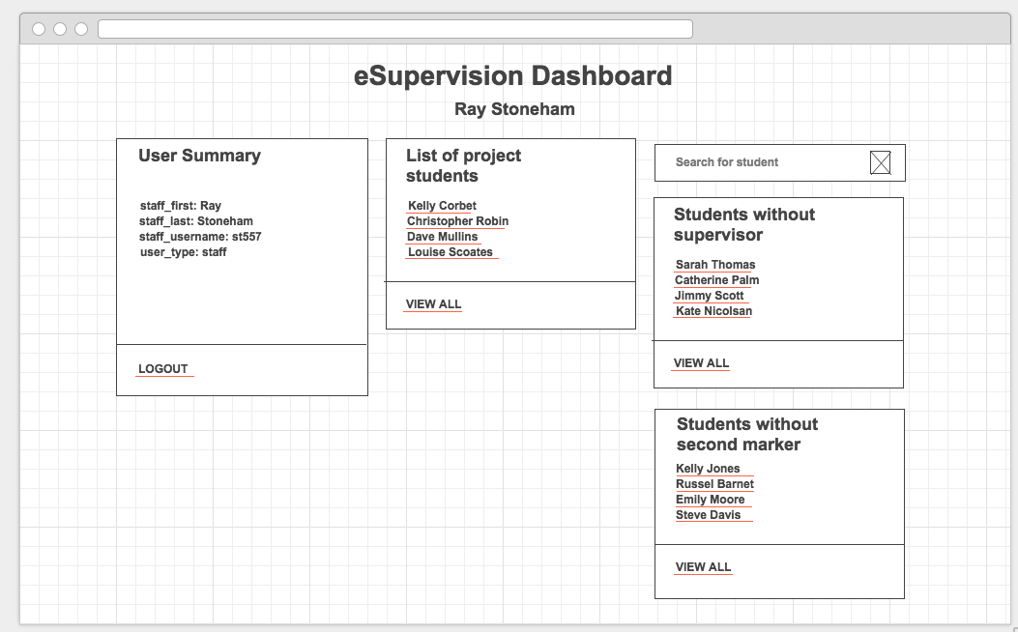  
  
  
  
  
  
  
  
  
  
  
  
  
  
  
  
  
  
  
  
  
  
  
  
  
  
1. Staff can view a list of their project students. Clicking on “View All” will bring up a full list of project students assigned to the staff member (see Figure 2).

Figure

2. Staff can view an exception report on students without a **supervisor** – this will be displayed in a new window as a document.

3. Staff can view an exception report on students without a **second marker**- this will be displayed in a new window as a document.

4. Clicking on the individual project student’s name will display their student dashboard between them and their assigned staff. (See Figure 3)

## Project students

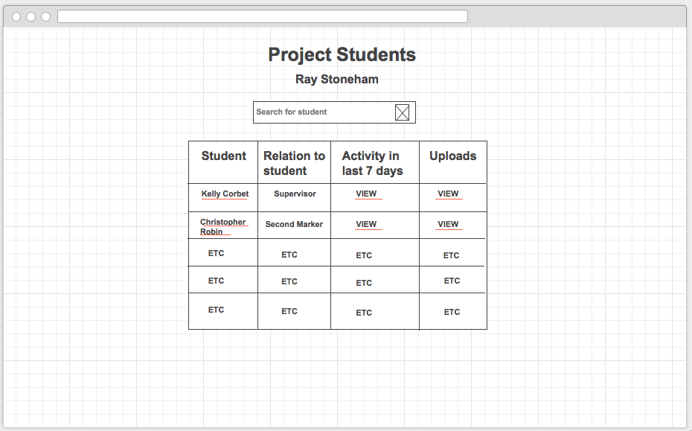

Figure

1. Staff member has the ability to search for a student by typing in their name.

2. A search icon will be included here.

3. Staff are able to view the student’s interaction within the last 7 days by clicking on “view”. This brings up the page in Figure 3. If the student hasn’t had any meetings, wrote any blogs, uploaded any work or hasn’t messaged their supervisor/second marker in the last 7 days, then this will mean there has been no interaction in the last week.

4. Staff are able to view if a student hasn’t uploaded a document on time by clicking on “view” under “uploads. This will also bring up the page in Figure 3, the staff member can then check if there is any upload history and if it was uploaded on time.

5. The “relation to student” column shows whether the staff member is assigned to their student as a supervisor or second marker.

6. Clicking on the students name will bring up their dashboard (see Figure 3).Example student-Kelly Corbet

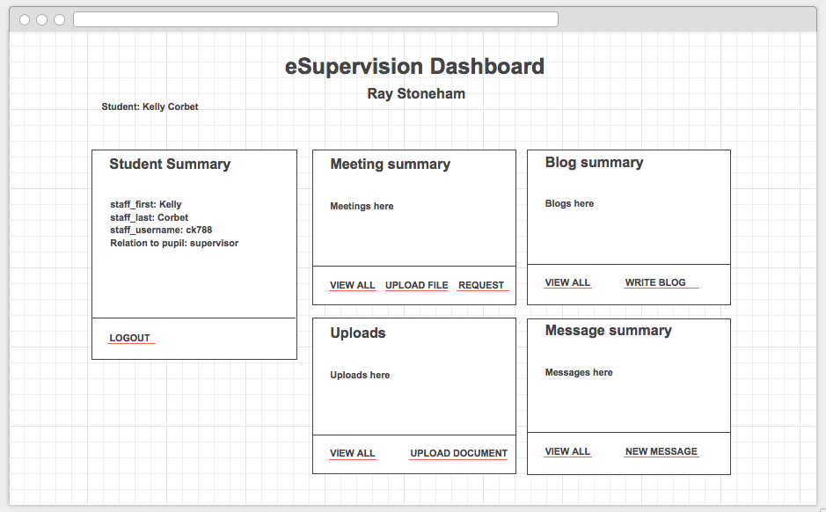This is how the staff (e.g. Ray) will be able to view the students information  
  
  
  
  
  
  
  
  
  
  
  
  
  
  
  
  
  
  
  
  
  
  
  
  
1. When the staff member clicks on their project student, from the “Project students” page (see Figure 2), their name appears here in the top left.

Figure

2. The student summary includes further detail on the student such as; student username and the relation the staff has to the student e.g. supervisor.

3. Staff can view here if their project student has uploaded their work on time since the list of uploads will also show a date for when the document was uploaded. Staff can also upload a document by clicking “upload document” containing feedback for the student, this is also another way to comment on the student’s work.

4. Staff can view all messages from a student and add a message to the student by clicking “new message”.

5. Staff can upload a file for meeting recording, a modal light box will appear to enable staff to choose a file to upload.

6. Staff can record and specify type the of meeting by clicking on “request”, in which case another page will appear where they can choose a date, specify a meeting reason, select a time and meeting type (see **prototype for student meeting page** –in GitHub- since the page will be almost identical to that).

7. Staff can comment on the student blog entry by clicking “write blog”.

**\*NOTE*: IF IN THE LAST 7 DAYS THERE IS NO ACTIVITY FOR BOOKING A MEETING, BLOGGING, UPLOADS OR MESSAGING BY THE STUDENT, THIS MEANS THE STUDENT HASN’T LOGGED IN FOR 7 DAYS.**

Admin

## Home

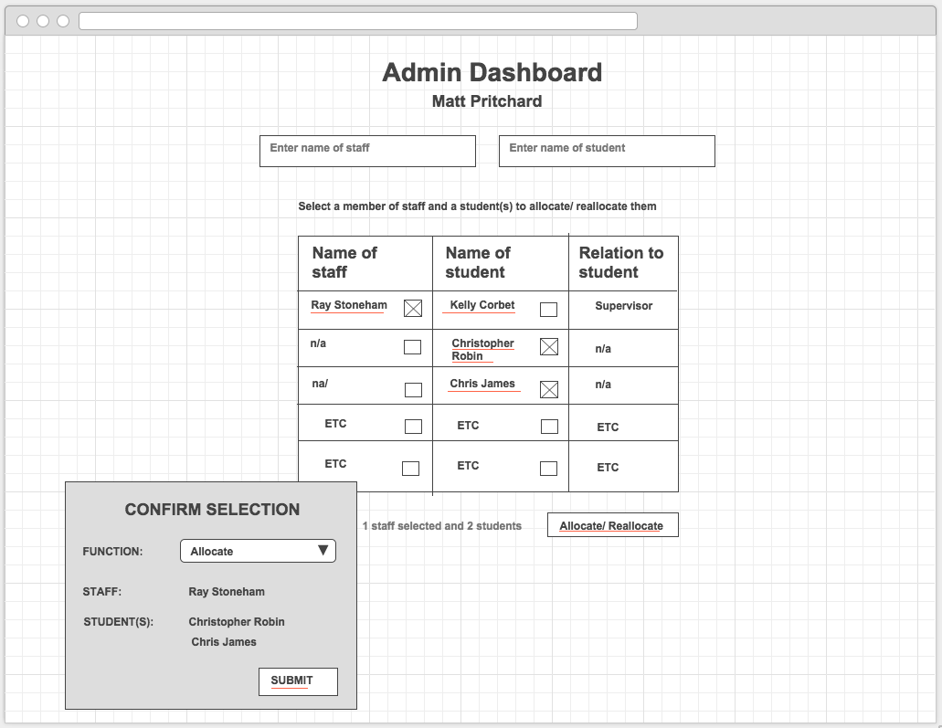

Figure

1. Admin is able to look up users by typing in the staff name. This will filter the table below to then only show students assigned to the staff being searched.

Figure

2. A check box is included beside each user to enable admin to select multiple records at once when allocating/reallocating students to staff.

3. A column showing the relation between the student and staff is also displayed to identify the staff as a supervisor or second marker to the student and to see if a student is unassigned i.e. without a supervisor/second marker.

4. Clicking on the name of the student or staff will display their dashboards.

5. Admin can allocate/re allocate supervisor and second markers to each student by clicking “Allocate/Reallocate”. To the left of this button it will display the selection i.e. 1 staff selected and 2 students”

6. Once the “Allocate/ Reallocate” button is clicked, a confirmation modal light box will appear to confirm selection. Once submitted changes will appear in the table.

# Notes-additional comments?