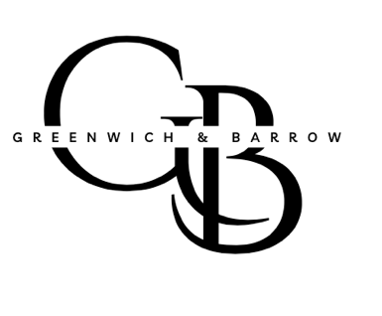

Acquisition Criteria & Search Mandate

1. What We Are Doing
Greenwich & Barrow is acquiring one exceptional, privately owned business where the owner is seeking a thoughtful transition and long-term steward. This is a traditional search fund acquisition, not a roll-up or minority investment strategy.

2. Transaction Profile
• Business Type: B2B or B2B2C only
• EBITDA: $2–5M (flexible slightly above for exceptional quality)
• Revenue: $10–50M
• Ownership: Founder-owned or closely held
• Structure: Majority or full acquisition
• Geography: United States (NY / Northeast preferred but not required)

3. Owner Profile
We are particularly interested in businesses where:
• Owner is actively involved today
• Owner is thinking about succession (1–5 year horizon)
• Owner values legacy, continuity, and employee stability
• No requirement that the owner fully exits on Day 1

4. Business Characteristics We Like
• Predictable or repeat revenue
• Mission-critical products or services
• Diversified customer base
• Strong unit economics
• Opportunity for professionalization, systems, or light tech enablement
• Asset-light preferred

5. Industries of Interest (Current Focus)
We are industry-selective, not industry-exclusive. Current focus areas include:
Primary Focus
• Software / Tech-Enabled Services (vertical SaaS, workflow tools)
• Business Services (compliance, infrastructure, outsourced functions)
• Healthcare Services (non-physician, non-provider owned)

Secondary / Opportunistic
• Specialty services supporting HNW individuals or enterprises
• Insurance-adjacent or risk-management services
• Other “boring but essential” service businesses

6. Explicit Exclusions (Please Do Not Send)
• VC-backed or PE-backed companies
• Public companies or subsidiaries
• Franchises
• Consumer retail / DTC
• Restaurants, hospitality, nightlife
• Construction or labor-heavy field services
• Capital-intensive manufacturing
• Real estate-dependent operating companies

7. How to Engage Us
• We welcome direct introductions to owners
• Intermediaries may send opportunities directly
• Confidentiality respected at all stages
• We move decisively when a business fits our mandate

8. About the Principal

Kay Schneider will serve as full-time CEO post-acquisition, backed by experienced investors and operators. This is a single-deal, long-term ownership strategy.

