UDAGRA



Thesis/Dissertation submitted in the partial fulfillment of the requirements for the award of the degree of

BACHELOR OF TECHNOLOGY
in
COMPUTER SCIENCE & ENGINEERING

by
GREESHMA REDDY
17K91A05C2
AKHIL REDDY
17K91A05D2
PRANEETH REDDY
17K91A05E0
RAKESH
18K95A0517

Under the guidance of
L.GNANENDER REDDY
<Designation Capitalize each word only >

DEPARTMENTMENT OF COMPUTER SCIENCE & ENGINEERING
TKR COLLEGE OF ENGINEERING & TECHOLOGY
(AUTONOMOUS)
(Accredited by NBA and NAAC with ‘A’ Grade)
Medbowli, Meerpet, Saroornagar, Hyderabad-500097

DECLARATION BY THE CANDIDATE

I, Ms. GREESHMA REDDY bearing Hall Ticket Number: 17K91A05C2, hereby declare that the mini project report titled UDAGRA under the guidance of Mr.L.GNANENDER REDDY, <Designation Capitalize each word only > in Department of Computer Science & Engineering is submitted in partial fulfillment of the requirements for the award of the degree of Bachelor of Technology in Computer Science & Engineering.

L.GREESHMA REDDY (17K91A05C2)
AKHIL REDDY (17K91A05D2)
PRANEETH REDDY (17K91A05E0)
RAKESH (18K95A0517).

Certificate by Company/Organization

CERTIFICATE

This is to certify that the mini project report entitled “UDAGRA”, being submitted by Ms. GREESHMA REDDY, bearing Roll.No:.17K91A5C2 in partial fulfillment of requirements for the award of degree of Bachelor of Technology in Computer Science & Engineering, to the TKR College of Engineering & Technology is a record of bonafide work carried out by him/her under my guidance and supervision.

Signature of the Guide Signature of the HOD
L.GNANENDER Dr.A.Suresh Rao
<Designation> Professor

ACKNOWLEDGEMENT

The satisfaction and euphoria that accompanies the successful completion of any task would be incomplete without the mention of the people who made it possible and whose encouragement and guidance have crowned my efforts with success.
I am indebted to the Internal Guide, Mr.L.GNANENDER REDDY, Designation, Dept. of Computer Science & Engineering, TKR College of Engineering & Technology, for him support and guidance throughout my Thesis/Dissertation.
I am also indebted to the Head of the Department, Dr. A. Suresh Rao, Professor, Computer Science & Engineering, TKR College of Engineering & Technology, for his support and guidance throughout my Thesis/Dissertation.
I extend my deep sense of gratitude to the Principal, Dr. D. V. Ravi Shankar, TKR College of Engineering & Technology, for permitting me to undertake this Thesis/Dissertation.
Finally, I express my thanks to one and all that have helped me in successfully completing this Thesis/Dissertation. Furthermore, I would like to thank my family and friends for their moral support and encouragement.

By,
L.GREESHMA REDDY (17K91A05C2)
AKHIL REDDY (17K91A05D2)
PRANEETH REDDY (17K91A05E0)
RAKESH (18K95A0517).

CONTENTS

Abstract i
List of Figures ii
List of Tables iii
List of Screens iv
Symbols & Abbreviations v

S.No. Topic name Pg.No.

- INTRODUCTION
  - Motivation 1
  - Problem definition 1
  - Limitations of existing system 2
  - Proposed system 2

- What influences your needs ? 4
- REQUIREMENTS ANALYSIS
  - Functional Requirements 5
  - Non-Functional Requirements 6

- DESIGN
  - DFDs & UML diagrams 8
  - Algorithm 9
  - Sample Data

- CODING 11
  - Pseudo Code

- IMPLEMENTATION & RESULTS
  - Explanation of Key functions 18
  - Method of Implementation 18
    - Forms 19
    - Output Screens 20
    - Result Analysis

- TESTING & VALIDATION
  - Design of Test Cases and Scenarios 21
  - Validation 23
  - Conclusion 24

- CONCLUSION 25

PAPER PUBLICATION
REFERENCES 26

Abstract

A key activity for college management is setting up and supervising the process by which student proposals are prioritized and matched with guides. In any case, understanding how departments commonly approaches guide and student selection that can help to ensure a better outcome from this critical step. Conceptually, the process of selecting students and mentors is simple. In practice, the process of prioritizing proposals and assigning mentors can be difficult and contentious. Firstly, the project involves storing the list of projects, guides, and assigned student teams into a database. Respective credentials for login portals are given to the guides, team lead, and PRC. On using parameters in the file, automatic mails are sent to students and guide. Students are now allowed to select the project based on the list and a couple of projects are selected. Through mail, the selected topic list been sent to the guide, and on bases of guide’s opinion the topic is allotted to the team. Final assessments by hand would be extremely difficult, therefore, a database would be a great asset to the program.

On the other side, the notification is sent from web server to the guide and students, may cause issues with deliverability due to security concerns such as suspicion of spam and blacklisting. It is suitable for simple, mostly text-based notifications in your local environment to use mails. An abstract submission mail is sent to the team from the respective guide and team lead is given access to upload the abstract document on the site. All this data is recorded into a database for future reference which would be a help for other students as well. Then after the project completion, their documentation been uploaded for the review. Then the PRC( project review committee) can access the team PPT’s which were uploaded by the team, through the login portal and email them the presentation date/details. The PRC grades the team accordingly with their project presentation. This website helps college CSE department/organization to store the project details properly into a database for future reference.

LIST OF FIGURES

Fig No. | Title | Page No.
4.1.1 | Usecase diagram | 9
4.1.2 | Sequence Diagram | 9
5.1 | HTML login form | 11
5.1 | Overall view of languages | 13
5.2.1 | Interaction of database with user and application | 14

LIST OF SCREENS

Screen No. | Title | Page No.
3.2.1 | Non-Functional Requirements | 6
4.2.1 | FRONT PAGE | 10
5.2.2 | Data stored into a database | 15
5.2.3 | Mysql query | 16
5.2.4 | Database table | 17
6.2.3 | Signing into a webpage | 19
6.2.4 | Page redirected | 20

LIST OF ABBREVIATION

Acronym | Expansion
SQL | STRUCTURED QUERY LANGUAGE
JS | JAVA SCRIPT
DB | DATABASE
PRC | PROGRAM REVIEW COMMITEE
HTML | HYPERTEXT MARKUP LANGUAGE
CSS | CASCADING STYLE SHEETS
JSON | JAVASCRIPT OBJECT NOTATION
HTTP | HYPERTEXT TRANSFER PROTOCOL

- INTRODUCTION

  - Motivation

This project deals with a process in which an experienced individual helps another person develop his or her goals and skills through a series of time-limited, confidential, one-on-one conversations and other learning activities. Guides also draw benefits from the mentoring relationship. As a user, you will have the opportunity to share your wisdom and experiences, evolve your own thinking, develop a new relationship, and deepen your skills. A application in with management users access to it and check for project status. It would be difficult to submit documents hand by, so this application helps to upload documents to guide and pass a message as well.

As a guide is more than an adviser. A guide provides you with wisdom, technical knowledge, assistance, support, empathy and respect throughout, and often beyond, your graduate career. Mentoring helps students understand how their ambitions fit into graduate education, department life and career choices.

  - Problem definition

A new guiding program is to make submission task easier. Keeping track of the management information, project information, pairings and results. Final assessments by hand would be extremely difficult, therefore, a database would be a great asset to the program.

This study is for a Web-based application to share assessment results, resources, and methodologies. The project assesses the feasibility of implementing a Web-based collaborative framework to provide common access and increased use from academic credential-related data currently stored in a number of stakeholder databases and other systems. This study aims to paint a clear enough image of the potential challenges and benefits of the project so stakeholders are able to make a decision about the next steps. We therefore try to present answers to the following questions in this report:
- Who are the key users that would contribute to/benefit from such an application?
- What data do the users possess and what is their willingness to share it with others? How are the users currently using their data?
- What are the requirements of the current data management systems?
- What synergies are possible from establishing relationships and connections between users data?
- On what basis are users willing to participate in such a sharing arrangement?
- What is the best model for overseeing such an arrangement.

Creating a database allows a user(faculty, PRC, Students) to have all this information in one convenient location, therefore, ensuring there is a good user interface is a key component to this project. The database is modeled to include the necessary results and post-mentoring assessments outlined in the guide. Furthermore, the type of program includes one-on-one mentoring time which needs to be kept track of well. Designing these forms and tables requires the information to be easily accessible. After every milestone or significant revision, the database was reviewed with the client to ensure once satisfaction since he/she will likely be the sole or co-user.
Ultimately, the database was a success by being straightforward, user-friendly, and including all necessary capabilities. Naturally, there are concerns of the durability of the database over time and Access only being designed for one user, but this can be assessed over time and use of the database after a round of the mentoring program has been completed.

  - Limitations of existing system

Sentiment analysis has its known faults and low accuracy when trained by a small sized data-set.
Requirement of high specification and is towards the benifit of limited users having a very good idea of data science.

1.4 Proposed system

A kick-off meeting was held with the working group. There were two main techniques of data collection, which took similar forms and were conducted simultaneously:
• collecting from college management regarding the student’s information.
• Asking student’s to give their data like name, hallticket number, sections , branch etc.

Projects enables students to

• acquire a body of knowledge and skills
• learn techniques for collaborating and networking
• gain perspective on how a discipline operates academically, socially, and politically
• develop a sense of scholarly citizenship by grasping their role in a larger educational enterprise
• deal more confidently with the challenges of intellectual work.
• keep abreast of new research questions, knowledge, paradigms, and techniques
• cultivate collaborators for current or future projects
• identify and train graduate assistants whose work is critical to the completion of a research project or successful course offering
• prepare the next generation of intellectual leaders in the disciplines and in society
• enjoy the personal and professional satisfaction inherent in mentoring relationships.

- What influences your needs ?

No two students experience advanced study in the same way. Students with similar backgrounds and characteristics can experience different challenges. Some graduate students of different backgrounds share similar concerns, such as presenting or publishing papers and job searching. Your gender, gender identification, race, ethnicity, disabilities, age, prior work experience, career aspirations, family responsibilities and socioeconomic background influence the mentoring you need.

Many students want frequent constructive feedback on their work, and the lack of constructive feedback can lead students to doubt their capabilities.Discuss with your mentor or professor what makes your participation in seminars or projects difficult.

Suggest ways that he or she can help you participate more, such as by directing questions to you
• If a professor or peer interrupts you, point out that you would like to complete your thought or contribution.
• Avoid addressing your peers or professors as spokespersons for their gender. Invite your peers to offer their perspectives and ask how gender may or may not influence them.
• Try to influence the tenor of group discussions that become excessively critical by asking, “What contributions does this particular article/person/report make?”
• Participate in discussions and projects through small group work, e-mail discussions or discussion boards, journal comments, informal discussions and office hours.
• Include all who want to participate in peer or discussion groups.
• Ask your mentors and/or professors to provide clear feedback on your work.
• Give your peers specific feedback on their projects
• Consult departmental resources and Graduate School representatives if you are being treated in ways that negatively impact your graduate work.

3.REQUIREMENTS ANALYSIS

3.1 Functional Requirements

The purpose of this project is to build a user-friendly website which help students to refer projects and documentations. Also it would be difficult to hand by the documentation to guide, so on uploading them on website will fetch more.
- OS : Windows 10
- VS code
- Web Technologies : HTML, JAVASCRIPT, CSS, JSON
- Xampp server
- Xampp control panel
- Http Server
- MySQL and MySQL drivers
Hardware requirements
- Minimum 8 GB RAM
- Minimum 12 GB Available Disk Space
- Wifi Availablility
- Input Devices : Keyboard, Mouse
Project Technical Specifications
- This project is web based project which uses HTML framework.
- The code is first compiled using a dot extension file , then the output is moved to the a directory where we need to save all other project related files.
- The API is provided from customer.
- The structure is designed and implemented accordingly.
- Install VS code to code the project.
- Xampp server to act as a local host.
- Create a directory to store all the project related files, later this directory is pushed to gitHub.
- GitHub helps to download the code anytime and stores safe at online.

3.2 Non-Functional Requirements
Non-functional requirements cover all the remaining requirements which are not covered by the functional requirements. They specify criteria that judge the operation of a system, rather than specific behaviours, for example: “Modified data in a database should be updated for all users accessing it within 2 seconds.”
Even in the case when the non-functional requirements are not met the basic functionality will not be impacted.

The answer is in usability. Non-functional requirements affect the user experience as they define a system’s behavior, features, and general characteristics.
Non-functional requirements when defined and executed well will help to make the system easy to use and enhance the performance.It is not mandatory to meet these requirements.
Non-functional requirements focus on user expectations, as they are product properties.
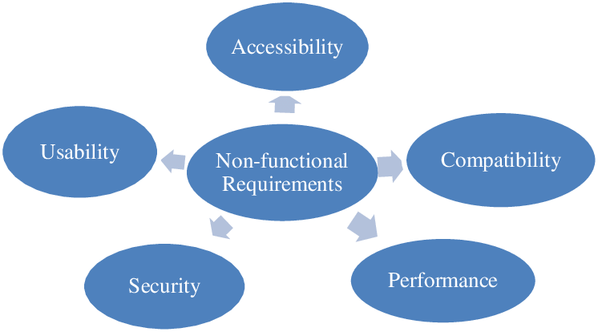
3.2.1 Non-Functional Requirements

Validation
Validation occurs on submit. If the user enters an incorrect user name or password, a validation message appears below the password field.
For security reasons, Clarity does not call out whether the error occurred in the user name or password field. The validation message text should indicate this situation; for example, “The user name or password is incorrect.”
Accessibility
In order to facilitate screen readers, you should still include label elements in the form controls. We provide the clr-sr-only class to add to the label to move it off screen, which keeps the visual experience as you see above while still helping screen readers understand what the form controls are for.
Responsiveness
The layout adapts to different screen sizes at 768px and 544px. A typical website will comprise different types of files of varying sizes and numbers. Most sites will have a mix of text (HTML), images and other static components, as well as dynamic content, such as chats, emails, comments, databases, and more.

Start the http and mysql xampp server :
xampp http start
xampp mysql start
sudo service kurento-media-server-6.0 start.

4.DESIGN

Software design is the process by which an agent creates a specification of a software artifact, intended to accomplish goals, using a set of primitive components and subject to constraints. Software design may refer to either "all the activity involved in conceptualizing, framing, implementing, commissioning, and ultimately modifying complex systems" or "the activity following requirements specification and before programming, as in a stylized software engineering process." Software design usually involves problem solving and planning a software solution. This includes both a low-level component design and a high-level, architecture design.

  - UNIFIED MODELING LANGUAGE (UML)
The unified modelling language is a standard language for specifying, visualizing, constructing and documenting the system and its components is a graphical language which provides a vocabulary and set of semantics and rules. The UML focuses on the conceptual and physical representation of the system. It captures the decisions and understandings about systems that must be constructed. It is used to understand, design, configure and control information about the systems.

Depending on the development culture, some of these artifacts are treated more or less formally than others. Such artifacts are not only the deliverables of a project; they are also critical in controlling, measuring, and communicating about a system during its development and after its deployment.

Object-oriented approaches focus on interaction from the beginning, which has the beneficial side-effect of defining the boundary between the system and its environment. The use cases identify the ways in which the operator will use the system. Sequence diagrams graphically illustrate the interactions the system must support. The "lifelines" of the diagram gather the behavioral responsibilities of each "object" participating in the use case. These responsibilities are the requirements to share data across the collection to produce the required result.

Depending on the development culture, some of these artifacts are treated more or less formally than others. Such artifacts are not only the deliverables of a project; they are also critical in controlling, measuring, and communicating about a system during its development and after its deployment.

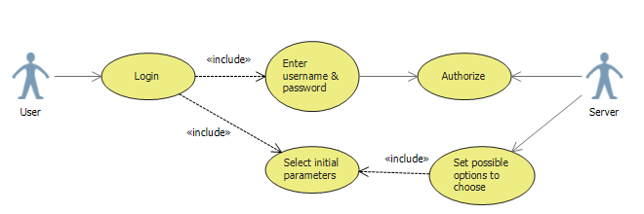
4.1.1 usecase diagram
The advantages of the object-oriented method are that it embraces the concept of effects-driven process development, and it promotes reuse, facilitating the federation of cross-functional domain architectures. The focus on system interfaces also supports the service-oriented architecture implementation pattern.
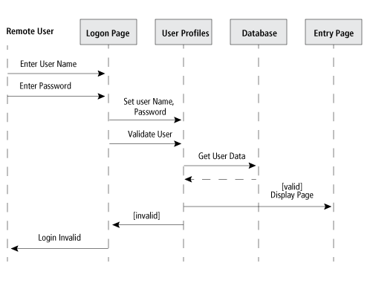
4.1.2 Sequence Diagram
4.2 Algorithm

The primary part of this project is to design a front-end page using HTML,CSS. As this project deals with a management and students,faculty were given credentials to login. So, a SIGNIN page has to be designed.
Create a HTML dot extension file and insert code. Save this file on UDAGRA folder. All the resources, documents and code files are saved at UDAGRA folder. As browsers have in-built compilers, they help in displaying the output.

This component provides a complete login experience.
To customize the login page, remove the elements you don’t need, per your use case. For example, your app may require fewer fields.
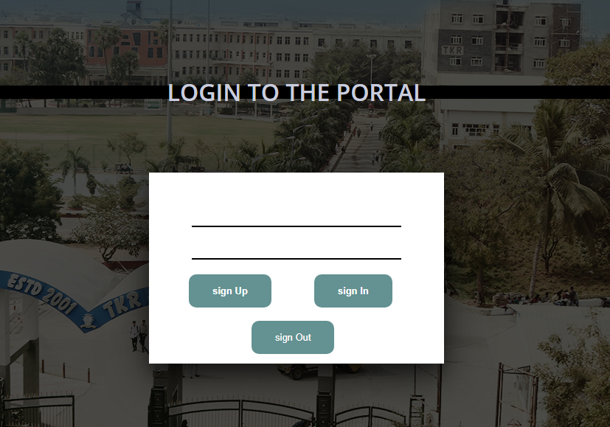
4.2.1 FRONT PAGE

4.3 Sample Data

Before jumping into exploring UX tips for creating the best design for your login form, ask yourself “what is the purpose of the login form in your project?”What input fields should you include to make the experience with the login form comfortable and pleasant? Do you want to let all potential clients in immediately? Or do you want to filter? Do you want to meet the expectations and behavior patterns of your target audience? Or do you want to make the experience standard?
Also, ask yourself questions concerning the purpose of the design. Do you want to use the login form solely for this purpose? Or do you want to make it a part of your brand identity? Do you want to make it a part of the reading flow or marketing campaign?
Decide on the purpose of the login form, and then move to the design.
Creating a working login form is a challenging task. Unlike contact forms that can exist on their own, login forms are the part of the User Authentication Mechanism that has a database in its core and requires a registration system.
5.CODING

HTML

The first step to this project is to create a Login page to users. Login page is used in most of the dynamic website to validate user based on their credentials. For making login page for websites HTML form and HTML elements are used. Text field is used to accept username and password text field is used to accept password from user.

5.1 html login form
The submit button is used for submitting data to server for validation. Its good to validate user input in the browser using JavaScript. In this tutorial we are creating a HTML Login page code and validating user input with JavaScript. In modern web application server-side validation is also very important it is done on server side with the program running on the server.
This project’s login page contain 3 button and 2 input fields. The student’s and faculty email-ids and their respective passwords are considered as input fields to the login page.This login page displays email-id, Password text fields and then buttons for sign-up, sign-out and sign-in. Once user enters the data and clicks on the sign-in button, JavaScript is used to validate the form and error message is displayed if validation fails These details are stored into a database and validated accordingly. After validating, users are directed to other webpages.
Pseudo Code

<body>
<h1>
LOGIN TO THE PORTAL
</h1>
<div id="formcontainer">
<div id="header"></div>

<input type="email" placeholer="email" id="email"/>
<input type="password" placeholer="password" id="password"/>

<button onclick="signUp()" id="signUp"> sign Up</button>
<button onclick="signIn()" id="signIn"> sign In</button>
<button onclick="signOut()" id="signOut"> sign Out</button>
</div>
</body>

CSS :
After the completion of the HTML we now need to begin the CSS part of the design. Firstly, we need to begin the layout of the login page. To begin, start by adding the code below. When adding this CSS be sure to leave space above the code to organize it accordingly. After, we can then add additional elements such as the design of the body.
Before we are completely finished with the design part of the form; we will need to add style to the checkbox for the web app to remember the user’s login information. The design part of the creation is all personal preference and can be customized to your needs; Especially the background.
Pseudo Code

Body {
margin:0;
color:#6a6f8c;
padding-top: 40px;
background:#816464;
font:600 16px/18px 'Open Sans',sans-serif;
background-image:linear-gradient(rgba(0, 0, 0, 0.7), rgba(0, 0, 0, 0.7)), url(TKRR.jpg);
}

JAVA SCRIPT
The login form, the login button and the login error message. We do it by calling the method document.getElementById passing it the id of the element we are looking for. Also, since the values of those three variables will not change, that is, the variables will always refer to the exact same elements, then we declare all three as const.
After that we create an event listener for all the buttons, of type click . In other words, every time the signin button is clicked, the function defined after ’click’, will be executed. The function receives a parameter that we call e, which is a mouse event that represents the click of the button
Whenever the user clicks the sign-in button we retrieve whatever values have been typed in the form fields. But we need to do something with those credentials. Then, we’ll write an if/else block to execute a chunk of code if the login credentials are valid or another chunk if they are invalid. We also need a condition, right? Let’s make that condition the actual validation of the credentials. For the sake of simplicity, that validation will check if the typed email-id is “email” and the password is “web_dev”. In JavaScript syntax, this translates to.If the credentials are indeed valid, then we display an alert dialog with the message that the user has logged in with success and next reload the page

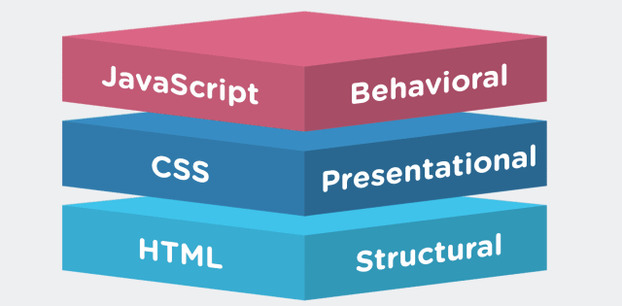
5.1 overall view of languages
5.1 pseudo code

function signUp(){
var email = document.getElementById("email");
var password = document.getElementById("password");
const promise = auth.createUserWithEmailAndPassword(email.value, password.value);
promise.catch(e => alert(e.message));
document.location.href = "page1.html";
alert("Signed Up");
}
function signIn(){
var email = document.getElementById("email");
var password = document.getElementById("password");
Const promise = auth.signInWithEmailAndPassword(email.value, password.value);
promise.catch(e => alert(e.message));
document.location.href = "page1.html"; }
function signOut(){
auth.signOut();
document.location.href = "index.html";
alert("Signed Out");
}

5.2 BACK-END
Management databases are used in a variety of mentoring programs. Large national organizations would not be able to operate without a database to keep track of their programs and the people in these programs. Software products also supports a variety of companies and organizations that have different needs anywhere from small community to nation-wide organizations. Innovative Mentoring is a company that offers a customizable software package based on the need of the customer and boasts that their software products are based on proven tactics for the success of mentoring programs.

CREATING A USER-FRIENDLY DATABASE
The primary goal is to establish a connection with the mentor in order to foster self-esteem, solidify academics and achievements as it would be extremely difficult to submit final assessments by hand , therefore, a database would be a great asset to the program. Additional benefits for the community and general society includes more supported youth, more effective educations, and increased happiness. Furthermore, establishing good relationships with the school, principals, parents, and teachers as well as having interviews with key stakeholders including the children is key for a successful foundation.

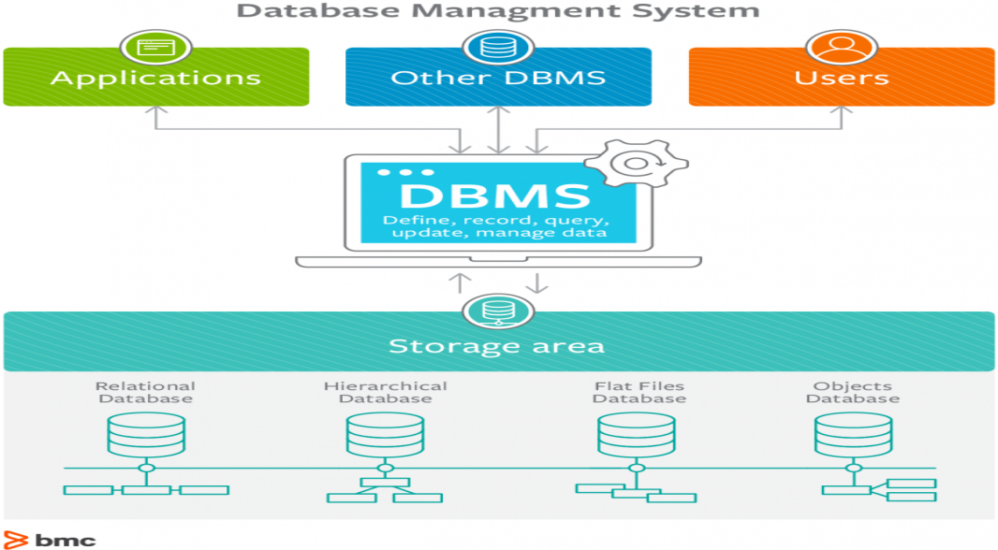
5.2.1 Interaction of database with user and application
DATABASE SYSTEM
Databases are widely used throughout this project. Different strategy to approach need different levels of database functionality. This project offers a database with 2 targets can also be credentials to log into a website. They include email-id and password. The data editions varies depending on the number of mentors and students in the system. However, this does vary the front-end application. Assessing the sign-up, sign-in or sign-out options helps narrow down features of web application to consider.

Several programs currently exist that could be used in building a database, but it should be noted that spreadsheet programs have a lot of room for potential error due to the fact that all data must be manually tabled through using arrow keys. In addition, only about 20 variables can be seen at a time on a spreadsheet program which could be another possible cause for error during scrolling or reorientation. This database eliminates these potential causes for error by allowing automatic tabbing from one variable to the next and through its format design which allows all variables to be seen on the screen at the same time. Therefore, using efficient database management system application chosen due to the increased functionalitysimplicity.

DATA ARRANGMENT
In creating any database, it is extremely essential that a plan is set in place that outlines the desired functions and capabilities of the database. Making a plan will save time and will help easily outline the tables and forms needed and how each data field will need to relate. When drafting the plan, the future user of the database should always be kept in mind, along with the tasks they will need to perform. By doing so, the creator of the database will be able to determine just how user-friendly it needs to be.

There are two major components in creating a database : tables and queries. All data in Access is stored in tables. Often times, each table will possess a primary key, which identifies each record in the table by a unique value. This is important because repeating groups of data within a table can create null values. By setting a primary key, it will be impossible for any duplicate data within that field to be entered into the table.

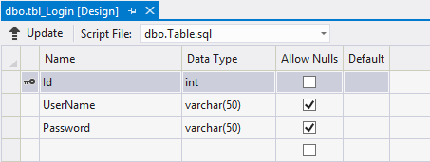
5.2.2 data stored into a database

A query pulls together specific records from one or more tables and consolidates all of them information onto a single sheet. Queries are extremely useful because they allow the user to view only the fields he or she is interested in analyzing within a given table. In addition, append queries, a specific type of query, make data entry easier by facilitating edits made to specific data tables without ever having to open the table itself.

Some sample queries that are performed on a database
If you are adding values for all the columns of the table, you do not need to specify the column names in the SQL query. However, make sure the order of the values is in the same order as the columns in the table.
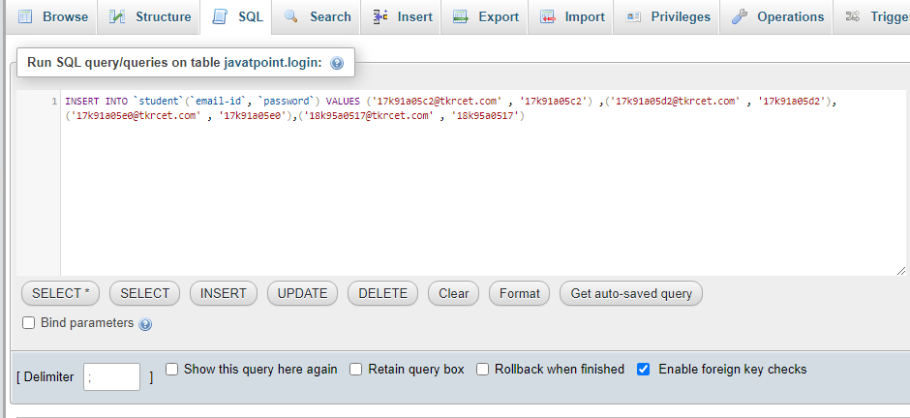5.2.3 insert query in mysql
INSERT INTO `student`(`email-id`, `password`) VALUES ('17k91a05c2@tkrcet.com' , '17k91a05c2') ,('17k91a05d2@tkrcet.com' , '17k91a05d2'),('17k91a05e0@tkrcet.com' , '17k91a05e0'),('18k95a0517@tkrcet.com' , '18k95a0517')
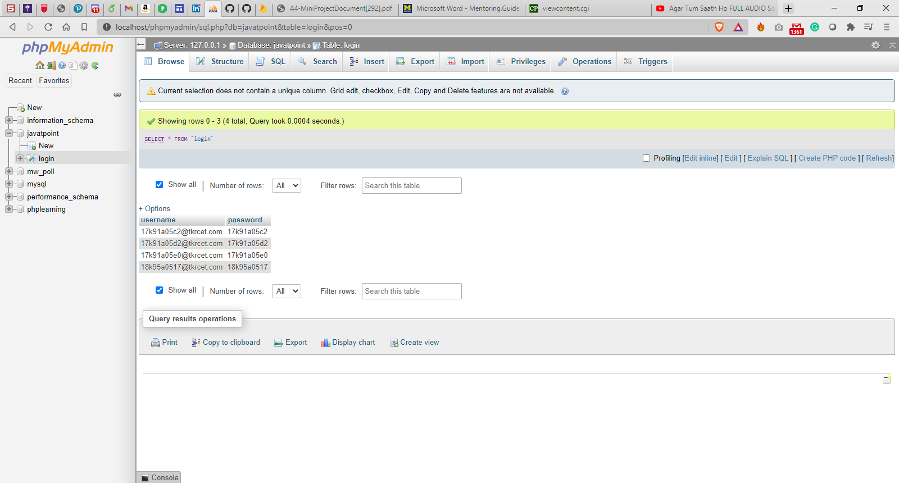
5.2.4 database table

6.IMPLEMENTATION & RESULTS
6.1 Explanation of Key functions

In web application:
- The user clicks your "signin" button or link, and our SDK redirects the user to the other webpage. The user authenticates using one of your configured login options (e.g., email and password).
- Application requests the user's credentials.
- These details are checked with the data inside a data base for authentication.
- If matches, user is re-directed to webpage and there he/she can verify their details.
- User can upload files to their respective guide.
- Guide can look after the project status as well.
- This process make to submit required documents easy than choosing to submit it by hand.

6.2 Method of Implementation

The first step in designing a successful website or application is to gather information. Well-defined goals are what you should set as your first step. Thinks to consider when creating a plan are user interface, application architecture, scalability and more. But the step where most fail is how all of these come together. How will the user interface work with the select architecture and how will they scale? A good plan is made to cover this kind of issues and could potentially reduce the development time by half. There are so many things to consider when creating and drafting your plan, so as a basic rule start small and grow later.

First start by creating a list with all your goals and methods on how can you measure these goals. Without having set goals, you cannot truly see if and how well is your application performing. Begin with a general outline and detail as you go along the development process. Also try to establish the tools and frameworks used to build and maintain the functionality.
Each section or functionality module should be considered in detail but also consider how will they work together with one another. We list each module by hierarchy and priority. This will give us a better understanding the amount of effort required to complete the project. Note that while the plan should cover the entire project it should not be bugged down by minute details that will stop you from seeing the big picture.

6.2.1 Forms

STYLING WEB FORM
This article provides an introduction to styling forms with CSS, including all the basics you might need to know for basic styling tasks.
Advanced form styling
Here we look at some more advanced form styling techniques that need to be used when trying to deal with some of the more difficult-to-style form elements.
UI pseudo-classes
An introduction to the UI pseudo-classes enabling HTML form controls to be targeted based on their current state.
A web form's HTML is made up of one or more form controls (sometimes called widgets), plus some additional elements to help structure the overall form — they are often referred to as HTML forms. The controls can be single or multi-line text fields, dropdown boxes, buttons, checkboxes, or radio buttons, and are mostly created using the <input> element, although there are some other elements to learn about too.

6.2.2 Output Screens
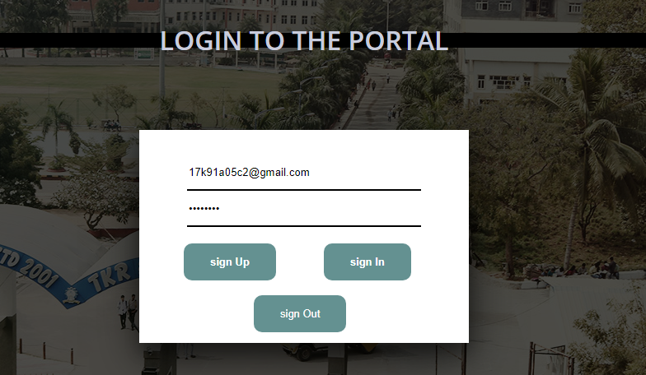

6.2.3 signing into a webpage

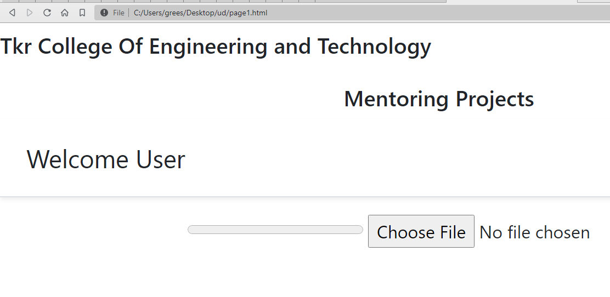
6.2.4 page redirected

6.2.3 Result Analysis
While viewing web page open up the Network tab in the Chrome dev tools. Ensure you perform a hard refresh (or disable the cache in network tab) to accurately analyze the assets served by your application. Assets not downloading in parallel. These will slow down the total page load.

Identify large blocking resources and, if possible, defer or load asynchronously, or better yet load lazily or use the idle until urgent strategy.
There are several scenarios where JS support may not work including user preference, script errors, and network/loading errors to name a few. Therefore, it is recommended to evaluate your application with JS disabled.

When conducting performance analysis of your application make sure you keep things simple by focusing strictly on the output that gets served to your customers in a production environment and not the server or UI framework.

7.TESTING & VALIDATION

7.1 Design of Test Cases and Scenarios

The design of tests for software and other engineering products can be as challenging as the initial design of the product. Test case methods provide the developer with a systematic approach to testing. Moreover, these methods provide a mechanism that can help to ensure the completeness of tests and provide the highest like hood for uncovering errors in software.
TESTING
As with traditional software, verification and validation processes have the purpose of respectively checking the quality of the implementation and revealing non compliances with the user requirements. Static techniques differ from dynamic ones in that they do not require execution. They rather work on artifacts such as design documents and HTML source.Dynamic validation methods aim at exercising the system by supplying a vector of input data (test case) and comparing the expected outputs with the actual ones after execution.

7.1.1 TESTING ACTIVITIES
- INSPECTING COMPONENTS: This finds faults in the individual component through the manual inspection of its source code.
- UNIT TESTING: This find faults by isolating an individual component using test stubs and drivers and by exercising the components using a test case.
- INTEGRATION TESTING: This finds faults by integrating several components together. System testing, which focuses on the complete system, its functional and non-functional requirements and its target environment

.
7.1.1.1 UNIT TESTING
Unit testing focuses on the building blocks of the software system, that is, objects and subsystems. They are three motivations behind focusing on components. First, unit testing reduces the complexity of the overall test activities, allowing us to focus on smaller units of the system. Unit testing makes it easier to pinpoint and correct faults given that few computers are involved in this test. Unit testing allows parallelism in the testing activities; that is each component can be tested independently of one another.
The specific candidates for unit testing are chosen from the object model and the system decomposition of the system. In principle, all the objects developed during the development process should be tested.

7.1.1.1.1 EQUIALENCE TESTING
It is a black box testing technique that minimizes the number of test cases. The possible inputs are partitioned into equivalence classes, and a test case is selected for each class. The assumption of equivalence testing is that the system usually behaves in similar ways for all members of a class. To test the behavior associated with an equivalence class, we only need to test one member of the class. Equivalence testing consists of two steps: identification of the equivalence classes and selection of the test inputs.
The following criteria are used for the equivalence testing:
- COVERAGE: Every possible input belongs to one of the equivalent classes.
- DISJOINTEDNESS: No input belongs to one of the equivalent classes.
- REPRESENTATION: If the execution demonstrates an error when a particular member of an equivalence class is used as input, then the same error can be detected by using any other member of the class as input.

7.1.1.1.2 BOUNDARY TESTING
Boundary testing is a special case of equivalence testing and focuses on the conditions at the boundary of the equivalence classes. Rather than selecting any element in the equivalence class, boundary testing requires that the element be selected from the “edges” of the equivalence class.
A disadvantage of equivalence class and boundary testing is that these techniques do not explore combination of test input data.

7.1.1.1.3 PATH TESTING
Path testing is a white box testing technique that identifies faults in the implementation of the component. The assumption behind path is that, by exercising all possible paths through the code at least once, most faults will trigger failures. The identification of paths requires knowledge of the source code and data structures.
The path testing technique was developed for imperative languages. Object oriented language introduce several difficulties when using path testing.
7.1.1.1.4 Polymorphism:
Polymorphism enables messages to be bound to different methods bases on the class of the target. Although this enables developers to reuse code across a large number of classes, it is also introduce more cases to test.
7.1.1.1.5 Shorter Methods:
Methods in object oriented language have the tendency to be shorter then procedures and functions in imperative languages. This decreases the likelihood of control flow faults, which can be uncovered using the path testing technique.

7.1.1.1.6 STATE BASED TESTING
Object oriented languages introduce the opportunity for new types of faults in object-oriented systems.
State based testing is a recent testing technique, which focuses on object-oriented systems. Most testing technique which focuses on selecting a number of test inputs for a given state of the system, exercising a component or a system, and comparing the observed outputs with java. State based testing focuses on comparing the resulting state of the system with the expected state. In the context of a class, state-based testing consists of deriving test cases from the UML state chart diagram for the class.

7.1.1.2 INTEGRATION TESTING
It detects faults that have not been detected during unit testing, by focusing on small group of component

7.2 Validation

7.2.1 Dynamic validation.
This section is focused on white box testing: the internal structure of a Web application is accessed to measure the coverage that a given test suite (collection of test cases)reaches, with respect to a given test criterion (stating the features to be tested). A test case for a Web application is a sequence of pages to be visited plus the input values to be provided to pages containing forms. Therefore it can be represented as a sequence of URLs specifying the pages to ask and, if needed, the values to assign to the input variables. Execution consists of requesting the Web server for the URLs in the sequence and storing the output pages. Differently from traditional software, branch selection can be forced by choosing the associated hyperlink, without having to track conditions back to input values (except for conditional edges). Some white box testing criteria, derived from those available for traditional software, are:Page testing: every page in the site is visited at leas once in some test case. Hyperlink testing: every hyperlink from every page in the site is traversed at least once. Definition use testing: all navigation paths from every definition of a variable to every use of it, forming a data dependence, is exercised.All-uses testing: at least one navigation path from every definition of a variable to every use of it, forming a data dependence, is exercised.All-paths testing: every path in the site is traversed in some test case at least once.

7.2.2 Static verification.
In addition to inspections, which are a valuable verification strategy also for Web applications, static analyzers can be employed to scan the HTML pages in a Web site and detect possible faults and anomalies.

7.3 Conclusion

- We implement an early reviewer system that takes benefits of a reduced sized data sets, advantage of social theories and simpler analysis with more effective results.
- In particular, we use social users’ sentiment to denote user preferences. Besides, we predict the sentiment based on a classifier which quickens the process.
- The experiment results demonstrate that sentimental factors make great contributions to the rating prediction. Also, it shows significant improvements over existing approaches on a real-world data set.

- CONCLUSION :

This was designed in such a way that future modifications can be done easily. The following conclusions can be deducted from the development of the project
- Automation of the entire system improves the efficiency.
- It provides a friendly graphical user interface which proves to be better when compared to the existing system.
- It gives appropriate access to the authorized users depending on their permissions.
- It effectively overcomes the delay in communications.
- Updating of information becomes so easier.
- System security, data security and reliability are the striking features.
- The system has adequate scope for modifications in future if it is necessary.
This application avoids the manual work and the problems concern with it. It is an easy and fast way to access the updates information.

The goal of the system is achieved and difficulties are solved. The project is built such that it is user friendly. Analysis of the scoring system it shows by the grade wise result of individual subject and final result also display grade wise .depending on its range of marks. The project can be easily used in college for college result analysis of student. It reduces time which required for manual calculation. This system helps to calculate result fast so it optimizes the manpower.
3333

PAPER PUBLICATION

REFERENCES :

- HTML5 W3C Recommendation 28 October 2014 (@ http://www.w3.org/TR/html5).
- WHATWG (Web HyperText Application Working Group) HTML(5) Specification (@ https://html.spec.whatwg.org/multipage/index.html).
- HTML 4.01 Specification W3C Recommendation 24 December 1999 (@ http://www.w3.org/TR/html401).
- XHTML 1.0 Specification W3C Recommendated Revised 1 August 2002 (@ http://www.w3.org/TR/xhtml1).
- CSS 2.1 Specification W3C Recommendation Revised 17 December 2014 (@ http://www.w3.org/TR/CSS21/).
- CSS3 Selectors module (@ http://www.w3.org/TR/selectors/); CSS3 Colors module (@ http://www.w3.org/TR/css3-color/).
- ECMAScript (JavaScript) Specification: "Standard ECMA-262 ECMAScript Language Specification 5.1", (same as "ISO/IEC 16262" 3rd eds).
- Mozilla's (MDN) JavaScript Project @ https://developer.mozilla.org/en-US/docs/Web/JavaScript.
- Mozilla's (MDN) "JavaScript Reference" @ https://developer.mozilla.org/en-US/docs/Web/JavaScript/Reference..
- MySQL Mother Site @ www.mysql.com.
- MySQL 5.7 "Reference Manual" @ http://dev.mysql.com/doc/.
- MySQL 5.7 "SQL Statement Syntax" @ http://dev.mysql.com/doc/refman/5.7/en/sql-syntax.html.
- "ISO/IEC 9075 Information Technology - Database Languages SQL": 1989 (SQL-89), 1992 (SQL-92 or SQL2), 1999 (SQL-99 or SQL3), 2003 (SQL-2003), 2006 (SQL-2006) and 2011 (SQL-2011).
- MySQL Employees Sample Database @ http://dev.mysql.com/doc/employee/en/index.html.
- MySQL Sakila Sample Database @ http://dev.mysql.com/doc/sakila/en/index.html.
- Codd E. F., "A Relational Model of Data for Large Shared Data Banks", Communications of the ACM, vol. 13, issue 6, pp. 377–387, June 1970.
- (For Java Programmers) "JDBC Basics", Java Online Tutorial @ http://download.oracle.com/javase/tutorial/jdbc/basics/index.html.
- Paul DuBois, "MySQL Developer's Library", 4th ed, 2009 (5th ed is probably available).
- Russell Dyer, "MySQL in a Nutshell", 2nd ed, O'reilly, 2008.
Reference websites
    - www.javatpoint.com
    - www.w3schools.com

