DATA VISUALISATION:

INTRODUCTION:

Detroit is the largest city in the midwestern state of Michigan. This data reflects reported criminal offenses that have occurred in the City of Detroit since January 1, 2009. The dataset is taken from “[data.world](https://data.world/detroit/dpd-crime-incidents-2009-2016)” [1]

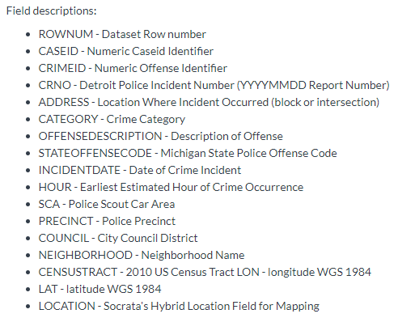

DATA CLEANING:

* Some of the Fields were removed from the dataset as those were of least importance. And some the columns were added to view the crimes in a different perspective.
* Field removed were : CASEID, CRIMEID, CRNO, NEIGHBORHOOD and STATEOFFENSECODE
* New Fields added are:

1. MAXIMUM_TEMP – Maximum temperature measured that day
2. MINIMUM_TEMP – Minimum temperature measured that day
3. AVERAGE_TEMP – Average temperature of that day
4. SNOW_DEPTH - Determine the depth of the new and old snow remaining on the ground at observation time.

* The Weather data has been taken from government website “ <https://w2.weather.gov/climate/xmacis.php?wfo=dtx> “
* Omitting NA rows from the dataset.
* Separating year, month and date columns out INCIDENTDATE column.

The dataset now has **1064523** rows and **20** columns after cleaning.

Given below is the summary of the dataset:

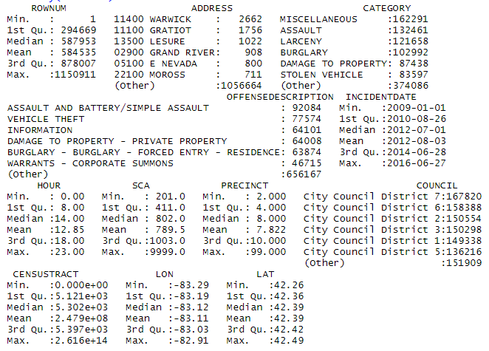

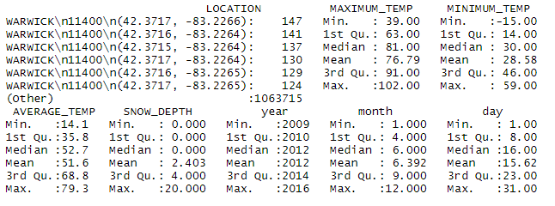

A glimpse of dataset:

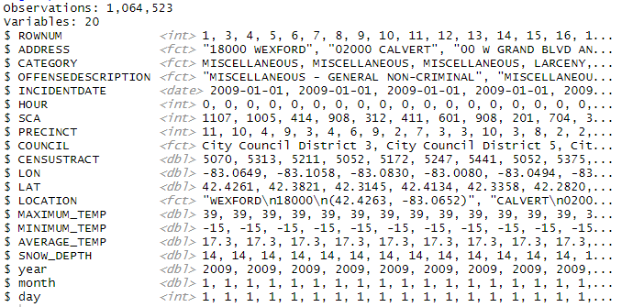

There are in total 14 numerical and 5 factor variable. This dataset also includes a date variable.

Council wise Crime Records:

This plot is interactive and made using Highcharts package. This shows 3 categories which are very less or null compared to the rest.[2]

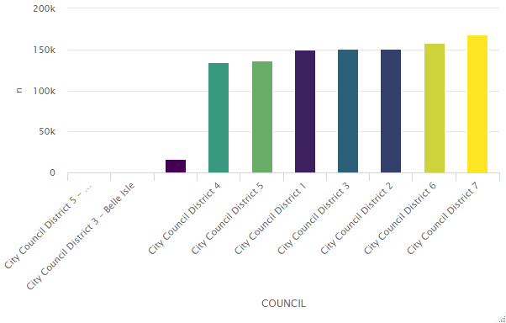

Category wise Crime records:

The interactive plot was made with “Highcharts” library. This shows that almost 10 categories are very less in numbers i.e. the number of crime records are far too less. So will omit those categories in further charts.

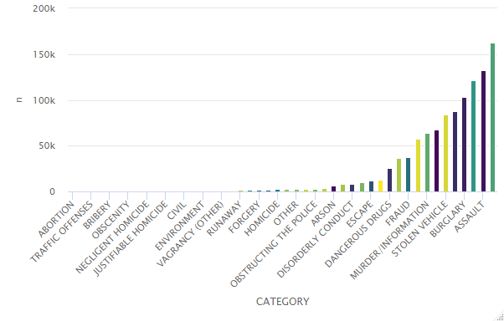

Following Maps are made using TABLEAU. Tableau is a powerful and fastest growing data visualization tool used in the Business Intelligence Industry. It helps in simplifying raw data into the very easily understandable format. [3]

Graphs based on different category with different years:

Bubble map of Crime category based on number of records. All the records are categorized by different years from 2009-2016. Stating all the top 5 crimes of each year.

* 2009 : Burglary, Assault, Larceny, Murder/Information, Miscellaneous

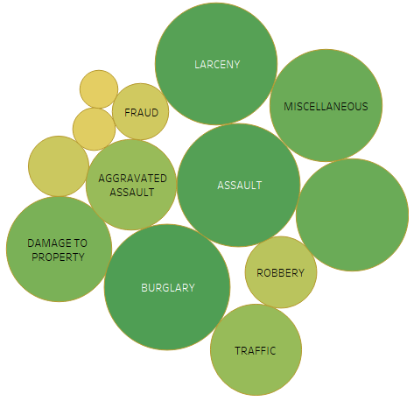

* 2010 : Assault, Larceny, Burglary, Murder/Information, Miscellaneous

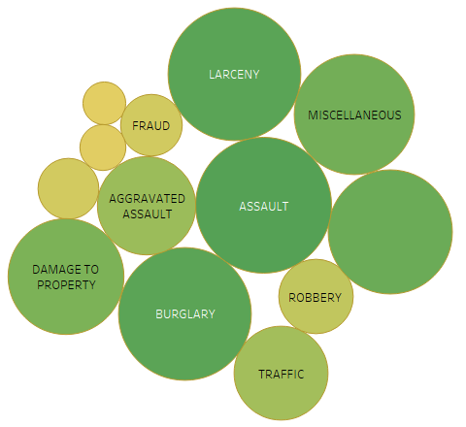

* 2011 : Assault, Burglary, Larceny, Murder/Information, Miscellaneous

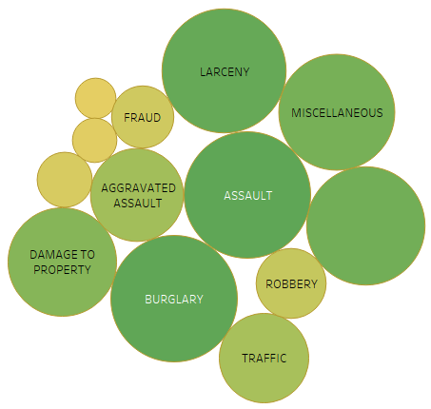

* 2012 : Assault, Larceny, Miscellaneous, Burglary, Murder/Information

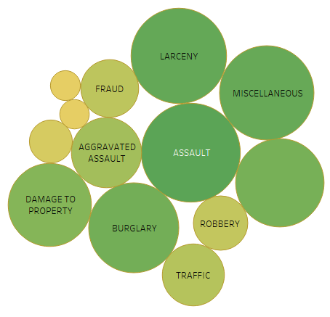

* 2013 : Miscellaneous, Larceny, Assault, Burglary, Damage to property

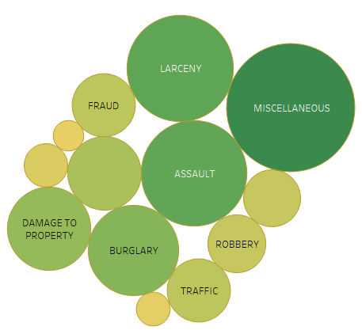

* 2014 : Miscellaneous, Assault, Larceny, Burglary, Damage to property

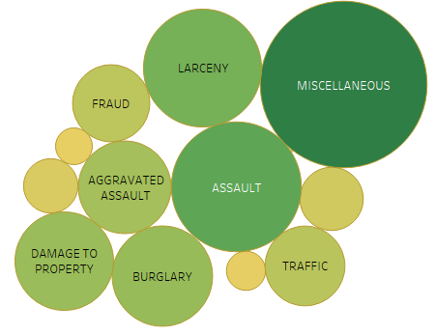

* 2015 : Miscellaneous, Assault, Larceny, Damage to property, Burglary

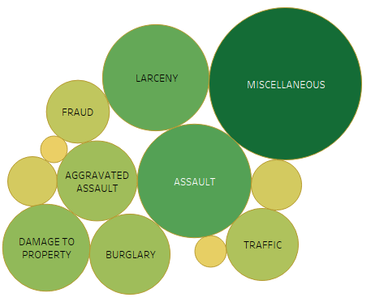

* 2016 : Miscellaneous, Assault, Larceny, Damage to property, Aggravated assault

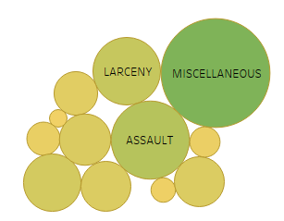

As seen from the plots, **Burglary** used to top the list during 2009 but moved out as of year 2016 and that year was surpassed by **Miscellaneous** crime category.

Plotting Crimes based on Category in Detroit Map:

Maps show the top 6 crime category spread across the city. All these maps were created using Tableau.

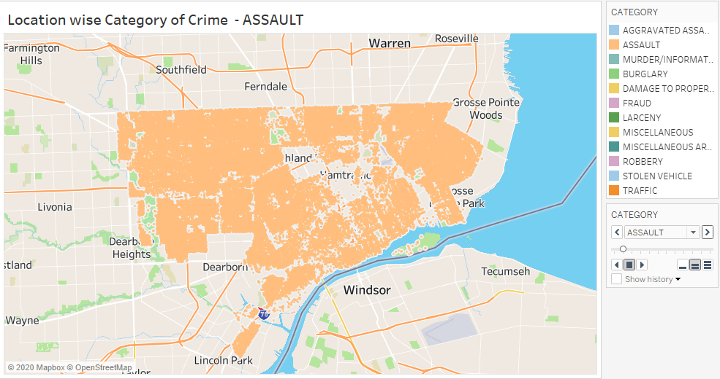

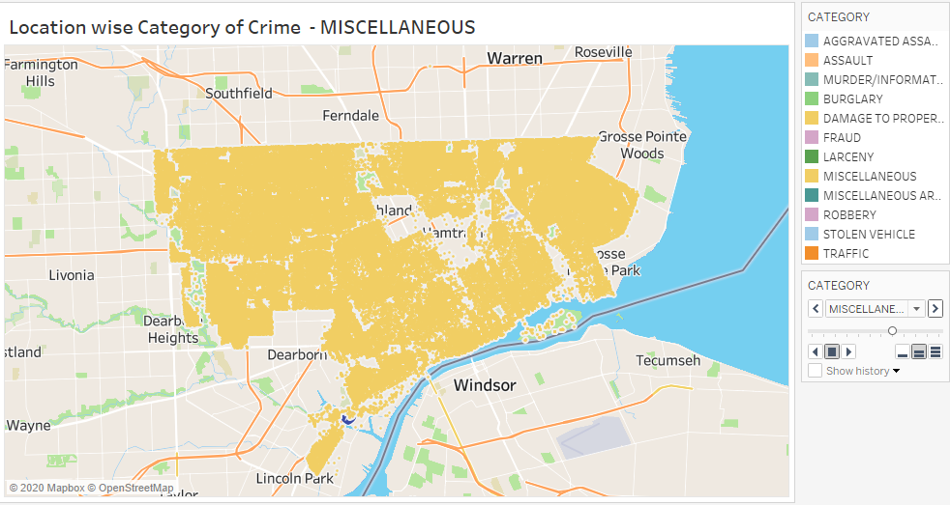

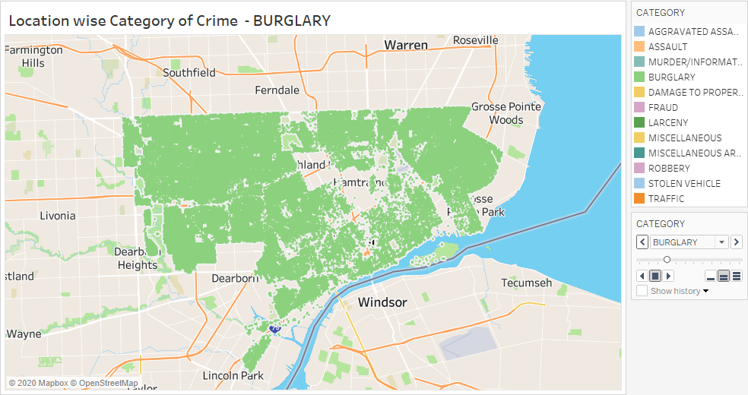

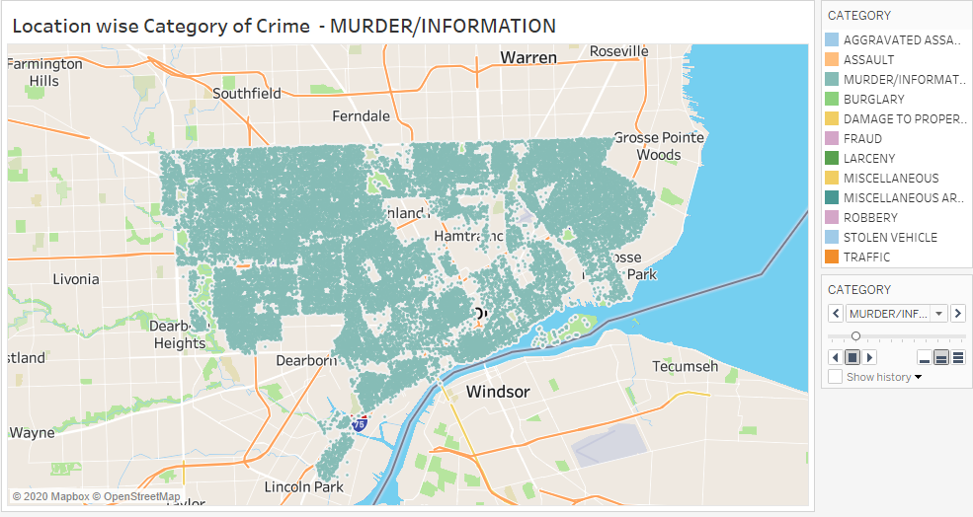

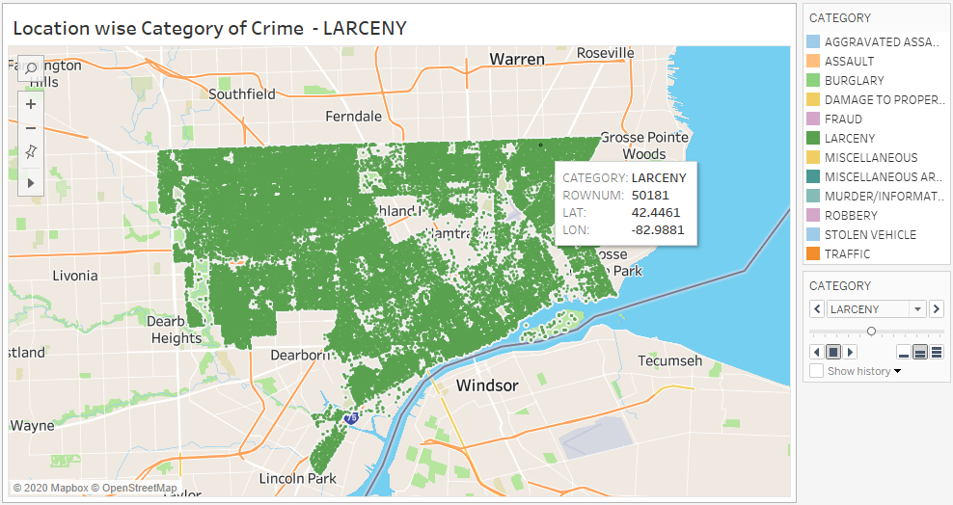

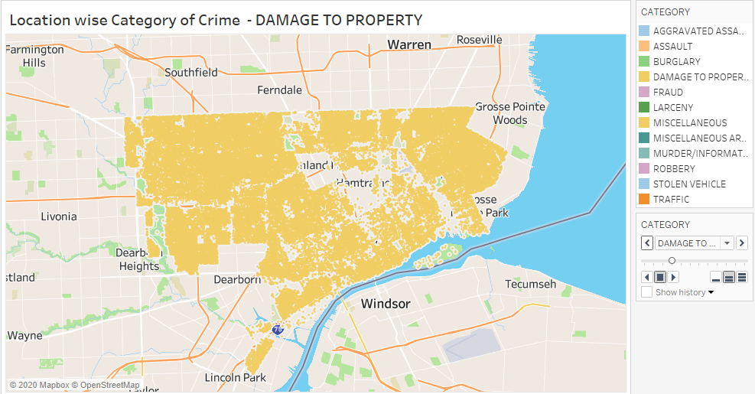

Below plots show the number of crime records per month and per hour basis:

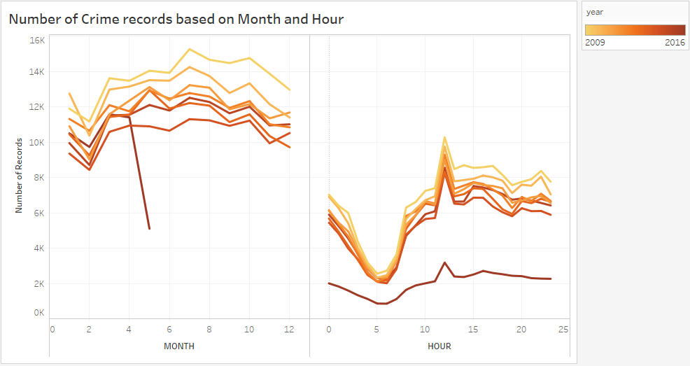

According to the graphs :

1. Year 2009 had large number of crime records and 2014 showed comparatively less crime records.
2. July is the month with high crime rate and February always showed a dip in crimes every year.
3. During 4am to 7 am the crimes happened are low also during 12pm there are high number of crime occurrences.
4. From year 2009 to 2014 there was a gradual decrease in line graph but then 2015 showed a bit of a rise.
5. 2016 can’t be considered as there is data of only 5 months.
6. Something that should not be missed is the peaks, i.e. the crime rise during the months March, May and October.

Below plots show crime records based on snow depth recorded every day:

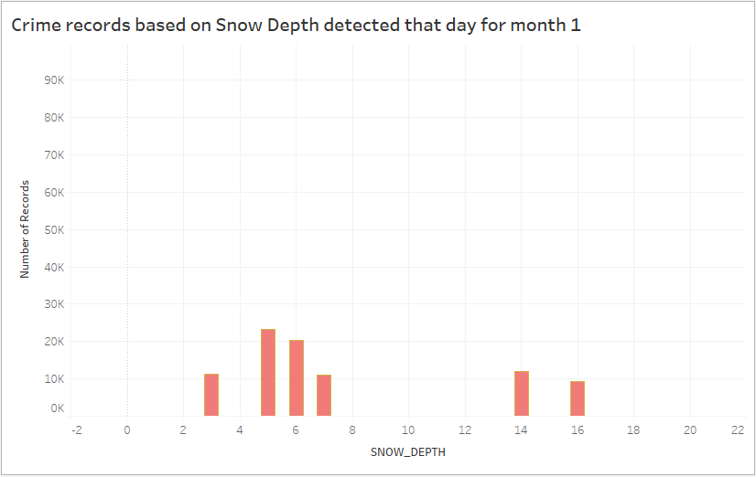

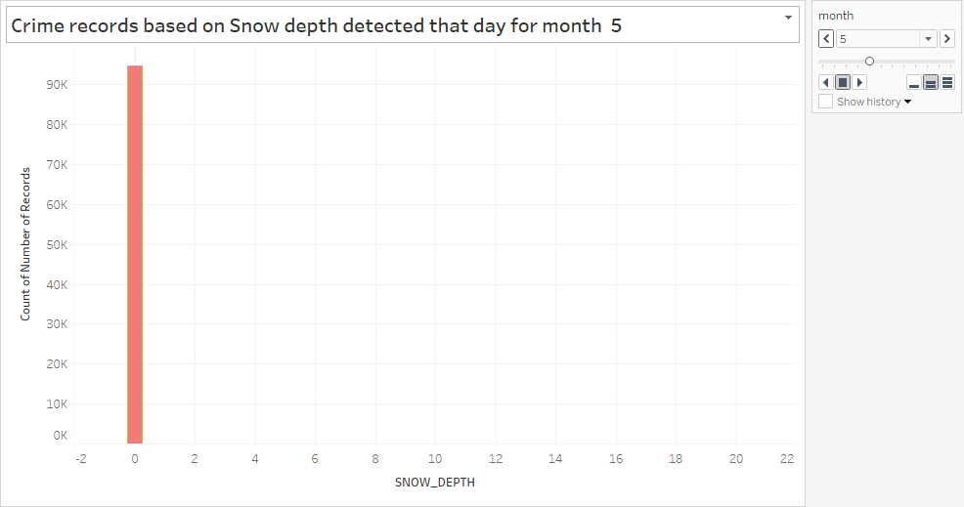

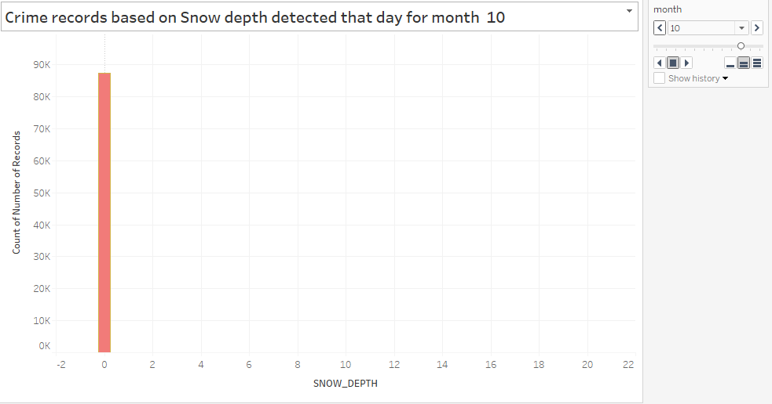

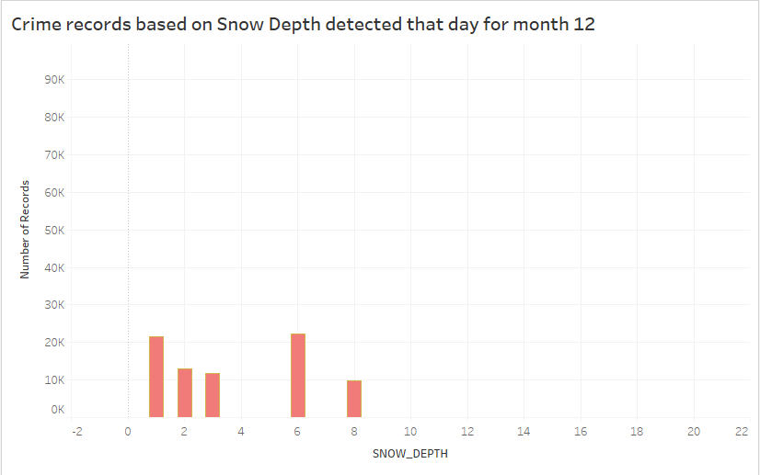

According to the Bar Graph above:

1. It shows month wise crime distribution based on snow depth.
2. As seen from the graphs from May to October there is very less snow and that’s the time when crime was largest.
3. Very less number of crimes have been recorded while the snow depth was 10 or more.

Below shown are the plots with respect to temperature:

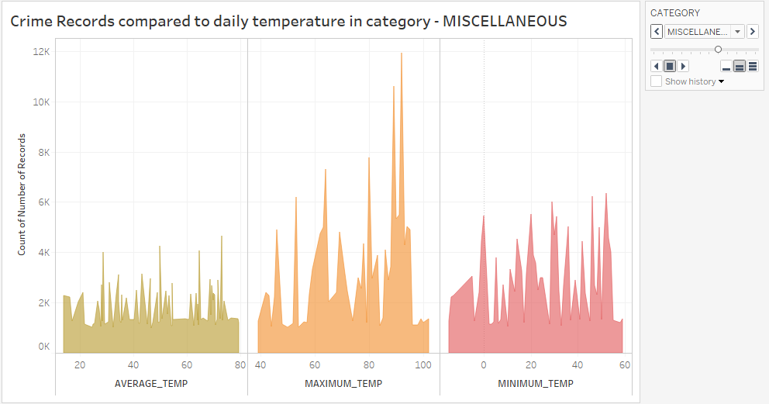

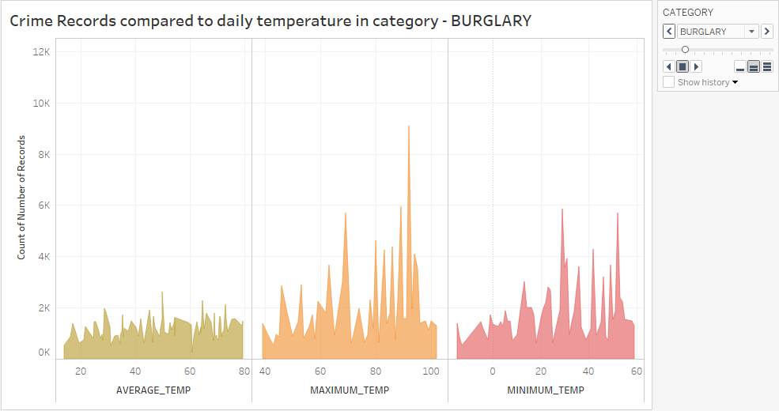

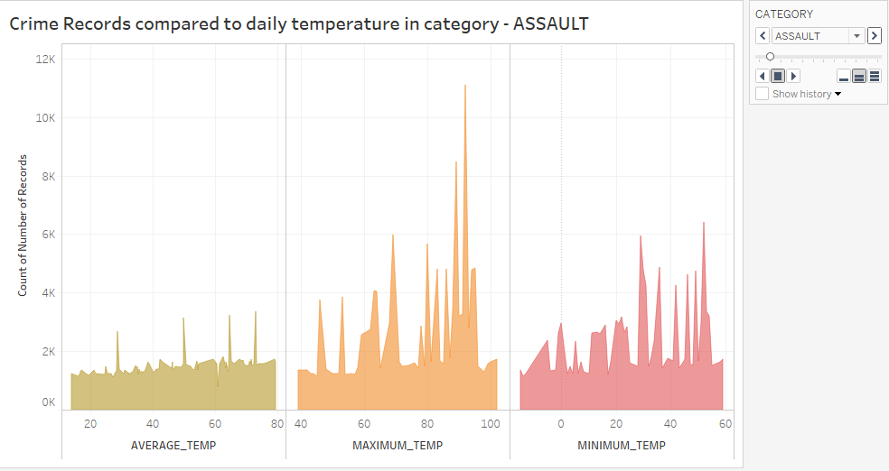

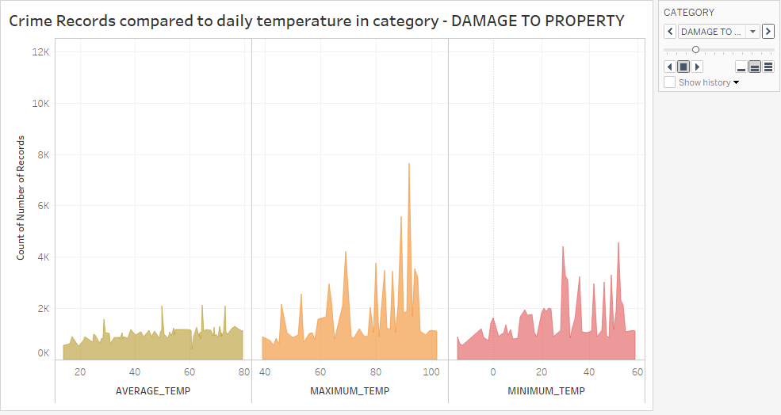

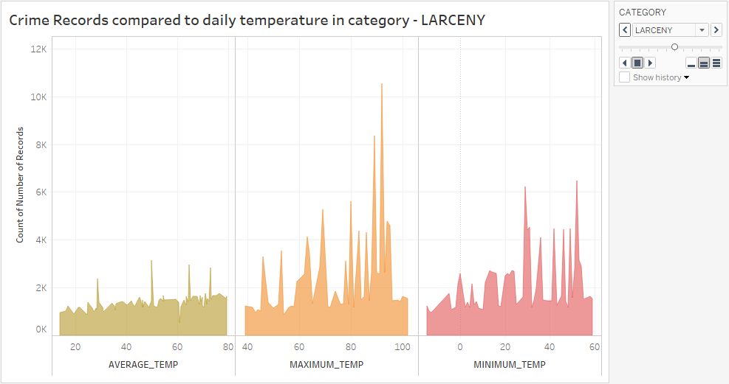

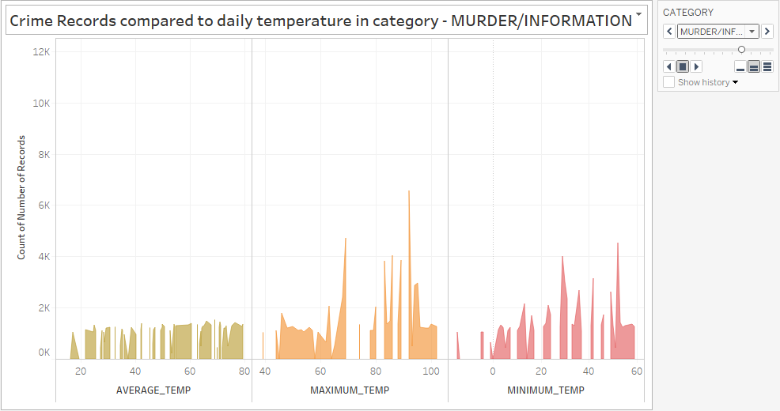

According to the above shown Area Graph:

1. Most occurred 6 category of crime are plotted here against Temperature recorded that day.
2. All the three categories of temperature has been recorded and plotted.
3. Most of the crimes occur when it’s a bit warmer climate.
4. Crime records of at least 500 to 1200 are recorded on all temperature range
5. Most of the crimes can be seen occurring at a 50, 64.50 and 72.90-degree Fahrenheit.

Below shown is plot of crime records on each day basis:

1. There are 2 plots, the graph below shows overall day to day crime reports, and the one above also shows the same with respect month.
2. It is clearly seen that on the first day of every month the crime is high and from the second day it drops drastically.
3. On 31st day there is comparatively low crimes happening.

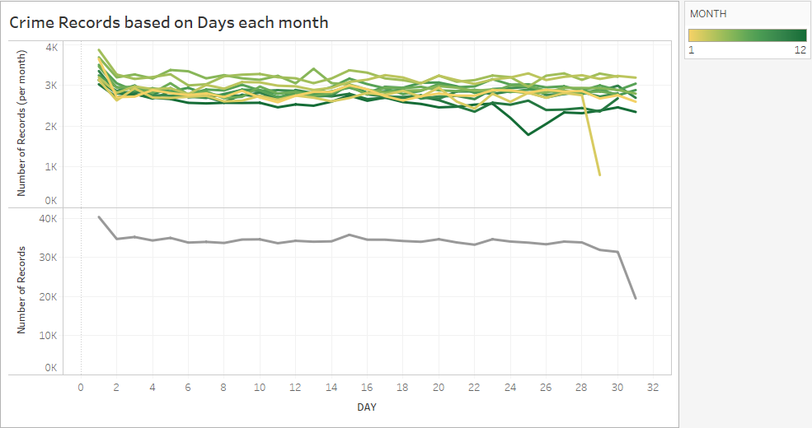

Below shown is a heatmap of offense description given by the people of the most occurred crime category:

1. Simple assault tops the offenses followed by Vehicle theft and murder information
2. Almost 90k crimes were recorded in total and vehicles were stolen and reported atleast 76k cases.

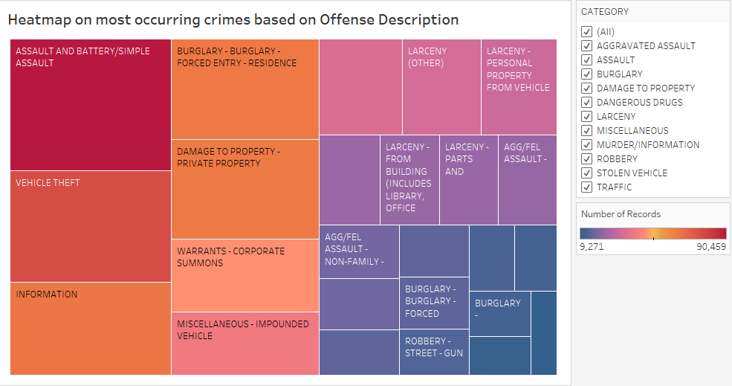

CONCLUSION:

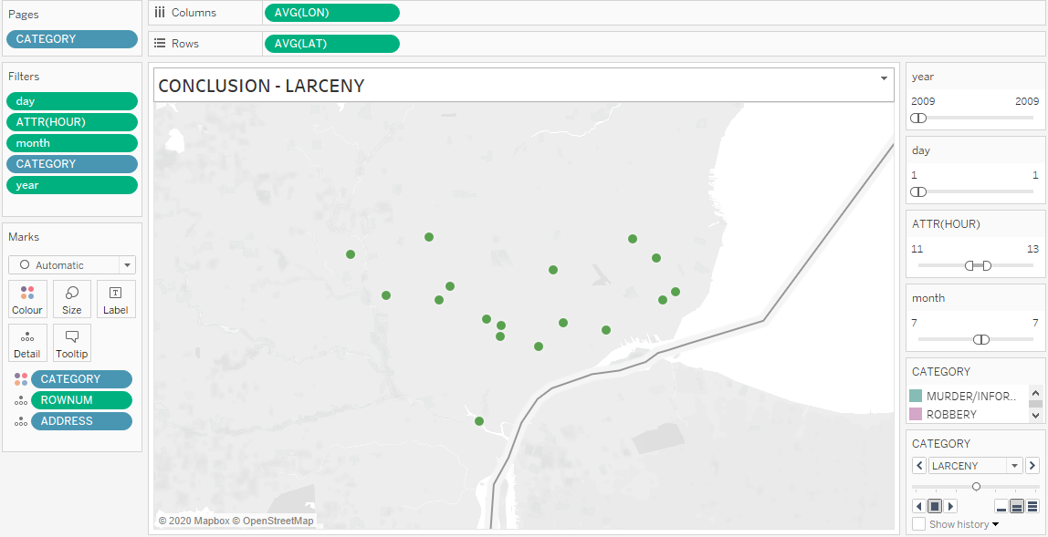

This is the final representation of all the details extracted from the above research on Detroit City Crime Records.

1. Most of the crime happened in the year 2009 and from then shown a decrease in the crime rate.
2. Most of the crimes occurred during the 1st day of the month.
3. Most Crime records have been recorded during the month of July.
4. The crime rate was at the peak during the afternoon 12 pm
5. Burglary, Larceny, Assault, Murder, Damage to properties and miscellaneous were the most prominent reasons observed for the crime to happen.
6. The last Map takes into consideration of these important points collected and plots only those crimes reported during this time and those of above said category.
7. All these Maps and graphs were plotted using Tableau and RStudio.

REFERENCES:

[1] “DPD Crime Incidents 2009-2016 - dataset by detroit,” *data.world*. https://data.world/detroit/dpd-crime-incidents-2009-2016 (accessed Mar. 27, 2020).

[2] “Highcharter.” http://jkunst.com/highcharter/shortcuts.html (accessed Mar. 27, 2020).

[3] “What is Tableau? Uses and Applications.” https://www.guru99.com/what-is-tableau.html (accessed Mar. 27, 2020).