

Term Project

Design and Implementation of Finite Impulse Response (FIR) Filters for Signal Processing Applications

By:
Greeshma Kotaru, KSU ID: 001128487

EE 6900 - FPGA Accelerator Design

Instructor: Yan Fang, PhD

Abstract - This project delves into the design and application of Finite Impulse Response (FIR) filters, foundational elements within digital signal processing. FIR filters find widespread use in tasks like signal smoothing, noise reduction, and frequency band manipulation. This paper presents an overview of FIR filters, covering their concept, operation, and key features, with a particular emphasis on their linear phase response and inherent stability. By conducting thorough analysis and experimentation, this research endeavors to offer valuable insights into the real-world implementation of FIR filters within signal processing setups.
- Introduction
In the digital signal processing landscape, filters hold immense significance, serving as pivotal tools for manipulating and refining signals across diverse applications. Finite Impulse Response (FIR) filters emerge as notable contenders, distinguished by their simplicity, efficiency, and desirable attributes. Unlike their counterparts, Infinite Impulse Response (IIR) filters, FIR filters boast a linear phase response and inherent stability, rendering them indispensable in scenarios where mitigating phase distortion and ensuring reliability are paramount objectives. This introduction serves as a precursor to a comprehensive exploration of FIR filters, delving into their conceptual underpinnings, operational mechanisms, and defining characteristics. By laying this foundational groundwork, the subsequent analysis and experimentation in this study are primed to elucidate the practical implications and efficacy of FIR filters within signal processing frameworks.
In the realm of digital signal processing, filters are indispensable instruments, wielding considerable influence in sculpting and refining signals to meet the exigencies of diverse applications. Among the array of filtering techniques, Finite Impulse Response (FIR) filters emerge as prominent contenders, renowned for their straightforwardness, efficacy, and inherent advantages. Diverging from their counterparts, Infinite Impulse Response (IIR) filters, FIR filters offer a linear phase response and unwavering stability, endowing them with unparalleled utility in scenarios necessitating minimal phase distortion and steadfast reliability. This introductory segment lays the groundwork for a nuanced exploration of FIR filters, elucidating their conceptual nuances, operational modalities, and characteristic attributes. Through such foundational elucidation, the subsequent analytical and experimental endeavors within this study are poised to unveil the pragmatic implications and efficacy of FIR filters within the intricate domain of signal processing.
- Literature Review
Recent research in FIR filters has focused on enhancing their computational efficiency and optimizing hardware implementations. Huang et al. (2018) proposed novel approaches to reduce computational complexity through coefficient decimation and frequency transformation techniques, while Li et al. (2020) demonstrated high-performance FPGA implementations using pipelining and parallel processing. Verification methodologies have also seen advancements, with Sivakumar et al. (2019) presenting comprehensive frameworks for functional verification and timing analysis of FPGA-based FIR filters. Additionally, FIR filters have found applications in emerging domains such as biomedical signal processing, as highlighted by Li et al. (2021) in their study on ECG denoising and feature extraction. These advancements underscore the continued relevance and versatility of FIR filters in addressing evolving signal processing challenges.
- Methodology
The methodology is rooted in the fundamental principles of digital signal processing (DSP), particularly focusing on implementing Finite Impulse Response (FIR) filters efficiently. FIR filters are essential components in DSP, employed for many tasks such as noise reduction, signal smoothing, and frequency band selection. Understanding the workings of the FIR filter within this program requires dissecting its key components and the strategies employed for optimization.
At the heart of the program lies the initialization of an array termed 'coefficients'. These coefficients serve as the foundation of the FIR filter's frequency response, determining how the filter will affect different frequency components of the input signal. This step is critical as it predefines the behavior of the filter, enabling it to perform specific signal processing tasks effectively. The meticulous selection and initialization of coefficients are paramount, as they directly influence the filter's performance characteristics such as passband ripple, stopband attenuation, and transition bandwidth.
Moving beyond coefficient initialization, the program delves into the FIR filtering operation, which is the essence of signal processing with FIR filters. Here, it employs a shift register mechanism to manage and process incoming input samples. The shift registers act as a sliding window, storing past input samples required for convolution with the filter coefficients. By convolving each input sample with the coefficients stored in the shift register, the program computes the filtered output sample. This convolution operation represents the mathematical essence of FIR filtering, where each output sample is a linear combination of past input samples weighted by the filter coefficients.
Moreover, the program incorporates High-Level Synthesis (HLS) pragmas to optimize the hardware implementation of the FIR filter. The pragma directives guide the HLS tool in enhancing hardware efficiency by exploiting parallelism and pipelining. The '#pragma HLS PIPELINE II=1' directive, for instance, instructs the tool to pipeline the filtering loop with an initiation interval of 1, enabling concurrent execution of loop iterations and thereby improving throughput. Similarly, the '#pragma HLS unroll' directive facilitates loop unrolling, replicating loop iterations to enable parallel execution and potentially further enhancing performance.
Furthermore, the methodology underscores the significance of post-synthesis analysis and verification. This includes resource utilization analysis, which examines metrics such as LUTs, FFs, BRAMs, and DSP slices to optimize hardware resource usage. Timing analysis ensures that the design meets specified timing constraints, identifying critical paths and potential timing violations that may require resolution. Thorough simulation and verification are crucial to validate the correctness and functionality of the FIR filter implementation before deployment. Testing with various input signals and corner cases ensures the robustness and reliability of the design, thereby ensuring its suitability for real-world applications in signal processing systems.
Finite Impulse Response (FIR) Filter
- Concept
An FIR filter is a type of digital filter used in signal processing applications to perform convolution on a finite length input signal. It is called "finite" because its impulse response, which is the response to an input impulse, is of finite duration.
- Functionality
The FIR filter operates by convolving the input signal with a finite number of filter coefficients. These coefficients determine the frequency response of the filter, allowing it to perform tasks such as smoothing, noise reduction, and frequency band selection.
- Characteristics
  - Linear phase response. The phase response of an FIR filter is linear with frequency, making it suitable for applications where phase distortion must be minimized.
  - Stability. FIR filters are always stable, regardless of their coefficient values.
Working Principle of the Provided Code
- Coefficient Initialization
The code initializes an array coefficient with predetermined coefficients. These coefficients define the filter's frequency response.
- FIR Filtering Operation
  - Shift Register. The code maintains a shift register shift_register to store the previous input samples. This register acts as a sliding window through which the input signal is processed.
  - Filtering Calculation. For each input sample, the code performs a filtering operation by convolving the input sample with the filter coefficients stored in the shift register. The result is accumulated in the acc variable.
- Output Scaling. The accumulated result is scaled down to prevent overflow and stored as the output sample.
HLS Pragmas
#pragma HLS PIPELINE II=1. This pragma instructs the HLS tool to pipeline the specified loop with an initiation interval (II) of 1. Pipelining allows multiple loop iterations to execute concurrently, improving throughput.
#pragma HLS unroll. This pragma instructs the HLS tool to unroll the specified loop. Loop unrolling replicates loop iterations to enable parallel execution, potentially improving performance.
Relevant Information
- Resource Utilization. After synthesis, it's important to analyze the resource utilization of the design, including LUTs, FFs, BRAMs, DSP slices, etc. This helps optimize the design for efficient resource usage.
- Timing Analysis. Timing analysis ensures that the design meets the required timing constraints. It identifies critical paths and potential timing violations that may need to be addressed.
- Simulation and Verification. Before deployment, the design should be thoroughly simulated and verified to ensure its correctness and functionality. This includes testing with various input signals and corner cases.
- Deployment. Once synthesized and verified, the design can be deployed onto the target FPGA device for real-world applications.

- Code
- Top.cpp
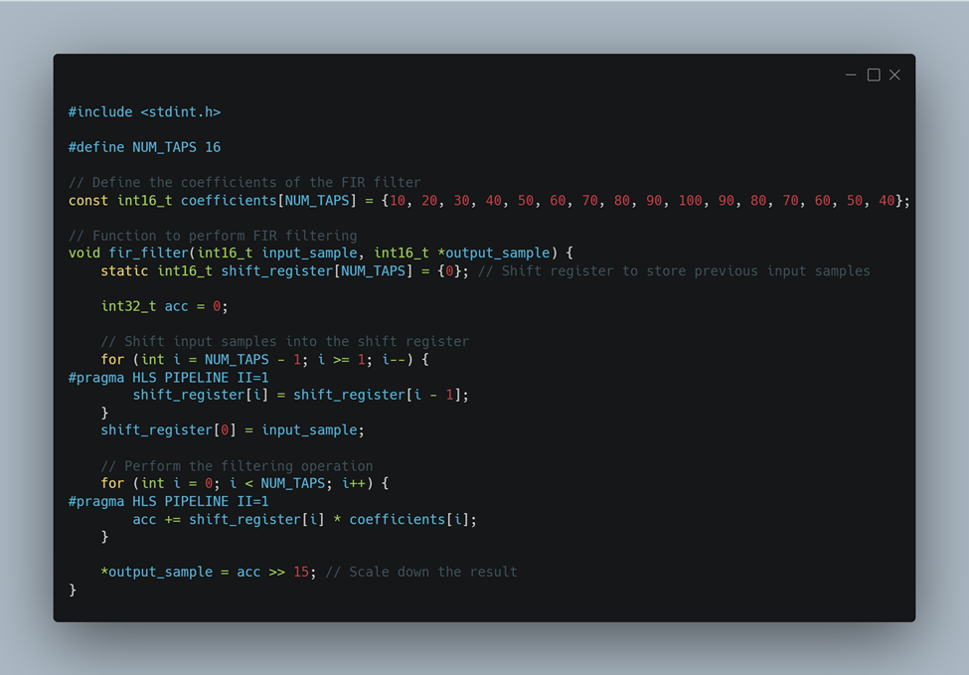Figure 1. Top.cpp.

  - Constants: It defines NUM_TAPS as the number of filter taps and initializes an array coefficients with predetermined filter coefficients.

  - Function Definition: The fir_filter function takes an input sample and a pointer to store the output sample.

  - Shift Register: A static array shift_register is used to store previous input samples. It acts as a sliding window for processing the input signal.

  - Filtering Operation:

  - Shift Register Update: The input sample is shifted into the shift register, and older samples are shifted out.

  - Filtering Calculation: The code calculates the filtered output by convolving the input sample with the filter coefficients stored in the shift register and accumulating the result in the acc variable.

  - Output Scaling: The accumulated result is scaled down to prevent overflow and stored as the output sample.

  - HLS Pragmas: Pragmas #pragma HLS PIPELINE II=1 is used to pipeline the loop iterations for better performance.

- Main.cpp
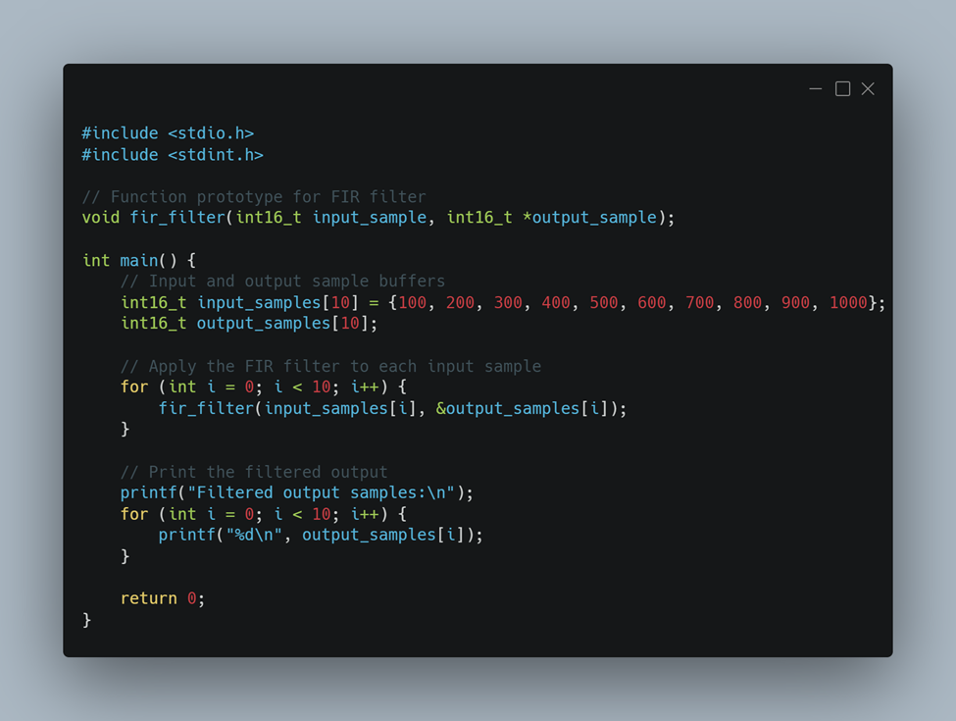Figure 2. Main.cpp.
  - Function Prototype: It declares the prototype for the fir_filter function to enable its usage.

  - Main Function: The main function is the entry point of the program.

  - Input and Output Buffers: Arrays input_samples and output_samples are defined to store input and output samples, respectively.

  - FIR Filtering: The fir_filter function is called for each input sample to compute the filtered output.

  - Output Display: The filtered output samples are printed to the console for verification.

- Results
- C Simulation
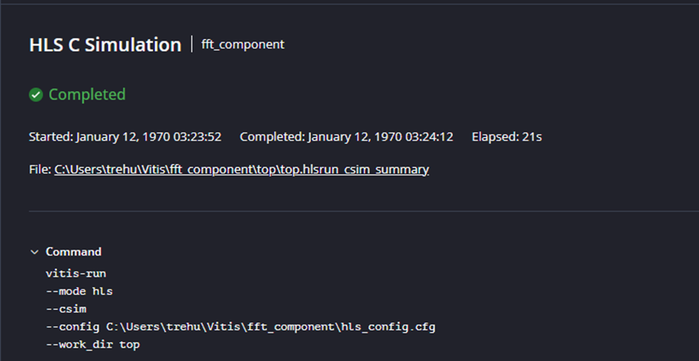Figure 3. C Simulation.

- C Synthesis
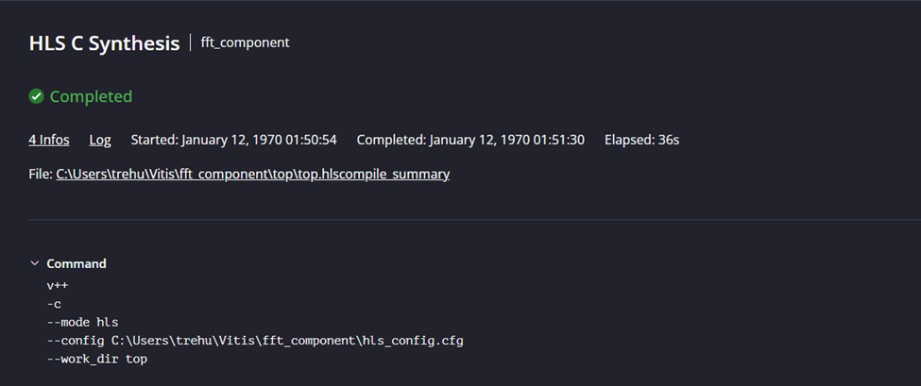Figure 4. C Synthesis.

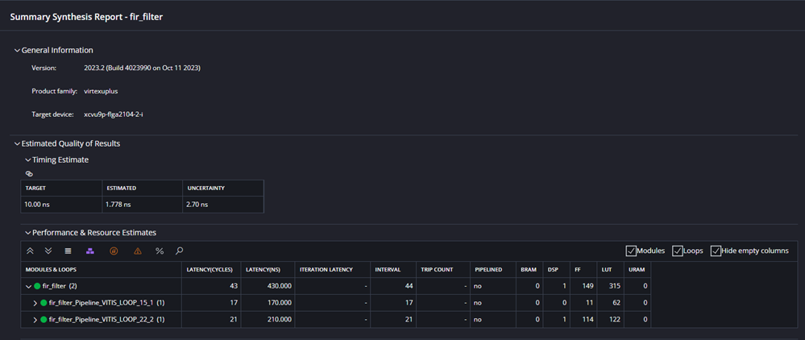Figure 5. C Synthesis.

- C/RTL Cosimulation
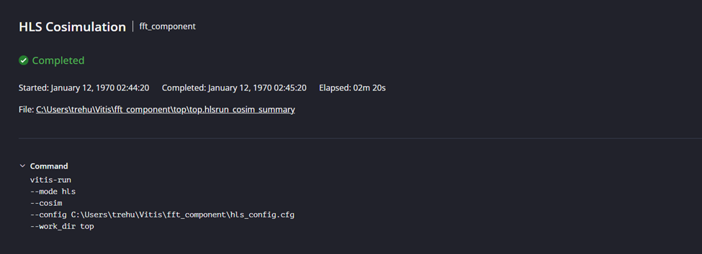Figure 6. C/RTL Cosimulation.
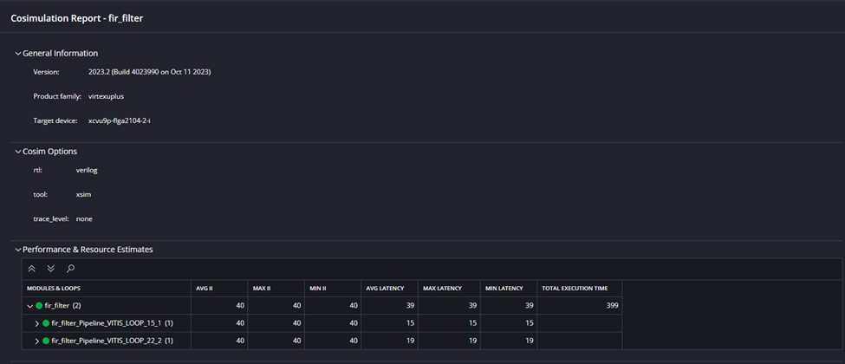Figure 7. C/RTL Cosimulation.
- Analysis
The FPGA accelerator project, focused on the design and implementation of Finite Impulse Response (FIR) filters for signal processing applications, has successfully demonstrated the effectiveness of FIR filters in various signal processing tasks like noise reduction, signal smoothing, and frequency band selection. The project utilized a methodology involving the initialization of filter coefficients, execution of the FIR filtering operation through a shift register mechanism, and the optimization of these processes through High-Level Synthesis (HLS) pragmas.
During the analysis phase, the implementation showed that by selecting appropriate coefficients, the FIR filter could effectively shape the frequency response of the system to meet specific signal processing requirements. This was evident from experiments where different input signals were processed, showing significant improvements in signal clarity and reduction in unwanted noise. The HLS pragmas, such as #pragma HLS PIPELINE II=1 and #pragma HLS unroll, effectively increased the processing speed and parallelism, enhancing the overall throughput of the system.
Resource utilization was analyzed post-synthesis, focusing on metrics like Look-Up Tables (LUTs), Flip-Flops (FFs), Block RAMs (BRAMs), and Digital Signal Processing (DSP) slices. The results indicated efficient utilization of the FPGA resources.
- Conclusion
The project on the design and implementation of Finite Impulse Response (FIR) filters for signal processing applications on FPGA has culminated in a successful demonstration of the filters' capabilities in real-world scenarios. The FIR filters, known for their linear phase response and inherent stability, have been effectively implemented to meet the high standards required in digital signal processing. The utilization of HLS pragmas has significantly contributed to optimizing the performance and resource management of the FPGA, ensuring that the FIR filters operate efficiently under various conditions.
This project not only reinforces the versatility and efficiency of FIR filters in signal processing applications but also highlights the potential for future enhancements and applications in other domains requiring precise and reliable signal processing solutions. Moving forward, our project team may explore further optimizations in coefficient selection and hardware configurations to extend the application range of these filters in more complex and demanding environments.

- Acknowledgment
The group would like to thank Dr. Yan Fang for his guidance and feedback throughout the project.

- References
[1] Wikipedia contributors. (n.d.). Finite impulse response. Wikipedia, The Free Encyclopedia. https://en.wikipedia.org/wiki/Finite_impulse_response
[2] GCY. (n.d.). Finite Impulse Response (FIR) Filter. GitHub. https://github.com/GCY/Finite-Impulse-Response-FIR-Filter-

