# **Team 2:**

# Rohit Kriplani, Gadipudi Chandana Sindhu, Greeshma Naga Lakshmi Palisetty, Sirisha Satish

1. Use Case Diagram

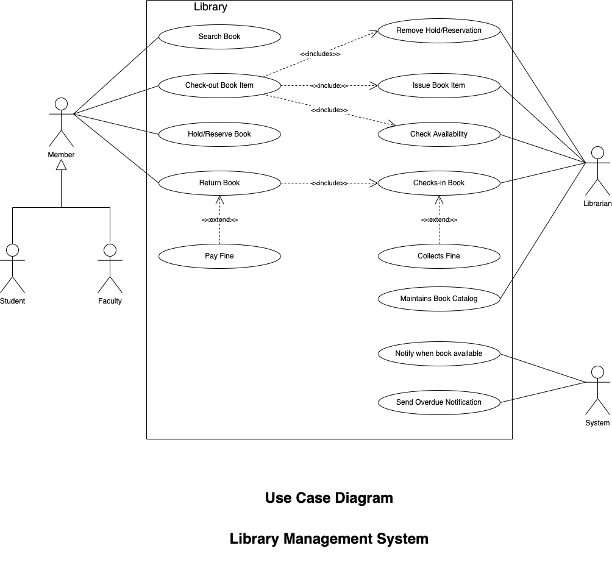

1. Use Case Description for ‘Return Book’ use case

| Use Case: Return Book |
| --- |
| ID: 4 |
| Brief Description:  The member returns the book borrowed from library |
| Primary Actors:  Member |
| Secondary Actors:  Librarian |
| Preconditions:   1. Member must have subscription at library 2. A book must be borrowed by the member |
| Main Flow:   1. Member returns the book 2. Librarian checks members profile and borrowed books 3. Librarian checks the book is present in borrowed books list   **Extension point:** Book is overdue - librarian issues fine (Issue Fine)   1. Librarian checks-in the book |
| Postconditions:  The borrowed book is returned |
| Alternative Flows:  None |

| Use Case: Issue Fine |
| --- |
| ID: 4 |
| Brief Description:  Librarian issues the overdue fine |
| Primary Actors:  Librarian |
| Secondary Actors:  None |
| Preconditions:   1. The book is being returned after the due date |
| Main Flow:   1. Librarian compares the due date and current date 2. Overdue fine is calculated 3. Member is issues the fine bill 4. Librarian collects the fine |
| Postconditions:  The fine is collected by librarian and recorded |
| Alternative Flows:  None |