# ***CS 6359 Project Description***

# ***Restaurant Management System***

# 

# **Team 2:**

# Rohit Kriplani, Gadipudi Chandana Sindhu, Greeshma Naga Lakshmi Palisetty, Sirisha Satish

1. Domain Model

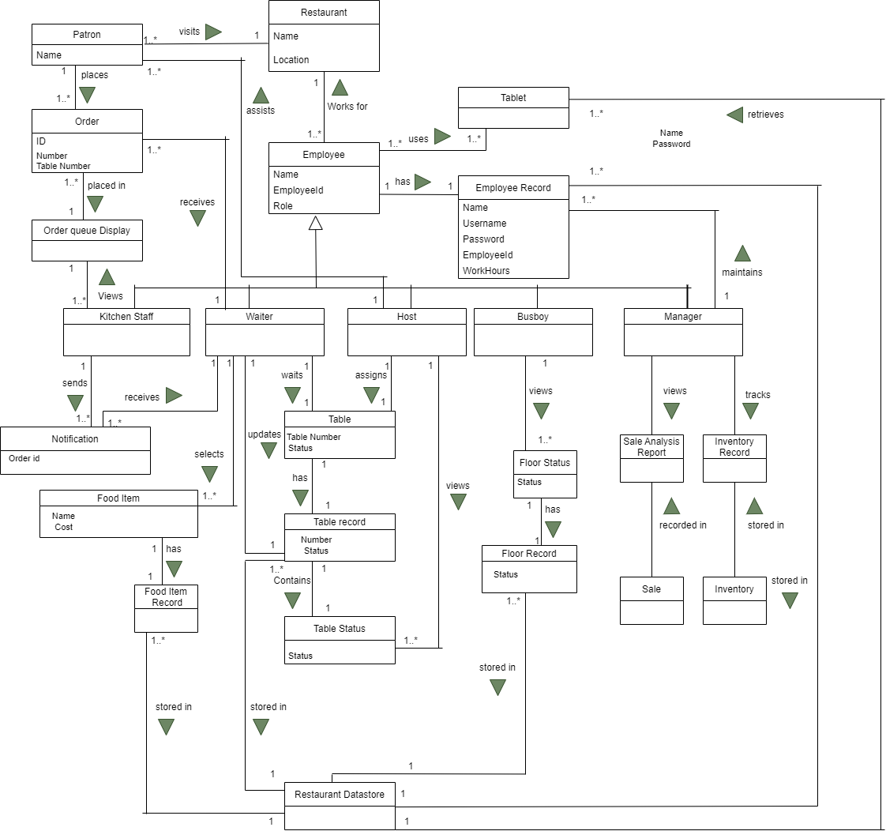

1. Use Case Model

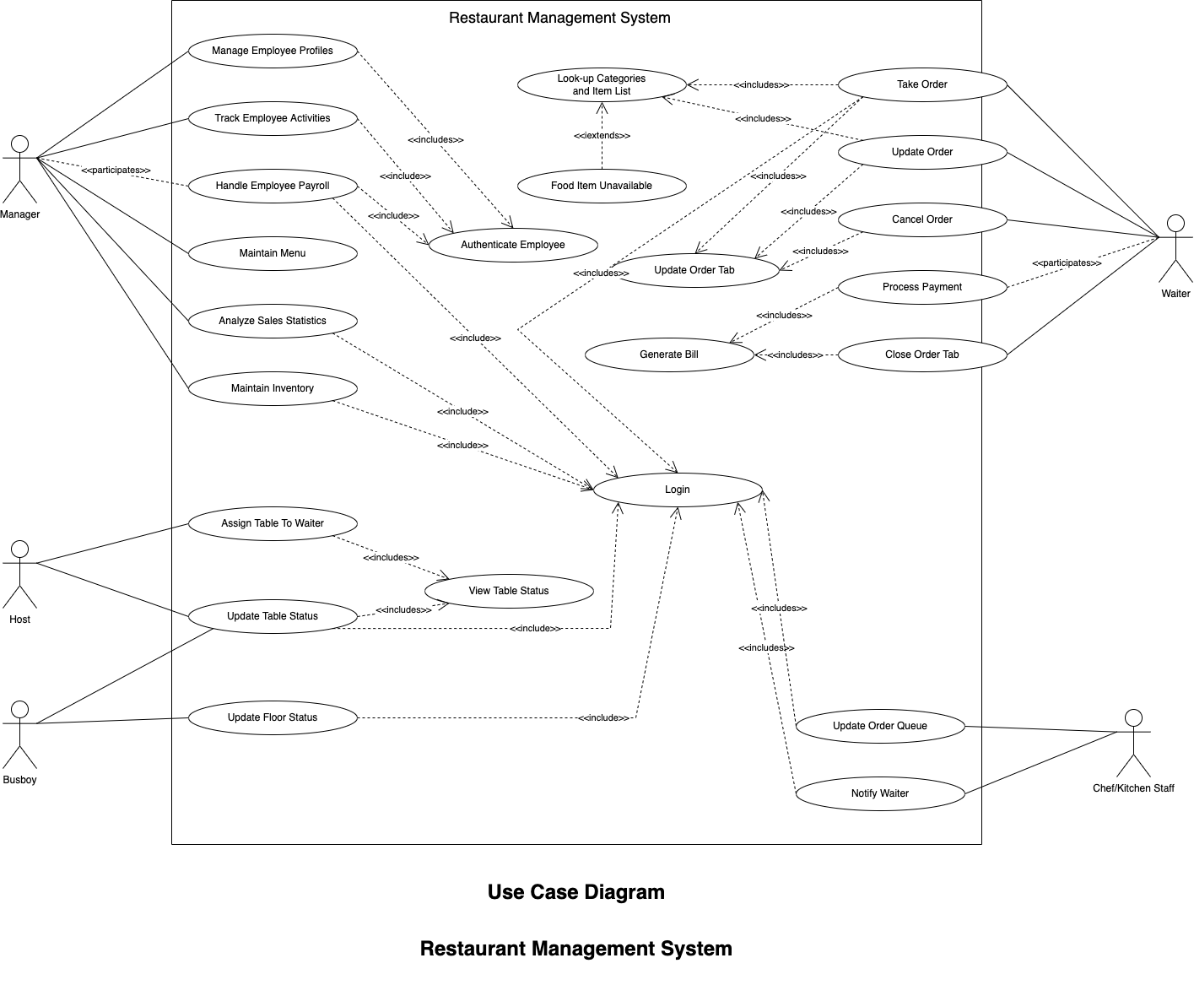

1. Use Case Prioritization

| **Sr. No.** | **Use Case** | **Description** |
| --- | --- | --- |
| 1 | Assign Table To Waiter | The host has the capability to assign the table to a waiter in order for waiter to initiate taking the order |
| 2 | Take Order | Wait staff is the primary actor, the process of taking/placing an order is initiated using the handheld device |
| 3 | Close Order Tab | When the patron asks for cheque, the wait staff closes the order tab of particular patron |
| 4 | Notify Waiter | When the food is prepared, the kitchen staff sends out a notification to the intended waiter/waitress |
| 5 | Update Table Status | Host updates the status of the table to be occupied or empty. Busboy updates the table status to be clean or dirty |
| 6 | Update Order | Wait staff updates the order if the patron asks for any changes in order before it is already served |
| 7 | Process Payment | System handles all the payment processing, wait staff will participate in this in the sense that it will let patron know of the bill amount and completes payment in system |
| 8 | Update Floor Status | Busboy updates the floor status i.e. how many tables are clean or dirty |
| 9 | Maintain Inventory | Manager maintains and looks over the inventory of the restaurant by looking at the inventory details present in system |
| 10 | Track Employee Activities | Manager tracks work-hours, leaves, etc. of all the employees |
| 11 | Handle Employee Payroll | System generates payroll of each employee based on the clocked-in hours. Manager participates by checking if there are any discrepancies in the generated payroll |
| 12 | Manage Employee Profiles | Manage adds/updates/maintains profiles of all the employees in the system |
| 13 | Update Order Queue | Kitchen staff updates the order queue by marking the order as initiated/pending/completed |
| 14 | Maintain Menu | Manager add, deletes, updates food items in the menu |
| 15 | Analyze Sales Statistics | Manager looks over the sales analysis report to analyse the revenue generated from each food item |
| 16 | Cancel Order | Wait staff can cancel the order if patron asks |

# 

# **Project Participation Report**

Team: 2

Submission Date: 04-20-2022

Deliverable: Updated Deliverable 1,UC Textual Descriptions (Fully dressed, Casual, brief formats),Black Box Sequence Diagram, Project participation report

**Areas/questions for discussion**

·

**Team Members participation**

Name 1: 25 %

Name 2: 25 %

Name 3: 25 %

Name 4: 25 %

**Member 1 (Rohit Kriplani)**

| **Tasks Completed** | **Hours** |
| --- | --- |
| Initially discussed the problem statement and requirements | 3 |
| Initial draft of use case diagram was replicated on draw.io and made further refinements | 2 |
| Discussed and prioritized the Use cases | 2.5 |
| Went through the final draft of domain model and made minute changes | 2 |
| Reviewed the final changes of both domain model and use case diagram and submitted | 1.5 |
| Made the final documentation | 1 |

Sign: Rohit Rajkumar Kriplani

**Member 2 (Sirisha Satish)**

| **Tasks Completed** | **Hours** |
| --- | --- |
| Initially discussed the problem statement and requirements | 3 |
| Discussed and made the initial draft on paper for the use case diagram, helped in refining changes | 2 |
| Discussed and prioritized the use cases | 2.5 |
| Went through the final draft of domain model and made minute changes | 2 |
| Reviewed the final changes of both domain model and use case diagram and submitted | 1.5 |
| Made the final documentation and project participation report | 1 |

Sign: Sirisha Satish

**Member 3 (Greeshma Nagalakshmi Palisetty)**

| **Tasks Completed** | **Hours** |
| --- | --- |
| Initially discussed the problem statement and requirements | 3 |
| Made the initial draft for domain model on paper, helped in further refinements | 2 |
| Reviewed the final changes of both domain model and use case diagram and submitted | 1.5 |

Sign: Greeshma Nagalakshmi Palisetty

**Member 4 (Chandana Sindhu Gadipudi)**

| **Tasks Completed** | **Hours** |
| --- | --- |
| Initially discussed the problem statement and requirements | 3 |
| Replicated the draft on draw.io and made further refinements | 2 |
| Reviewed the final changes of both domain model and use case diagram and submitted | 1.5 |

Sign: Chandana Sindhu Gadipudi