PROJECT HANDBOOK — READ THIS FIRST
Object–Context Decoupled Pooling (OCDP) for Label-Free Mitigation of Shortcut Learning
Problem statement, datasets, literature survey, proposed architecture, flow chart and implementation plan
Task | Image classification under spurious (shortcut) correlations
Primary dataset | Waterbirds (official Group DRO splits)
Backbone | ImageNet-pretrained ResNet-50
Contribution | OCDP head: object path + learned gate + training-only context sink
Supervision | Class labels only; no group labels in training or model selection
Main metric | Worst-group accuracy (WGA), mean ± std over 3 seeds
Framework | Python / PyTorch
Coding agent | Google Antigravity, one stage at a time with /plan
Compute | Laptop GPU for development; lab GPU for full runs
Target | Journal paper (shortlist in Section 10)
Status (19 Oct 2026) | Literature survey and design done; no code yet. Next: Stage 0 in Antigravity

Companion file: shortcut-starter-kit.zip (AGENTS.md, rules, stage prompts, literature matrix). Novelty is assessed against literature searched up to 19 October 2026; re-check before submission.

1. Problem statement
Deep image classifiers often learn shortcuts: features that predict the label in training data but are not its real cause. On Waterbirds, 95% of training waterbirds appear on water, so a model can score well by recognising water instead of the bird. It then fails on rare groups such as a waterbird on land.
Three things make this hard today:
- The architecture hides it. A ResNet averages its final feature map (global average pooling, GAP) before classifying, so bird evidence and water evidence are mixed into one vector.
- Most fixes need extra labels. Group DRO and DFR need group labels (class × background); ISNet and similar methods need segmentation masks.
- Label-free fixes are multi-stage and post-hoc. ExMap, Decompose-and-Compose and MaskTune train an ERM model, explain it with Grad-CAM or LRP, then retrain. The explanation is an approximation and the pipeline is long.
Problem we solve: design a classification head that separates object evidence from context evidence inside the model, trains itself to ignore the context shortcut without group labels or masks, and exposes that separation as a faithful evidence map and a per-image shortcut score.
Scope limit: OCDP targets shortcuts that sit in a different image region from the object (backgrounds, co-occurring objects, patches). It is not expected to help when the shortcut overlaps the object, such as hair colour vs. gender in CelebA.

2. Objectives and research questions
Main objective: a label-free architectural head that matches or beats multi-stage label-free methods on worst-group accuracy, with negligible overhead.
ID | Objective | Measured by
O1 | Design and implement the OCDP head for ResNet-50 | Working code, unit tests, about 2% extra parameters
O2 | Improve robustness without group labels | Waterbirds WGA vs ERM, JTT, LfF, ExMap, DaC, EVaLS
O3 | Show the gain comes from the architecture | Same recipe with GAP, attention-MIL, top-k and DAR-style heads
O4 | Produce a faithful evidence map | Energy-in-mask vs Grad-CAM (CUB masks, evaluation only); deletion/insertion curves
O5 | Provide a per-image shortcut score | AUROC for detecting minority-group images
O6 | Show it generalises | UrbanCars and MetaShift results

Research questions
- RQ1 (main): Does replacing GAP with OCDP improve worst-group accuracy without group labels, compared with label-free methods and with pooling heads that lack the context sink?
- RQ2: Does OCDP's evidence map localise the object better than Grad-CAM on a standard ERM model?
- RQ3: Does the context sink's confidence identify bias-conflicting images better than loss, confidence and heatmap-cluster signals?
- RQ4: Do the gains hold with several shortcuts at once (UrbanCars), where fixing one can amplify another?

3. Dataset suggestions
Start with Waterbirds only. Add the next dataset only after the Waterbirds pipeline gives stable numbers over 3 seeds.
Priority | Dataset | Shortcut | Why we use it
1 (primary) | Waterbirds | Land or water background | Standard benchmark; four groups (class × background); passes benchmark validity checks (Bell et al. 2024). Source: Group DRO repository
2 | UrbanCars | Background and co-occurring object | Several shortcuts at once; used by ExMap
3 | MetaShift (cat vs dog) | Indoor or outdoor context | Natural photos rather than composites; used by Decompose-and-Compose
4 (if time) | Spawrious or ISIC | Generated backgrounds / colour patches | Spawrious is harder; ISIC gives a medical case study
Control only | CelebA | Hair colour vs gender (not spatial) | Shows the scope limit honestly; not a headline result

Waterbirds facts to verify in the Stage 1 audit
Commonly reported figures, not yet checked by us.
- Train / validation / test sizes of about 4,795 / 1,199 / 5,794 images.
- Training groups heavily skewed: about 3,498 landbird-on-land, 184 landbird-on-water, 56 waterbird-on-land, 1,057 waterbird-on-water.
- Group id g = 2 × label + place, read from metadata.csv.

Rules for every dataset
- Use the official splits; never tune on test.
- Group labels and CUB segmentation masks live in an evaluation-only folder. Training code must not read them, and a test enforces it.
- Record download source, licence, file hashes and counts per split × group in results/dataset_audit/.

4. Literature survey
Label-free reweighting already reaches 88–93% WGA on Waterbirds, so we do not compete on a new weighting rule. The open space is architectural: no published method we found separates object and context evidence spatially, inside the classifier, without labels. Numbers are as reported on each source page; papers use different ERM recipes, so compare with care.
Supervision tiers: T1 = group labels in training; T2 = group labels only on validation; T3 = no group labels.

4.1 Methods we must beat or match
Method | Venue | Idea in one line | Tier | WB WGA (%)
Group DRO | ICLR 2020 | Minimise the worst group's loss | T1 | 91.4
JTT | ICML 2021 | Up-weight examples a short ERM run gets wrong | T2 | 86.7
DFR | ICLR 2023 | Retrain last layer on group-balanced data | T2 | 92.1–92.3
LfF | NeurIPS 2020 | Train a biased model with GCE; up-weight what it fails on | T3 | check paper
ExMap | CVPR 2024 | Cluster LRP heatmaps into pseudo-groups | T3 | 92.5
Decompose-and-Compose | CVPR 2024 | Grad-CAM masks; paste parts across classes | T2 | 92.3
ShortcutProbe | IJCAI 2025 | Probe latent shortcut directions, retrain | T3 | 90.8 ± 0.6
EVaLS | arXiv 2024 | Loss-balanced last-layer retraining | T3 | 88.4 ± 3.1
HSFM | arXiv 2026 | Meta-learn embeddings on a hard validation set | T2 | 93.1 ± 0.1
MaskTune | NeurIPS 2022 | Mask salient regions, fine-tune | T3 | check paper

4.2 Closest to our architecture
Work | Venue | What it does | How OCDP differs
Deep Attention Reweighting (DAR) | arXiv, May 2026 | Post-hoc spatial attention replaces GAP; retrained on a 1,000-image balanced set | Needs a balanced set; main runs ResNet-18 from scratch (WB 74.6). No context sink, not end to end
Rethinking GAP as MIL | arXiv, Jun 2026 | Proves GAP + linear = mean of per-location logits | Analysis only; lists a learned background component as future work, which OCDP is
Box-Guided Evidence Routing (BGER) | arXiv, Oct 2026 | Trains a gate on the final feature map using boxes or masks to improve CAMs | Needs boxes/masks; targets localisation, not shortcut robustness. Closest in mechanism: cite and contrast
Two-stage ViT hard masking | ICPR 2026 | Stage 1 finds parts; stage 2 sees only those regions | Two passes, ViT, input masking; no sink or reweighting
ReBias / DisEnt | ICML 2020 / NeurIPS 2021 | Separate biased network or encoder | OCDP's biased path is spatial and shares the backbone
AGS | ICLR 2026 | Label-free gating of classifier–feature alignment (WB 80.9) | Not spatial; names channel/head gating as future work
XAI analysis of shortcuts (Le et al.) | xAI 2025 | Finds neurons that encode spurious features | Analysis; supports the motivation
FocusMIL | arXiv 2024 | Max-pooling MIL more robust than attention MIL | Pathology; we include max/top-k pooling as a control

4.3 The gap we target
A single-stage, label-free pooling head that (a) gates each location into object or context, (b) trains the context path as a deliberate shortcut sink, and (c) up-weights images the sink gets wrong. We found no paper doing all three as of 19 October 2026. Re-run the search before submission with the terms “context sink”, “background instance”, “dense readout” and “evidence routing”.
We will not claim to be first with spatial attention (DAR), a gated final feature map (BGER), or a biased auxiliary model (LfF, ReBias).

5. Proposed architecture: OCDP
OCDP replaces GAP and the final linear layer of an ImageNet-pretrained ResNet-50. Everything up to layer4 is unchanged. It adds about 0.53 M parameters (about 2% of ResNet-50's 25.6 M).
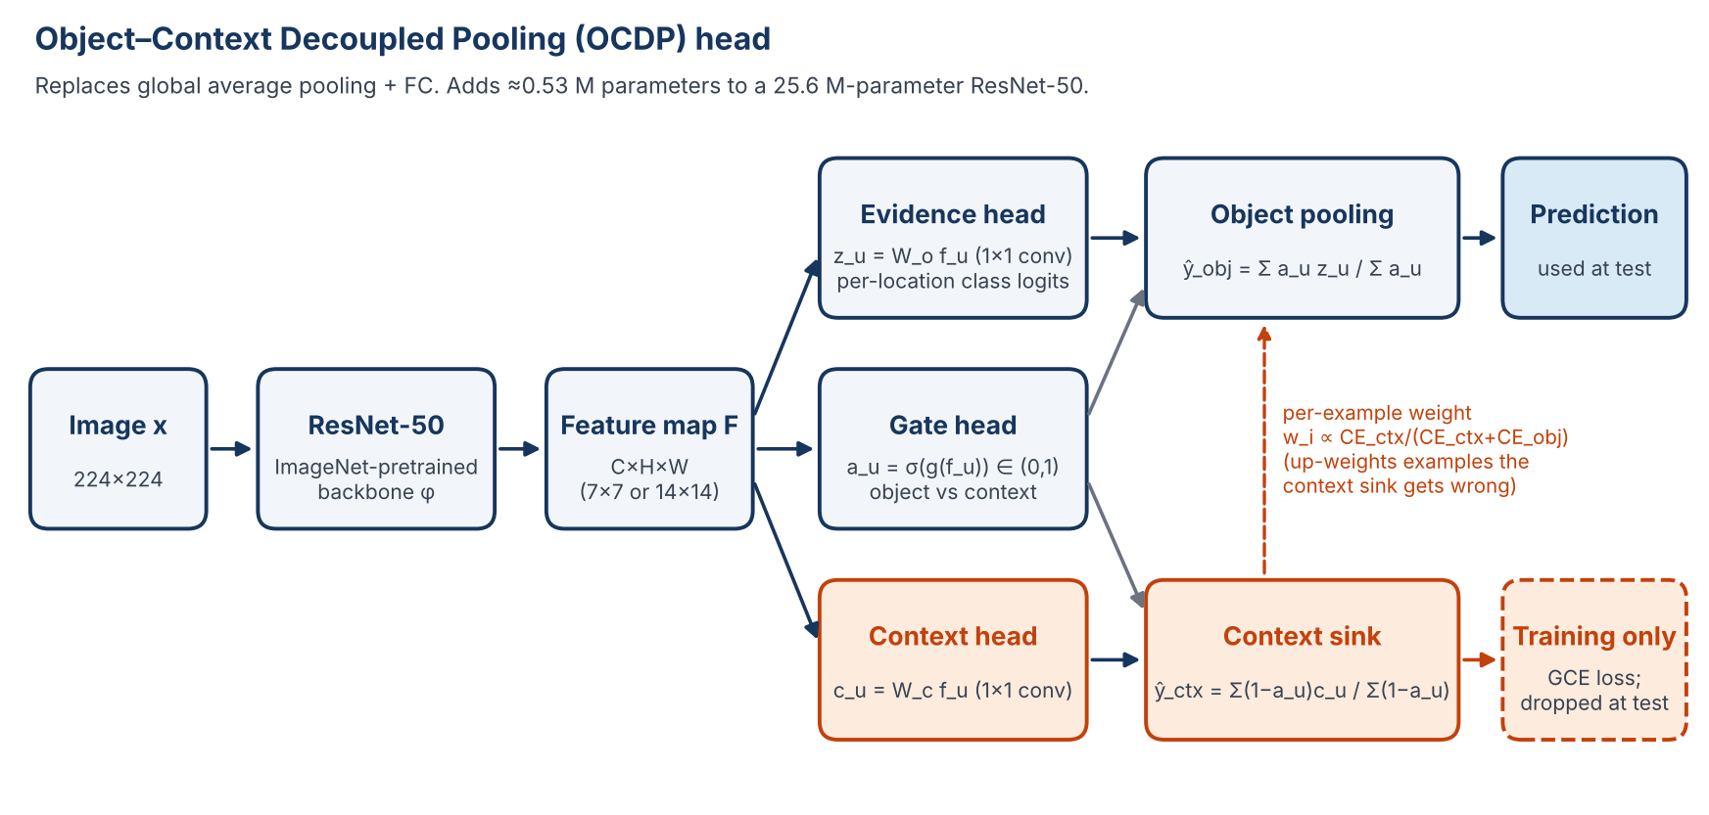
Figure 1. The gate splits every location between the object path (kept at test) and the context sink (training only). The sink learns the shortcut on purpose; its mistakes tell the object path which images to weight more.

5.1 Components
Let F be the layer4 feature map (2048 channels, 7×7 at 224 px input) with feature vector f_u at location u, and K classes.
Part | What it computes | Used at test?
Evidence head | 1×1 conv: class logits at every location, z_u = W_o f_u + b_o | Yes
Gate head | 1×1 conv MLP (2048 → 256 → 1) + sigmoid: a_u in (0, 1), how much location u is object | Yes
Object pooling | Gate-weighted mean of location logits | Yes — this is the prediction
Context head | Separate 1×1 conv: c_u = W_c f_u | No
Context sink | Mean of c_u weighted by (1 − a_u); trained to fit the shortcut | No

ŷ_obj = Σ_u a_u z_u / (Σ_u a_u + ε) ŷ_ctx = Σ_u (1 − a_u) c_u / (Σ_u (1 − a_u) + ε)
With all gates equal, object pooling is exactly GAP + linear, so OCDP can be initialised from the ERM model.

5.2 Training objective
L = L_obj + λ_g L_ctx + λ_a L_area + λ_c L_cons
L_obj = Σ_i w_i CE(ŷ_obj,i , y_i) / Σ_i w_i L_ctx = mean_i GCE_q(ŷ_ctx,i , y_i)
L_area = mean_i (ā_i − ρ)² L_cons = mean_i KL(p_obj(x_i) ‖ p_obj(x_i ⊙ M(a_i)))
- Context sink loss (GCE, q ≈ 0.7, as in LfF): makes the sink fit the easiest, most shortcut-like evidence first.
- Example weights: w_i = CE_ctx,i / (CE_ctx,i + CE_obj,i), smoothed with a moving average and clipped. Images the sink gets wrong (bias-conflicting) get more weight on the object path.
- Area prior: keeps the mean gate near ρ (start at 0.3) so it cannot collapse to all-object or all-context.
- Consistency: masking low-gate regions of the input should not change the object prediction. Needs a second forward pass, so it is used only in end-to-end training, not in the pilot.
- Schedule: a few warm-up epochs with w_i = 1 and no consistency, so the sink learns the shortcut first.

5.3 What we get for free
- Shortcut score per image: s_i = p_ctx(y_i | x_i). High means the background alone predicts the label.
- Faithful evidence map: a_u · z_u[y] at each location. The prediction is exactly the sum of these terms, so the map is the computation, not an approximation like Grad-CAM.
- Label-free: training uses class labels only; model selection uses worst-class validation accuracy.

5.4 Known risks
Risk | Sign | Safeguard
Gate collapses | Mean gate goes to 0 or 1 | Area prior; log gate histograms every epoch
Sink learns the bird too | Majority-group accuracy drops | Stop gradient from sink into backbone; lower λ_g
7×7 too coarse | Bird and water share cells | Try dilated layer4 (14×14)
Weights explode | A few images dominate | Clip and normalise weights; log their distribution
Gain is just reweighting | LfF on a GAP model matches OCDP | Always run the LfF-on-GAP control

6. Research flow chart
We test the cheapest version first and stop early if it fails. Each box is one or more Antigravity stages; each gate is a team decision made from real numbers.
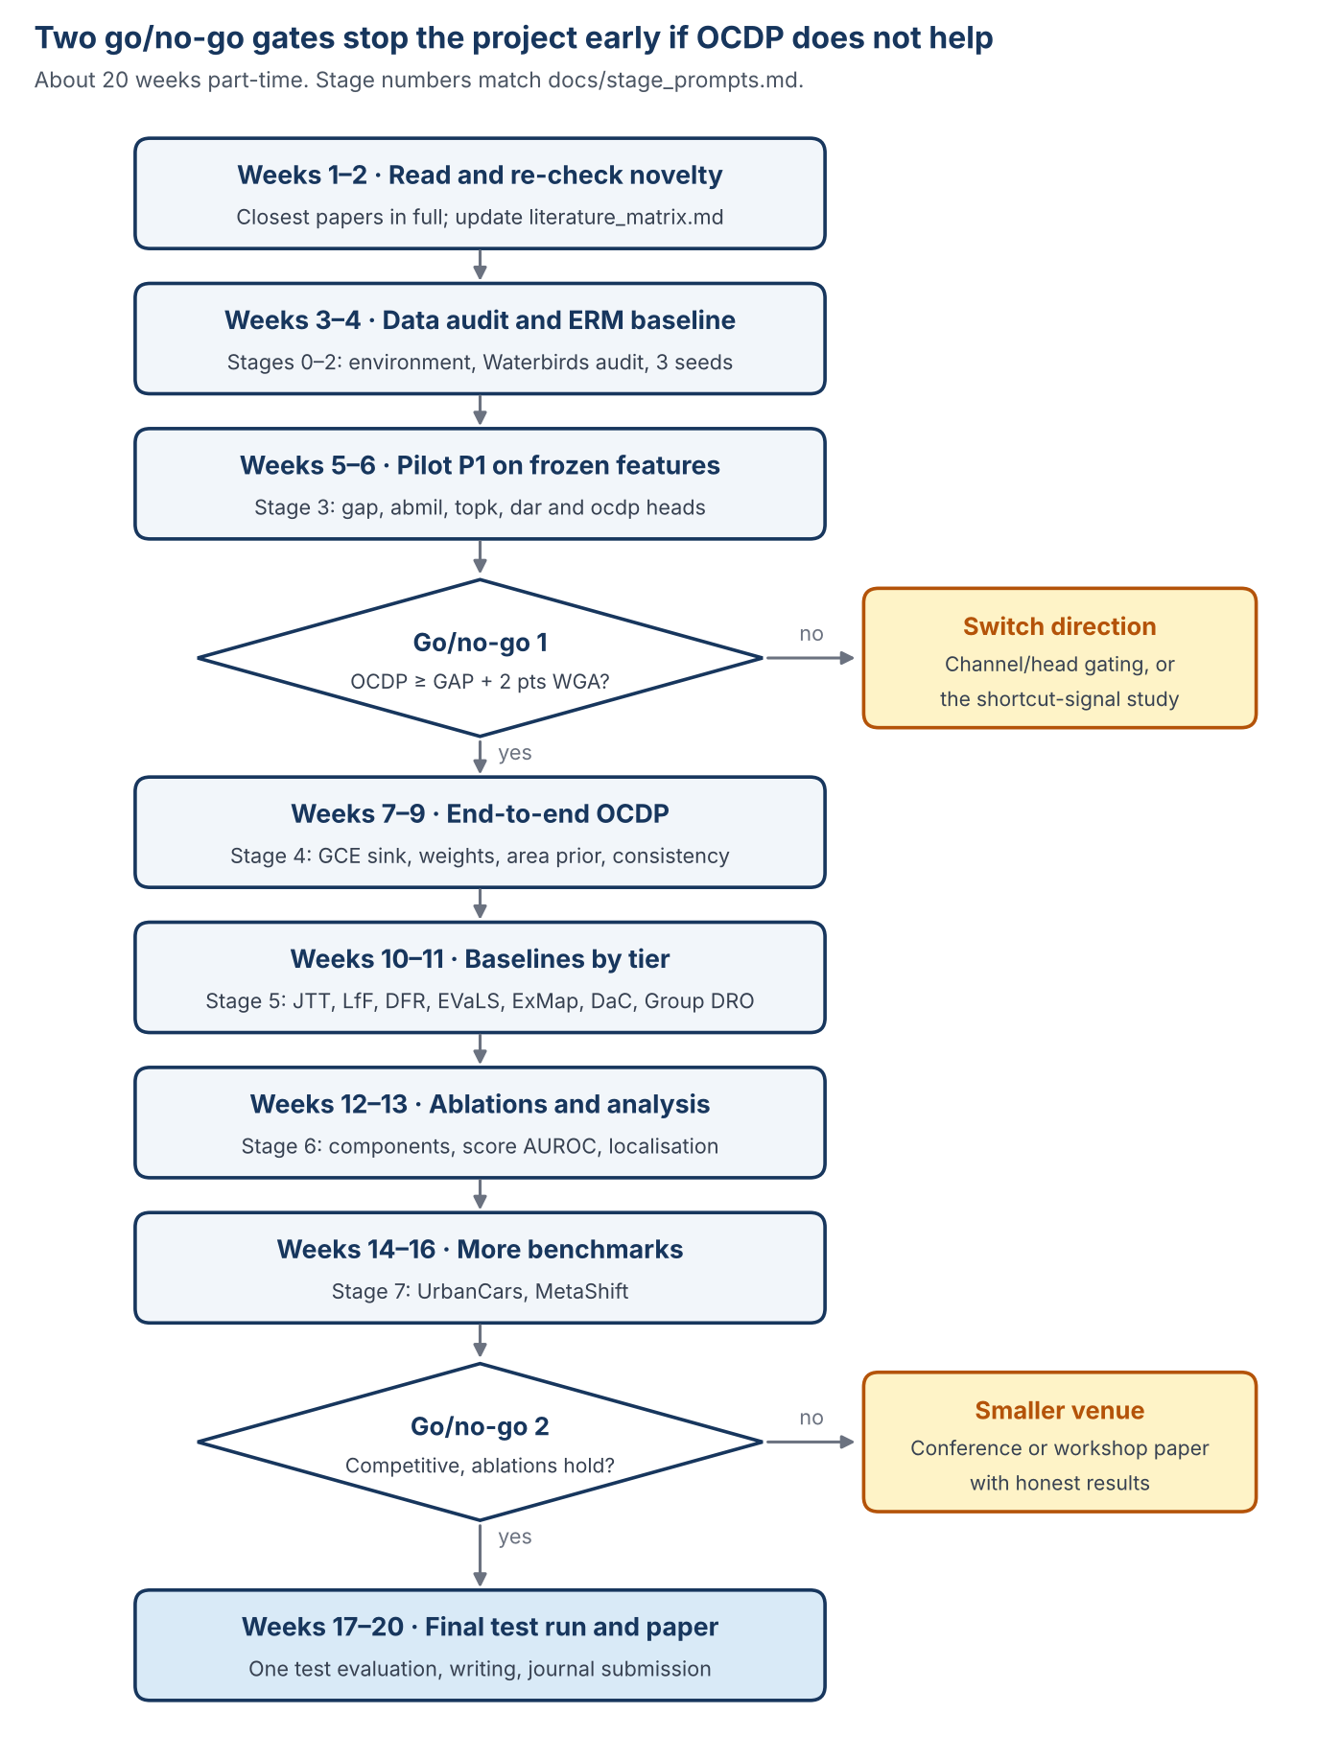
Figure 2. The pilot at week 6 trains only the head on saved ERM features, so it is cheap, and it tells us whether the architecture is worth the end-to-end work.

7. Implementation plan
Build the cheapest test first. Reuse existing code for baselines (SubpopBench or the official DFR repository) instead of writing them from scratch.

7.1 Stack
Python 3.10+, PyTorch + torchvision, NumPy, pandas, scikit-learn, matplotlib, tqdm, PyYAML, pytest, and a documented Grad-CAM library (for the ERM comparison only). Pin versions in requirements.txt; record PyTorch, CUDA and GPU model with every run.

7.2 Repository layout
AGENTS.md rules Antigravity always follows
.agents/rules/ evaluation protocol
.agents/skills/stage-report/ end-of-stage report procedure
docs/literature_matrix.md the only papers the agent may cite
docs/stage_prompts.md one /plan prompt per stage
src/data/ loaders, group definitions, audits
src/models/ backbone; heads: gap, abmil, topk, dar, ocdp
src/losses/ ce, gce, example weights, area prior, consistency
src/baselines/ jtt, lff, dfr, evals, exmap, dac wrappers
src/evaluation/ metrics, localisation, interventions, statistics
configs/ one YAML per experiment
tests/ data, group mapping, metrics, mask-import guard
results/ CSV/JSON per run (figures generated from these)
checkpoints/ git-ignored

7.3 Run sequence
Run | What | Why | Output
R0 ERM | Fine-tune ResNet-50 with GAP; 3 seeds; fixed recipe | Baseline and frozen features for the pilot | results/erm/
P1 Pilot | Train only the head on frozen R0 features: gap, abmil, topk, dar, ocdp; same recipe | Cheapest test of whether OCDP helps | Go/no-go 1 table
R1 OCDP | End-to-end training with warm-up, weights, area prior, consistency | Main method | results/ocdp/
R2 Baselines | JTT, LfF, label-free DFR, EVaLS, ExMap, DaC; Group DRO and DFR as references | Fair comparison by tier | Comparison table
R3 Ablations | Remove each component; stop-gradient; 7×7 vs 14×14; ρ; q | Show each part matters | Ablation table
R4 Analysis | Shortcut-score AUROC; evidence-map localisation; background swaps | RQ2 and RQ3 | Figures
R5 Benchmarks | UrbanCars, MetaShift; then Spawrious or ISIC | RQ4 | Multi-dataset table

7.4 Logging every run must produce
- Resolved config, git commit hash, seed, package and GPU versions.
- Per epoch: train loss, validation accuracy per group, worst-class accuracy, mean gate and gate histogram, weight distribution, sink accuracy.
- Final: overall, per-group (with counts), mean-group and worst-group accuracy, as JSON.

8. Evaluation: metrics, baselines, ablations
Worst-group accuracy is the headline number; every other metric supports a specific research question.
Metric | Answers | Notes
Worst-group accuracy | RQ1 | Mean ± std over 3 seeds; 95% bootstrap CI
Mean-group and average accuracy | RQ1 | Average reported plain and weighted by training group sizes (Group DRO/DFR convention); say which
Per-group accuracy with counts | RQ1 | Shows which groups moved
Energy-in-mask, pointing game | RQ2 | CUB masks, evaluation only; compare with Grad-CAM on ERM
Deletion / insertion curves | RQ2 | Faithfulness of the evidence map
Shortcut-score AUROC, AUPRC, precision@k | RQ3 | Detecting minority-group images on validation vs loss, confidence, entropy, ExMap clusters
Background-swap sensitivity | RQ2, RQ3 | Logit change when only the background is swapped (same bird, new background)
ECE, Brier score | Calibration | Overall and per group
Parameters, training time, peak memory | Cost | For every method

Baselines, grouped by tier
- T3 (our tier, main comparison): ERM, JTT, LfF, label-free DFR (class-balanced), EVaLS, ExMap, ShortcutProbe if the code runs.
- T2 (reference): DFR, Decompose-and-Compose, JTT with group-based selection.
- T1 (upper reference): Group DRO.
- Architecture controls (same recipe as OCDP): GAP, attention-MIL pooling, max/top-k pooling, DAR-style attention head, LfF on a GAP model.

Ablations
- No context sink (gate and object path only).
- No gate (GAP object path plus a global context head) — separates spatial decoupling from reweighting.
- Sink trained with CE instead of GCE; no reweighting; no area prior; no consistency.
- Stop-gradient from sink to backbone on vs off; 7×7 vs 14×14; ρ in {0.2, 0.3, 0.5}; q in {0.5, 0.7, 0.9}.
- Random gate with the same area. Optional: B-cos ResNet-50 backbone.

9. Timeline and go/no-go criteria
About 20 weeks part-time (6–8 hours a week each), with two decision points.
Weeks | Focus | Stage | Deliverable
1–2 | Read and re-check novelty | — | Updated literature matrix
3–4 | Data audit and ERM baseline | 0–2 | ERM table (3 seeds)
5–6 | Pilot P1 on frozen features | 3 | Go/no-go 1
7–9 | End-to-end OCDP | 4 | Working method
10–11 | Baselines by tier | 5 | Comparison table
12–13 | Ablations and analysis | 6 | Ablation and analysis tables
14–16 | More benchmarks | 7 | Go/no-go 2
17–20 | Final test run and paper | 7 | Submission draft

Go/no-go 1 — end of week 6
- OCDP head beats the GAP head (same T3 recipe) by at least 2 points mean validation WGA over 3 seeds.
- OCDP beats attention-MIL and the DAR-style head, so the context sink matters beyond attention.
- Evidence maps put more mass on the bird than Grad-CAM on ERM (energy-in-mask).
- If not: switch to the backup gap (label-free channel or head gating) or write up the shortcut-signal evaluation study.

Go/no-go 2 — end of week 16
- End-to-end OCDP is within the confidence interval of the best T3 baseline on Waterbirds and better on at least one other dataset (ideally UrbanCars).
- Ablations show the gate and the sink each add value; LfF on GAP does not explain the gain.
- The shortcut score beats loss and confidence at finding minority images.
- Stable over 3 seeds; overhead reported; novelty search re-run with no new overlapping paper.
- If not: report results honestly and consider a conference or workshop paper instead.

10. Target journals
Shortlist by topic fit; check the current quartile in JCR or SJR and recent similar papers before choosing.
- Pattern Recognition (Elsevier) — architecture and robustness papers with thorough experiments.
- IEEE Transactions on Neural Networks and Learning Systems — learning-method papers with strong empirical work.
- Neural Networks (Elsevier) — fits a pooling/learning mechanism.
- Knowledge-Based Systems (Elsevier) — published OCIE, so explanation-guided robustness is in scope.

11. How we work
One stage at a time, reviewed by a person before code is merged. The coding agent writes code; we decide what counts as a result.

11.1 Antigravity
- Unzip shortcut-starter-kit.zip into the repository root. It holds AGENTS.md (always-on rules), .agents/rules/evaluation-protocol.md, the stage-report skill, docs/literature_matrix.md and docs/stage_prompts.md.
- Settings: terminal command execution = Request Review; non-workspace file access = off.
- New conversation per stage. Type /plan followed by that stage's prompt from docs/stage_prompts.md.
- Read the Implementation Plan it produces, comment where it is wrong, then click Proceed.
- Finish with the stage report. Check every number against the files in results/.
- The agent may cite only papers in docs/literature_matrix.md.
Antigravity's agent manager cannot work on a remote server directly (as of October 2026). Write and smoke-test on the laptop, push, then run long jobs on the lab server inside tmux.

11.2 Stages
Stage | Prompt summary | Ends with
0 Inspect | Inspect repo and machine; read the rules and this handbook; review SubpopBench and DFR code; propose layout and pinned dependencies. No file changes | Plan
1 Data | Waterbirds loader, metadata checks, group-mapping test, audit tables, evaluation-only mask folder with an import guard | Audit report
2 ERM | Config-driven ERM; smoke test; tmux command for 3 seeds; summary script; no test evaluation | ERM table
3 Pilot | Heads gap, abmil, topk, dar, ocdp on frozen ERM features; same T3 recipe; 3 seeds | Go/no-go 1
4 End-to-end | Full OCDP with warm-up, GCE sink, weights, area prior, consistency | OCDP results
5 Baselines | Wrap JTT, LfF, label-free DFR, EVaLS, ExMap, DaC, Group DRO; matched budgets | Comparison table
6 Ablations | Component ablations; score AUROC; localisation; background swaps | Analysis
7 Final | UrbanCars, MetaShift; one final test evaluation; statistics; reproducibility audit | Draft report

11.3 Git and integrity rules
- Branch per stage (stage-1-data, …); open a pull request; the other person reviews before merge.
- Commit at every checkpoint with a clear message; never commit data, checkpoints or credentials.
- Shell commands in bash syntax (Git Bash on Windows; Linux on the server).
- The test set is touched once, at the end, by an explicit final-evaluation command.
- No fabricated numbers, no placeholder result files, no silent shortening of runs. Failed runs are reported.
- Every results table carries a supervision-tier column.

12. Getting started checklist
Work through these in order in your first week; ask before skipping one.

Read (about 6 hours)
☐ This handbook, end to end
☐ Group DRO paper and repository README — how Waterbirds is built
☐ DFR — the simple baseline everyone compares with
☐ LfF — the GCE biased-model idea our sink borrows
☐ Deep Attention Reweighting and Rethinking GAP as MIL — our closest prior work
☐ Box-Guided Evidence Routing — closest in mechanism; note exact overlaps
☐ ExMap — the strongest label-free result we compare with

Set up (about 3 hours)
☐ Get access to the GitHub repository and the lab GPU server
☐ Install Antigravity; apply the settings in Section 11.1
☐ Clone the repository; unzip the starter kit at the root
☐ Create a Python environment from requirements.txt (after Stage 0 writes it)
☐ Run python -c "import torch; print(torch.__version__, torch.cuda.is_available())" and share the output

First tasks
☐ Run Stage 0 in Antigravity and share its plan before approving
☐ Download Waterbirds (Stage 1) and check counts per split × group against Section 3
☐ Add one line to docs/literature_matrix.md for any paper you find that overlaps OCDP

Open questions to settle as a team
☐ Who owns which stages (suggested: one person on data, ERM and baselines; one on OCDP, pilot and ablations)
☐ Lab GPU model, VRAM and disk quota
☐ Target journal shortlist and submission month

Appendix. Reference links
- Group DRO / Waterbirds: https://github.com/kohpangwei/group_DRO
- JTT: https://proceedings.mlr.press/v139/liu21f.html
- DFR: https://openreview.net/pdf?id=Zb6c8A-Fghk
- LfF: https://arxiv.org/abs/2007.02561
- AFR: https://proceedings.mlr.press/v202/qiu23c/qiu23c.pdf
- ExMap: https://arxiv.org/abs/2403.13870
- Decompose-and-Compose: https://arxiv.org/abs/2402.18919
- MaskTune: https://arxiv.org/abs/2210.00055
- ShortcutProbe: https://www.ijcai.org/proceedings/2025/795
- EVaLS: https://arxiv.org/abs/2410.05345
- HSFM: https://arxiv.org/abs/2603.29313
- POTER: https://arxiv.org/abs/2610.01028
- SCER: https://arxiv.org/abs/2511.04401
- Deep Attention Reweighting: https://arxiv.org/abs/2605.20732
- Rethinking GAP as MIL: https://arxiv.org/abs/2606.14555
- Box-Guided Evidence Routing: https://arxiv.org/abs/2610.05891
- Two-stage ViT hard masking: https://github.com/ananthu-aniraj/ifam
- AGS (ICLR 2026 notes): https://en.papernotes.org/ICLR2026/others/regulating_internal_alignment_flows_for_robust_learning_under_spurious_correlati/
- FocusMIL: https://arxiv.org/abs/2408.09449
- ReBias: https://proceedings.mlr.press/v119/bahng20a/bahng20a.pdf
- DisEnt: https://arxiv.org/abs/2107.01372
- SupER: https://arxiv.org/abs/2508.08570
- Memorization neurons: https://arxiv.org/abs/2501.00961
- ASM: https://arxiv.org/abs/2501.00942
- XAI analysis of shortcut learning: https://link.springer.com/chapter/10.1007/978-3-032-08327-2_20
- ISNet: https://www.nature.com/articles/s41467-023-44371-z
- OCIE: https://github.com/DLAIResearch/OCIE
- Rao et al., ICCV 2023: https://arxiv.org/abs/2303.11932
- Benchmark validity (Bell et al.): https://arxiv.org/abs/2409.04188
- UrbanCars / Whac-A-Mole: https://arxiv.org/abs/2212.04825
- AutoBackSwap: https://arxiv.org/abs/2606.32018
- Survey (Ye et al.): https://arxiv.org/abs/2402.12715
- Antigravity docs: https://antigravity.google/docs/getting-started
- Antigravity rules: https://antigravity.google/docs/rules
- Antigravity remote SSH thread: https://discuss.ai.google.dev/t/how-to-remote-ssh-access-under-antigravity-2-0/145573
Background Challenge (ICLR 2021), Right for the Right Reasons (2017), SubpopBench (ICML 2023) and B-cos (CVPR 2022) are cited from prior knowledge; add verified links before submission.

