
PROJECT REPORT
(2019-2020)
ONLINE SHOPPING WEBSITE
Department of Computer Engineering &
Applications
Institute of Engineering & Technology
GLA UNIVERSITY, MATHURA
SUBMITTED TO:
Mr. Sharad Gupta
(Assistant Professor)
SUBMITTED BY:
Shiv Shankar Tripathi (171500319)
Greeshma Gupta (171500116)
Manali Sharma(171500176)
CERTIFICATE
We hereby declare that the work which is being presented in the mini project
“Online Shopping Website ”,in fulfillment of the requirements for viva voce, is
an authentic record of my own work carried under the supervision of “Sharad
Gupta”



Declaration

Department of computer Engineering and Applications
GLA University, Mathura

17 km. Stone NH#2, Mathura-Delhi Road, P.O. – Chaumuhan,
Mathura – 281406

Semester: Sixth
Year: 3rd
Course: Bachelor of Technology
Roll. No.:171500116 ,171500176,171500319
Name of Candidate: Greeshma Gupta , Manali Sharma and Shiv Shankar
Tripathi
Signature of Candidate:
I hereby declare that the work which is being presented in the mini project “Online
Shopping Website” ,in partial fulfillment of the requirements for Summer
Training viva voce, is an authentic record of my own work carried under the
supervision of “ Sharad Gupta ”
Abstract
This mini project report documents the amount of work done in the Mini Project
during this semester. The report first shall give an overview of technologies used
in making of this project. Then different Modules of the project with all their
description. Report shall also elaborate on the future works which are still to be
persuaded as an advancement of current work. We have tried our best to keep the
report simple yet technically correct.
Acknowledgement
It is our pleasure to acknowledge the assistance of a number of people without
whose help this project would have not been possible.First and Foremost, We
would like to express our gratitude to Mr. Sharad Gupta project guide, for
providing invaluable encouragement, guidance and assistance.
After doing this project, We can confidently say that this experience has not only
enriched me with technical knowledge but also has unparsed the maturity of
thought and vision. The attributes required being a successful professional.
CONTENT
Page No.
Certificate
Declaration
Abstract
Acknowledgement
2
3
4
5
1. Introduction
1.1 Motivation
1.2 Overview
1.3 Implementation
2. Overall Description
2.1
2.2
Data Flow Diagram
Sequence Diagram
7
7
7
7
8
8
10
10
12
12
15
21
44
44
3. Testing of project
4. Future Scope
5. Project Screenshot
6. Technologies Used
7. Project Code
8. Contribution of team members
9. Bibliography
1. Introduction
1.1 Motivation
It is difficult for everyone to go out for shopping as everyone is so busy in all other
work. This project offers them to buy products of their choice from there home
thus saving there lot of time.
1.2 Overview
It is difficult for everyone to go out for shopping as everyone is so busy in all other
work. This project offers them to buy products of their choice from there home
thus saving there lot of time. They don’t need to stand in lines for getting there
product. They don’t need to travel from one place to another. There are also some
problem with the online shopping such as we are not able to check the quality of
the product which is reaching to us.
The project aimed at developing a web application where a user can buy
products. The Website involves all the compulsory feature of online shopping
website. The major feature of this web application is to help the user to buy the
product of their choice where a large number of product are available in the
market which makes the user a bit in a confusion. It lists all the type of product
and its all relevant information.
1.3 Implementation and user interface
Just like every other application, this too has two major parts. The front end and
the back end. The Frontend end part relies on HTML and CSS. This is then
styled and made to render in the browser. All the relevant information are fetched
and are carefully laid on the webpage. The backend is supported by the PHP and
database is made by the help of xampp server. All the data is stored in the
database from where it is fetched to the user.
Frontend of website
When the user first time visits the website he has to create his account by
entering his basic details. After that user receive a mail on his registered mail
for verification of his details. After verification user can login his account by
his/her username and Password. After login user can search for products of
his/her choice and add them to his cart and order them.
Backend of website
Backend database is managed with the help of the Xampp server and PHP. There
are two tables which are stored in the database. One table
Contain all the information of the user and the other table contains the
information regarding the user.
2. Overall description
2.1 Data flow diagram
A data-flow diagram (DFD) is a way of representing a flow of a data of
a process or a system (usually an information system). The DFD also provides
information about the outputs and inputs of each entity and the process itself. A
data-flow diagram has no control flow, there are no decision rules and no loops.
Specific operations based on the data can be represented by a flowchart.
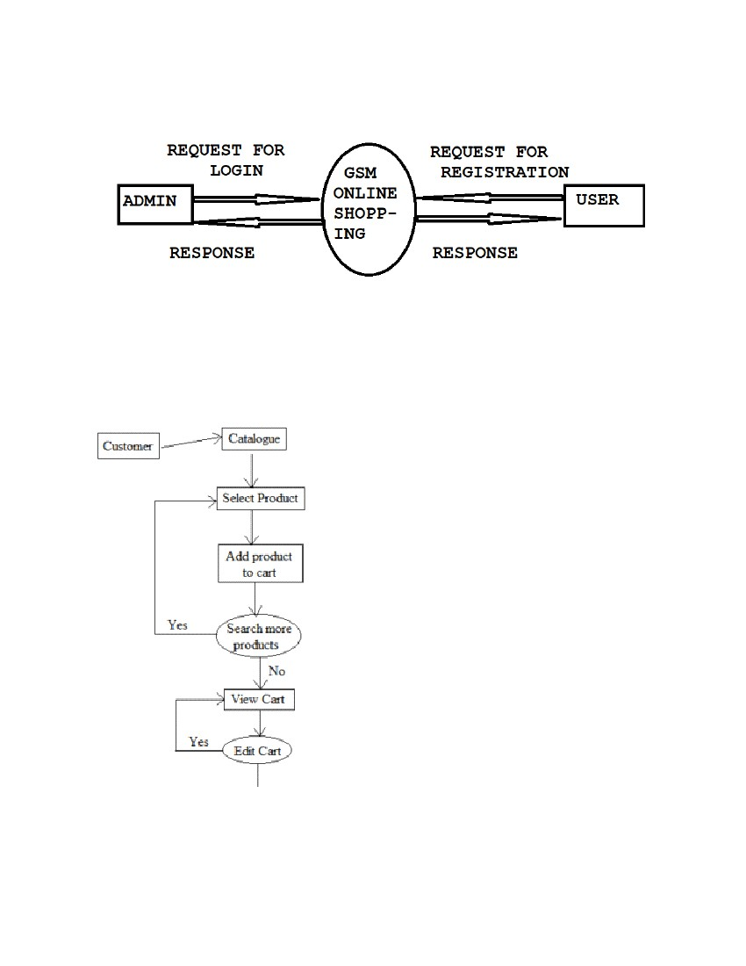
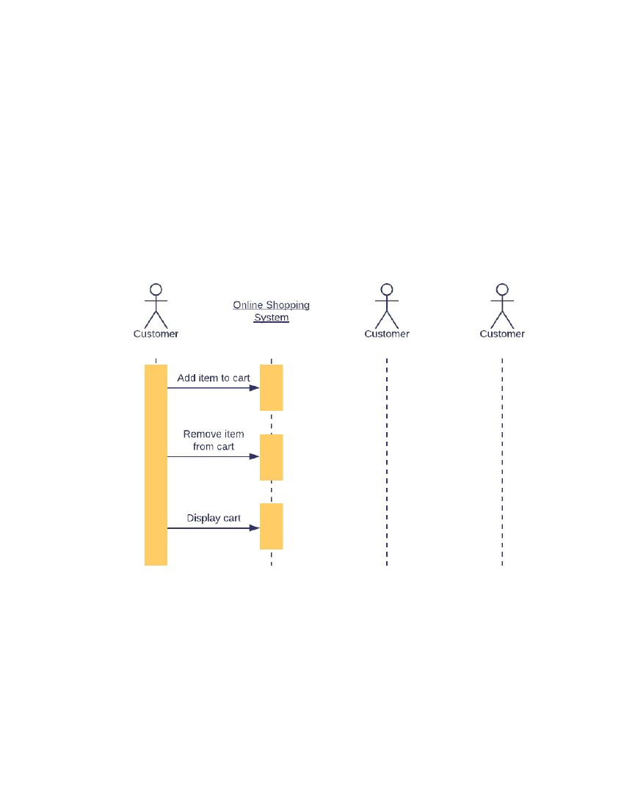
2.2 Sequence diagram
A sequence
diagram simply
depicts
interaction
between
objects
in
a sequential order i.e. the order in which these interactions take place. We can also
use the terms event diagrams or event scenarios to refer to a sequence
diagram. Sequence diagrams describe how and in what order the objects in a
system function.
3. Testing of project
A project must be tested on all its features. Type of testing a website must go are
•
•
•
•
Functional Testing
Usability Testing
Security Testing
Performance Testing
•
•
Database Testing
Mobile Application Testing(Responsiveness)
Testing must be done on all the pages of the website
1 Homepage
We must check that the product on homepage can be clicked for
Product image has a hover or not
Details about project are shown properly
2. Register Page
Register Page must be checked with duplicate mail and username.
Correct details are filled on each column.
3. Login Page
Login Page must have a testing that unregistered user must not login
Username and password must be associated with same account
4. Cart
Cart must check that right product must e added to the cart
Price of the product must be correct.
The product should not be added to the cart without account
Product should not be removed if account is logged out
more details.
5. Database
Database must have check details or saved on the right table
Database must have received all the detail.
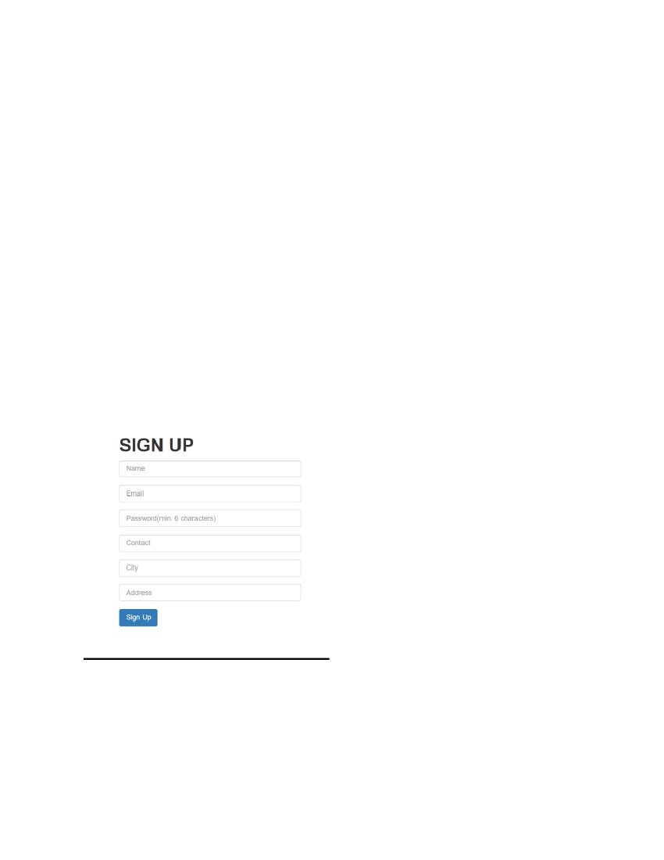
4. Future Scope of Project
This project does not contain all the facilities which are provided in the shopping
website. The Module which can be added in this project are
1. Payment Module
2 Separate Admin Module
3. More Details about the project
There are many other modules which can be added to this project if this project
is taken further.
5. Project Screenshot
SIGN UP
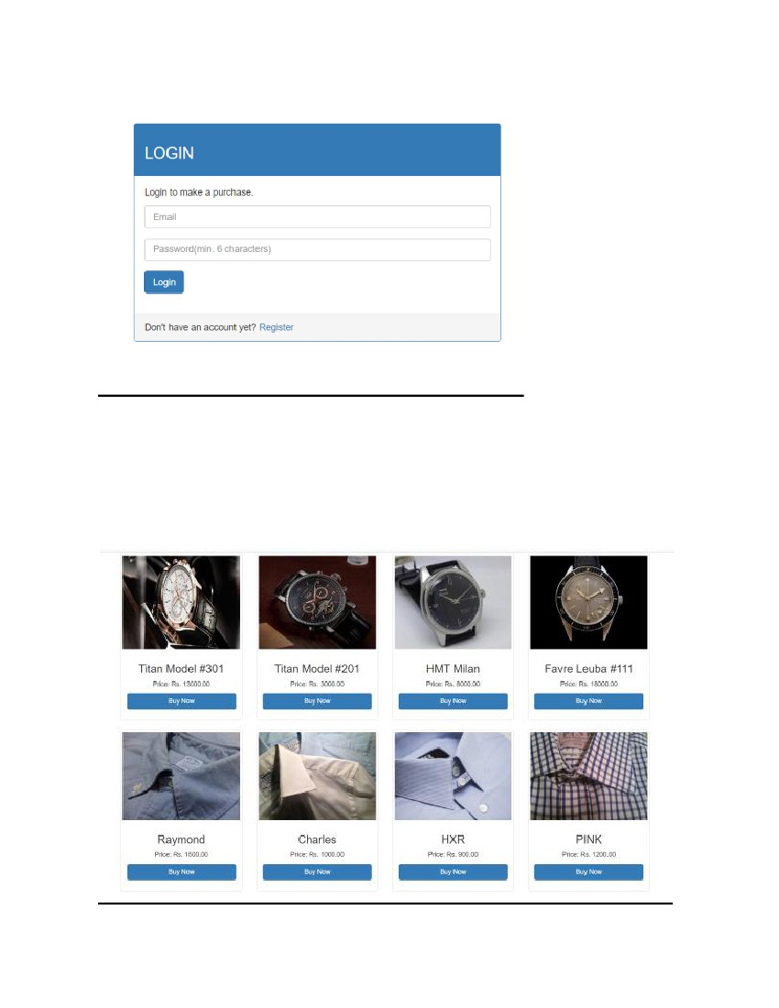
LOGIN
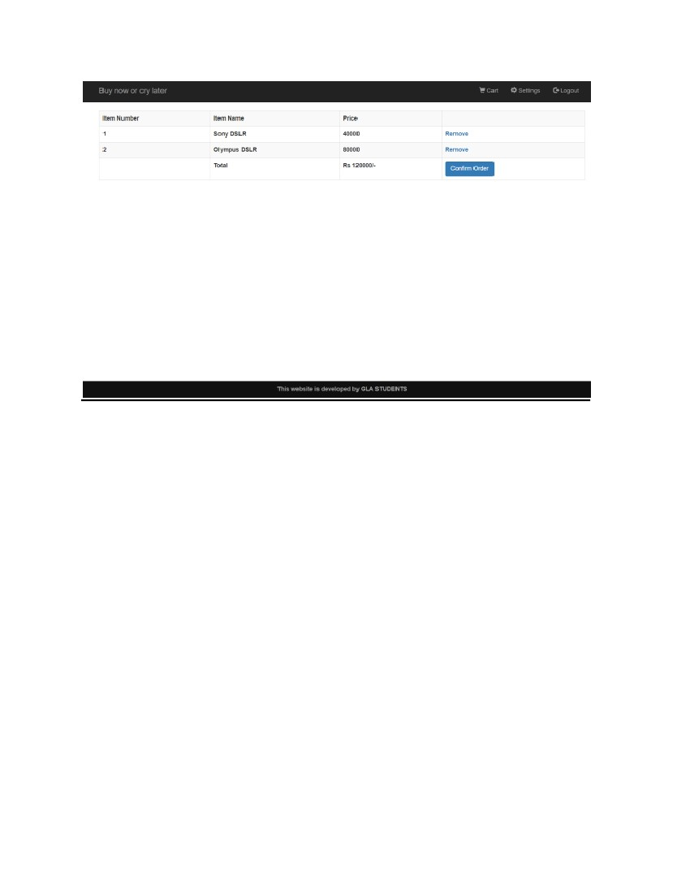
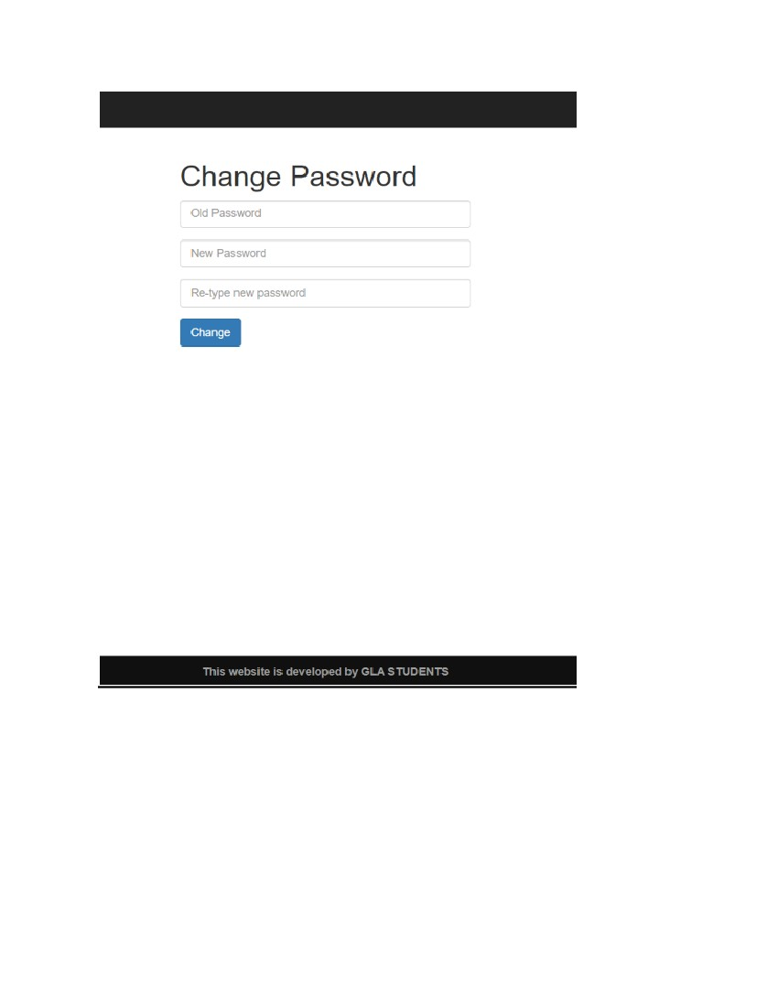
6. Technologies Used
a) HTML
Hypertext Markup Language is the standard markup language for documents
designed to be displayed in a web browser. It can be assisted by technologies such
as Cascading Style Sheets and scripting languages such as PHP. Web
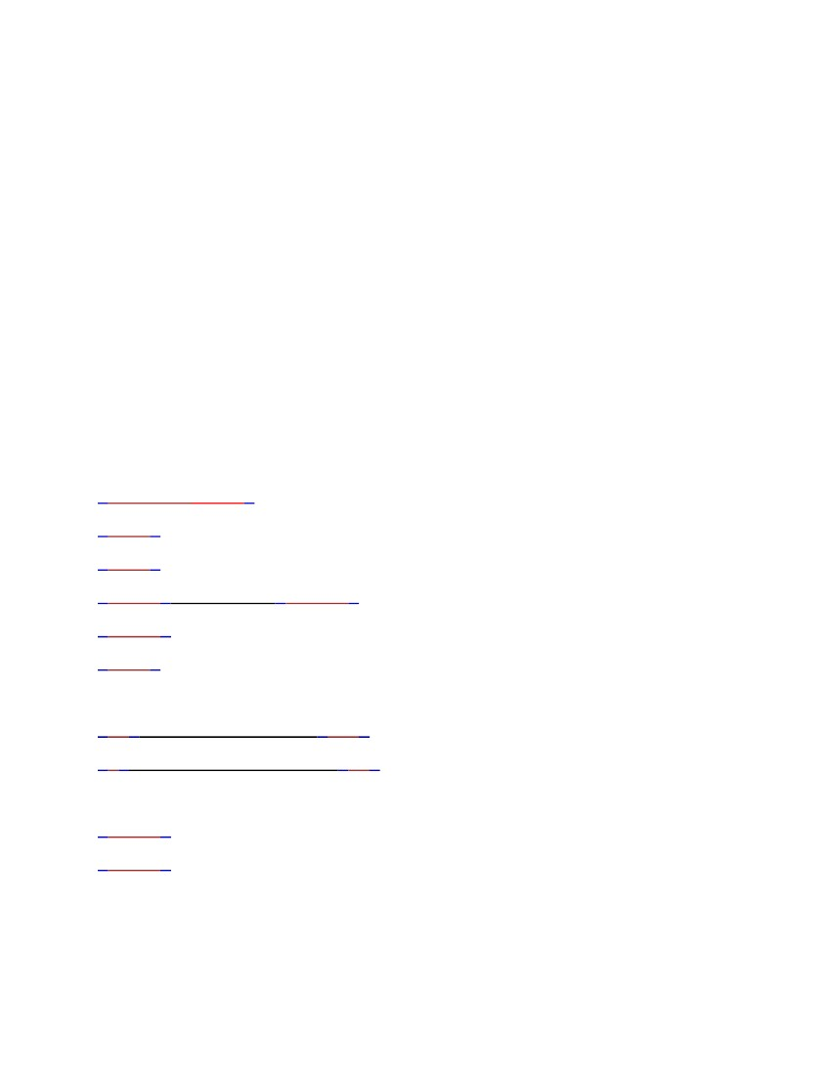
browsers receive HTML documents from a web server or from local storage
and render the documents into multimedia web pages. HTML describes the
structure of a web page semantically and originally included cues for the
appearance of the document.
HTML
markup
consists
of
several
key
components,
including
those
called tags (and
their attributes),
character-based data
types, character
references and entity references. HTML tags most commonly come in pairs
like <h1> and </h1>, although some represent empty elements and so are
unpaired, for example <img>. The first tag in such a pair is the start tag, and the
second is the end tag.
<!DOCTYPE html>
<html>
<head>
<title>Page Title</title>
</head>
<body>
<h1>This is a Heading</h1>
<p>This is a paragraph.</p>
</body>
</html>
Example of HTML
b) CSS
Cascading Style Sheets (CSS) is a style sheet language used for describing
the presentation of a document written in a markup language like HTML CSS is a
cornerstone technology of the World Wide Web, alongside HTML and JavaScript
CSS is designed to enable the separation of presentation and content,
including layout, colors,
and fonts. This
separation
can
improve
content accessibility, provide more flexibility and control in the specification of
presentation characteristics, enable multiple web pages to share formatting by
specifying the relevant CSS in a separate .css file, and reduce complexity and
repetition in the structural content.
CSS has a simple syntax and uses a number of English keywords to specify the
names of various style properties.
A style sheet consists of a list of rules. Each rule or rule-set consists of one or
more selectors, and a declaration block.
Example of css code.
body {
background-color: lightblue;
}
h1 {
color: white;
text-align: center;
}
p {
font-family: verdana;
font-size: 20px;
}
c) Bootstrap
Bootstrap is a free and open-source CSS framework directed at responsive,
mobile-first front-end web development. It contains CSS- and
JavaScript-based
design
(optionally)
template
fortypography, forms, buttons, navigation and other interface components.
Bootstrap is the third-most-starred project on GitHub, with more than 135,000
stars, behind only freeCodeCamp (almost 305,000 stars) and marginally
behind Vue.js framework
Bootstrap also comes with several JavaScript components in the form
of jQuery plugins. They provide additional user interface elements such as dialog
boxes, tooltips, and carousels. Each Bootstrap component consists of an HTML
structure, CSS declarations, and in some cases accompanying JavaScript code.
They also extend the functionality of some existing interface elements, including
for example an auto-complete function for input fields.
Example of Bootstrap Code
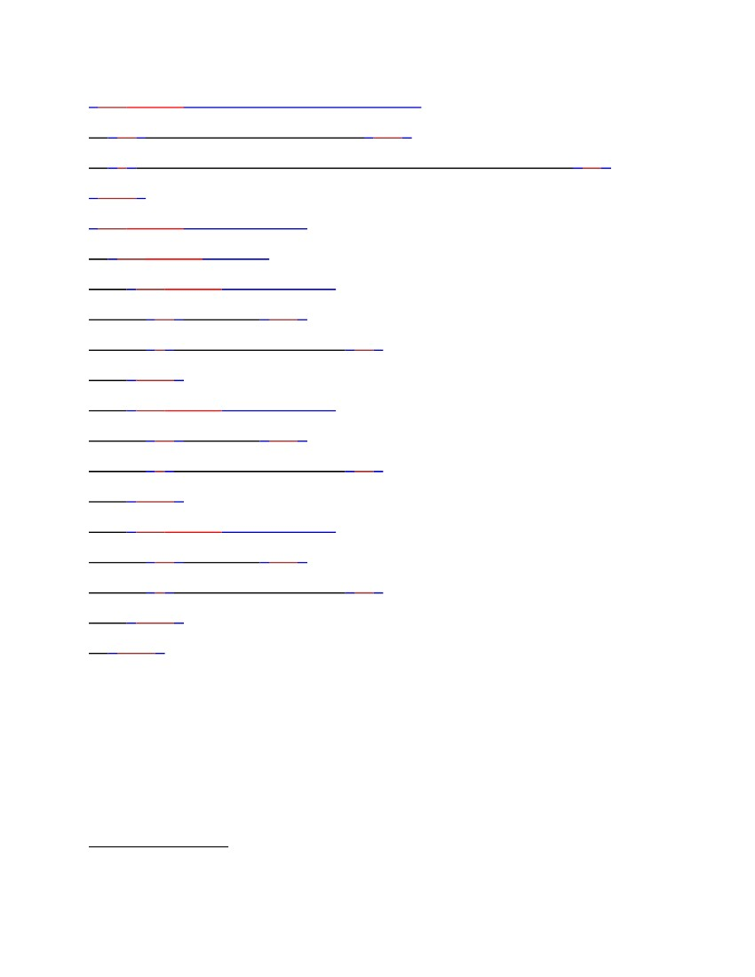
<div class="jumbotron text-center">
<h1>My First Bootstrap Page</h1>
<p>Resize this responsive page to see the effect!</p>
</div>
<div class="container">
<div class="row">
<div class="col-sm-4">
<h3>Column 1</h3>
<p>Loremipsum dolor..</p>
</div>
<div class="col-sm-4">
<h3>Column 2</h3>
<p>Loremipsum dolor..</p>
</div>
<div class="col-sm-4">
<h3>Column 3</h3>
<p>Loremipsum dolor..</p>
</div>
</div>
d) PHP
PHP: Hypertext Preprocessor (or simply PHP) is a general-purpose programming
language originally designed for web development.
PHP code with html
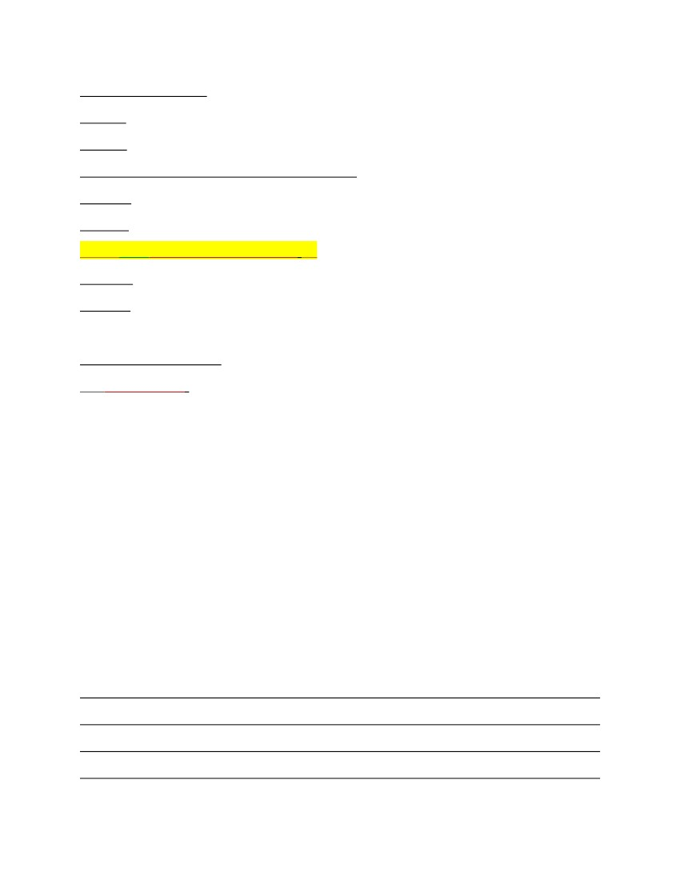
<!DOCTYPE html>
<html>
<head>
<title>PHP "Hello, World!" program</title>
</head>
<body>
<?phpecho'<p>Hello, World!</p>';?>
</body>
</html>
Php code without html
<?='Hello world';
The term PHP is an acronym for PHP: Hypertext Preprocessor. PHP is a server-
side scripting language designed specifically for web development. PHP can be
easily embedded in HTML files and HTML codes can also be written in a PHP
file. The thing that differentiates PHP with client-side language like HTML is,
PHP codes are executed on the server whereas HTML codes are directly rendered
on the browser.
GET and POST Method
Both GET and POST create an array (e.g. array( key1 => value1, key2 => value2,
key3 => value3, ...)). This array holds key/value pairs, where keys are the names of
the form controls and values are the input data from the user.Both GET and POST
are treated as $_GET and $_POST. These are superglobals, which means that they

are always accessible, regardless of scope - and you can access them from any
function, class or file without having to do anything special.$_GET is an array of
variables passed to the current script via the URL parameters.$_POST is an array
of variables passed to the current script via the HTTP POST method.
e) Xampp Server
XAMPP is a free and open-source cross-platform web server solution
stack package developed by Apache Friends, consisting mainly of the Apache
HTTP Server, MySQL database, and interpreters for scripts written in
the PHP .Since most actual web server deployments use the same components as
XAMPP, It makes transitioning from a local test server to a live server possible.
XAMPP is regularly updated to the latest release
of Apache, MariaDB, PHP and Perl. It also comes with a number of other modules
including OpenSSL, phpMyAdmin, MediaWiki, Joomla, and more. Self-
contained, multiple instances of XAMPP can exist on a single computer, and any
given instance can be copied from one computer to another. XAMPP is offered in
both a full and a standard version.
7. Project Code
Login Module code
<?php
require 'connection.php';
session_start();
?>
<!DOCTYPE html>
<html>
<head>
<link rel="shortcut icon" href="img/lifestyleStore.png" />
<title>GSM</title>
<meta charset="UTF-8">
<meta name="viewport" content="width=device-width, initial-
scale=1.0">
<!-- latest compiled and minified CSS -->
<link rel="stylesheet" href="bootstrap/css/bootstrap.min.css"
type="text/css">
<!-- jquery library -->
<script type="text/javascript" src="bootstrap/js/jquery-
3.2.1.min.js"></script>
<!-- Latest compiled and minified javascript -->
<script type="text/javascript"
src="bootstrap/js/bootstrap.min.js"></script>
<!-- External CSS -->
<link rel="stylesheet" href="css/style.css" type="text/css">
</head>
<body>
<div>
<?php
require 'header.php';
?>
<br><br><br>
<div class="container">
<div class="row">
<div class="col-xs-6 col-xs-offset-3">
<div class="panel panel-primary">
<div class="panel-heading">
<h3>LOGIN</h3>
</div>
<div class="panel-body">
<p>Login to make a purchase.</p>
<form method="post" action="login_submit.php">
<div class="form-group">
<input type="email" class="form-control"
name="email" placeholder="Email" pattern="[a-z0-9._%+-]+@[a-z0-9.-
]+\.[a-z]{2,3}$">
</div>
<div class="form-group">
<input type="password" class="form-control"
name="password" placeholder="Password(min. 6 characters)"
pattern=".{6,}">
</div>
<div class="form-group">
<input type="submit" value="Login" class="btn btn-
primary">
</div>
</form>
</div>
<div class="panel-footer">Don't have an account yet? <a
href="signup.php">Register</a></div>
</div>
</div>
</div>
</div>
<br><br><br><br><br>
<footer class="footer">
<div class="container">
<center>
<p>This website is developed by GLA STUDENTS</p>
</center>
</div>
</footer>
</div>
</body>
</html>
Description
Login Module led the user to login to his account by his unique username and
password . After logging in user can see his previous history and the user can also
order something which the user want to order. User can also logout his account
after doing his task.
SignUp Module code
<?php
require 'connection.php';
session_start();
if(isset($_SESSION['email'])){
header('location: products.php');
}
?>
<!DOCTYPE html>
<html>
<head>
<link rel="shortcut icon" href="img/lifestyleStore.png" />
<title>Projectworlds Store</title>
<meta charset="UTF-8">
<meta name="viewport" content="width=device-width, initial-
scale=1.0">
<!-- latest compiled and minified CSS -->
<link rel="stylesheet" href="bootstrap/css/bootstrap.min.css"
type="text/css">
<!-- jquery library -->
<script type="text/javascript" src="bootstrap/js/jquery-
3.2.1.min.js"></script>
<!-- Latest compiled and minified javascript -->
<script type="text/javascript"
src="bootstrap/js/bootstrap.min.js"></script>
<!-- External CSS -->
<link rel="stylesheet" href="css/style.css" type="text/css">
</head>
<body>
<div>
<?php
require 'header.php';
?>
<br><br>
<div class="container">
<div class="row">
<div class="col-xs-4 col-xs-offset-4">
<h1><b>SIGN UP</b></h1>
<form method="post" action="user_registration_script.php">
<div class="form-group">
<input type="text" class="form-control" name="name"
placeholder="Name" required="true">
</div>
<div class="form-group">
<input type="email" class="form-control" name="email"
placeholder="Email" required="true" pattern="[a-z0-9._%+-]+@[a-z0-9.-
]+\.[a-z]{2,3}$">
</div>
<div class="form-group">
<input type="password" class="form-control"
name="password" placeholder="Password(min. 6 characters)"
required="true" pattern=".{6,}">
</div>
<div class="form-group">
<input type="tel" class="form-control" name="contact"
placeholder="Contact" required="true">
</div>
<div class="form-group">
<input type="text" class="form-control" name="city"
placeholder="City" required="true">
</div>
<div class="form-group">
<input type="text" class="form-control" name="address"
placeholder="Address" required="true">
</div>
<div class="form-group">
<input type="submit" class="btn btn-primary"
value="Sign Up">
</div>
</form>
</div>
</div>
</div>
<br><br><br><br><br><br>
<footer class="footer">
<div class="container">
<center>
<p>This website is developed by GLA STUDENTS</p>
</center>
</div>
</footer>
</div>
</body>
</html>
Description
Signup Module led the user to create his account on the website. You must have an
account before you can do anything on this website. For signup you must have a
username ,email and a password.
Logout Module Code
<?php
session_start();
session_unset();
session_destroy();
?>
<!DOCTYPE html>
<html>
<head>
<link rel="shortcut icon" href="img/lifestyleStore.png" />
<title>Projectworlds Store</title>
<meta charset="UTF-8">
<meta name="viewport" content="width=device-width, initial-
scale=1.0">
<!-- latest compiled and minified CSS -->
<link rel="stylesheet" href="bootstrap/css/bootstrap.min.css"
type="text/css">
<!-- jquery library -->
<script type="text/javascript" src="bootstrap/js/jquery-
3.2.1.min.js"></script>
<!-- Latest compiled and minified javascript -->
<script type="text/javascript"
src="bootstrap/js/bootstrap.min.js"></script>
<!-- External CSS -->
<link rel="stylesheet" href="css/style.css" type="text/css">
</head>
<body>
<div>
<?php
require 'header.php';
?>
<br>
<div class="container">
<div class="row">
<div class="col-xs-6">
<div class="panel panel-primary">
<div class="panel-heading"></div>
<div class="panel-body">
<p>You have been logged out. <a href="login.php">Login
again.</a></p>
</div>
</div>
</div>
</div>
</div>
<footer class="footer">
<div class="container">
<center>
<p>This website is developed by GLA STUDENTS</p>
</center>
</div>
</footer>
</div>
</body>
</html>
Cart Module code
<?php
require 'connection.php';
//require 'header.php';
session_start();
$item_id=$_GET['id'];
$user_id=$_SESSION['id'];
$add_to_cart_query="insert into users_items(user_id,item_id,status) values
('$user_id','$item_id','Added to cart')";
$add_to_cart_result=mysqli_query($con,$add_to_cart_query) or
die(mysqli_error($con));
header('location: products.php');
?>
Description
It is an important module of the project as it help to order the product bought. The
user can select the product of there choice and add to the cart for the further
processing. The cart has a feature to increase the quantity of each product. In cart
we can see the total payment and we can not pay for the product as this website
does not have payment module.
Database
-- phpMyAdmin SQL Dump
-- version 4.8.0.1
-- https://www.phpmyadmin.net/
--
-- Host: 127.0.0.1
-- Generation Time: Jun 18, 2018 at 11:47 AM
-- Server version: 10.1.32-MariaDB
-- PHP Version: 7.2.5
SET SQL_MODE = "NO_AUTO_VALUE_ON_ZERO";
SET AUTOCOMMIT = 0;
START TRANSACTION;
SET time_zone = "+00:00";
/*!40101
SET
@OLD_CHARACTER_SET_CLIENT=@@CHARACTER_SET_CLIENT
*/;
/*!40101
SET
@OLD_CHARACTER_SET_RESULTS=@@CHARACTER_SET_RESULT
S */;
/*!40101
SET
@OLD_COLLATION_CONNECTION=@@COLLATION_CONNECTION
*/;
/*!40101 SET NAMES utf8mb4 */;
--
-- Database: `store`
--
-- --------------------------------------------------------
--
-- Table structure for table `items`
--
CREATE TABLE `items` (
`id` int(11) NOT NULL,
`name` varchar(255) NOT NULL,
`price` int(11) NOT NULL
) ENGINE=InnoDB DEFAULT CHARSET=latin1;
--
-- Dumping data for table `items`
--
INSERT INTO `items` (`id`, `name`, `price`) VALUES
(1, 'Cannon EOS', 36000),
(2, 'Sony DSLR', 40000),
(3, 'Sony DSLR', 50000),
(4, 'Olympus DSLR', 80000),
(5, 'Titan Model #301', 13000),
(6, 'Titan Model #201', 3000),
(7, 'HMT Milan', 8000),
(8, 'Favre Lueba #111', 18000),
(9, 'Raymond', 1500),
(10, 'Charles', 1000),
(11, 'HXR', 900),
(12, 'PINK', 1200);
-- --------------------------------------------------------
--
-- Table structure for table `users`
--
CREATE TABLE `users` (
`id` int(11) NOT NULL,
`name` varchar(255) NOT NULL,
`email` varchar(255) NOT NULL,
`password` varchar(255) NOT NULL,
`contact` varchar(255) NOT NULL,
`city` varchar(255) NOT NULL,
`address` varchar(255) NOT NULL
) ENGINE=InnoDB DEFAULT CHARSET=latin1;
--
-- Dumping data for table `users`
--
INSERT INTO `users` (`id`, `name`, `email`, `password`, `contact`, `city`,
`address`) VALUES
(4,
'yugesh
verma',
'yugeshverma32@gmail.com',
'14e1b600b1fd579f47433b88e8d85291', '6263056779', 'bhilai', '25 commercial
complex, nehru nagar,east near vijya bank, bhilai C.G.'),
(5,
'yugesh',
'yugeshverma@gmail.com',
'14e1b600b1fd579f47433b88e8d85291', '9165063741', 'bhilai', 'bhilai');
-- --------------------------------------------------------
--
-- Table structure for table `users_items`
--
CREATE TABLE `users_items` (
`id` int(11) NOT NULL,
`user_id` int(11) NOT NULL,
`item_id` int(11) NOT NULL,
`status` enum('Added to cart','Confirmed') NOT NULL
) ENGINE=InnoDB DEFAULT CHARSET=latin1;
--
-- Dumping data for table `users_items`
--
INSERT INTO `users_items` (`id`, `user_id`, `item_id`, `status`) VALUES
(7, 3, 3, 'Added to cart'),
(8, 3, 4, 'Added to cart'),
(9, 3, 5, 'Added to cart'),
(10, 3, 11, 'Added to cart'),
(11, 1, 9, 'Added to cart'),
(12, 1, 2, 'Added to cart'),
(13, 1, 8, 'Added to cart'),
(14, 4, 2, 'Confirmed'),
(18, 5, 11, 'Added to cart'),
(20, 5, 5, 'Added to cart');
--
-- Indexes for dumped tables
--
--
-- Indexes for table `items`
--
ALTER TABLE `items`
ADD PRIMARY KEY (`id`);
--
-- Indexes for table `users`
--
ALTER TABLE `users`
ADD PRIMARY KEY (`id`);
--
-- Indexes for table `users_items`
--
ALTER TABLE `users_items`
ADD PRIMARY KEY (`id`),
ADD KEY `user_id` (`user_id`,`item_id`),
ADD KEY `item_id` (`item_id`);
--
-- AUTO_INCREMENT for dumped tables
--
--
-- AUTO_INCREMENT for table `items`
--
ALTER TABLE `items`
MODIFY
`id`
int(11)
NOT
NULL
AUTO_INCREMENT,
AUTO_INCREMENT=13;
--
-- AUTO_INCREMENT for table `users`
--
ALTER TABLE `users`
MODIFY
`id`
int(11)
NOT
NULL
AUTO_INCREMENT,
AUTO_INCREMENT=6;
--
-- AUTO_INCREMENT for table `users_items`
--
ALTER TABLE `users_items`
MODIFY
`id`
int(11)
NOT
NULL
AUTO_INCREMENT,
AUTO_INCREMENT=22;
--
-- Constraints for dumped tables
--
--
-- Constraints for table `users_items`
--
ALTER TABLE `users_items`
ADD CONSTRAINT `users_items_ibfk_1` FOREIGN KEY (`user_id`)
REFERENCES `users` (`id`),
ADD CONSTRAINT `users_items_ibfk_2` FOREIGN KEY (`item_id`)
REFERENCES `items` (`id`);
COMMIT;
/*!40101
SET
CHARACTER_SET_CLIENT=@OLD_CHARACTER_SET_CLIENT */;
/*!40101
SET
CHARACTER_SET_RESULTS=@OLD_CHARACTER_SET_RESULTS */;
/*!40101
SET
COLLATION_CONNECTION=@OLD_COLLATION_CONNECTION */;
8. Contribution of team Members
The whole project is made by the help of all the team members. We have help
each other in their work. A good discussion is made between us before any
implementation
9. Bibliography
https://www.geeksforgeeks.org/
https://www.w3schools.com/
https://stackoverflow.com/
https://www.php.net/

