**AWS Cloud Computing**

**Introduction**

Amazon Web Services offers a broad set of global cloud-based products including compute, storage, databases, analytics, networking, mobile, developer tools, management tools, IoT, security, and enterprise applications: on-demand, available in seconds, with pay-as-you-go pricing. From data warehousing to deployment tools, directories to content delivery, over 200 AWS services are available. In the AWS we create the own server through VPC and EC2.

First we create account on AWS as route user.

Step1: Go to complete your Sign in

Create a new user account and fill the details

Step 2: Sign up for a email account. They send the email for verification.

Verify your email.

Step3: Set up a Password.

Step4: fill the Personal details.

Step5: Add the credit card information [it should be international payment enabled]

Step6:login the page

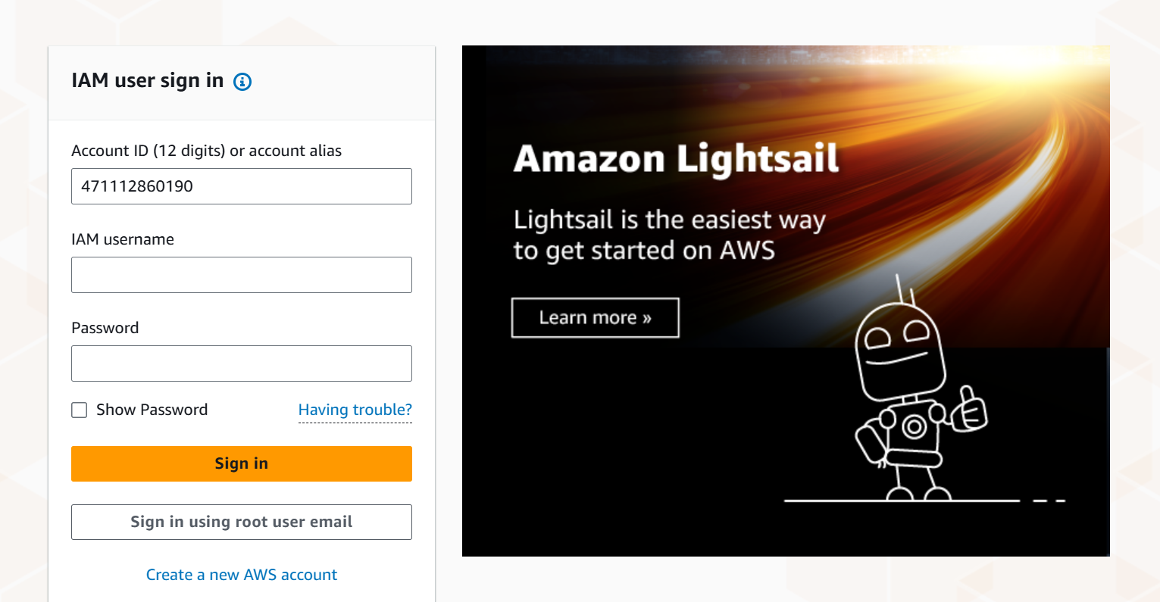

**Project 1: Deploying website an AWS EC2 instances**

**Step 1**: In the VPC Dashboard, click on Your VPCs in the left-side menu.

* + Select **Create VPC** and fill the details:
  + **Name tag**: A name for your VPC.
  + **IPv4 CIDR block**: Specify the IP range for your VPC (e.g., 10.0.0.0/16).
  + Click on Create VPC.

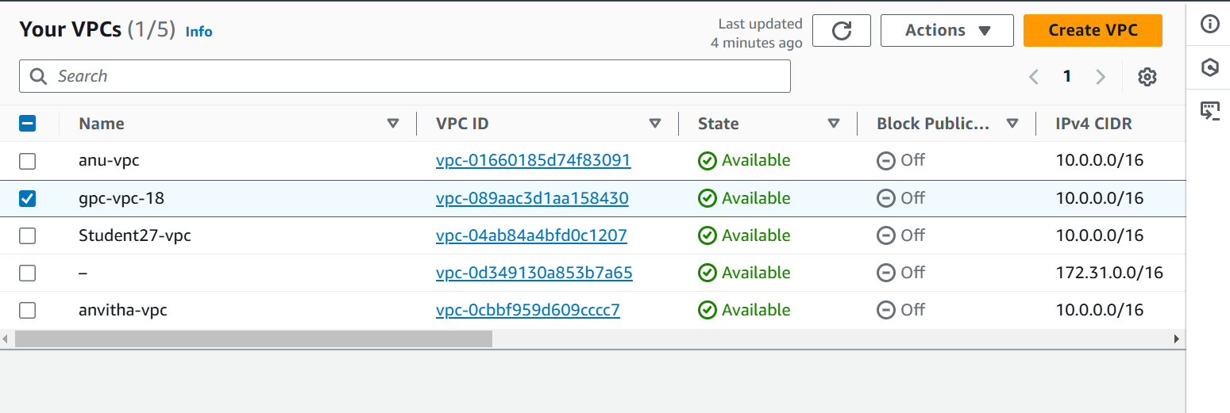

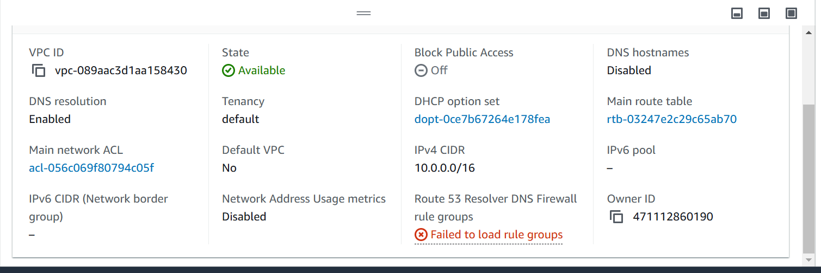

**Step 2: Creating Internet Gateway (IGW)**

* In the VPC Dashboard, select **Internet Gateways**.
* Click **Create internet gateway**, give it a name, and then attach it to your VPC.
* After creating the IGW, select it and choose **Attach to VPC**.

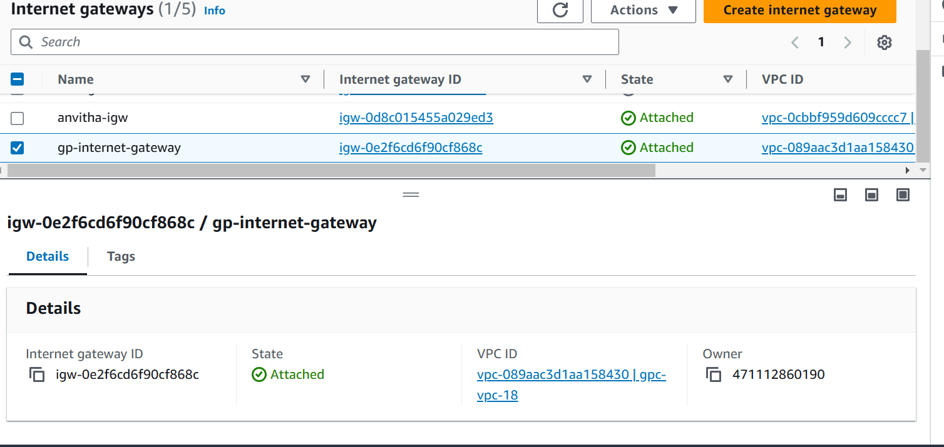

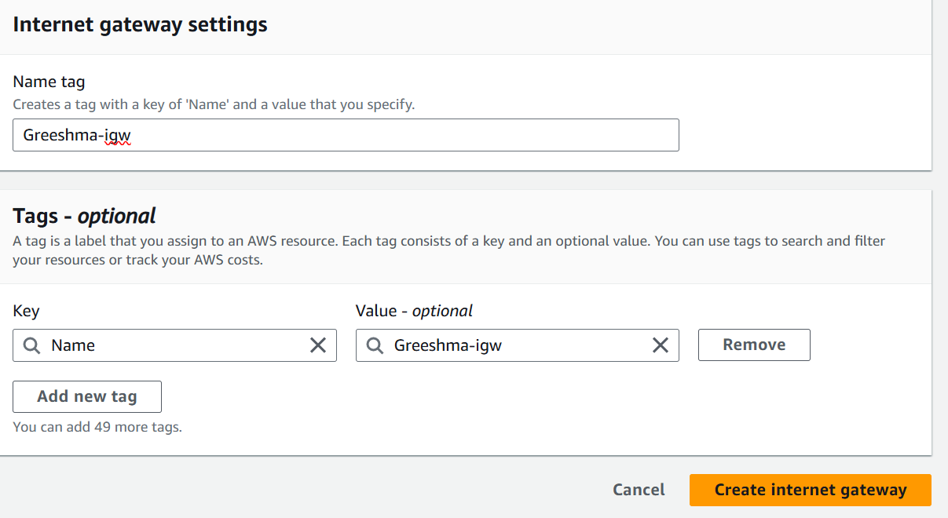

**Step 3.Add Subnets**

* Go to **Subnets** in the VPC Dashboard.
* Select **Create Subnet** and provide the following details:
  + **VPC ID**: Select the VPC you just created.
  + **Subnet name**: Give your subnet a name.
  + **Availability Zone**: Choose a specific zone or let AWS select.
  + **CIDR block**: A subset of the VPC CIDR range (e.g., 10.0.1.0/24).

Repeat the process for create multiple subnets (public and private).

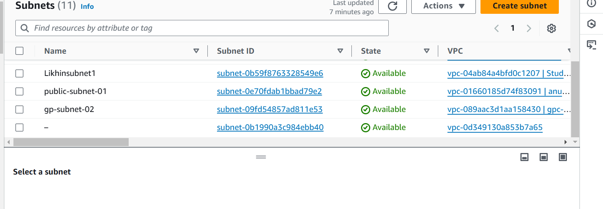

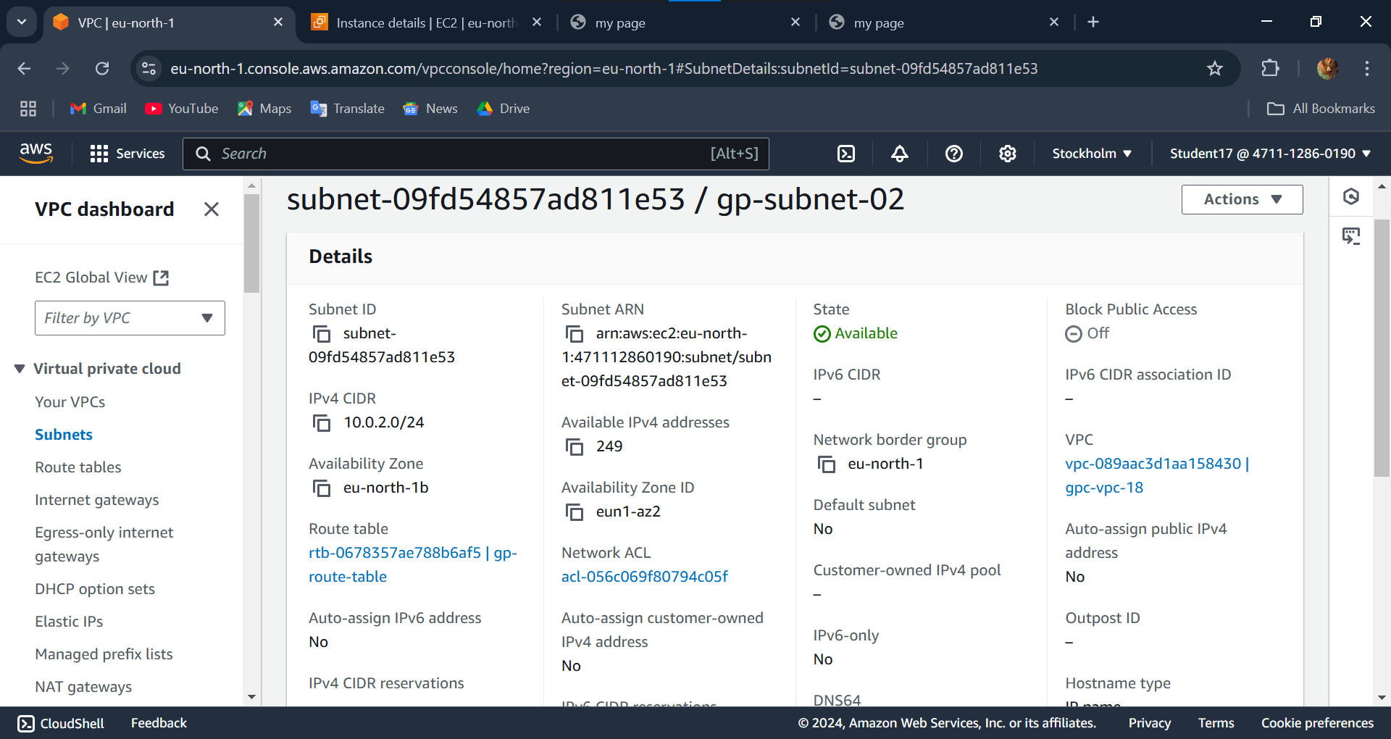

**Step4:Set up Route Tables**

* Go to **Route Tables** in the VPC Dashboard.
* Select **Create route table** and associate it with your VPC.
* Add routes:
  + For public subnets, add a route with the destination 0.0.0.0/0 (for IPv4) or ::/0 (for IPv6) and target the IGW.

Associate the route table with the public subnets.

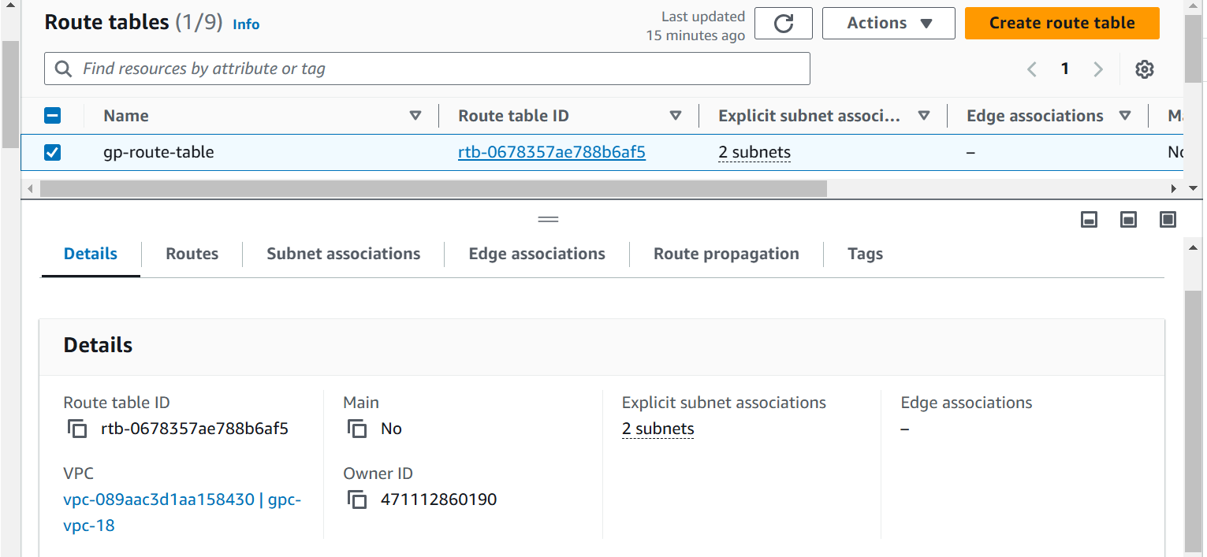

In a route table we edit the routes.

First go to edit routes. choose add next add 0.0.0.0/0 and choose the internet gateway

Add your created IGW

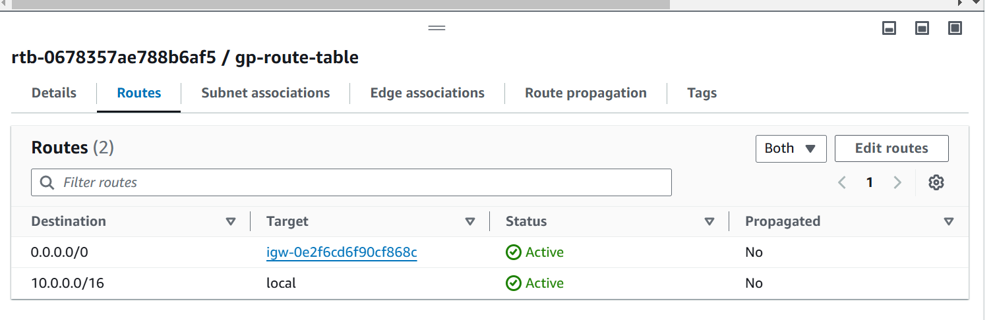

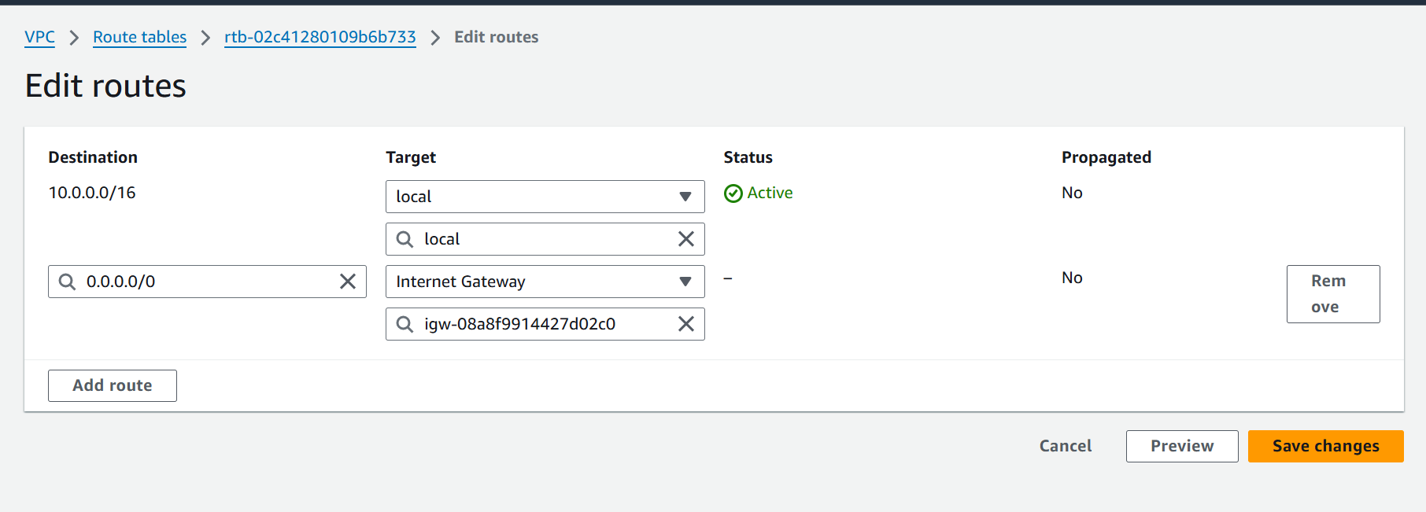

In a route table we edit the Subnet associations

First go to edit choose the 2 subnet we already created. Checked on it .

Click save associations.

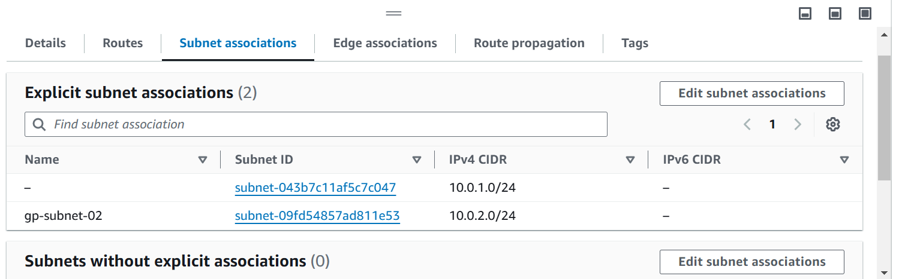

**Create and Launch Resources**

Your VPC is now ready. You can launch EC2 instances or other resources within the subnets of your VPC.

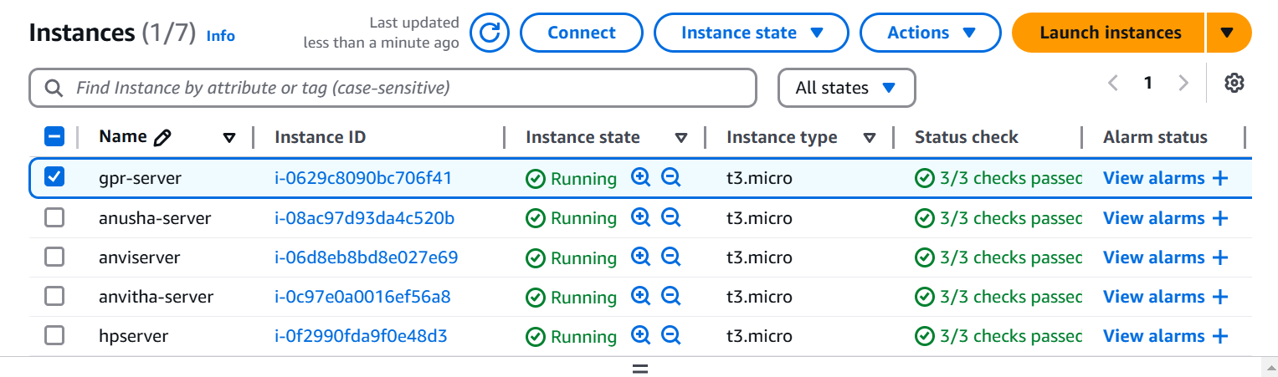

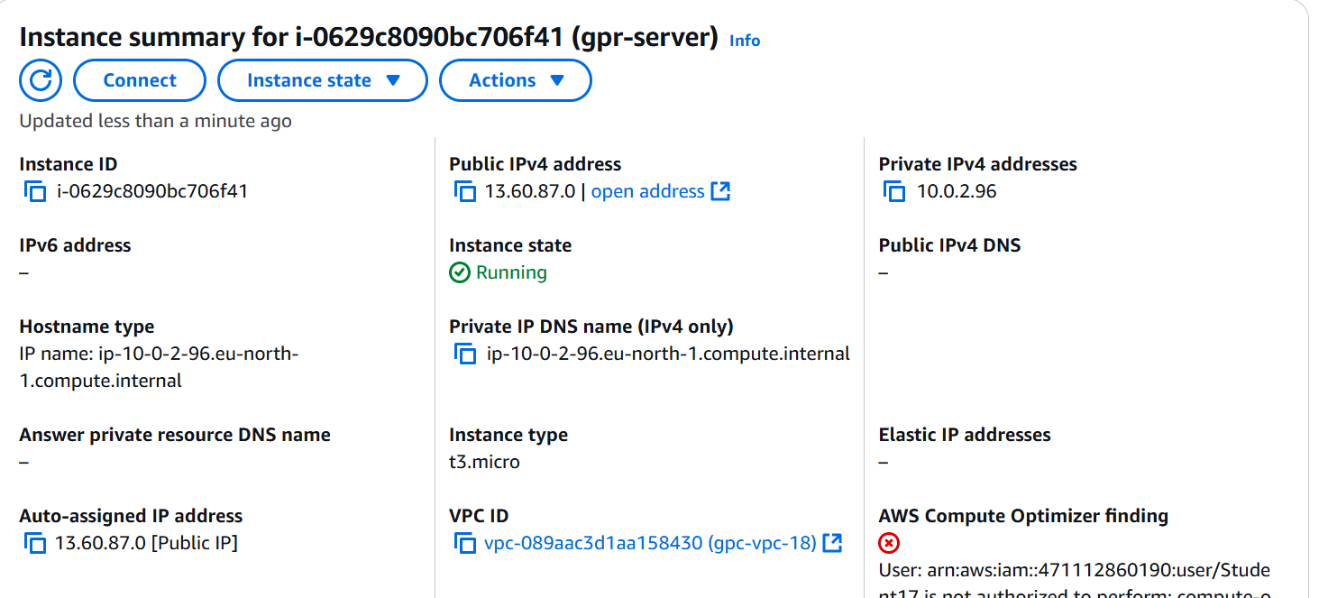

In this command prompt we install server and uploading webpage to the server.

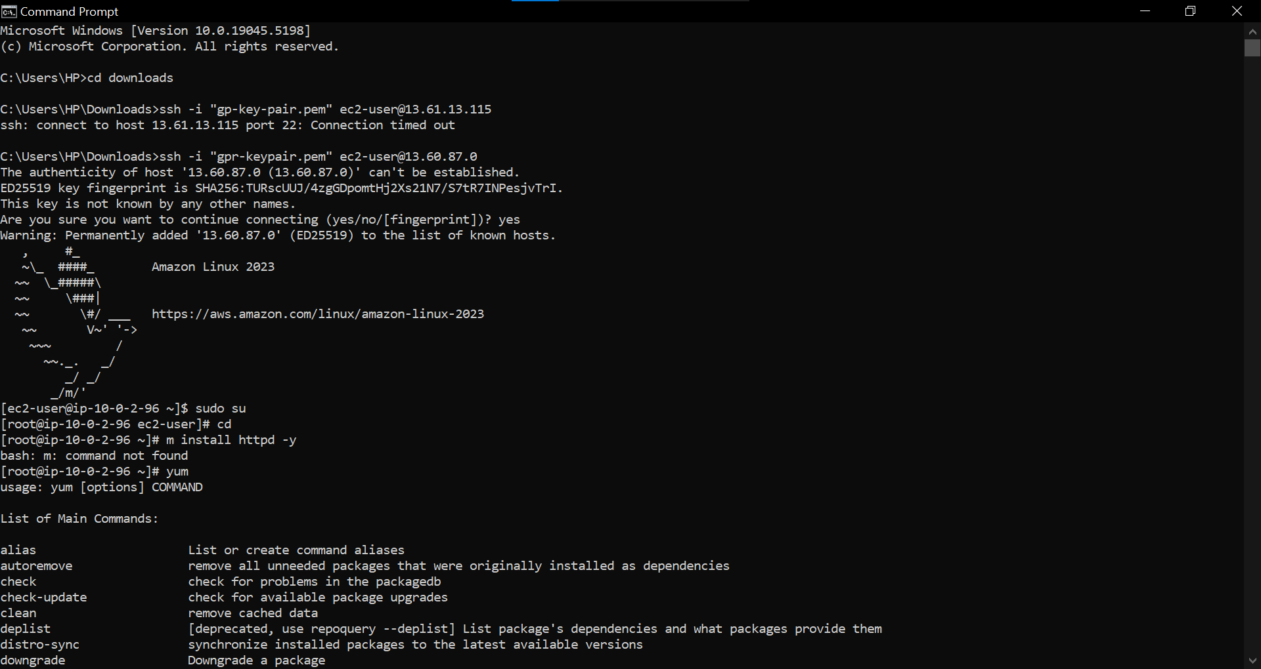

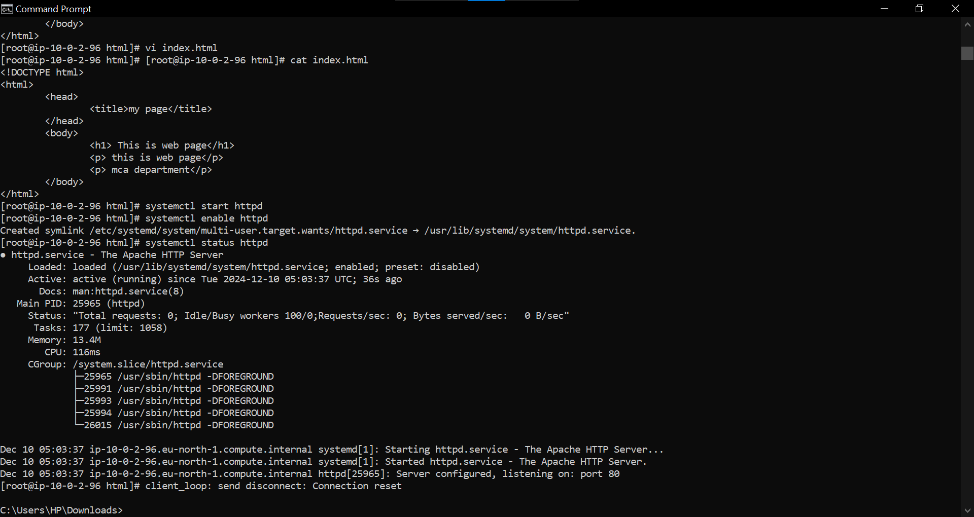

After uploading copy the public IP to the web browser.

