**Admin Use Case**

|  |
| --- |
|  |

**ADMIN**

|  |
| --- |
|  |

**Vehicle Use Case**

**VEHICLE**

|  |
| --- |
|  |

**Employee/RTO Officer Use Case**

**RTO Officer/Employee**

**User Use Case**

|  |
| --- |
|  |

**USER**

**Activity Diagram**

1. **License Issue**

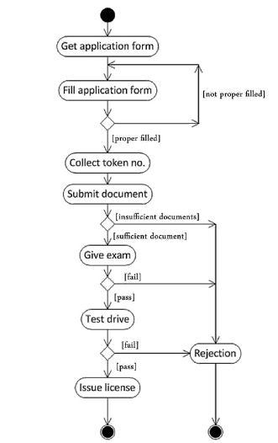

1. **Vehicle Registration**

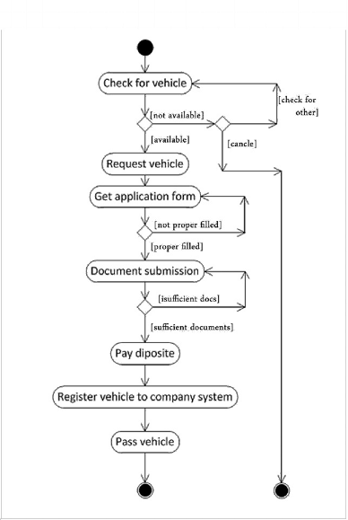

**State Diagram**

1. **License Issue**

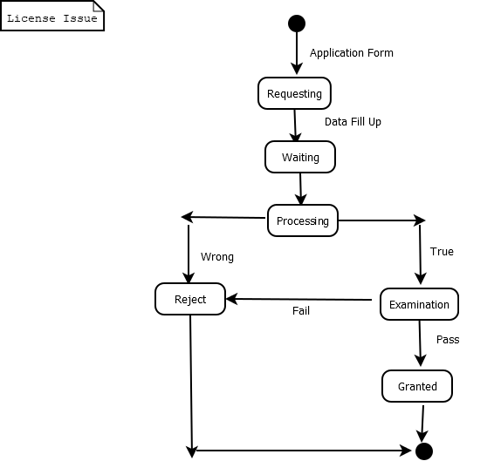

1. **Vehicle Registration**

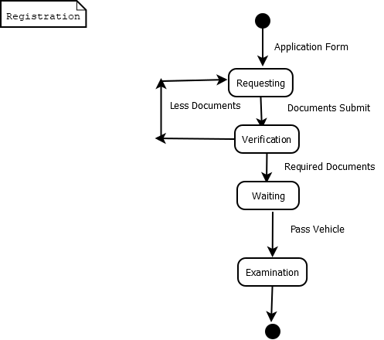

**Sequence Diagram**

1. **License Issuing**

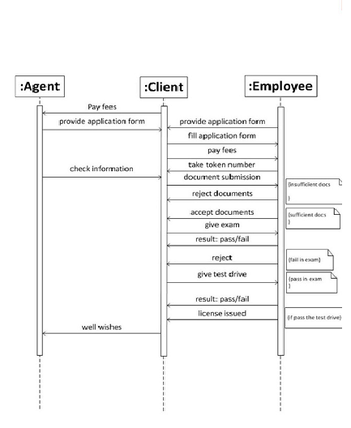

1. **Registration**

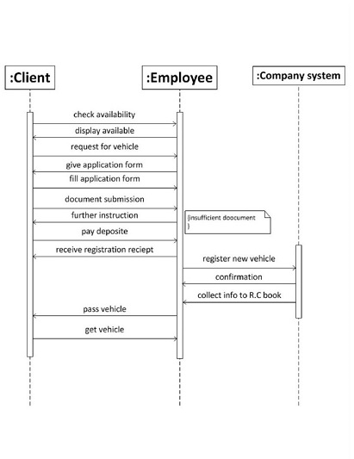

**Deployment Diagram**

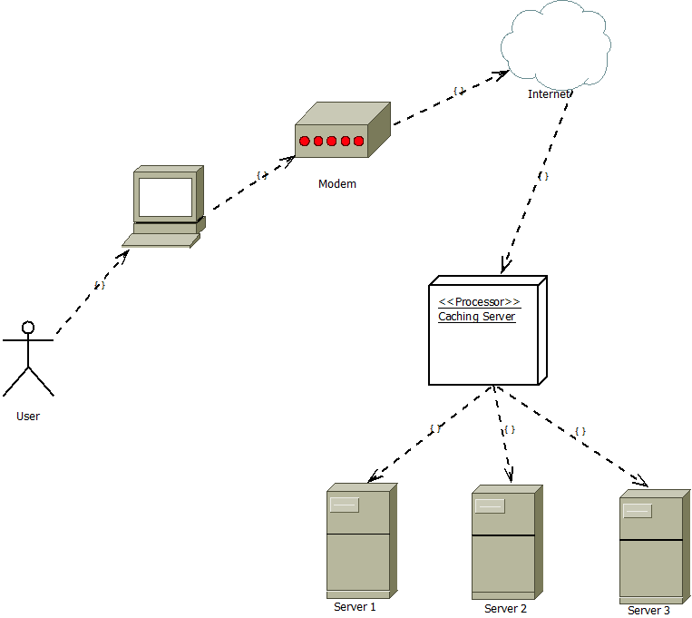

**Class Diagram**

