Superstore Sales Data Analysis
Dataset :- Superstore Sales Dataset

Tools Used
- Python
- Google Colab
- Pandas
- NumPy
- Matplotlib
- Seaborn
- Power BI

Table of Contents
- Executive Summary
- Project Overview
- Dataset Description
- Tools and Technologies
- Data Cleaning
- Exploratory Data Analysis
- Dashboard Development
- Key Findings
- Trends Observed
- Business Recommendations
- Conclusion
- References

1. Executive Summary
This project focuses on analyzing the Superstore Sales dataset to understand overall business performance using data analytics techniques. The analysis includes data cleaning, exploratory data analysis (EDA), data visualization and dashboard development using Python and Power BI. Various business metrics such as sales, profit, order volume, product performance, regional performance and discount impact were analyzed to identify meaningful insights. The findings from this project provide a clear understanding of sales trends and support data-driven decision-making through actionable business recommendations.

2. Project Overview
The primary objective of this project is to analyze the Superstore Sales dataset and extract meaningful business insights using data analytics techniques. The project focuses on understanding sales performance, profitability, regional performance, product performance and the impact of discounts on profit. The analysis was carried out using Python for data cleaning and exploratory data analysis, while Power BI was used to develop an interactive dashboard for visualizing key business metrics.
The project demonstrates how data can be transformed into actionable insights that support informed business decision-making.

3. Dataset Description

Dataset Source
The dataset used for this project is the Superstore Sales Dataset, obtained from Kaggle. It contains historical sales transaction records of a retail superstore and is widely used for learning data analytics and business intelligence.

Dataset Type
The dataset includes transactional retail sales data.

Features Included
The dataset contains important business attributes such as:
- Order Date
- Sales
- Profit
- Discount
- Category
- Sub-Category
- Product Name
- Customer Name
- Segment
- Region
- State
- Ship Mode

Reason for Selecting the Dataset
This dataset was selected because it contains real-world retail business data that allows comprehensive analysis of sales performance, customer purchasing behavior, product performance and regional trends. It is well suited for applying data cleaning, exploratory data analysis, visualization and dashboard development techniques.

4. Tools and Technologies
The following tools and technologies were used throughout this project:
Tool | Purpose
Python | Data Analysis
Google Colab | Code Execution
Pandas | Data Manipulation
NumPy | Numerical Operations
Matplotlib | Data Visualization
Seaborn | Statistical Visualization
Power BI | Dashboard Development
GitHub | Project Repository

5. Data Cleaning
Before performing the analysis, the dataset was cleaned to improve data quality and ensure reliable results. The following preprocessing steps were carried out:
- Checked for missing values.
- Removed duplicate records.
- Verified and corrected data types.
- Converted the Order Date & Ship Date columns into datetime format.
- Validated the cleaned dataset before analysis.
These preprocessing steps ensured that the dataset was accurate, consistent and suitable for exploratory data analysis.

6. Exploratory Data Analysis (EDA)
Exploratory Data Analysis (EDA) was performed to understand the sales performance, profitability, customer purchasing patterns and regional performance of the Superstore dataset. Various statistical summaries and visualizations were used to identify business trends and generate actionable insights.
The following business questions were analyzed during the EDA process:
- What is the total sales generated by the Superstore?
- What is the total profit earned by the Superstore?
- How many unique orders were placed?
- What is the average order value?
- How have sales changed over time?
- Which product categories generate the highest sales revenue?
- Which region generates the highest sales revenue?
- Which products generate the highest sales revenue?
- Which products generate the lowest sales revenue?
- How does discount impact profit?

Key Performance Indicators (KPIs)

KPI | Description
Total Sales | Overall sales generated during the analysis period.
Total Profit | Overall profit earned by the business.
Total Orders | Number of unique customer orders placed.
Average Order Value | Average sales value per order.
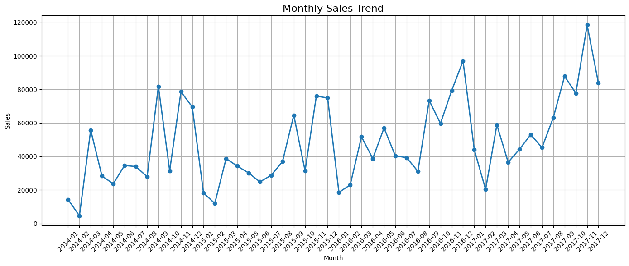
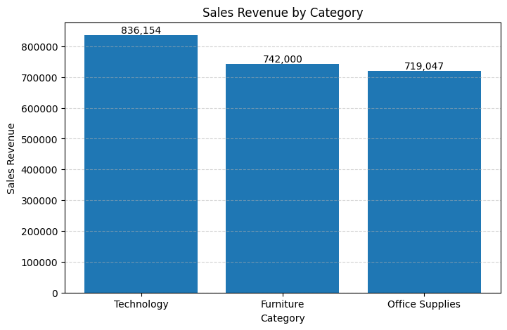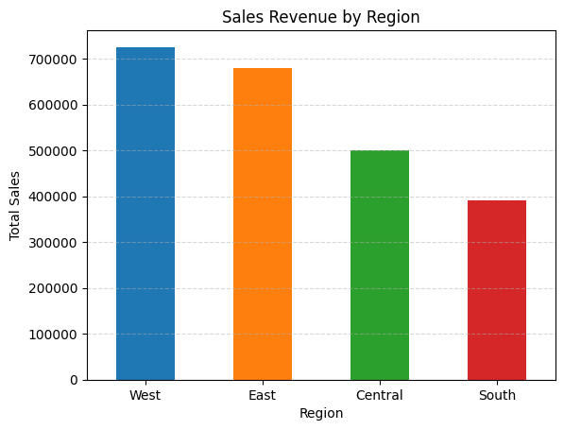

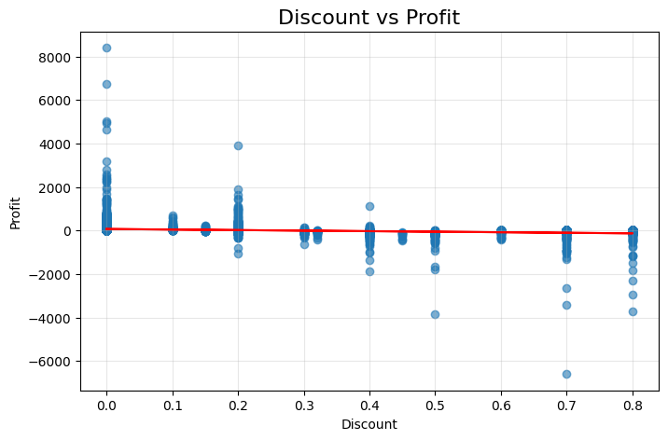

The EDA revealed important patterns related to sales growth, category performance, regional contribution, product performance and the relationship between discounts and profitability. These insights formed the basis for the business recommendations presented later in the report.

7. Dashboard Development
An interactive dashboard was developed using Microsoft Power BI to present the analysis in a visually appealing and user-friendly format. The dashboard allows users to monitor business performance through key performance indicators and interactive visualizations.
The dashboard includes the following components:
- Total Sales
- Total Profit
- Total Orders
- Average Order Value
- Sales by Customer Segment
- Sales by Sub-Category
- Sales by Category
- Sales by Region
- Yearly Sales Trend
- Sales by Ship Mode
- Interactive slicers for Year-Month and State
The dashboard enables users to filter the data and quickly identify important business trends and performance metrics.
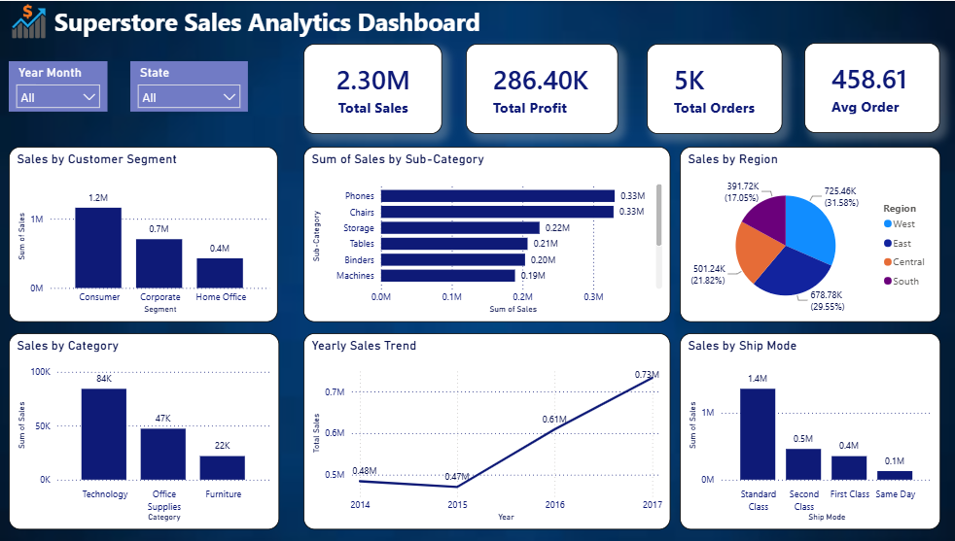

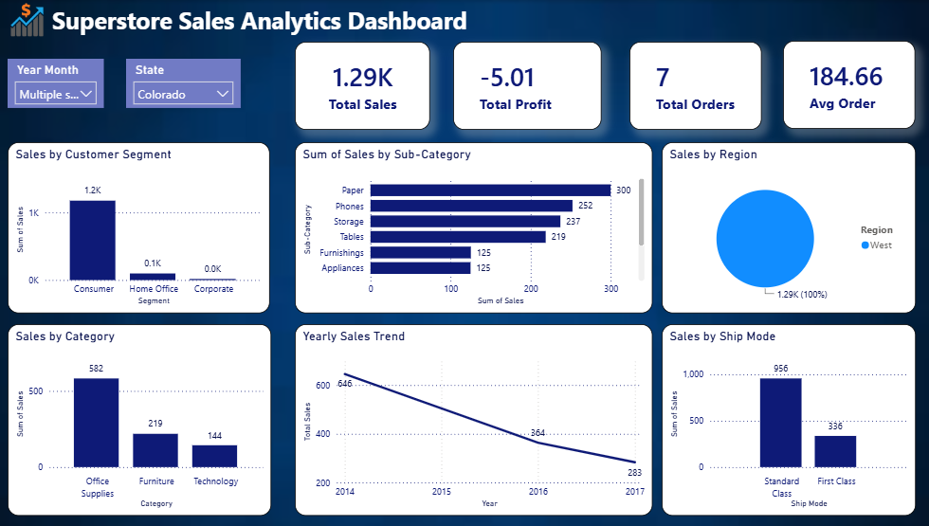

8. Key Findings
The analysis of the Superstore Sales dataset revealed several important business insights:
- The business generated over $2.30 million in total sales and over $286 thousand in total profit during the analysis period.
- Sales showed an overall upward trend over the years, indicating consistent business growth.
- The Technology category generated the highest sales revenue among all product categories.
- The West region recorded the highest sales contribution compared to the other regions.
- A few top-performing products contributed a significant share of total sales, while several products generated very low revenue.
- Certain states consistently achieved higher sales, indicating stronger market demand.
- Higher discounts generally resulted in lower profits, suggesting that excessive discounting negatively impacts profitability.

9. Trends Observed
The exploratory analysis identified several notable business trends:
- Sales increased steadily over the analysis period, reflecting positive business growth.
- Technology products consistently outperformed other categories in terms of sales revenue.
- Customer demand varied across regions, with the West region contributing the highest sales.
- Sales were concentrated among a limited number of products, while many products had relatively low sales.
- Higher discount rates were associated with lower profitability, highlighting the importance of balanced pricing strategies.
- Customer purchasing behavior differed across ship modes and market segments, indicating opportunities for targeted business strategies.

10. Business Recommendations
Based on the analysis, the following recommendations are proposed:
- Continue investing in the Technology category to maintain strong revenue growth.
- Strengthen marketing and promotional activities in lower-performing regions and states to improve sales performance.
- Maintain sufficient inventory levels for top-selling products to avoid stock shortages.
- Review the performance of low-selling products and consider promotional strategies or product portfolio optimization.
- Implement a balanced discount strategy to increase sales without significantly reducing profitability.
- Monitor sales trends regularly through interactive dashboards to support timely and data-driven business decisions.

11. Conclusion
This project analyzed the Superstore Sales dataset using Python and Power BI to gain insights into business performance. The analysis included data cleaning, exploratory data analysis, visualization and dashboard development to evaluate sales trends, profitability, product performance and regional performance.
The findings highlighted key growth opportunities, identified high-performing categories and regions and demonstrated the impact of discounting on profitability. The interactive dashboard provides a simple and effective way to monitor business performance and supports informed decision-making through clear visualizations and business insights.
Overall, this project demonstrates the practical application of data analytics techniques for solving real-world business problems and converting raw data into actionable insights.

12. References
- Kaggle. Superstore Sales Dataset. https://www.kaggle.com/
- Microsoft. Power BI Documentation. https://learn.microsoft.com/power-bi/
- Pandas Documentation. https://pandas.pydata.org/
- NumPy Documentation. https://numpy.org/
- Matplotlib Documentation. https://matplotlib.org/
- Seaborn Documentation. https://seaborn.pydata.org/

