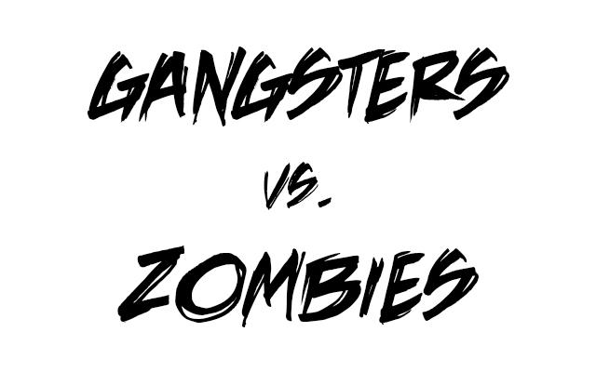

Course: COMP 2659, Winter 2016

Instructor: Paul Pospisil

Author(s): Jaedwin Montal, Greg Muchka

Last Modified: 4/16/2016

# **1. General Game Overview**

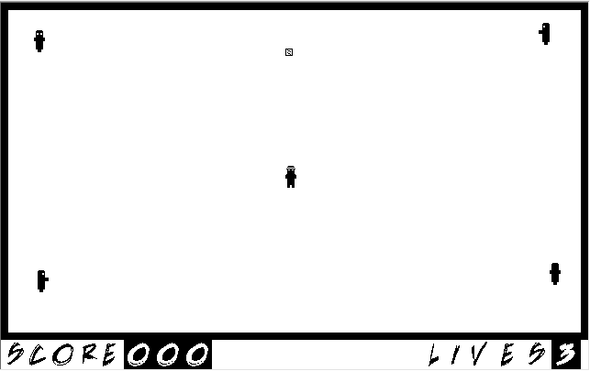  
Gangsters vs. Zombies is a top down strategy-survival game. The objective of the game is for the player(s) to collect as many points as they can without losing all three lives. There is no time limit as the game will end if the player(s) have no remaining lives left. The game is either single player or cooperative 2 players.

# **2. Gameplay Details for Core 1-Player Version**

## **2.1 Objectives and Rules**

**2.1.1 Start Screen**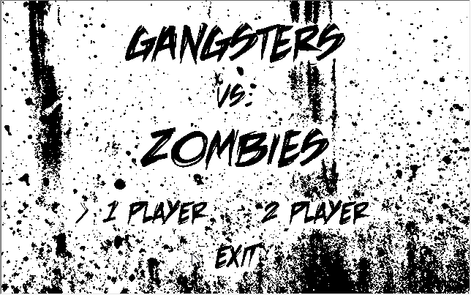

* The start screen displays the game logo and options for single player, cooperative multiplayer, or exit with the background music playing.

**2.1.2 Game Level Start State**

* The player starts at 320x200 (centre position), enemies appear instantly.

**2.1.3 Game Rules**

* Scoring is achieved by picking up ammo boxes worth 5 points each.
* The game screen dimensions are 640x400, and there is a surrounding wall around the edges.
* The Player
  + The player starts at 320,200 and has 3 lives.
  + The player has a hitbox of 32x32.
  + If the player shoots a bullet and the bullet is within the enemy's hitbox, the enemy dies.
  + If the player shoots a bullet and the bullet is not within the hitbox of an enemy, the bullet will travel until it reaches a wall. The player may only shoot if there are less than 3 bullets on the screen at a time.
  + If the player’s hitbox is encountered by an enemy, the player’s life will be reduced by 1. The game will reset to the starting position with the score remaining the same.
  + Player’s cannot go through walls
* The Enemies
  + The enemy will die if a bullet comes within it’s hitbox.
  + If an enemy comes within a player’s hitbox, the enemy will kill the reduce the player’s life by 1 and reset the level, keeping the score the same.
  + Enemies move towards the player's position.

**2.1.4 End Screen**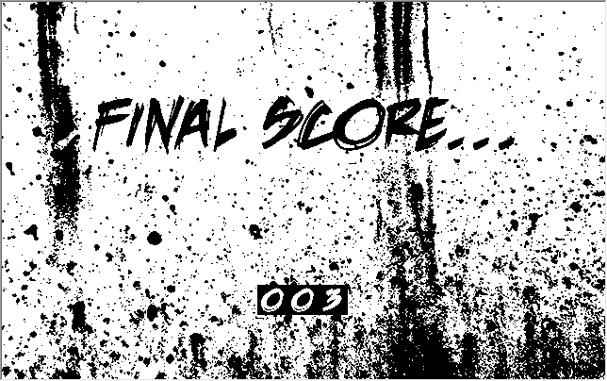

* The end screen will display the player’s final score.

**2.2 Objects**

|  |  |  |  |
| --- | --- | --- | --- |
| Object or Object Type Name | Properties | Behaviours | Graphical Image |
| Screen | Dimensions are 640x400 pixels  Score Box  Lives Box | Forms UI |  |
| Score Box | Stationary location at bottom left corner  Size: 32x192 (Maximum)  Shows Score  Max Score of 999 | Displays  Updates |  |
| Lives Box | Stationary location at bottom left corner  Size: 32x192 (Maximum)  Shows Lives | Displays  Updates |  |
| Zombie | Starting locations are (319, 0),(319, 299),  (0, 150),(639, 150)  Speed is constant.  Enemy direction move is based on the player's position. | Move |  |
| Player | Starting location is (319, 150)  Movement speed is constant.  Starting lives are 3 (Will not increase) | Move  Shoot:  A player may shoot if there is less than 3 bullets on the screen at a time. If there is 3 the player must wait until a bullet collides with something and is undrawn from the board |  |
| Walls | Outside Perimeter Location:  (0,0) -> (314, 0)  (324, 0) -> (639, 0)  (0,0) -> (145,0)  (155,0) -> (299,0)  (0, 299) -> (314, 299)  (324, 299) -> (639, 299)  (639, 299) -> (639, 155)  (639,145) -> (639, 0) | Stationary  Collide |  |
| Bullets | 10 bullets allowed on screen at one time  Starting from player, traveling straight, up,  down, left or right.  Travel speed is 2 pixels per clock tick  Direction travel will be same as direction player is facing when fire key is pressed | Move  Collide |  |

**2.3 Asynchronous (Input) Events**

|  |  |  |
| --- | --- | --- |
| Event Name | Triggering Input Event | Description |
| Player’s Movement | ‘up’, ‘down’, ‘left’, or ‘right’ keys are depressed. | 4-Way Movement, Player is assigned ‘up arrow’ to move up, ‘left arrow’ to move left, ‘down arrow’ to move down, and ‘down arrow’ to move right. Movement only occurs when assigned keys are depressed. |
| Shooting | ‘Spacebar’ is depressed. | When spacebar is pressed a bullet comes out the current position of the player in the direction the player was facing when ‘Spacebar’ is depressed |

## **2.4 Synchronous (Timed) Events**

|  |  |  |
| --- | --- | --- |
| Event Name | Trigger Timing | Description |
| Level Starts | 1 clock tick. | The player selects one or two players, after the map is loaded. |
| Enemy’s Movement | 1 clock tick | Moves enemy 4 pixel |
| Bullet Movement | 1 clock tick | Moves bullet 15 pixels per 1 clock tick. |
| Player Movement | 1 clock tick | Moves player 3 pixels per 2 clock tick |
| Bullet Generation | 2 clock tick | A new bullet generates from player when ‘spacebar’ is depressed. |

## 

## **2.5 Condition-Based (Cascaded) Events**

|  |  |  |
| --- | --- | --- |
| Event Name | Triggering Condition | Description |
| Reset level | Player killed | If the player collides with the zombie, the level will reset the player's position and the zombies positions |
| Player or enemy collides with wall | Player or enemy comes within range of wall hitbox (1 pixel range) | Player stops moving in that direction or Zombie stops moving then resumes a direction that is open. |
| End game screen | Player dies from an enemy claiming the last remaining life | A enemy comes into contact with the player and takes the last remaining life. |
| Zombie collides with player or Player collides with enemy | Player or enemy comes within range of player’s hitbox | Zombie is within player’s hitbox range and triggers the player’s life. |
| Bullets collide with Enemy | Bullet comes within range of enemy's hitbox | Bullet is within range of enemy’s hitbox, the bullet kills the enemy. |
| Bullets collide with wall | Bullet comes within range of wall coordinates (1 pixel) | Bullet is within range of wall coordinates and the bullet is destroyed. |

## **2.6 Hypothetical Gaming Session**

- Menu Board starts up prompting for one or two player session

- Scenario for One Player:

- Player starts in center of map

- After any key is pressed the level starts

- The player must try to collect as much points/ammo as possible.

- The player loses points for every shot fired.

- The enemy's will move to your location until they are dead or have attacked

you

- Score is displayed on the bottom right

- Once a level is complete the next will appear after 5 clock ticks

- The player loses all 3 lives.

- End game screen is displayed with final score.

# **3. Gameplay Details for Core 2-Player Version (Not Implemented)**

## 

## 

## 

## 

## **3.1 Objectives and Rules**

**3.1.1 Start Screen**

* Same as Player 1, See 2.1.1

**3.1.2 Game Level Start State for 2-Players**

* Player 1 starts at 320x196 and Player 2 starts at 320x204, players facing back to back, enemy’s will start to appear after 5 clock ticks.

**3.1.3 Game Rules Modification(s) for 2-Players**

* Both players score are tracked cumulatively for a combined score located at the bottom right of the screen
* Friendly fire is not allowed, and bullets will collide with a player and then be taken of the board.
* Players cannot walk through each other
* Each player is given 3 lives
* If either player dies and has no remaining lives, they must wait until either a) the other player wins the round or b) the other player loses their lives and they lose the game
* The game can be won with either one or two players lasting until the final level
* Player 1 and Player 2 uses arrow keys for input.
* Player 1 and Player 2 are represented as two different images below

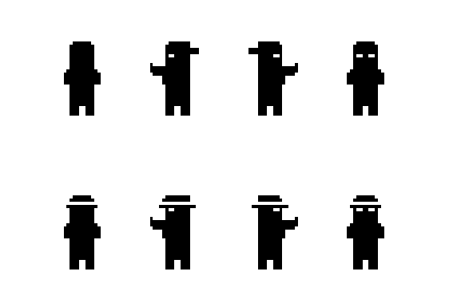

**3.1.4 End Screen**

* Same screen as 2.14
* The end screen will display the player's final combined score.

**4. Sound Effects**

|  |  |  |
| --- | --- | --- |
| **Sound Effect Name** | **Brief Description** | **Event which Triggers Playback** |
| Bullet Shot | Fast high pitch “pew” with fast end | Player fires bullet |
| Ammo/Point Pickup | Reload bullet/shell sound | Player collides with pickup |
| Background Music | Similar tone to the walking dead | Constant |

# **5. Additional Features (Time Permitting)**

* Tactical nuke after round 5 (Pressing ‘N’ detonates)