DIT636 / DAT560 - Assignment 5:
Finite-State Verification
Due Date: Friday, March 13th, 23:59 (Via Canvas)

There are five questions worth a total of 100 points. You may discuss these problems in your teams and turn in a single submission for the team (consisting of a zipped archive containing a PDF report, model code, and additional supporting files) on Canvas. Answers must be original and not copied from online sources.

Report Template: A template for your report can be found here. You may modify this template for your own purposes, if needed.

Cover Page: On the cover page of your report, include the name of the course, the date, your group name, and a list of your group members.

Peer Evaluation: All students must also submit a peer evaluation form. This is a separate, individual submission on Canvas.

Overview
For this exercise, you are required to create a finite-state model of a traffic controller for a “lift bridge” (see below) and verify its properties using the NuSMV symbolic model checker.

NuSMV is a free, open-source model checker. Similar tools are used at companies writing safety-critical code like Volvo, Boeing, and Amazon. Knowing how to use any of these tools could prove very useful in getting a specialized well-paying job.

NuSMV can be downloaded from http://nusmv.fbk.eu/
A tutorial for NuSMV can be found at: https://nusmv.fbk.eu/tutorial/v26/tutorial.pdf

NuSMV is a command-line tool. It is available for all major operating systems. To check your properties, you can simply run the following command from the command line:

(Windows) NuSMV <model filename>
(Mac/Linux) ./NuSMV <model filename>

Consider a simple model, with a property at the end:

MODULE main
VAR
request : boolean;
state : {ready, busy};

ASSIGN
init(state) := ready;
next(state) := case
state = ready & request = TRUE : busy;
TRUE : {ready, busy};
esac;

SPEC AG (state = ready);

This model has two variables, request and state. request is an input from the outside environment, outside of our control. Therefore, its value is set randomly at each timing step (with possible values “true” and “false”). state is an internal variable of our model, with values “ready” and “busy”. We set its value based on the value of request and the current value of state. If the current value is “ready” and we get a request, we transition to the value “busy”. Otherwise, we set the next value of state randomly.

The property states that the value of state is always “ready”, and will always remain “ready”. This is absolutely not going to be the case. Therefore, when we run NuSMV, we get a counterexample illustrating a situation where the property is violated (the value of state becomes “busy”):
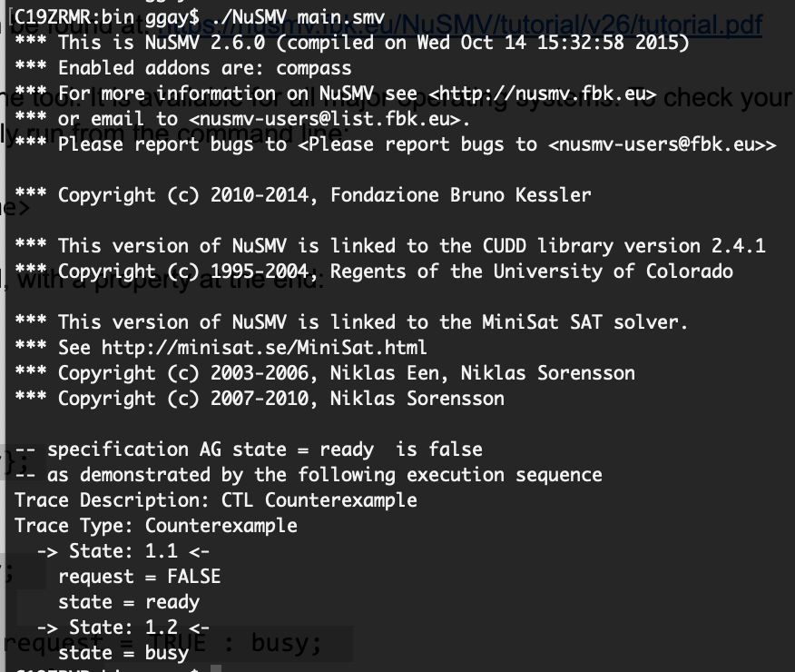
Because we set the value randomly in the absence of a request, it will eventually become “busy” no matter what we do, as is the case in this example. The counterexample consists of two steps (two state transitions). In the first, request is “false”, and state is “ready”. Because request is “false”, we set the next value of state randomly. As a result, in the second step, state becomes “busy” (request is not printed, as its value is not relevant).

Your Tasks
Now, it is your turn to design a slightly more complicated model - the control software for a “lift bridge” (e.g., Hisingsbron in Gothenburg).
- The bridge allows car traffic in both directions. At the start of the bridge (on both sides), there is a traffic light that should turn red when cars are not allowed onto the bridge, and should be green when cars are allowed. There should also be a transition (yellow) period when the light is about to turn red.
- The bridge can lift a segment into the air to allow boat traffic to pass. When the segment is lifted, cars should not be allowed to drive across the bridge. There is a similar traffic light for boards, that is red when the bridge is lowered (i.e., boats cannot pass), green when the bridge is lifted, and yellow during a transition.
- Assume that the system has sensors for both car and boat traffic to detect if either is present and waiting to pass through.
- This controller must manage traffic flow efficiently by varying the amount of time that the light is green for vehicles to pass or red (i.e., the bridge is raised) to allow ship traffic to pass, based on demand. Your model should capture and represent this notion of varying time and varying demand in some manner (i.e., do not completely abstract away time).
- There is an emergency vehicle sensor for road traffic, which lets the system provide priority access for emergency vehicles. If an emergency vehicle is waiting to pass, then ship traffic should be halted as soon as it is safe to do so.
- Note that it takes a short period of time for the bridge to raise or lower, so you cannot switch between road and ship traffic immediately. The light for vehicles should be red while the bridge is in motion, as new cars cannot enter at this time. This means that the transition should affect the time that the system calculates for a green light for boats.

You may state and make any other reasonable assumptions that you need.

For inspiration, consider the traffic light model that appears in the slides for Lecture 13. Understanding that model is a good first step in solving this problem, as it models a similar situation. There is also a useful model example in Exercise Session 6.

In your submission, you must address the following:

- In the report, define the scope, assumptions, and requirements for the system that are modeling. (30 Points)
  - Describe the system and environment you have modeled.
  - State any assumptions that you have made.
  - State the requirements you expect the system to satisfy.
- Build a finite state model of the system in the NuSMV language. Be sure to write sufficient comments in the model to document the code. (30 Points)
- Write at least three safety properties (“something bad must never happen”) in temporal logic (CTL or LTL) that must be satisfied by the system. (15 Points)
  - Explain each property using natural language.
  - State which system requirements those properties are derived from.
- Write at least three liveness properties (“something good must eventually happen”) in temporal logic (CTL or LTL) that must be satisfied by the system. (15 Points)
  - Explain each property using natural language.
  - State which system requirements those properties are derived from.
- Verify your properties on your system using the NuSMV symbolic model checker and provide a transcript of your NuSMV session. (10 Points)
  - This transcript should be provided as a separate file, not placed in the report.

