**CSCE 740 - Sequence Diagram Activity**

**Name(s):**

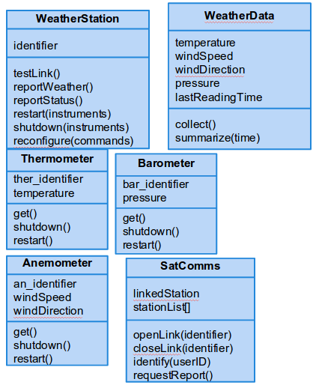

A local television station wishes to gather weather data. To do so, it identifies itself to the SatComms module and requests a link to the WeatherStation instance for a particular location. It then requests a weather report from the WeatherStation. The WeatherStation requests a summary from that location’s WeatherData instance. If new readings have not been take in the last five minutes, then the WeatherData will gather new values for its attributes. WeatherData will then return its summary.

**Draw a sequence diagram for this scenario using objects that instantiate these classes.**