# CSCE 740 - Practice Final

**Name:**

**Student ID Number:**

# Question 1—7 Points.

The following short questions are worth 1 or 2 points each.

**2 Points each: (more than one answer may be correct, pick all that apply).**

1. Which of the following make sense as classes (rather than objects) in a class diagram?  
   a. Homework Assignment b. Manton Matthews  
   c. Group 5’s assignment 5   
   d. Person
2. Which of the following coverage criteria **always** requires more test cases than the others?

a. Statement Coverage

b. Branch Coverage

c. Path Coverage

d. None of the above

**1 Point:**

1. Requirements-based test cases help the writer clarify the requirements.

a. True

b. False

1. In UML, a Class describes an Object.  
   a. True  
   b. False
2. The use of global variables generally increases coupling.  
   a. True   
   b. False

# Question 2—6 Points.

Describe the key difference between black-box testing and white-box testing.

# Question 3—8 Points.

Mention two fundamental characteristics of software that makes software engineering different than other engineering disciplines. Please elaborate briefly on each characteristic as to why it makes software engineering different.

(Alternatively, if you do not agree with the premise of the question, argue briefly that there is no difference between software engineering and other engineering disciplines.)

# Question 4 – 9 Points.

When we discuss software testing, we refer to Faults and Failures. Please briefly describe what a Fault is and what a Failure is. Make sure to point out the difference between a Fault and a Failure.

# Question 5—10 Points.

Are path coverage and exhaustive testing the same thing? Motivate your answer.

# Question 6—14 (3 + 9 + 2) Points.

You are developing a train scheduling tool for a rail network, where - for each station - a list of arriving trains is tracked (using a train ID that is a string of three characters and four single-digit integers). Each day, a new schedule is initialized and the previous day’s schedule is deleted. Additionally, a list is kept of valid train IDs.

The data structure containing train records contains the following independently testable features:

* void insertInSchedule(station, trainID)
* Boolean existsInSchedule(station, trainID)
* void deleteFromSchedule(station, trainID)

**Part 1:**

For the system, you receive the following requirement:

“We can’t have a train arrive at a station more than once.”

Revise this requirement so that it is testable.

**Part 2:**

Given the obvious meaning of the above methods, develop test cases using input domain partitioning. You can define your test cases as input/output pairs. For example, to test insert(station, trainID), one test case could be:

Input: station with empty container, valid trainID

Output: trainID in container

*Note - Do not go overboard with test cases, 4-6 test cases per method is adequate*

**Part 3:**

Identify a test case from the above that could be used to verify your revised requirement from Part 1.

**Question 7—16 (3+3+3+3+4) Points.**

For the following function,

1. Draw the program flow graph for the program.
2. Develop test input that will provide statement coverage. (Input output pairs will be fine.)
3. Develop test input that will provide branch coverage.
4. Develop test input that will provide full-path coverage.
5. Modify the program to introduce a fault so that you can demonstrate that even achieving full path coverage will not guarantee that we will reveal all faults. Please explain how this fault is missed in your example.

int findMax(int a, int b, int c)

{

int temp;

if (a>b)

temp=a;

else

temp=b;

if (c>temp)

temp = c;

return temp;

}

# Question 8 – 12 Points.

Students at the University of South Carolina can be enrolled in more than one class at the time. There is also an option to not be enrolled in any classes (under special circumstances such as completion of all requirements except your PhD dissertation defense). Naturally, we do not offer classes with no students at all.

To equitably allocate teaching effort, there is one instructor assigned to each class (there is no co-teaching). Some instructors might not teach any class (buyout for research for example). Each class uses a textbook (a book that—incidentally—can be used in other classes also).

Depending on class size, there are TAs assisting in the class. A small class gets no TAs, a large class might get several TAs.

When all is done in the class, the instructor assigns the student a grade for the course. In return, each student must fill out a course evaluation form for the course.

Draw a **class diagram** for the description above. Make sure to show attributes, multiplicities, association names, data attributes, and aggregations/compositions, where appropriate. You may omit operations.

# Question 9—10 Points.

Based on the class diagram below, please draw possible sequence diagrams for the two high-level scenarios below. Note that the operations are not yet defined for the classes. We are drawing these sequence diagrams to help us discover what operations will be needed for each class. Thus, the sequence diagrams will have to contain a little bit more detail then the high-level scenarios we captured when we discussed the use-cases with the customer.

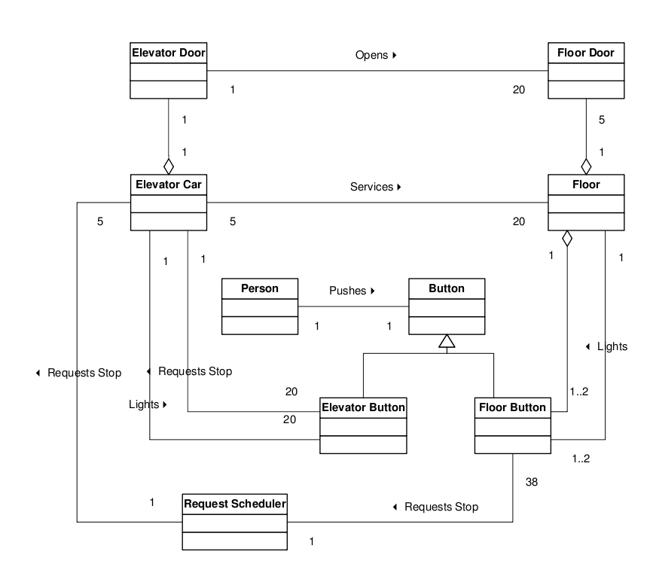

**Scenario 1 (Requesting a Ride Down):**A person approaches the elevator on the fifth floor. She wants to go down so she presses the “down” button next to the elevators. She waits until an elevator arrives and the doors open. She enters the elevator and presses the elevator button for the ground floor (floor 1). The light next to the button for the first floor is lit.

**Scenario 2 (Getting Off at a Floor):**A person is standing in the elevator with the door closed. The person pushes the elevator button for floor 5(and there are no other requests). The elevator stops at the fifth floor, opens the doors, and the person steps out. The elevator doors close.

# Question 10—8 Points.

You are developing software that will simulate and execute finite state machines.

A state machine consists of states and transitions. One state is special and designated to be the initial state (this is where we always start). Besides this, the initial state is just like all other states.

The transitions have transition conditions associated with them. A transition condition consists of a trigger event, a guarding condition, and a possibly empty set of actions (actions are events generated as a result of taking the transition).

Draw a **class diagram** for the description above. Make sure to show attributes, multiplicities, association names, data attributes, and aggregations/compositions, where appropriate. You may omit operations.