**CSCE 740 - Planning Activity**

**Name(s):**

You are involved in the development of a new software product. The product is an insurance application intended to determine what insurance products a potential customer is eligible for. The eligibility requirements are captured in various laws and regulations. You have a team of 10 developers, about 33% of which were newly hired for this project. Half of the team members have experience with projects that required adaptability. Your organization has hired a contractor to perform all levels of testing - the contractor has retained the ability to request additional funds to license additional testing tools.

Your organization has chosen the waterfall model as their development process. The product will be long-lived and good documentation is a must. In addition, the existing laws and regulations were thought to constitute a good start for the requirements of the project.

1. **Identify at least four risks of the project and place them on a risk assessment matrix:**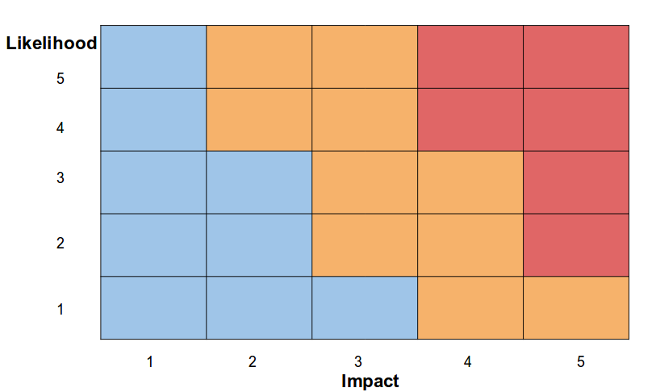
2. **Diagram the organizational factors for this project:**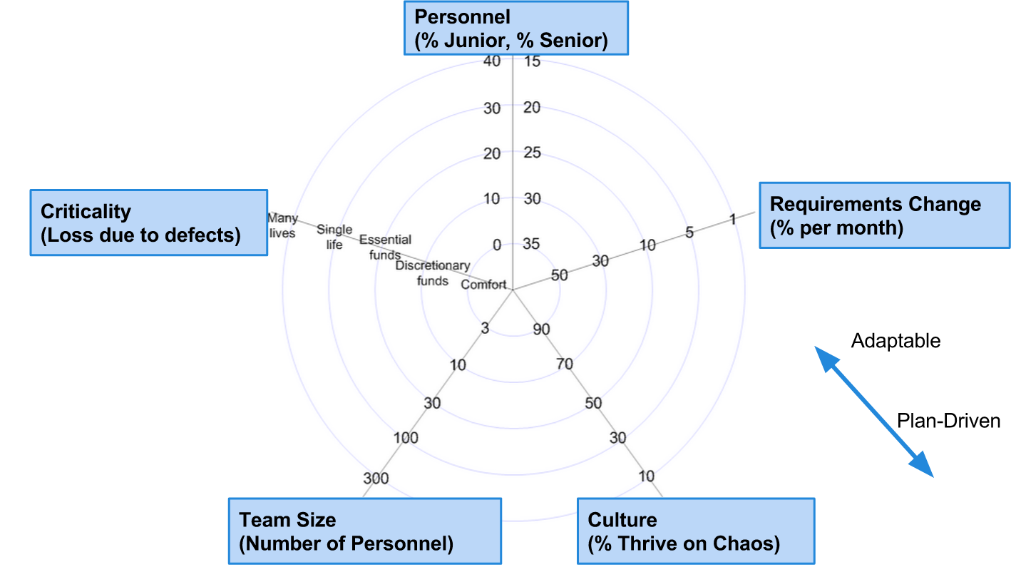
3. **What are some of the pros and cons of using the waterfall process for this project?**