**CSCE 740 - Domain Modeling Activity**

**Name(s):**

**You are developing a furnace system for a home. The furnace has a physical burner and thermometer. The software can control the burner and monitor the thermometer.**

**You have the following requirement for the furnace system:**

* If the furnace temperature drops below the user-defined threshold, then the burner shall be activated.

**1: Establish the properties of the world, machine, and interface required to satisfy this requirement.**

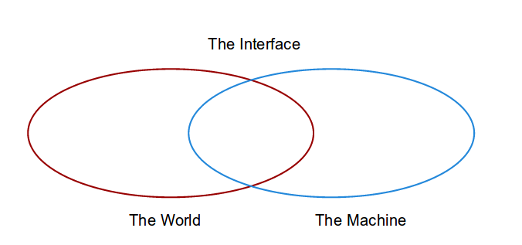

**2: State specification and domain knowledge properties that can be used to argue for fulfillment of the requirement.**