**CSCE 742 - View Activity**

**Name(s):**

A hospital has recently purchased a small clinic across the city where they will move lengthy outpatient procedures, such as dialysis. The hospital will have to provide meals (breakfast and lunch) to the clinic. The patients should be able to choose their meals using standard hospital meal tickets.

The hospital and clinic are both connected to the internet. However, the current meal system is antiquated; it is managed with ticket readers and is on the internal network (behind the firewall). In the current system, no authentication or encryption is performed. The volume of traffic will likely be low (anticipated top demand is 30-40 users).

System functionality:

* Transmit menu to clinic
* Allow patients to order food
* Deliver food to clinic

Current environment:

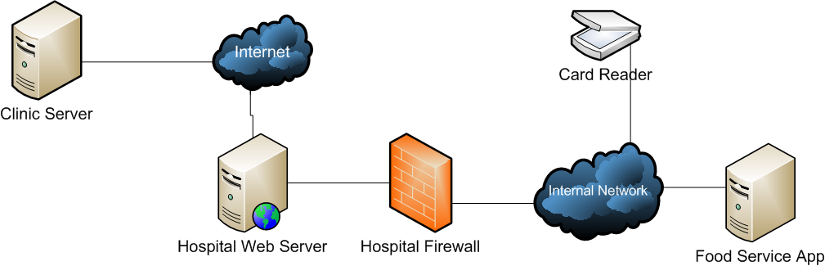

1. **Who are the stakeholders in this system?**
2. **What questions would you ask them?**
3. **What information is missing from the system description?**
4. **What are the relevant views? (This can include aspects not covered in this lecture) What are some considerations that belong to each view?**