**TDA 594/DIT 593 - Feature Model Analysis Activity**

Consider the following Feature Models:

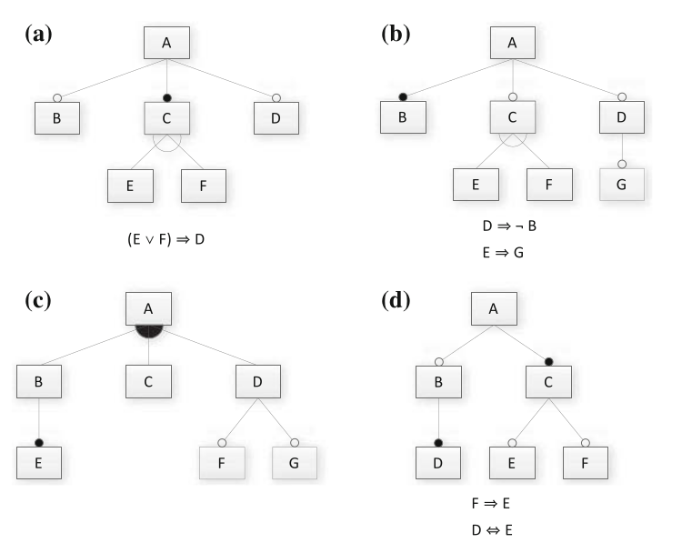

**Start with Models A and B. If you have time, also try Models C and D.**

1. Translate the feature model into a propositional logic formula. Note that the logical expressions next to models A, B, and D are cross-tree constraints that must be incorporated as well.
2. Provide two valid and two invalid feature selections (if possible).
3. Determine whether the feature model is consistent (are there any valid configurations?). If it is not consistent, identify one reason why.

Recall the following transformations from diagram to logic (where p and f are two features, and p is the parent of f):

* mandatory(p, f) ≡ f ⇔ p
* optional(p, f) ≡ f ⇒ p
* alternative(p, {f1,...,fn}) ≡ ((f1 ∨ … ∨ fn) ⇔ p) ∧(fi,fj) ￢(fi ∧ fj)
  + empty fan, choose exactly one
* or(p, {f1,...,fn}) ≡ ((f1 ∨ … ∨ fn) ⇔ p)
  + filled fan, choose at least one