**TDA 594/DIT 593 - Feature Diagram Activity**

You work at a company that is developing an **operating system for smart televisions**. You have decided to develop this as a software product line, so that you can easily provide different feature sets for different physical products.

1. Analyze the domain and identify a set of features.
2. Model the domain with a feature diagram.

To analyze the domain, you may draw on your own experiences with such products, or may search the internet for examples of such products (e.g., looking at Samsung, Sony, or other manufacturer websites or at shopping websites).

Some items to consider:

* Which features are likely to be requested by many customers?
* Which features are likely to be requested only by a few customers?
* Which features could distinguish your products from the products of your competitors in this market segment?
* Do not go crazy trying to identify all features. Try to capture an interesting set of important features (15 - 25, including all options for choices).
  + (don’t try to capture all media apps, for example)
* Pay attention to feature dependencies and make sure you capture relevant cross-tree constraints and model structures (mandatory, optional, alternative, or).

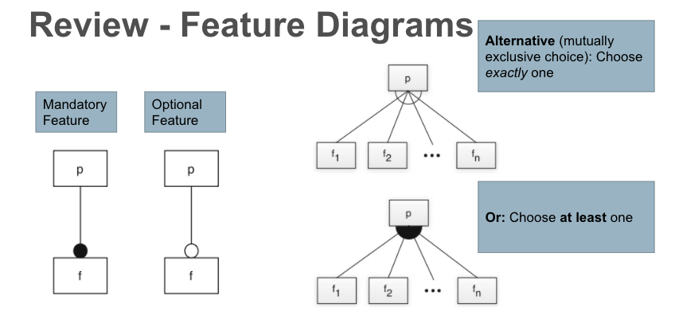

**Answer:**