**CSCE 747 - Model-Based Testing Activity  
Name(s):**

1. **Given the following finite state machine: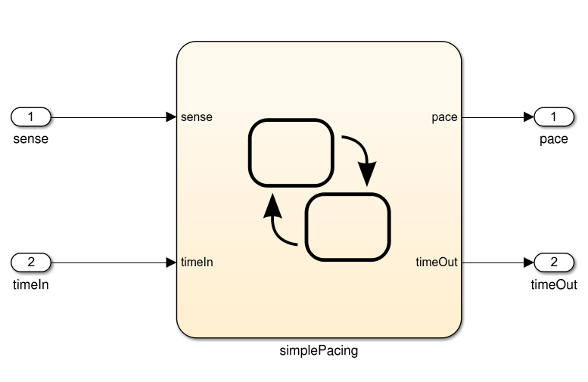 Input: sense (boolean), timeIn (integer). Output: pace (boolean), timeOut (integer)  
   Model:**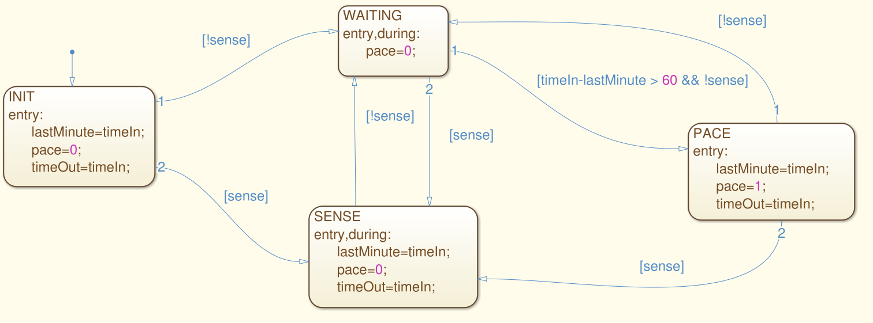
2. **Derive a test suite that achieves state coverage.**

1. **For the same model, derive a test suite that achieves transition coverage.**