**CSCE 747 - Model-Based Testing Activity  
Name(s):**

1. **Given the following finite state machine:  
   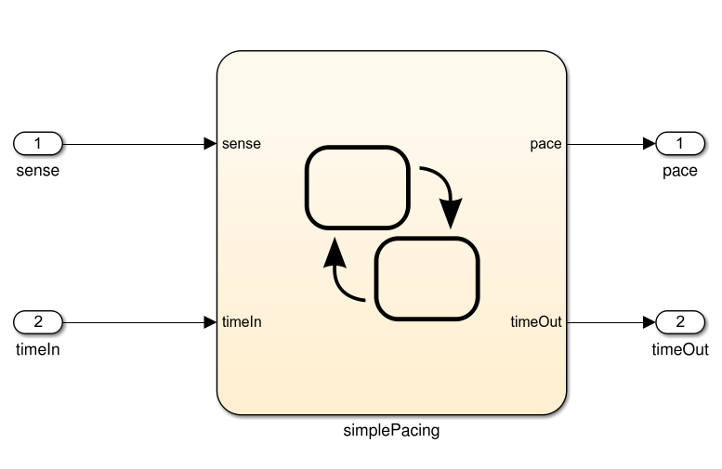  
   Input: sense (boolean), timeIn (integer). Output: pace (boolean), timeOut (integer)  
   Model:  
   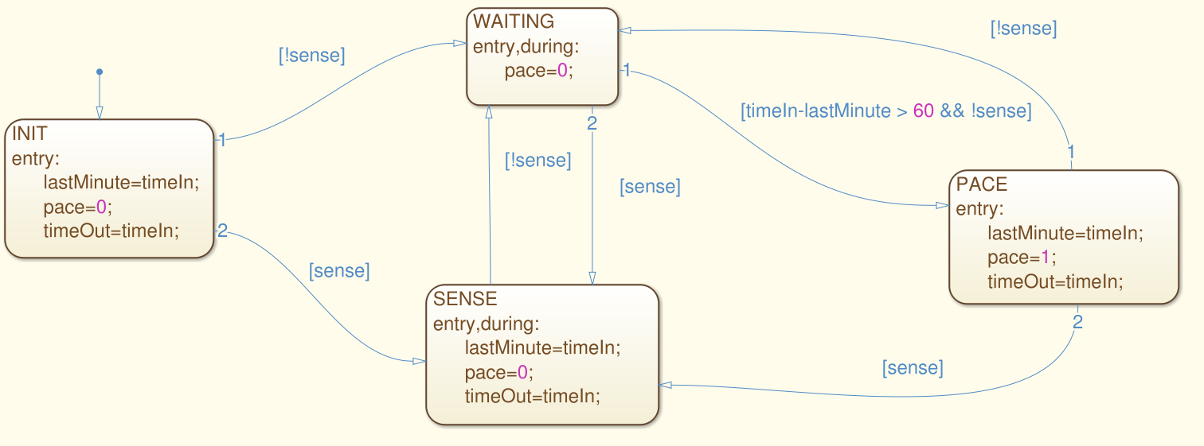**
2. **Derive a test suite that achieves state coverage.**

1. **For the same model, derive a test suite that achieves transition coverage.**
2. **Draw a decision table for the following specification. Be sure to indicate any constraints that you feel should be specified on the combinations of values.**  
     
   PDiscount is a function that determines the final price of an airplane ticket, based on the following conditions:  
     
   If the passenger is an infant (<2 years old), and the flight is domestic, than an 80% discount shall be given. If the passenger is an infant and the flight is international, than a 70% discount shall be given.  
     
   If the passenger is a child (2-16 years old) and an early reservation is made, than a 20% discount shall be given. If the passenger is a child, but a normal reservation is made, than a 10% discount shall be given.  
     
   If the passenger books an international flight in the off-season, then a 15% discount shall be given.  
     
   If an early reservation is made, then a 10% discount shall be given.   
     
   If multiple of the above combinations of conditions are met, the largest discount shall be awarded.
3. **How many tests would be required for compound condition coverage?**
4. **Derive test cases to achieve MC/DC coverage over the decision table.**
5. **Given the following grammar, derive a test suite that covers each production in the grammar.**expr : term | term * term | term / term   
   term : factor | factor + factor | factor - factor  
   factor : ATOM | LPAREN expr RPAREN  
     
   ATOM = 0..9  
   LPAREN = (  
   RPAREN = )