**CSCE 247 - Design Pattern Activity**

**Name(s):**

You are designing the software for a weather monitoring station. This station consists of:

* Humidity, Temperature, and Pressure Sensors
* A computer with a monitor

The software for this system must be able to create three displays that can be sent to the monitor: **the current conditions, weather statistics, and a simple forecast.**

**Use either the Visitor or Observer pattern to design this software.** You can assume that a class called WeatherData exists that stores readings from the sensors (you can add additional functionality to this class).

**For reference:**

**Observer Pattern**

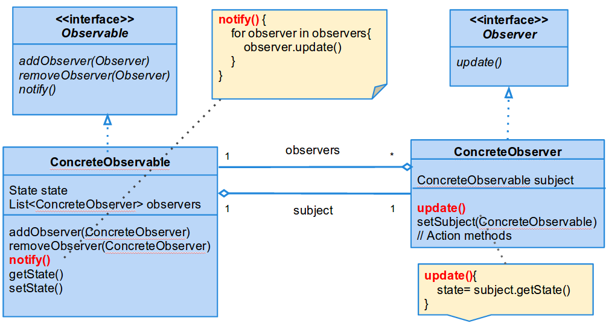

**Visitor Pattern**

