**DIT635 - Model-Based Testing Activity**

1. **Dracula wants to keep his valuables in a safe that’s hard to find. So, to reveal the lock to the safe, Dracula must remove a strategic candle from its holder. This will reveal the lock only if the door is closed. Once Dracula can see the lock, he can insert his key to open the safe. For extra safety, the safe can only be opened if he replaces the candle first. If someone attempts to open the safe without replacing the candle, a monster is unleashed.**

**Design a finite state machine for the controller of the secret panel in Dracula’s castle.**

1. **Given the following finite state machine:  
   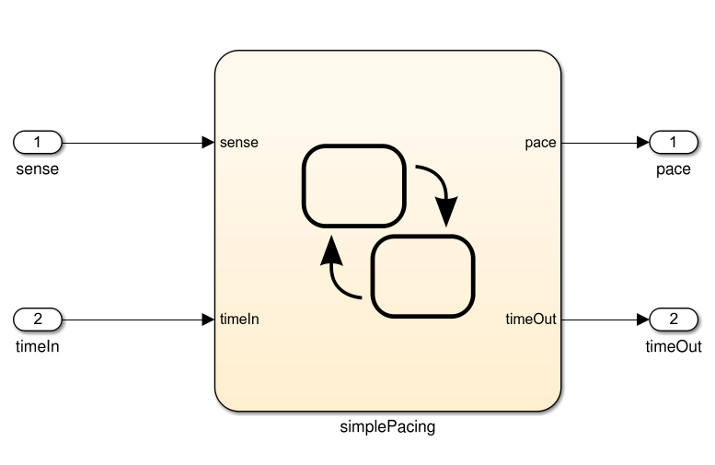  
   Input: sense (boolean), timeIn (integer). Output: pace (boolean), timeOut (integer)  
   Model:  
   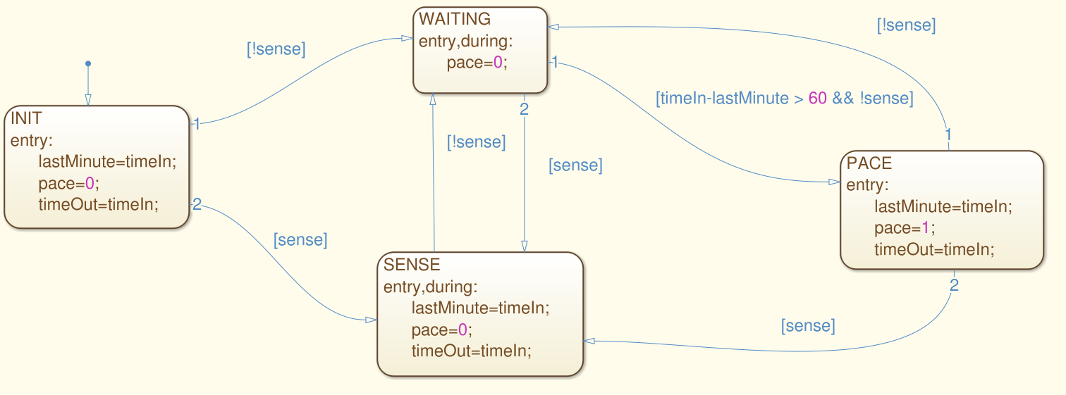**
2. **Derive a test suite that achieves state coverage.**

1. **For the same model, derive a test suite that achieves transition coverage.**