**DIT635 - Model-Based Testing Activity**

1. **Dracula wants to keep his valuables in a safe that’s hard to find. So, to reveal the lock to the safe, Dracula must remove a strategic candle from its holder. This will reveal the lock only if the door is closed. Once Dracula can see the lock, he can insert his key to open the safe. For extra safety, the safe can only be opened if he replaces the candle first. If someone attempts to open the safe without replacing the candle, a monster is unleashed.**

**Design a finite state machine for the controller software in the secret panel in Dracula’s castle. This software controls the entire system described above. When designing your state machine, model the state from the perspective of the software - that is, what the software is aware of, and what it can control (e.g., states like “lock revealed” or “candle removed”, and not “Dracula in the room”).**

1. **Given the following finite state machine:  
   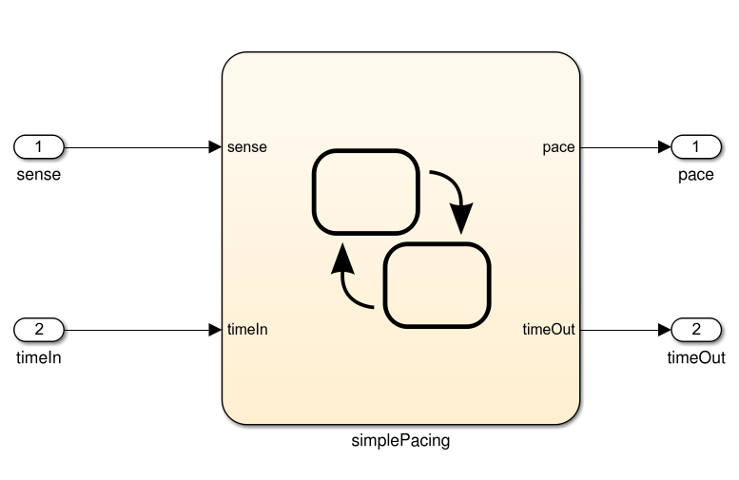  
   Input: sense (boolean), timeIn (integer).   
   Output: pace (boolean), timeOut (integer)  
     
   Model:  
   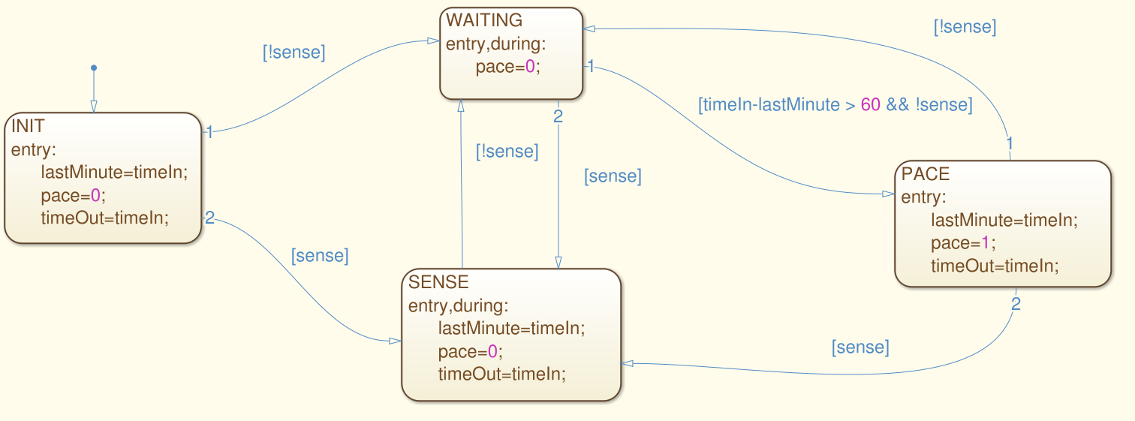**
2. **Derive test input (series of input values for sense and timeIn) that achieves state coverage of the model.**

1. **For the same model, derive test input that achieves transition coverage.**