Board Game Analyzer

Low Level Requirements

General

|  |  |  |
| --- | --- | --- |
| Number | Text | Tested In |
|  |  |  |
| BGA001 | In order to help analyze game progress, the application will have three run states:  Run – game moves are allowed to run without impediment due to the run state  Pop – game moves are allowed to run until the current piece is pulled off the board when the run state transitions to Step  Step – game moves are suspended. |  |
| BGA 002 | When |  |

GUI

|  |  |  |
| --- | --- | --- |
| Number | Text | Tested In |
|  |  |  |
| BGA 101 | The GUI will be laid out according to diagram 1 below. | N/A |
| BGA 102 | The GUI will have a selection box containing the list of available games, initialized with “No Game Selected”. |  |
| BGA 103 | The GUI will have a selection box for each the X dimension and Y dimension of the chosen game. The selections will be limited to values allowed by the current game, initialized to the lowest valid value. |  |
| BGA 104 | The GUI window title will display the current game and dimensions. |  |
| BGA 105 | The GUI will display the current score for each player. |  |
| BGA 106 | The GUI will display the current total games solved. |  |
| BGA 106 | The GUI will display the wins for Player 1. |  |
| BGA 107 | The GUI will display the wins for Player 2. |  |
| BGA 108 | The GUI will display the total draws encountered. |  |
| BGA 109 | The GUI will have a check box entitled “Show Every Move”. When checked the game will be displayed after every move. |  |
| BGA115 | The GUI will have a combo box entitled “Update Display Every” with the following values: “0.1”, “0.5”, “1”, “2”, “3”, “5”, “10”, and “20”. This value, in seconds, will control the periodic update of the display. Note: The display update is to allow visual verification of the game in progress. |  |
| BGA 110 | The GUI will display the current run state in a text box entitled “Run State”. |  |
| BGA 111 | The GUI will have a button entitled “Step”. Clicking this button will take the following actions depending on the current run state:  Run - enter run state “Stopped”.  Pop - enter run state “Stopped”.  Step – execute one move and remain in run state “Stopped” |  |
| BGA 112 | The GUI will have a button entitled “Pop”. Clicking this button will take the following actions depending on the current run state:  Run - enter run state “Stopped”.  Pop – pop the highest number on the board and remain in run state “Stopped”.  Step – execute one move and remain in run state “Stopped” |  |
| BGA113 | The GUI will have a button entitled “Run”. Clicking this button will enter run state “Run”. |  |
| BGA114 | When a game is selected the chosen game will be displayed with the initial pieces placed. |  |
| BGA115 | When a game is displayed, it will display the current board situation, the current player, and the available moves for that player. In addition it will display the available moves for the current player. Note: This is to facilitate visual verification of the game is progress. |  |

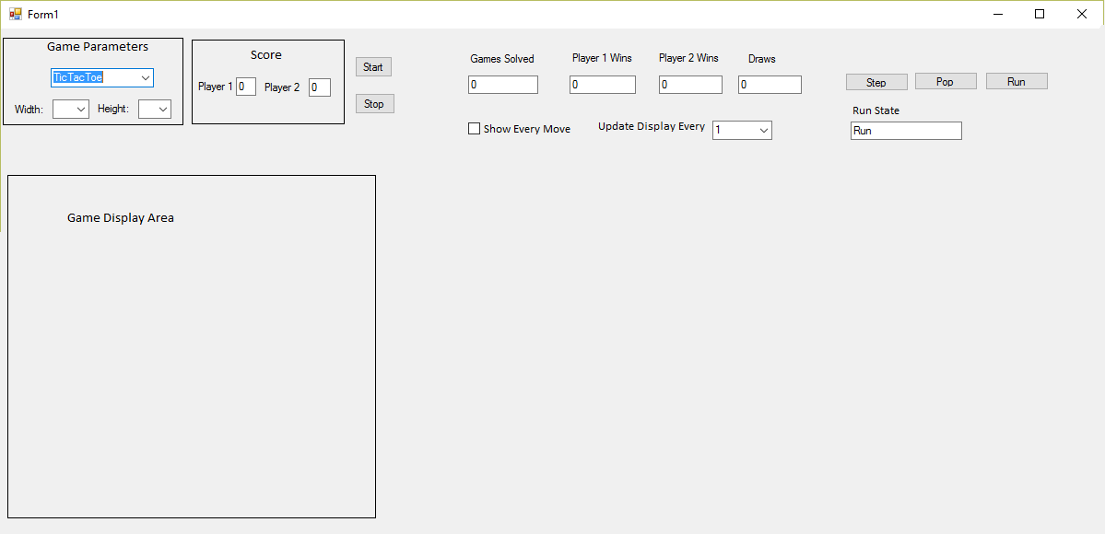

Diagram 1

Game Generation

|  |  |  |
| --- | --- | --- |
| Number | Text | Tested In |
|  |  |  |
| BGA 200 | The Board Game Analyzer will create and populate a Game Graph Database for each combination of game and board dimensions. | N/A |
| BGA 201 | The Board Game Analyzer will create and populate the Master Database. |  |