Getter and Setter Methods
An important role in class design is to preserve the integrity of object state. Generally, class definitions are the foundation of the software stack; class models are defined at the onset of a project so the classes can later be used to enable other services and processes. Accordingly, the team that designs the classes will probably not be the same team that uses these classes to build out processes. Returning to our file example, a class model is defined at the start of a project. The class designer validates the design by “unit testing” (exercising the class attributes and behaviors in a scripted environment with known inputs and outputs) the code, then releases the code to other team members, who utilize the code in real-world circumstances. As you can see, the team that designs the class is not necessarily the same team that uses the class.
The class designer is expected to know what range of values constitute a valid object state. For example, the File class is defined with an integer property that specifies the file size. Integers can have negative values, but a file cannot have a negative size. A negative value would be an unexpected value for a file size. The file class is also defined with a creation date; while the year 2079 is a valid date, it would be an unexpected value for a file creation date. Assigning a negative file size or future creation date to a File object would violate the integrity of the object’s state, and probably indicates an error has occurred elsewhere in the software stack. Rather than corrupt the object state by assigning an unexpected value, the class can guard against compromised state assignments.
As a reminder, the object’s state is held in properties or attributes of the object. These attributes are expressed as discrete elements (such as file name, file size, file creation date, etc.) Some programming languages support well-defined data types, including numeric, character array, date/time values, but Python is a typeless language. We can annotate classes using attribute hints defined as annotations, but the Python language does not honor the hints. Nonetheless, these annotations serve as valuable communication artifacts for the developers who use class definitions.
Typically, an instance attribute is examined or modified using dot “.” notation. For example, to examine or modify the creation date of a file object in Python, we can use the following syntax:
01 | myDocument = File("/users/desktop/resume.docx")
02 | print(f"Creation date: {myDocument.creationDate}")
03 | myDocument.creationDate = "2079/01/01"

Line 1 creates a File object; line 2 examines the creationDate attribute of the object using dot “.” notation, and line 3 assigns a new value to the object’s attribute.
As you can see, the object attributes are exposed, because unexpected values can be assigned to the object instance, without any input validation. In many programming languages, modifying an attribute can be prohibited by access keywords in the class definition, preventing code from assigning an unexpected value to the attribute. Python does not honor this mechanism. Instead, Python uses a naming convention to signal that attributes should not be directly modified. An attribute with an underscore “_” prefix is a signal to users of the class that the attribute should not be assigned directly. Instead, the class definition provides methods that can be used to modify the attribute safely, with input validation.
Consider the Point class from the previous lab. The point class exposed 2 attributes – x and y. To protect these attributes, we can rename these attributes to _x and _y, but we must then add methods to the class definition to allow the attributes to be examined or modified. These methods are called getter and setter methods (another pair of terms is accessor and mutator methods). The getter method is used to retrieve the value, while the setter is used to safely modify the value.
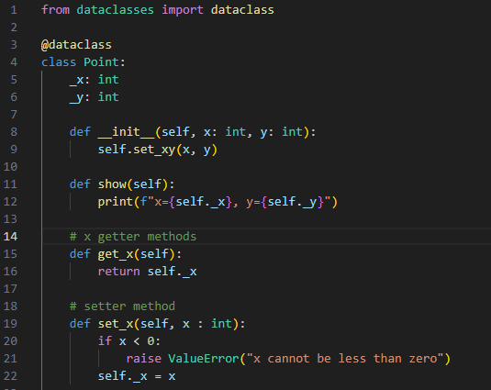
In the code snippet above, the x and y attributes are renamed to _x and _y on lines 5 and 6. A new method, get_x, is defined on line 15. This getter method returns the attribute value. The setter method is defined on line 19, and the method accepts a parameter, x, that it tests before assigning to the attribute. If the value of the x parameter is out of range (for example, a negative value) an exception is thrown. The setter method guards against changes to the object that will put it into an unexpected state.
The following code snippet illustrates how the user of the class examines and modifies the x attribute:
01 | lowerLeft = Point(10, 10)
02 | print(f"the x value is {lowerLeft.get_x()}")
03 | lowerLeft.set_x(-100)

Line 1 creates a new instance of the Point class; line 2 retrieves the value of the x attribute using the get_x accessor method, and line 3 attempts to set an unexpected value in the setter method, but instead triggers an exception. The exception is the signal to the class user that the object’s state was about to be comprised. The surrounding software logic must handle the exception. Depending where the unexpected value originated, this may require terminating the process, notifying an interactive user, or taking an alternative code path.
Python supports another paradigm called “properties” that support assignment using the dot operator, but it’s not a good idea to use properties when the class performs input validation, because a class user does not expect a property assignment to raise an error. Using the setter method is a way of signaling that the method call can raise an error. This is known as the principle of least surprise, which holds that code should honor the expectations of those who use it. This approach is considered to be more Pythonic, or written in a way that conforms to the majority expectations about the language.
One more point to note – the initiator method on line 8 of the revised Point class calls another instance method, self.set_xy. Both the class initiator and the set_xy method perform the same functionality – the validate the x and y parameters, and assign the values if the inputs are valid.
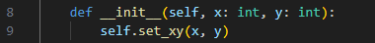
Rather than repeat the code from lines 36-39 in the __init__ method, it’s easier to call the self.set_xy method.
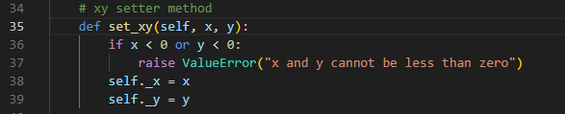
In this code snippet, the method set_xy defined on line 35 checks the x and y values for out-of-bounds values, and raises an error. Otherwise, if the inputs are positive, the parameter values are assigned to the attributes. This is a very simple example of code reuse – calling the same software unit from multiple locations in the code stack. An important software principal is the DRY principal, which stands for Don’t Repeat Yourself. Express an algorithm once, and use it pervasively. The more often a code unit is called, the higher its testability, and the greater the likelihood of catching and fixing errors.
Static Methods
So far we’ve talked about instance methods that operate on instance variables to interrogate or update an object’s state. Instance methods are evoked on objects using the dot notation. There are certain operations that don’t require an instance In order to execute an operation. Let’s say we want to compare 2 Point objects to see if there x and y attributes match. The operation is relatively straightforward; return true if both points have matching and y attributes; otherwise return false. To implement this type of instanceless method, we use the @staticmethod annotation.
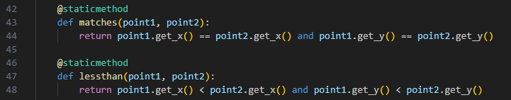
In this code snippet, the @staticmethod annotation on line 42 indicates the matches method is a static, instanceless method. The method accepts 2 Point objects as parameters, and compares their x and y attributes. The same applies to the lessthan method implemented on line 47.
As this code snippet illustrates, 2 points are created on lines 59 and 60. Line 61 calls the matches method, passing the points as parameters. Note that the method name is prefixed with the class name, as in Point.matches.
Another good use case for static methods would be a method that calculates the midpoint between 2 other points. The return value would be an instance of the new Point object, but its x and y values would be calculated from the x and y values of 2 input parameters. While the same results can be achieved using instance methods, sometimes static methods can provide greater readability and flexibility.
List Attributes
We have learned how to use annotations to declare integer attributes in classes. Using a list attribute is a little more complicated. The syntax for using a list annotation can be illustrated in an enhanced version of the Canvas class.
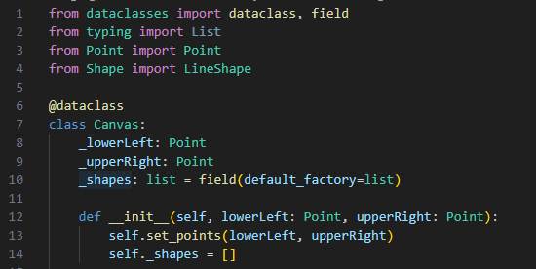
Line 1 imports the dataclass and field annotation from dataclasses; line 2 imports the List annotation. Lines 3 and 4 are used to import the Point and LineShape definitions (the LineShape definition will be discussed later). Lines 8 and 9 declare “private” attributes _lowerLeft and _upperRight, which are both of type Point. Line 10 defines an attribute named _shapes that is of type List. The syntax can be somewhat confusing, but allows us to declare a list attribute using annotations.
Line 12 defines the parameters to the __init__ method, and line 13 passes these parameters to the set_points method. Line 14 initializes the _shapes attribute to an empty list.
Lists are an ideal way to deal with objects, because you can store a variable number of objects in a list, and then iterate through the list, calling methods on each of its contained objects. As we are building our graphics system, we will use a list to store the shapes that we want to draw on the canvas.
The Canvas class does not provide a getter or setter method for its list attribute. Instead, Canvas provides a method for adding shapes to the list, and for examining the shapes in the list. The list attribute is considered “private”.
Exercise
- Update your Point class definition to use “private” attributes for x and y; add getter and setter methods for x and y, and a setter method for x and y together. Add code to prevent the x or y value from being assigned a negative value. Add static methods to compare two points, and to identify whether one point is less than another point.
- Create a new class called LineShape. This class will contain 2 private attributes of type Point. Add getter and setter methods for the 2 Point attributes, as well as a setter method that assigns both points. Add code to prevent either point from being assigned a value that matches the other point. in other words, the LineShape object cannot have 2 points with x, y coordinates of (0,0) and (0, 0).
- Update your Canvas class to use private attributes for the lowerLeft and upperRight attributes; add getter and setter methods for lowerLeft and upperRight, as well as a setter methiods for both coordinates. Add code to prevent the lowerLeft point from being greater than the upperRight point. Add a list attribute that stores shapes, Provide a method to add a shape (we will use the LineShape object as the parameter type). Add code to the Canvas show method to iterate through all the shapes in the list, and call the show method on each element.
- Add code that creates a Canvas object with the coordinates (0, 0) and (500, 500). Add 10 LineShape objects to the canvas, each with different points. Call the show method on the canvas to display iits shapes.

