When you attend a university, you’re likely to enroll in several different courses in a single semester. In order to keep the lecture notes, assignment instructions and due dates for each course separate, you may use a separate notebook for each course. Class definitions provide the same way of organizing code. Each class definition describes only the attributes and behaviors needed to characterize that specific class. A class definition for files would not define an algorithm for sorting integers; the integer sorting algorithm would be defined in its own class definition. Each class definition is a discrete software unit that focuses on the attributes and behaviors of the real-world item the class is modeling. Class definitions are one way of achieving a modular software design. Software is modular if it can be decomposed into discrete, single-purpose units. Modular design limits complexity by reducing the roles each class is responsible for. It’s easier to reason about the behaviors of small, discrete units rather than have to contemplate the behaviors of a large system. Solving a problem by focusing on small, discrete units is known as the divide-and-conquer principle.
Our graphics system is a good illustration of this principle. Because we designed a simple, primitive class called Point, we were able reuse the Point class in two other classes – LineShape and Canvas. We did not add line and canvas features to the simple Point class; instead, because the Point class was lightweight and single-purpose, we were able to extend the capabilities of our graphics system by composing new classes. Composition is one way of leveraging the open-closed principle. According to this principle, software should be open to extension but closed to modification.
As the number of class definitions in a system grows, it’s not uncommon to recognize that some classes share similar attributes and behaviors. For example, a spreadsheet file and an image file both have file names, file sizes and creation dates. Both files can be copied or deleted. However, creating a spreadsheet file requires spreadsheet software, and creating an image file may require a camera accessory. A spreadsheet file has a count of cells, and an image file has an image resolution. So both files share attributes and behaviors, but also have distinct attributes and behaviors that cannot be shared. Would you design a single class definition for both classes? If so. How would you account for the distinct attributes and behaviors? Would you design two distinct class definitions for each class? If so, you would be duplicating the shared attributes and behaviors. This would violate the DRY principle.
Fortunately, there is a design strategy that allows us to combine the shared characteristics of a class, and isolate the unique characteristics of this class. This design strategy is called inheritance.
The image below illustrates the design strategy of inheritance. A class is defined with primitive file characteristics, such as file name, size, and creation date. Beneath this primitive class, two distinct classes (spreadsheet file and image file) inherit the shared characteristics of the primitive file class, but each has its own distinct characteristics.

Inheritance in file definitions
The common, shared class is called a base class. The base class contains only the characteristics that are shared across the family of classes. Each specific class inherits the characteristics of the base class, but defines its own unique characteristics. The base class is general-purpose; the classes inheriting from the base class are special-purpose (a spreadsheet is more special-purpose than a file). Ckasses that inherit from a base class are called derived classes; these classes derive their characteristics from the base class, and extend the capabilities of the base class with their own special features.
Let’s consider a more complex inheritance structure:

Inheritance in shape definitions
In the hierarchy depicted above, there is a base class called Shape. Both LineShape and RectangleShape derive from Shape. The PolyLineShape class derives from the LineShape class, and the SquareShape class derives from the RectangleShape class.
Inheritance can be many levels deep, but in practice you may only need 2-3 levels of inheritance.
Let’s say we want to draw each of our shapes in our canvas. We can define a behavior named show() and assign this behavior to each class. Then, when we want to draw a particular shape, we would call its show() method. Since all of our Shape classes have a show() method, we can define this method at the basest level, in the Shape base class. Then each derived class would inherit the show() method.
There are a few drawbacks to this approach. First, the base class Shape has no shape! The class is only a placeholder for the derived classes, like LineShaoe and SquareShape. These derived classes have coordinates that can be drawn, but the Shape class itself does not have any coordinates. There is no way to draw an instance of the base class Shape.
Secondly, each derived class requires its own graphic primitives for drawing its shape. Drawing a square is different than drawing a line, just as drawing a line is different than drawing a circle. So, the base class Shape can’t actually be drawn, and each derived class must implement its own drawing method. This design method, where a base class defines a placeholder behavior that is implemented by derived classes, is called polymorphism. We will deal with this issue shortly.
In Python, you can define a base class using annotations. Consider the Shape class defined below:
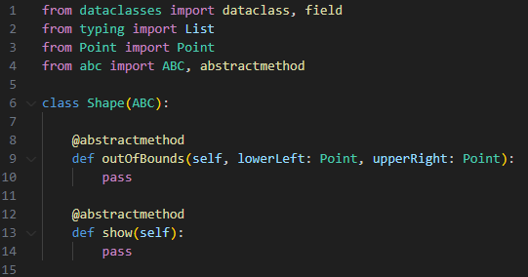
In Python, when a class is derived from a base class, the base class is listed in parentheses after the derived class name. Here, the Shape class is derived from the ABC class (ABC stands for abstract base class). Shape declares two methods as abstract – outOfBounds() and show(). An abstract method is one that must be defined in a derived class. So the Shape class is signaling that any class deriving from Shape must define these two methods. The keyword pass indicates that Shape is only defining the method as a placeholder – it is not providing any code to implement either method.
LineShape derives from Shape. As implemented, a LineShape contains two points (one point for each end of the line). LineShape also defines an __init__ method where the two points comprising a line can be passed to the instance.
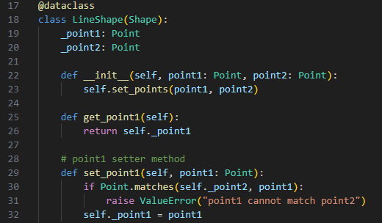
With a LineShape, you don’t want both line ends to reference the same point (then it wouldn’t be a line, it would be a point).
The LineShape class must define the outOfBound() and show() methods, as illustrated in the code snippet below.
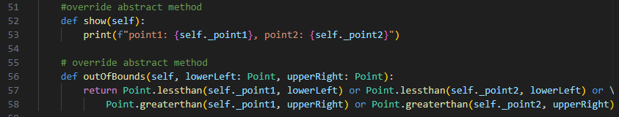
As a shortcut, the show() method simply prints the values of each line end (for now). Note the method name and the parameters on lines 52 and 56 must match the name and parameters defined on lines 9 and 23 of the base class Shape.
The outOfBounds() method will be used later by the Canvas object. The purpose of this method is to ensure we don’t add any shapes to the Canvas object that are lower than the lower-left or higher than the upper-right coordinates of the Canvas.
We can derive more classes, to provide drawing primitives like ellipses, polylines, polygons, rectangles, etc. Each new shape type would derive from Shape and implement the outOfBounds() and show() methods.
The Canvas class
In the second lab, we used the Canvas class to store a list of LineShape objects. The Lineshape was a simplified version of the LineShape class defined above; we have also added a base class called Shape. Accordingly, we want the Canvas class to define a store for objects that derive from the Shape class.
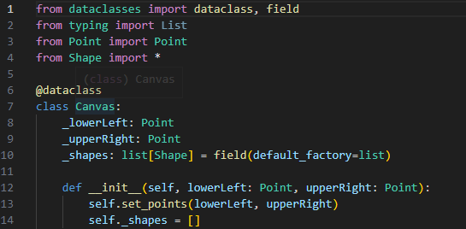
Line 7 defines the Canvas class, which contains two points from the Canvas lower and upper bound. Line 10 defines a list of shapes using the Shape base class. This means that the list can be used to store objects that derive from Shape, such as LineShape, SquareShape, etc. The __init__ method on line 12 accepts the lower and upper bound points as parameters, and initlizes the list to the empty list.
The Canvas class also defines a show() method. This method displays the lower and upper bounds of the Canvas object, then loops through all the shapes in the list, calling the show() method. Since the base class Shape does not implement the show() method, the method call is marshalled to the derived classs,
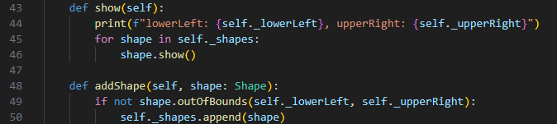
Note as well that the addShape method on line 48 first tests whether the shape is out-of-bounds before adding the shape to the list. The outOfBounds() method is another polymorphic method that is marshalled to the derived class’ version, to test whether the shape can be added to the list.
Finally, we must add our new shapes to the canvas.
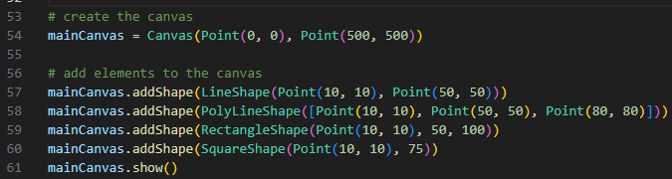
Line 54 creates a new canvas with lower and upper bounds. Lines 57-60 add different shape objects to the canvas. Note that all the classes listed in this example are derived from Shape. Finally, the show() method is called on the canvas.
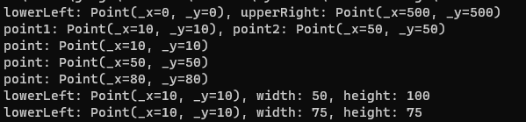
The results illustrate how the Canvas show() method will call the show() method on each of the Shape-derived objects added to the list.
Exercises
- Create an abstract base class called Shape, with show() and outOfBounds() abstract methids. The outOfBounds() method must accept two Point objects as parameters.
- Modify the LineShape class from lab 2 to derive from Shape; implement the show() and outOfBounds() methods. The LineShape class must define two points representing line ends.
- Create at least 3 other classes to derive from Shape. Each class must contain the primitive element needed to “draw” the shape. For example, a PolyLineShape object must have a list of lines; a RectangleShape class must store an upper-left point, a length and width. A CircleShape class must define a center point and a radius. All classes must implement the show() and outOfBounds() methods correctly.
- Modify the Canvas class to store a list of objects derived from Shape. When each shape is added to the Canvas object, check for out-of-bounds. Implement a show() method that prints the Canvas coordinates and each shape
- Add at least one of each of the shapes you’ve defined to a canvas object, and show the results.

