Up to this point, we’ve designed a number of different classes that describe several of the elements of a two-dimensional graphics system, including a canvas which has a rectangular boundary and contains a list of shapes. While we’ve used several classes to describe shapes, such as a line, a polyline, a rectangle and an ellipse, we’ve used inheritance and polymorphism to isolate the base characteristics and behaviors of a shape, and to imbue each of our shapes with these common characteristics, while still allowing each class to define the unique attributes of the shape it describes. For example, the LineShape and EllipseShape classes inherit from the abstract base class called Shape; both classes implement the abstract method show() which is used to display properties; however, each class specializes in its own unique attributes needed to describe the related shape.
By this point you may have noticed that the classes don’t really provide a mechanism for drawing shapes in the canvas. Both the Canvas and Shape-derived classes contain only the primitives (lines, points, dimensions, coordinates, etc.) that could be used for drawing shapes, but don’t provide a mechanism for actually drawing shapes. In other words, there is no implementation of a drawing feature.
Because the classes describe two-dimensional primitives, they can be used by any number of drawing libraries. There are many different two-dimensional drawing libraries for Python. These libraries typically provide interfaces for drawing shape primitives (that is, lines, arcs, ellipses, allowing you to specify border and fill colors, line thickness, opacity, and other features). In order to get the highest use from our primitive two-dimensional classes, we’d like to support any or all of these graphics libraries.
If we were to modify our Canvas and Shape classes so the code will interact with many graphics libraries, our simple classes will quickly become bloated many lines of code, which will lead to conflicts and clutter. This approach violates two important software principles – modularity and the open-closed principle. Instead, we’d like to adopt a plugin architecture where we consider each graphics library to be a plugin. The plugin interface supports weak coupling, by ensuring that both the consumer and the provider of plugin features adhere to a common set of methods. Rathe than modify our suite of classes, we extend the classes by adding the plugin interface. When our software executes, we decide which modules to bind to our plugin interface.
There are a number of idioms we can use to present this plugin architecture, though many of these are beyond the scope of these lectures. One simple mechanism we are already familiar with is inheritance. We can create derived classes that inherit from our base classes, and provide implementations that are specific to one or more graphics libraries.
So, in addition to the show() method we’ve already provided our Shape classes, let’s add a new method called draw(). Since we are not going to change our current classes, we are going to create another abstract base class. This abstract base class is lightweight, and will only be used to inject the draw() abstract method. A lightweight, single-purpose base class is called a mixin.
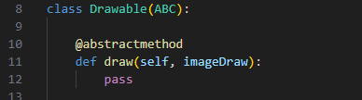
Consider the class defined on lines 8-12 above. The class Drawable inherits from the ABC, or abstract base class. Lines 10 and 11 define a simple abstract method called draw(). The draw() method takes as parameters the reference to self, as well as to a graphics object using for the drawing surface.
In order to use this new mixin class, we take advantage of a feature in Python called multiple inheritance. Multiple inheritance allows a class to derive from more than one base class. Consider the class definition below.
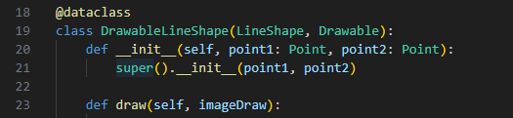
On line 19, class DrawableLineShape derives from both LineShape and our new Drawable class. Note that we have to repeat the signature of the __init__ method for this derived class, so it can pass the same parameters to the LineShape base class. Line 23 provides the definition of the draw() method. We’ll see the full method body in a moment.
Now we must add our implementation of a two-dimensional graphics library. The implementation code is shifted into the derived class so the base class remains general-purpose and unburdened with actual drawing instructions.
For this example we are going to use a two-dimensional graphics library called Pillow. You can download Pillow using the command:
pip install Pillow
Note that you can use another two-dimensional graphics library if you wish! This is by no means a class on two-dimensional graphics, so students who are already familiar with different graphics libraries are free to use them.
To include the Pillow library in our derived class, we add the instruction:
from PIL import Image, ImageDraw
Now we can execute graphics instructions:
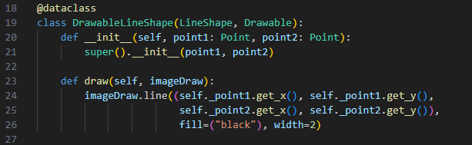
Lines 24 – 26 contain instructions for drawing a line shape in a drawing surface (more on that later). We provide the coordinates of the origin and termination of a line by using the LineShape’s attributes for point1 and point2; further, we specify that a line shape will be depicted as a black line 2 pixels wide. The point1 and point2 attributes were defined in the base class, LineShape. The draw() method is defined in the abstract base class Drawable. By the way, there is a conflict in the way the Pillow library works with our classes. Pillow sets the (0, 0) x-y coordinates in the upper left, whereas our classes define this coordinate in the lower left. For the sake of the lab exercise though, we can ignore it.
Here's another example:
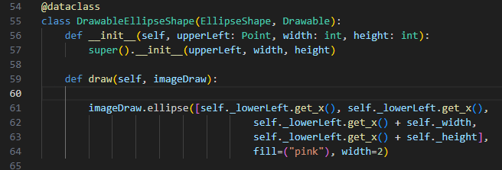
Lines 54-55 declare the class DrawableEllipseShape which derives from both EllipseShape and Drawable. Line 59 defines the override method draw(), and lines 61-64 use the attributes of the EllipseShape class (upperLeft, width, height) to calculate the dimensions of the ellipse, which will be drawn in the graphics surface with a pink interior and a line that is 2 pixels wide.
By isolating the code that interacts with the graphics library, we are encapsulating the implementation. Encapsulation is a pattern for concealing an implementation, so that if the implementation is later changed, the underlying interface is not affected. This also touches upon another important principle called separation of concerns. Separation of concerns uses different techniques, such as layers, inheritance and plugin architectures to allow core modules to focus on individual features.
Since we are passing a graphics context to our shape objects, where does the graphics context originate? To answer this question we’ll need to look at a new class we have defined called DrawingCanvas. DrawingCanvas derives from Canvas. Its declaration looks like this:
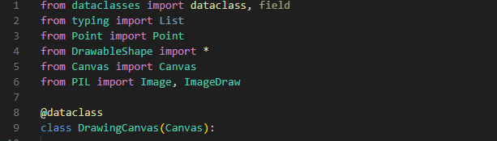
Lines 1-6 include our libraries, including the new Python file DrawableShape, the Canvas file, which contains our base class Canvas, and the Pillow library.
Lines 8-9 declare a new class called DrawingCanvas that derives from Canvas.
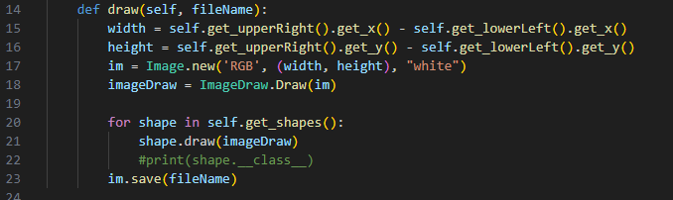
Line 14 declares a rather lengthy method draw(), but this is where all our work is done! Note that this is not the same abstract method draw() we declared in the Drawable mixin class. This method simply shares the method name draw() to signal what the purpose of the method is.
Lines 15-16 calculate the size of the drawing canvas from the attribute upperRight and lowerLeft, declared in the base class Canvas. Line 17 calls the Image.new() method, part of the Pillow library, to create a graphics context using the specified dimensions, and with a white background. Line 18 calls the Image.Draw method, passing it the Image object created on line 17, and returns the graphics context.
The shapes attribute is a list of Shape objects declared n the base Canvas class. Line 20 iterates through all the shape objects in the last, and calls the draw() method. This is the method declared as abstract, and overridden in the derived class, to draw each shape in the graphics context.
When all shapes have been drawn, the image is saved to a file.
How do we construct a DrawableCanvas object and add Drawable-derived shapes to it? Consider the code segment below.
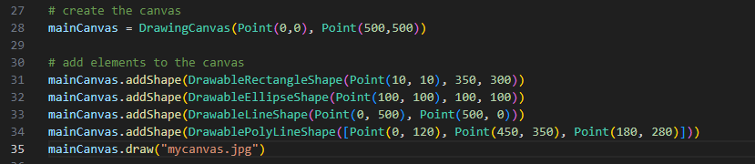
Line 23 constructs a new DrawingCanvas object that s 500 x 500 pixels in dimension. Lines 31 – 34 construct new shapes and add them to the canvas, and line 35 draws the shapes, which are saved to the file specified in the draw() parameter.
Here’s a (not very pretty) example of what the shapes look like:
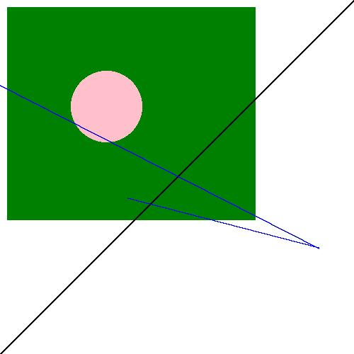
I told you it wasn’t very pretty! However, this lecture gave us an opportunity to explore some important patterns and principles in software design.
Exercises
Exercises
- Create an abstract base class called Drawable, with a draw() method that takes a single parameter (besides self.
- Modify the LineShape class from lab 3 to derive from Drawable; implement the draw() method. The DrawableLineShape class must draw its shape in a graphics context, either by using the Pillow library or another two-dimensional library of your choosing.
- Create at least 3 other classes to derive from Drawable. Each class must implement the graphics instructions needed to “draw” the shape. For example, a DawablePolyLineShape object must draw its lines in the graphics context; a RectangleShape class must draw 4 connected lines that match the shape’s coordinates.
- Create a new DrawingCanvas class that derives from the Canvas class to store a list of objects derived from Shape. Implement a draw() method that draws each shape on the graphics context, and save the graphics context to a file.
- Add at least one of each of the shapes you’ve defined to a canvas object, and show the resulting file.

