Recipes

Breakfast

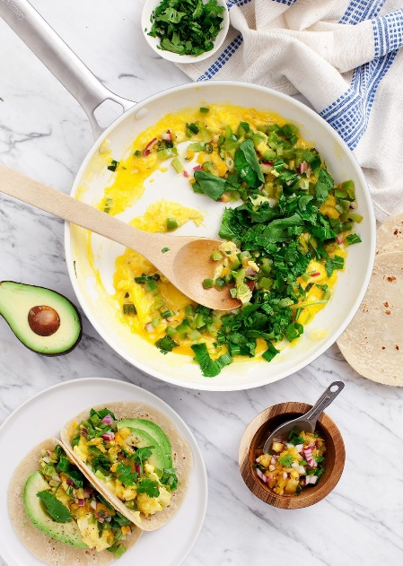

**Ingredients**

**Salsa**

* 1 large yellow tomato, diced
* 3 tablespoons diced red onion
* 3 tablespoons chopped cilantro
* ½ to 1 serrano pepper, thinly sliced
* 1 garlic clove, minced
* juice from ½ lime
* ¼ teaspoon sea salt

**For the tacos:**

* 1 green pepper, cored, stem removed, and diced
* 3 scallions, chopped
* 6 eggs, beaten
* 2 cups arugula or spinach, chopped
* extra-virgin olive oil, for drizzling
* sea salt and freshly ground black pepper
* 8 tortillas, corn, flour, wheat - whatever you like
* ¼ cup chopped cilantro, more for garnish
* 1 avocado, sliced
* lime wedges

Dinner

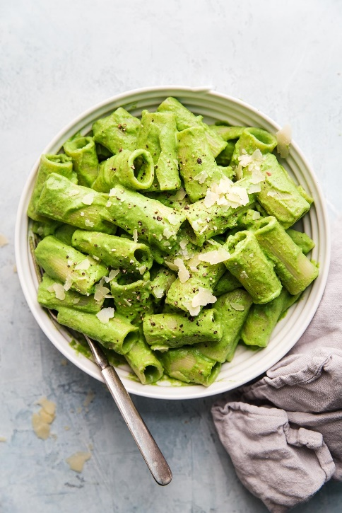

* **1 lb**Cooked pasta of your choice, pasta water reserved
* **4 cups**Broccoli florets
* **2 cups**Basil leaves, lightly packed
* **2**Garlic cloves
* **¼ cup**Pine nuts
* **1 cup**Extra virgin olive oil
* **½ tsp**Salt
* **1 cup**Parmigiano-reggiano, grated