**IST 659**

Doggie Lifestyle

**March 2021**

# Overview

A few years ago, we welcomed a new pup in our family named Boston. Boston is a medium-standard American Bulldog. American Bulldogs are a well-balanced athletic dog that demonstrate great strength, endurance, agility, and a friendly attitude. Their average weight ranges from 66-130 lbs. American bulldogs shed a lot due to his short haired breed. Dogs shed heavily twice a year. This shedding is triggered by light more than temperature. As the days get longer, your dog will start to shed, even though the weather may still be very cold outside. Whenever we would wash Boston, multiple towels were used to dry him, and his hair would get all over the towel and re-washing towels is a pain even with the de-shedding detergent. After speaking to multiple pet owners, I realized I am not the only one with this dilemma. Washing your dog can be time-consuming and a challenging task which is not always enjoyable for some dogs/dog parents. There are already doggy robes out there for such dogs, such as small and medium dogs. For large/extra-large dogs, there are not a lot of choices. Thus, came the idea of Doggie Lifestyle. Doggie robes for all sized dogs.

# Goal

The primary objective of Doggie Lifestyle is to pamper your dog with a soft robe after a bath without the hassle of using multiple towels to dry your dog. In 2019, $95.7 billion was spent on our pets in the U.S. alone. According to the 2019-2020 APPA National Pet Owners Survey, 67% of U.S. households own a pet, dogs equate to 63.4 million homes[1]. Doggie Lifestyle robes are sold online, and the fabric used is absorbent/shed control. After a dog wash all the owner or groomer would have to do is put the robe on the pup and when the dog is dry. Air out the robe, and when the robe is completely dry. The dog’s hair will fall right off for easy disposal.

EXECUTABLE CODE -- DATABASE CREATION

-- drop all database objects in reverse order of their dependencies

-- including views, stored procedures and tables; note the use of

-- OBJECT_ID to detect if the object exists and conditionally deletes

-- existing objects only. The 2nd parameter to OBJECT_ID is the object

-- type - P for procedure, V for view, U for table

-- drop all procedures

IF Object_ID ('dbo.InsertProduct', 'P') IS NOT NULL DROP PROCEDURE IF EXISTS dbo.InsertProduct;

go

IF Object_ID ('dbo.InsertPayment', 'P') IS NOT NULL DROP PROCEDURE IF EXISTS dbo.InsertPayment;

go

IF Object_ID ('dbo.InsertCustomer', 'P') IS NOT NULL DROP PROCEDURE IF EXISTS dbo.InsertCustomer;

go

-- drop all views

IF OBJECT_ID ('dbo.CustomerPayment', 'V') IS NOT NULL DROP VIEW IF EXISTS dbo.CustomerPayment;

go

--DROP VIEW IF EXISTS dbo.CustomerPayment;

go

-- drop all tables in reverse order of their dependencies

IF OBJECT_ID ('dbo.OrderDetail', 'U') IS NOT NULL DROP TABLE IF EXISTS dbo.OrderDetail;

go

IF OBJECT_ID ('dbo.CustomerOrder', 'U') IS NOT NULL DROP TABLE IF EXISTS dbo.CustomerOrder;

go

IF OBJECT_ID ('dbo.Employee', 'U') IS NOT NULL DROP TABLE IF EXISTS dbo.Employee;

go

IF OBJECT_ID ('dbo.Supplier', 'U') IS NOT NULL DROP TABLE IF EXISTS dbo.Supplier;

go

IF OBJECT_ID ('dbo.Product', 'U') IS NOT NULL DROP TABLE IF EXISTS dbo.Product;

go

IF OBJECT_ID ('dbo.Payment', 'U') IS NOT NULL DROP TABLE IF EXISTS dbo.Payment;

go

IF OBJECT_ID ('dbo.Customer', 'U') IS NOT NULL DROP TABLE IF EXISTS dbo.Customer;

go

-- create all tables in order of their dependencies

CREATE TABLE dbo.Customer

(

CustomerID int Not Null IDENTITY,

FirstName varchar(50) NOT NULL,

LastName varchar(50) NOT NULL,

ShipAddress varchar(255) NOT NULL,

ShipCity varchar(30) NOT NULL,

ShipState varchar(30) NOT NULL,

ShipPostal varchar(30) NOT NULL,

Email varchar(255) Null,

CreditCard varchar(255) Null,

CardExp int Null,

DogSize varchar(30) Null,

CONSTRAINT PK_Customer Primary Key (CustomerID),

CONSTRAINT U1_Customer Unique(LastName)

);

go

CREATE TABLE dbo.Payment

(

PaymentID int NOT Null IDENTITY,

PaymentType varchar(50) Not Null,

PaymentDate date Null,

CustomerID int NOT Null,

Allowed int Null,

CONSTRAINT PK_Payment Primary Key (PaymentID),

CONSTRAINT FK1_Payment FOREIGN KEY (CustomerID) references Customer(CustomerID)

);

go

CREATE TABLE dbo.Product

(

ProductID int NOT NUll IDENTITY,

ProductName varchar(50) NOT NULL,

ProductDescription varchar(255) NOT Null,

Fabric varchar(50) Null,

Color varchar(50) Null,

Size varchar(50) Null,

CONSTRAINT PK_Product Primary Key (ProductID),

CONSTRAINT U1_Product Unique(ProductName)

);

go

CREATE TABLE dbo.Supplier

(

SupplierID int Not Null IDENTITY,

CompanyName varchar(50) Not Null,

ProductID int NOT Null,

SupplierAddress varchar(255) Null,

CONSTRAINT PK_Supplier Primary Key (SupplierID),

CONSTRAINT FK1_Supplier FOREIGN KEY (ProductID) references dbo.Product (ProductID)

);

go

CREATE TABLE dbo.Employee

(

EmployeeID int NOT NULL IDENTITY,

FirstName varchar(50) NOT NULL,

LastName varchar(50) NOT NULL,

Department varchar(50) NULL,

DateHired date Null,

CONSTRAINT PK_Employee Primary Key (EmployeeID)

);

go

CREATE TABLE dbo.CustomerOrder

(

OrderID int Not Null IDENTITY,

CustomerID int Not Null,

PaymentID int Not Null,

OrderDate date Null,

ProductID int Not Null,

EmployeeID int Not Null,

CONSTRAINT PK_CustomerOrder Primary Key (OrderID),

CONSTRAINT FK1_CustomerOrder Foreign Key (CustomerID) references Customer(CustomerID),

CONSTRAINT FK2_CustomerOrder Foreign Key (PaymentID) references Payment(PaymentID),

CONSTRAINT FK3_CustomerOrder Foreign Key (EmployeeID) references Employee(EmployeeID),

CONSTRAINT FK4_CustomerOrder Foreign Key (ProductID) references Product(ProductID)

);

go

CREATE TABLE dbo.OrderDetail

(

OrderDetailID int Not Null IDENTITY,

ProductID int not Null,

Quantity int Null,

Discount int Null,

Total money Null,

Size varchar(20) Null,

Color varchar(20) Null,

Available int Null,

OrderID int Not Null,

ShipDate date Null,

CONSTRAINT PK_OrderDetail Primary Key (OrderDetailID),

CONSTRAINT FK_OrderDetailProduct Foreign Key (ProductID) references Product(ProductID),

CONSTRAINT FK_OrderDetailCustomer Foreign Key (OrderID) references CustomerOrder(OrderID)

);

go

CREATE PROCEDURE dbo.InsertCustomer

@FirstName varchar(50),

@LastName varchar(50)

AS

INSERT dbo.Customer (FirstName, LastName) VALUES (@FirstName, @LastName);

go

CREATE PROCEDURE dbo.InsertPayment

@PaymentType varchar(50)

AS

INSERT dbo.Payment(PaymentType) VALUES (@PaymentType);

go

CREATE PROCEDURE dbo.InsertProduct

@ProductName varchar(50),

@ProductDescription varchar(255)

AS

INSERT dbo.Product(ProductName, ProductDescription) VALUES (@ProductName, @ProductDescription);

go

-- insert records into tables

INSERT dbo.Customer(FirstName, LastName, ShipAddress, ShipCity, ShipState, ShipPostal, DogSize, Email)

VALUES ('Sheev', 'Palpatine', '2324 Empire State', 'Los Angeles', 'CA', '90001', 'Large', 'sheeve.pal@gmail.com'),

('Qui','Jinn', '1371 Darth State', 'Los Angeles', 'CA', '90010','XLarge', 'jinn09@gmail.com'),

('Obi', 'Kenobi', '917 Ocean Jedi', 'Los Alamitos', 'CA', '90721', 'Medium', 'obik23@gmail.com'),

('Mace', 'Windu', '3101 Blue Springs', 'Beverly Hills', 'CA', '90209','Large', 'windumace@gmail.com'),

('Maul', 'Darthomir', '8787 Sith Empire', 'Carlsbad', 'CA', '92008','XLarge', 'darthstar@gmail.com'),

('Chewy', 'Becca', '3012 Space Drive', 'Malibu', 'CA', '90263','Large', 'becca909@gmail.com');

go

INSERT dbo.Payment(PaymentType,PaymentDate, CustomerID)

VALUES ('VISA', '03/16/2021', (SELECT CUSTOMERID FROM dbo.Customer where LastName= 'Palpatine')),

('MasterCard', '03/17/2021', (SELECT CustomerID from dbo.Customer where LastName= 'Jinn')),

('VISA', '3/18/2021', (SELECT CustomerID from dbo.Customer where LastName= 'Kenobi')),

('Discover', '3/19/2021', (SELECT CustomerID from dbo.Customer where LastName= 'Windu')),

('MasterCard', '3/24/2021', (SELECT CustomerID from dbo.Customer where LastName= 'Darthomir')),

('American Express', '3/25/2021', (SELECT CustomerID from dbo.Customer where LastName= 'Becca'));

go

INSERT dbo.Product(ProductName, ProductDescription)

VALUES ('Blue Mid Rim', 'Blue Microfiber robe with galaxy trim'),

('Green Maze', 'Green All Cotton robe with abstract trim'),

('Orange Wild Space', 'Orange Microsuede robe with tie dye trim');

go

INSERT dbo.Supplier(CompanyName, ProductID)

VALUES ('Microfiber LLC',(SELECT ProductID from dbo.Product where ProductName= 'Blue Mid Rim')),

('AllCotton',(SELECT ProductID from dbo.Product where ProductName= 'Green Maze')),

('FabricsRUs', (SELECT ProductID from dbo.Product where ProductName= 'Orange Wild Space'))

go

INSERT dbo.Employee(FirstName, LastName)

VALUES ('Boba','Fett'),

('Cara', 'Dune'),

('Fennec', 'Shand');

go

INSERT dbo.CustomerOrder(CustomerID, PaymentID, OrderDate, ProductID, EmployeeID)

VALUES

(1, 1, '03/16/2021',1,1),

(2, 2, '03/17/2021',2,1),

(3, 3, '03/18/2021',2,2),

(4, 4, '03/19/2021',3,2),

(5, 5, '03/24/2021',1,3),

(6, 6, '03/25/2021',1,1);

go

INSERT dbo.OrderDetail(ShipDate, Total, Quantity, ProductID, OrderID)

VALUES ('03/17/2021', '$80', 2, 1, (SELECT OrderID from dbo.CustomerOrder where OrderID=1 )),

('03/18/2021', '$56',1, 2, (SELECT OrderID from dbo.CustomerOrder where OrderID=2)),

('03/19/2021', '$35', 1, 3, (SELECT OrderID from dbo.CustomerOrder where OrderID=3)),

('03/20/2021', '$120', 3, 1, (SELECT OrderID from dbo.CustomerOrder where OrderID=4)),

('03/25/2021', '$112', 2, 2, (SELECT OrderID from dbo.CustomerOrder where OrderID=5)),

('03/26/2021', '$40', 1, 1, (SELECT OrderID from dbo.CustomerOrder where OrderID=6));

go

-- Pull results from the tables

SELECT *

FROM dbo.Customer;

go

SELECT *

FROM dbo.Payment;

go

SELECT *

FROM dbo.Product;

go

SELECT *

FROM dbo.CustomerOrder

go

--Create a view with Customer and Payment

Create VIEW dbo.CustomerPayment

AS

SELECT PT.PaymentType, CUST.Email, CUST.LastName, PRD.ProductName, PRD.ProductDescription

FROM dbo.Customer as CUST

INNER JOIN dbo.Payment AS PT ON PT.CustomerID = CUST.CustomerID

INNER JOIN dbo.CustomerOrder AS CO ON CO.PaymentID= PT.PaymentID

INNER JOIN dbo.Product AS PRD ON PRD.ProductID = CO.ProductID

;

go

--Check the CustomerPayment View

SELECT * from dbo.CustomerPayment

--Data Question 1: How many orders each week so far?

Select DATEADD(Day, -DateDiff(Day, 0, [OrderDate])%7,[OrderDate]) AS [Weekof],

COUNT (*) AS Count

From dbo.CustomerOrder

Group By DATEADD(Day, -DateDiff(Day,0,[OrderDate]) %7, [OrderDate])

--Data Question 2: Which product is ordered the most?

Select ProductID, COUNT (ProductID) AS value_occurrence

From OrderDetail

Group By ProductID

Order By value_occurrence DESC

Select * from Product where ProductID= 1

--Data Question 3: What size are most commonly ordered?

Select DogSize, Count (*) from Customer

Group By DogSize

Order By DogSize asc

--Date Question 4: What is the monthly total? And weekly total?

SELECT

DATEPART (m, ShipDate) AS Month,

Sum(Total) AS Total

FROM OrderDetail

Group By DATEPART (m, ShipDate);

SELECT

DATEPART (wk, ShipDate) AS Week,

Sum(Total) AS Total

FROM OrderDetail

Group By DATEPART (wk, ShipDate);

--Data Question 5: What are the most ordered areas (zip code)?

Select ShipPostal from Customer

Appendix I-- Raw Data

Appendix II -- Maintenance Form

ANSWERING DATA QUESTIONS:

1. How many orders are made each week so far?

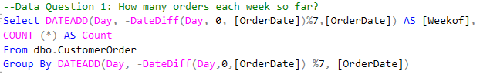

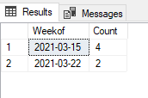

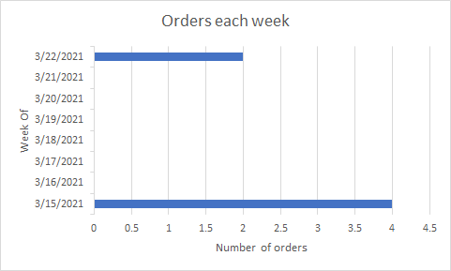

1. Which product is ordered the most?

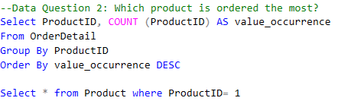

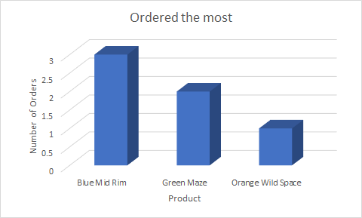

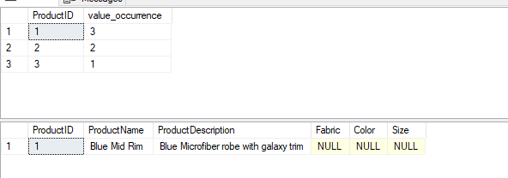

1. What size dogs are most ordered for?

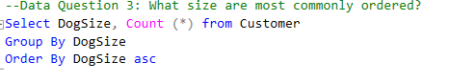

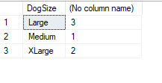

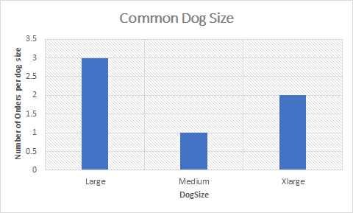

1. What is the monthly total? What is the weekly total?

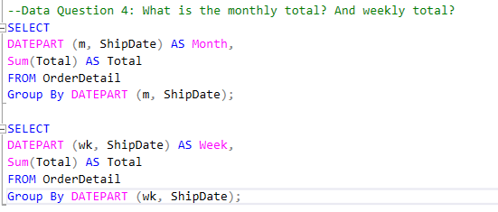

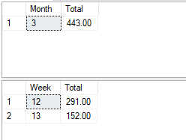

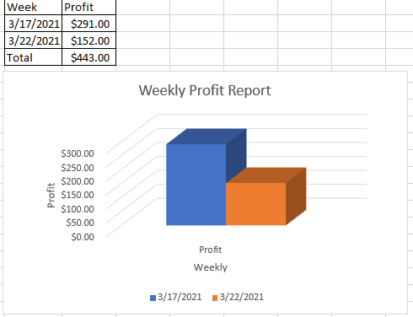

1. What are the most ordered areas (zip code)?



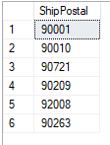

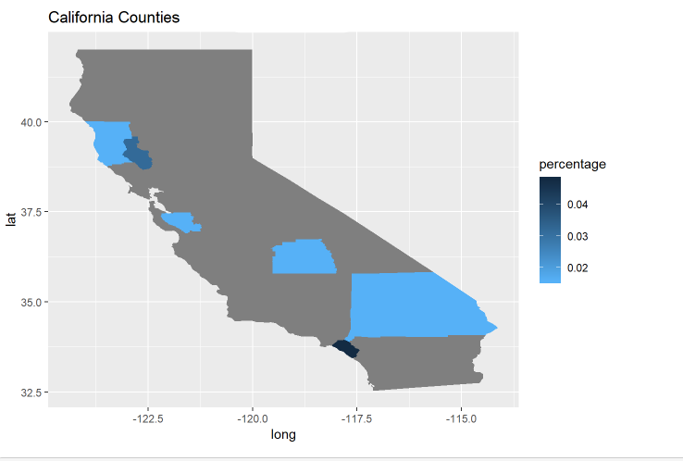

Appendix I - Raw Data:

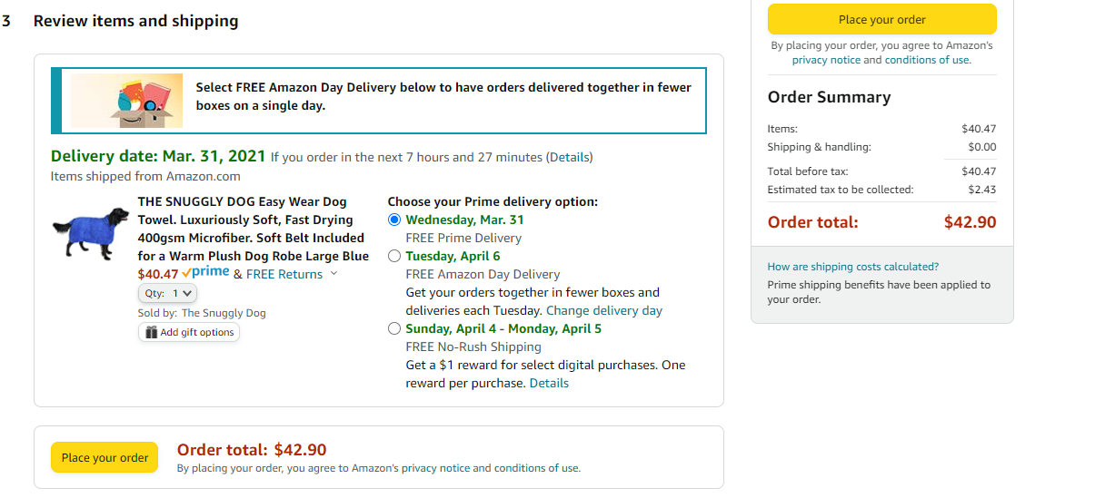

Appendix II - Maintenance Form

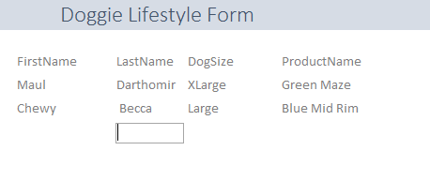

Reflection

When I first started working on the project I did not understand the importance of the conceptual and logical model. After full completion of the project, I understand how helpful conceptual/logical models are. Once the models are completed the design of the database is a walk in the park. The only thing I would do differently is create a web interface using R to collect more data and show another visualization. Also, learning how to connect Access to SQL was very important because I can now apply what I have learned to my job.

Summary

This class was extremely helpful. I learned how to create my own database, connect sql to R and Access. Most of my data questions were answered by a combination of SQL SELECT statements and creating a chart in either R and/or Excel. I now feel comfortable creating my own database and creating primary, foreign, and unique keys. I really enjoyed this course.

1. “Pet Industry Market Size and Ownership Statistics.”*APPA,* Feb. 2021, [*https://www.americanpetproducts.org/press_industrytrends.asp*](https://www.americanpetproducts.org/press_industrytrends.asp)*.*