2020 Bristol Bay Stock Recruit Analysis

Greg Buck

2020-12-01

knitr::opts_chunk$set(warning = FALSE, message = FALSE)  
#===========================================================================  
# 1.0 Set Modeling Environment   
#===========================================================================  
# Clear data   
rm(list=ls(all=TRUE))  
# load packages  
#---------------------------------------------------------------------------  
# 1.1 Set Data input output file and directory   
#---------------------------------------------------------------------------  
# Set directory where data file is located  
# read in 2012 brood table Escapement and Recuits by brood year (excluding togiak)  
# and merge into a 'old.master' object  
library(readxl)  
library(kableExtra)  
library(rmarkdown)  
library(ggplot2)  
library(png)  
library(tidyverse)  
library(plotly)  
library(tinytex)  
library(flextable)  
data <- "S:/REG2/BBsalmon/BroodTables/2012 Brood Tables Cunningham.xlsx"  
sheets <- excel_sheets(data)  
x <- length(sheets)  
brood.tables.2012 <- lapply(excel_sheets(data),read_excel,path=data)  
names(brood.tables.2012) <- sheets  
  
for (i in 1:x){  
 temp <- brood.tables.2012[[sheets[i]]]  
 temp <- temp[,c("Brood Year","Escapement","Recruits")]  
 temp <- as.data.frame(sapply(temp,as.numeric))  
 temp <- temp[complete.cases(temp),]  
 temp$version <- "old"  
 temp$river<-sheets[i]  
 if (exists("old.master")){  
 old.master <- rbind(old.master,temp)  
 } else {  
 old.master <- temp  
 }  
}  
  
  
# add 2012 togiak data to 'old.master' object  
data <- "S:/REG2/BBsalmon/BroodTables/Togiak Brood Table.xlsx"  
tog <- read_excel(data, sheet = "BroodTable",  
 skip = 8,  
 n_max = 62)  
  
tog <- tog[,c("Year","Escapement","Total")]  
names(tog) <- c("Brood Year","Escapment","Recruits")  
tog$version <- "old"  
tog$river <- "Togiak"  
tog <- tog[7:nrow(tog),]  
z <- names(old.master)  
names(tog) <- z  
old.master <- rbind(old.master,tog)  
  
  
  
# read 2020 brood tables and construct dataset 'new.master'  
data <- "S:/REG2/BBsalmon/Run Reconstruction/2020/2020_BBay_Brood_Tables.xlsx"  
sheets <- excel_sheets(data)  
x <- length(sheets)  
brood.tables.2020 <- lapply(excel_sheets(data),read_excel, skip = 1, path = data)  
names(brood.tables.2020) <- sheets  
  
for (i in 1:x){  
 temp <- brood.tables.2020[[sheets[i]]]  
 temp <- temp[,c("Brood Year","Escapement","Recruits")]  
 temp <- as.data.frame(sapply(temp,as.numeric))  
 temp <- temp[complete.cases(temp),]  
 temp$version <- "new"  
 temp$river<-sheets[i]  
 if (exists("new.master")){  
 new.master <- rbind(new.master,temp)  
 } else {  
 new.master <- temp  
 }  
}  
  
dat1 <- rbind(old.master,new.master)  
names(dat1) <- c("yr","e","r","ver","riv")  
k <-1000  
  
  
  
##########################################  
#### plot function  
##########################################  
plot.riv <- function(riv){  
# Extract old data   
d1 <- dat1[dat1$riv==riv & dat1$ver=='old',]  
# limite data from 1959   
d1 <- d1[d1$yr>=1959,]  
# Extract New data   
d2 <- dat1[dat1$riv==riv & dat1$ver=='new',]  
# Rikcer model old and new   
rk1 <-lm(log(r/e)~e,data=d1)  
rk2 <-lm(log(r/e)~e,data=d2)  
s <- seq(0,max(d1$e,d2$e),length.out=50)  
# plot data   
# Old data   
  
  
dat <- rbind(d1,d2)  
dat <- dat %>%  
 mutate(e = e/k) %>%  
 mutate(r = r/k)  
  
pred1 <- exp(predict(rk1,newdata=data.frame(e=s)))*s  
t <- data.frame(e=s)  
pred1 <- cbind(t,pred1)  
  
pred1 <- pred1 %>%  
 mutate(yr = 2020) %>%  
 mutate(r = pred1/k) %>%  
 mutate(e = e/k) %>%  
 mutate(ver = "newMSY") %>%  
 mutate(riv = riv) %>%  
 select(yr,e,r,ver,riv)  
  
pred2 <- exp(predict(rk2,newdata=data.frame(e=s)))*s  
t <- data.frame(e=s)  
pred2 <- cbind(t,pred2)  
  
pred2 <- pred2 %>%  
 mutate(yr = 2012) %>%  
 mutate(r = pred2/k) %>%  
 mutate(e = e/k) %>%  
 mutate(ver = "oldMSY") %>%  
 mutate(riv = riv) %>%  
 select(yr,e,r,ver,riv)  
  
smsy1 <- -rk1$coefficients[1]*(0.5-0.07*rk1$coefficients[1])/rk1$coefficients[2]  
smsy2 <- -rk2$coefficients[1]*(0.5-0.07*rk2$coefficients[1])/rk2$coefficients[2]  
  
labelold <- paste("oldMSY:",round(smsy1/k),sep=" ")  
labelnew <- paste("newMSY:",round(smsy2/k),sep=" ")  
  
  
  
if(riv != "Egegik"){  
p <- ggplot(dat, aes(x = e, y = r, shape = ver, color = ver)) +  
 geom_point() +  
 xlab("Escapement (x1000)") +  
 ylab("Recruits (x1000)") +  
 ggtitle(riv) +  
 theme(plot.subtitle = element_text(color = "red")) +  
 geom_abline(slope = 1, intercept = 0) +  
 geom_line(pred1, size = 1.2, colour = "black", mapping = aes(x = e, y = r)) +  
 geom_line(pred2, size = 1.2, colour = "red", mapping = aes(x = e, y = r)) +  
 geom_vline(xintercept = smsy1/k, colour = "red") +  
 geom_vline(xintercept = smsy2/k) +  
 theme(legend.position = "none")  
   
  
 } else {  
 p <- ggplot(dat, aes(x = e, y = r, shape = ver, color = ver)) +  
 geom_point() +  
 xlab("Escapement (x1000)") +  
 ylab("Recruits (x1000)") +  
 labs(title = riv) +  
 geom_abline(slope = 1, intercept = 0)   
}  
print(p)  
  
} # end plot.riv function  
  
  
#####################################################  
##### ricker parameter function  
#####################################################  
  
  
ricker.parameters <- function(riv){  
d1 <- dat1[dat1$riv==riv & dat1$ver=='new',]  
d1 <- d1[d1$yr>=1959,]  
SR1 <- lm(log(r/e)~e,data=d1)  
lnalpha <- SR1$coefficients[1]  
alpha <- exp(lnalpha)  
beta <- -SR1$coefficients[2]  
sigma <- sigma(SR1)  
Seq <- lnalpha/beta  
Smsy <- Seq*(0.5-0.07*lnalpha)  
MSY <- Smsy*(exp(lnalpha-beta*Smsy)-1)  
s <- seq(0,Seq,by=5000)  
pred <- exp(predict(SR1,newdata=data.frame(e=s)))*s  
  
foo <- s[sign(pred-0.9*MSY-s)==1]  
msy90 <- c(min(foo),max(foo))  
boot.R <- matrix(0,nrow=10000,ncol=3)  
colnames(boot.R) <- c('ln.alpha','beta','sigma')  
 s <- d1$e  
 SRP <-predict(SR1)  
 SRR <-residuals(SR1)  
 for (i in 1:10000)  
 {  
# Create bottstrap random ln(R/S)   
 bootR <- sample(SRR,length(SRR),replace = TRUE) + SRP  
# Calculate SR model   
 SRi <- lm(bootR~s)  
# Extract, Ricker lnalpha, beta, sigma  
 boot.R[i,1] <- SRi$coefficients[1]  
 boot.R[i,2] <- -SRi$coefficients[2]  
 boot.R[i,3] <- sigma(SRi)  
 }  
# Change to data.frame   
 boot.R <- data.frame(boot.R)  
 boot.R$alpha <- exp(boot.R$ln.alpha)  
 boot.R$ln.alpha.c <- with(boot.R,ln.alpha+0.5*sigma^2)  
 boot.R$Seq <- with(boot.R,ln.alpha/beta)  
 boot.R$Smsy <- with(boot.R,Seq*(0.5-0.07*ln.alpha))  
# Remove bad data (i.e. beta is neagative)   
 boot.R[boot.R[,2]< 0,] <- NA   
 tbl <- apply(boot.R,2,function(x) quantile(x,probs=c(0.025,0.5,0.975),na.rm=TRUE))  
 tbl <- as.data.frame(tbl, row.names = c("2.5%", "50%", "97.5%"))  
   
 tbl <- tbl %>%  
 mutate(ln.alpha = round(ln.alpha, 2),  
 sigma = round(sigma, 2),   
 alpha = round(alpha, 2),  
 ln.alpha.c = round(ln.alpha.c, 2),  
 Smsy = round(Smsy, 0))  
 row.names(tbl) <- c("2.5%", "50%", "97.5")  
   
 flextable(tbl)  
   
   
   
} # end ricker parameters  
  
  
#################################################  
### lower Confidence bound  
#################################################  
  
ricker.msy.lo <- function(riv){  
d1 <- dat1[dat1$riv==riv & dat1$ver=='new',]  
d1 <- d1[d1$yr>=1959,]  
SR1 <- lm(log(r/e)~e,data=d1)  
lnalpha <- SR1$coefficients[1]  
alpha <- exp(lnalpha)  
beta <- -SR1$coefficients[2]  
sigma <- sigma(SR1)  
Seq <- lnalpha/beta  
Smsy <- Seq*(0.5-0.07*lnalpha)  
MSY <- Smsy*(exp(lnalpha-beta*Smsy)-1)  
s <- seq(0,Seq,by=5000)  
pred <- exp(predict(SR1,newdata=data.frame(e=s)))*s  
  
foo <- s[sign(pred-0.9*MSY-s)==1]  
a <- min(foo)  
format(a, scientific = FALSE, big.mark = ",")  
} # end ricker msy parameters  
  
  
#################################################  
### upper Confidence bound  
#################################################  
  
ricker.msy.hi <- function(riv){  
d1 <- dat1[dat1$riv==riv & dat1$ver=='new',]  
d1 <- d1[d1$yr>=1959,]  
SR1 <- lm(log(r/e)~e,data=d1)  
lnalpha <- SR1$coefficients[1]  
alpha <- exp(lnalpha)  
beta <- -SR1$coefficients[2]  
sigma <- sigma(SR1)  
Seq <- lnalpha/beta  
Smsy <- Seq*(0.5-0.07*lnalpha)  
MSY <- Smsy*(exp(lnalpha-beta*Smsy)-1)  
s <- seq(0,Seq,by=5000)  
pred <- exp(predict(SR1,newdata=data.frame(e=s)))*s  
  
foo <- s[sign(pred-0.9*MSY-s)==1]  
a <- max(foo)  
format(a, scientific = FALSE, big.mark = ",")  
} # end ricker msy parameters

## Togiak River

**How Current Goal Was Established:**

A BEG of 120,000–270,000 was established in 2007 based on spawner-recruit analysis. The goal was then updated to an SEG in 2010. The current goal is based on spawner-recruit models used to analyze spawner-recruit data from all available brood years. Escapements counts are from a long-established counting tower.

**Review of Goal Since Established:**

During the last Board cycle, cumulative escapements and available returns through 2018 were used to update the stock-recruit analysis. The results of the updated analysis were similar to the last analysis ran in 2012. The escapement goal has been met each year and exceeded in three years (2017–2018, 2020) since its establishment.

**Rationale For No Change in 2018:** Based on these results of the updated spawner-recruit analysis and additional years of escapements, the committee recommended no changes to the SEG.

**New Information since Last review:**

Escapements in 2018–2020 ranged from 261K–512K and were within the historic range. Updating the spawner-recruit analysis is not likely to result in a significantly different goal. In the plot below, the 2012 S/R analysis is shown in red while the 2020 S/R analysis is shown in black.

plot.riv("Togiak")

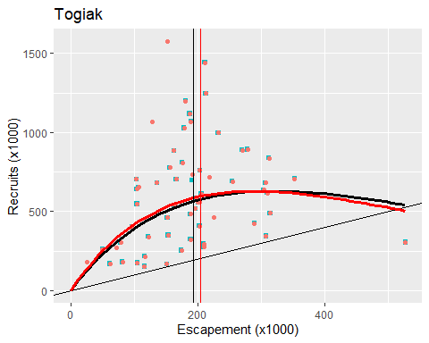

## Togiak MSY (90%)

The current escapement goal range is **120,000 - 270,000**.

The MSY 90% Confidence interval from this analysis is **130,000 - 280,000**

## Togiak Ricker Parameters

ricker.parameters("Togiak")

| ln.alpha | beta | sigma | alpha | ln.alpha.c | Seq | Smsy |
| --- | --- | --- | --- | --- | --- | --- |
| 1.4 | 1.8e-06 | 0.43 | 4.2 | 1.6 | 410,837 | 146,864 |
| 1.8 | 3.4e-06 | 0.51 | 5.9 | 1.9 | 523,814 | 196,905 |
| 2.1 | 5.0e-06 | 0.59 | 8.2 | 2.2 | 812,664 | 322,261 |

## Igushik River

**How Current Goal Was Established:**

An SEG of 150,000–400,000 was established in 2015 based on spawner-recruit analysis. The goal is based on spawner-recruit models used to analyze spawner-recruit data from all available brood years. Escapements counts are from a long-established counting tower.

**Review of Goal Since Established:**

During the last Board cycle, cumulative escapements and available returns through 2018 were used to update the stock-recruit analysis. The results of the updated analysis were similar to the last analysis ran in 2012. The escapement goal has been met each year and exceeded in four years (2015–2018) since its establishment.

**Rationale For No Change in 2018:**

After updating the spawner recruit analysis with the extended time series of escapements and returns, the committee concluded there were insufficient changes to the updated analysis to warrant modifying the escapement goal and recommended no change to the SEG.

**New Information since Last review:**

Escapements in 2018–2020 ranged from 256K–770K and were within the historic range. Updating the spawner-recruit analysis is not likely to result in a significantly different goal. In the plot below, the 2012 S/R analysis is shown in red while the 2020 S/R analysis is shown in black.

plot.riv("Igushik")

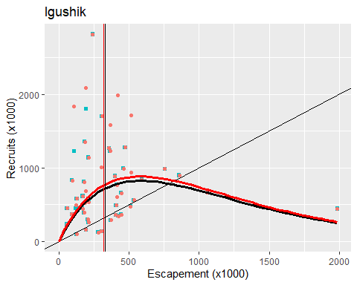

## Igushik MSY (90%)

The current escapement goal range is **150,000 - 400,000**.

The MSY 90% Confidence interval from this analysis is **215,000 - 460,000**

## Igushik Ricker Parameters

ricker.parameters("Igushik")

| ln.alpha | beta | sigma | alpha | ln.alpha.c | Seq | Smsy |
| --- | --- | --- | --- | --- | --- | --- |
| 1.1 | 1.1e-06 | 0.59 | 3.0 | 1.4 | 652,771 | 257,266 |
| 1.4 | 1.7e-06 | 0.74 | 4.2 | 1.7 | 829,141 | 331,360 |
| 1.8 | 2.4e-06 | 0.89 | 5.7 | 2.0 | 1,147,321 | 473,498 |

## Wood River

**How Current Goal Was Established:**

An SEG of 700,000–1,800,000 was established in 2015 based on spawner-recruit analysis. The goal is based on spawner-recruit models used to analyze spawner-recruit data from all available brood years. Escapements counts are from a long-established counting tower.

**Review of Goal Since Established:**

During the last Board cycle, cumulative escapements and available returns through 2018 were used to update the stock-recruit analysis. The results of the updated analysis were similar to the last analysis ran in 2012. The escapement goal has been met each year and exceeded in all but one year (2016) since its establishment.

**Rationale For No Change in 2018:**

After updating the spawner recruit analysis with the extended time series of escapements and returns, the committee concluded there were insufficient changes to the updated analysis to warrant modifying the escapement goal and recommended no change to the SEG.

**New Information since Last review:**

Escapements in 2018–2020 ranged from 2.1mil–7.5mil and though the 2018 escapement was the highest in the time series, returns from that escapement will not be seen until the next Board cycle. Updating the spawner-recruit analysis is not likely to result in a significantly different goal. In the plot below, the 2012 S/R analysis is shown in red while the 2020 S/R analysis is shown in black.

plot.riv("Wood")

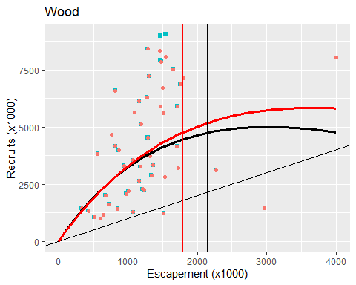

## Wood MSY (90%)

The current escapement goal range is **700,000 - 1,500,000**.

The MSY 90% Confidence interval from this analysis is **1,390,000 - 3,005,000**

## Wood Ricker Parameters

ricker.parameters("Togiak")

| ln.alpha | beta | sigma | alpha | ln.alpha.c | Seq | Smsy |
| --- | --- | --- | --- | --- | --- | --- |
| 1.4 | 1.8e-06 | 0.43 | 4.2 | 1.6 | 408,207 | 145,902 |
| 1.8 | 3.4e-06 | 0.51 | 5.8 | 1.9 | 522,455 | 196,607 |
| 2.1 | 5.0e-06 | 0.59 | 8.2 | 2.2 | 803,754 | 317,745 |

## Nushagak River

**How Current Goal Was Established:**

An SEG of 370,000–900,000 was established in 2015 based on spawner-recruit analysis. The goal is based on spawner-recruit models used to analyze spawner-recruit data from all available brood years. Escapements counts are based off sonar data.

**Review of Goal Since Established:**

During the last Board cycle, cumulative escapements and available returns through 2018 were used to update the stock-recruit analysis. The results of the updated analysis were similar to the last analysis ran in 2012. The escapement goal has been met each year and was exceeded in 2018.

**Rationale For No Change in 2018:**

After updating the spawner recruit analysis with the extended time series of escapements and returns, the committee concluded there were insufficient changes to the updated spawner-recruit analyses to warrant modifying the escapement goal and recommended no change to the SEG.

**New Information since Last review:**

Escapements in 2018–2020 ranged from 709K–1.3mil and were within the historic range. Updating the spawner-recruit analysis is not likely to result in a significantly different goal. In the plot below, the 2012 S/R analysis is shown in red while the 2020 S/R analysis is shown in black.

plot.riv("Nushagak")

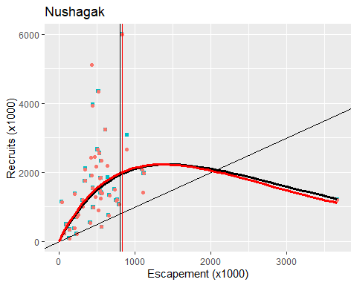

## Nushagak MSY (90%)

The current escapement goal range is **370,000 - 900,000**.

The MSY 90% Confidence interval from this analysis is **525,000 - 1,135,000**

## Nushagak Ricker Parameters

ricker.parameters("Nushagak")

| ln.alpha | beta | sigma | alpha | ln.alpha.c | Seq | Smsy |
| --- | --- | --- | --- | --- | --- | --- |
| 1.2 | 3.4e-07 | 0.50 | 3.3 | 1.4 | 1,480,627 | 569,655 |
| 1.5 | 7.3e-07 | 0.67 | 4.4 | 1.7 | 2,035,942 | 804,167 |
| 1.8 | 1.1e-06 | 0.83 | 5.8 | 2.0 | 3,732,745 | 1,528,449 |

## Kvichak River

**How Current Goal Was Established:**

An SEG of 2,000,000–10,000,000 was established in 2010 based on spawner-recruit analysis. The goal is based on spawner-recruit models used to analyze spawner-recruit data from all available brood years. Escapements counts are from a long-established counting tower.

**Review of Goal Since Established:**

During the last Board cycle, cumulative escapements and available returns through 2018 were used to update the stock-recruit analysis. The results of the updated analysis were similar to the last analysis ran in 2012. Since its establishment, the escapement goal has been met every year and never exceeded.

**Rationale For No Change in 2018:**

After updating the spawner recruit analysis with the extended time series of escapements and returns, the committee concluded there were insufficient changes to the updated analysis to warrant modifying the escapement goal and recommended no change to the SEG.

**New Information since Last review:**

Escapements in 2018–2020 ranged from 2.2mil–4.1mil and were within the historic range. Updating the spawner-recruit analysis is not likely to result in a significantly different goal. In the plot below, the 2012 S/R analysis is shown in red while the 2020 S/R analysis is shown in black.

plot.riv("Kvichak")

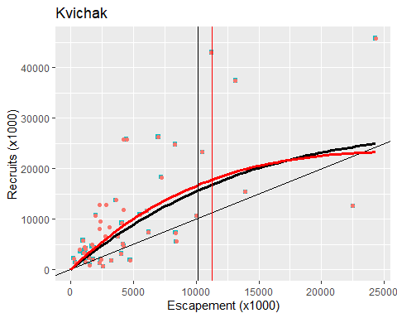

## Kvichak MSY (90%)

The current escapement goal range is **2,000,000 - 10,000,000**.

The MSY 90% Confidence interval from this analysis is **6,740,000 - 13,950,000**

## Kvichak Ricker Parameters

ricker.parameters("Kvichak")

| ln.alpha | beta | sigma | alpha | ln.alpha.c | Seq | Smsy |
| --- | --- | --- | --- | --- | --- | --- |
| 0.61 | 4.7e-09 | 0.64 | 1.8 | 0.94 | 1.2e+07 | 5.3e+06 |
| 0.90 | 3.9e-08 | 0.80 | 2.5 | 1.22 | 2.3e+07 | 1.0e+07 |
| 1.20 | 8.6e-08 | 0.94 | 3.3 | 1.50 | 1.6e+08 | 6.9e+07 |

## Alagnak River

**How Current Goal Was Established:**

A lower bound SEG of 320,000 was established in 2007 using tower counts and a risk-based approach. A lower bound SEG of 125,000, assessed by aerial survey and risk analysis, was established in 2015, but discontinued in 2018 in deference to the tower-based lower bound SEG The current lower bound SEG of 210,000 (based on tower counts) was established in 2018.

**Review of Goal Since Established:**

The current SEG has been achieved each of the three years it has been in place. Escapements have been well above the LB SEG and ranged from approximately 820k-2.39M fish.

**Rationale For Updating SEG in 2018:**

The previous goal was based upon aerial counts and the assessment was upgraded to one based on tour counts.

**New Information since Last review:**

Escapements in 2018–2020 ranged from 820k4 to 2.3M. Updating the analysis is not likely to result in a significantly different goal.

## Naknek River

**How Current Goal Was Established:**

An SEG of 800,000–2,000,000 was established in 2015 based on spawner-recruit analysis. The goal is based on spawner-recruit models used to analyze spawner-recruit data from all available brood years. Escapements counts are from a long-established counting tower.

**Review of Goal Since Established:**

During the last Board cycle, cumulative escapements and available returns through 2018 were used to update the stock-recruit analysis. The results of the updated analysis were similar to the last analysis ran in 2012. The escapement goal has been met each year and exceeded in three years (2018–2020) since its establishment.

**Rationale For No Change in 2018:**

After updating the spawner recruit analysis with the extended time series of escapements and returns, the committee concluded there were insufficient changes to the updated analysis to warrant modifying the escapement goal and recommended no change to the SEG.

**New Information since Last review:**

Escapements in 2018–2020 ranged from 2.4mil–4.4mil and though the 2020 escapement was the highest in the time series, returns from that escapement will not be seen until the next Board cycle. Updating the spawner-recruit analysis is not likely to result in a significantly different goal. In the plot below, the 2012 S/R analysis is shown in red while the 2020 S/R analysis is shown in black.

plot.riv("Naknek")

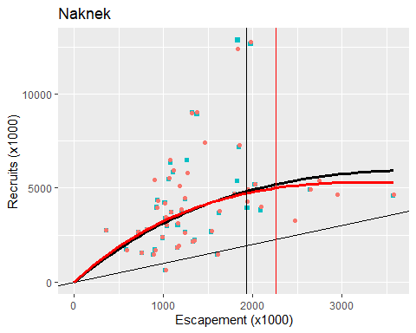

## Naknek MSY (90%)

The current escapement goal range is **800,000 - 1,400,000**.

The MSY 90% Confidence interval from this analysis is **1,255,000 - 2,715,000**

## Naknek Ricker Parameters

ricker.parameters("Naknek")

| ln.alpha | beta | sigma | alpha | ln.alpha.c | Seq | Smsy |
| --- | --- | --- | --- | --- | --- | --- |
| 1.1 | 8.8e-08 | 0.40 | 3.1 | 1.3 | 3.3e+06 | 1,250,742 |
| 1.5 | 3.1e-07 | 0.51 | 4.4 | 1.6 | 4.9e+06 | 1,920,940 |
| 1.8 | 5.4e-07 | 0.64 | 6.3 | 2.0 | 1.3e+07 | 5,591,567 |

## Egegik River

**How Current Goal Was Established:**

An SEG of 800,000–2,000,000 was established in 2015 based on spawner-recruit analysis. The goal is based on spawner-recruit models used to analyze spawner-recruit data from all available brood years. Escapements counts are from a long-established counting tower.

**Review of Goal Since Established:**

During the last Board cycle, cumulative escapements and available returns through 2018 were used to update the stock-recruit analysis. The results of the updated analysis were similar to the last analysis ran in 2012. The escapement goal has been met each year and exceeded in four years (2015, 2017, 2019–2020) since its establishment.

**Rationale For No Change in 2018:**

After updating the spawner recruit analysis with the extended time series of escapements and returns, the committee concluded there were insufficient changes to the updated analysis to warrant modifying the escapement goal and recommended no change to the SEG.

**New Information since Last review:**

Escapements in 2018–2020 ranged from 1.6mil–2.4mil and were within the historic range. Updating the spawner-recruit analysis is not likely to result in a significantly different goal.

plot.riv("Egegik")

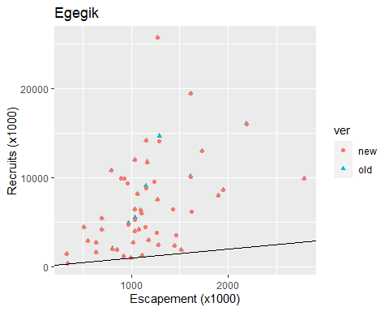

## Egegik MSY (90%)

The current escapement goal range is **800,000 - 2,000,000**.

The Ricker model does not convincingly fit this dataset so we have not MSY confidence interval to report

## Ugashik River

**How Current Goal Was Established:**

An SEG of 500,000–1,400,000 was established in 2015 based on spawner-recruit analysis. The goal is based on spawner-recruit models used to analyze spawner-recruit data from all available brood years. Escapements counts are from a long-established counting tower.

**Review of Goal Since Established:**

During the last Board cycle, cumulative escapements and available returns through 2018 were used to update the stock-recruit analysis. The results of the updated analysis were similar to the last analysis ran in 2012. The escapement goal has been met each year and exceeded in four years (2015–2016, 2019–2020) since its establishment.

**Rationale For No Change in 2018:**

After updating the spawner recruit analysis with the extended time series of escapements and returns, the committee concluded there were insufficient changes to the updated analysis to warrant modifying the escapement goal and recommended no change to the SEG.

**New Information since Last review:**

Escapements in 2018–2020 ranged from 1.2mil–1.7mil and were within the historic range. Updating the spawner-recruit analysis is not likely to result in a significantly different goal. In the plot below, the 2012 S/R analysis is shown in red while the 2020 S/R analysis is shown in black.

plot.riv("Ugashik")

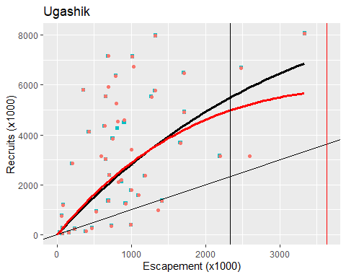

## Ugashik MSY (90%)

The current escapement goal range is **500,000 - 1,400,000**.

The MSY 90% Confidence interval from this analysis is **1,525,000 - 3,255,000**

## Ugashik Ricker Parameters

ricker.parameters("Ugashik")

| ln.alpha | beta | sigma | alpha | ln.alpha.c | Seq | Smsy |
| --- | --- | --- | --- | --- | --- | --- |
| 0.96 | 1.9e-08 | 0.79 | 2.6 | 1.4 | 2.5e+06 | 9.5e+05 |
| 1.33 | 2.6e-07 | 0.98 | 3.8 | 1.8 | 5.0e+06 | 2.1e+06 |
| 1.75 | 6.4e-07 | 1.14 | 5.8 | 2.2 | 5.8e+07 | 2.4e+07 |

## Chinook Salmon:

|  |  |  |  |  |  |  |
| --- | --- | --- | --- | --- | --- | --- |
| System | Goal | Type | Year | Assessment | Method |  |
| Nushagak | 55,00 - 120,000 | SEG | 2013 | Sonar, M/R | Ricker |  |

**How Current Goal Was Established:**

The Nushagak River Chinook sustainable escapement goal (SEG) of 55,000 – 120,000 was established in 2013. During the 2012 Board of Fisheries meeting old (pre-2005) Bendix counts were upwardly revised into ‘DIDSON equivalent’ counts (Buck et al. 2012). The current SEG is calculated from this DIDSON (or equivalent) dataset. We have met the current SEG every year since (2013-2017).

**Review of Goal Since Established:**

This goal has been reviewed every BOF cycle since inception. During these reviews, the EG committee has evaluated stock-recruit data as means of setting an escapement goal.

**New Information since Last review:**

Since the establishment of the current SEG two major studies designed to produce inriver abundance estimates of Chinook in the Nushagak River have been completed. The first was a study conducted between 2011 and 2014 that relied on acoustically tagged Chinook being tracked past the sonars using a hydrophone array to estimate the proportion of the run that is not available to the sonar. The other study was a Mark Recapture study undertaken between 2014 and 2016. While these two studies were fairly consistent internally, the results between the two studies are not well aligned. The Mark-Recapture estimates averaged 128% of the sonar count while the acoustic based estimates of Chinook abundance averaged 191% of the sonar count (attached table).

## Chum Salmon:

|  |  |  |  |  |  |
| --- | --- | --- | --- | --- | --- |
| System | Goal | Type | Year | Assessment | Method |
| Nushagak | >200,000 | LB SEG | 2013 | Sonar | risk analysis |

**How Current Goal Was Established:**

A lower bound SEG of 190,000 was established in 2007. The goal was based on sonar counts established using the risk analysis approach.. The original goal was based on net apportioned Bendix counts. During the 2012 review the data set was extended and all estimates were converted to DIDSON equivalents (DIDSON:Bendix ratio of 1.27). The risk and analysis was updated and an escapement level of 200,000 resulted in a 2.0% risk of an unwarranted concern and a 16.0% risk that drop in mean escapement of 85% would not be detected in 3 consecutive years. The lower bound SEG of 200,000 was adopted in 2013.

**Review of Goal Since Established:**

In 2015 the historic dataset was updated to extend the historical escapement time series .For the 2015 analysis cumulative escapements through July 20 were selected fall all years even though the sonar project in recent years have been extended into mid-August. The results of the updated risk analysis were similar to the 2012 analysis. The 3-tier percentile method (High contrast, low measurement error, moderate harvest) would have resulted in lower bound SEG of approximately 187,000

During the 2018 review the data set was updated with 3 additional years of data (2015–2017). Each of the recent escapements were above the lower bound SEG and well within the range of historical escapements.

**Rational for not updating the goal in 2018:**

Because recent escapements from 2015 to 2017 were above the lower bound SEG and well within the range of historical escapements; the committee concluded updating the analysis for this stock would not result in a substantially different escapement goal.

**New Information since Last review:**

Escapements in 2018–2020 were 735K, 514k, and 111k respectively and all were within the range of historical escapements. Updating the analysis is not likely to result in a significantly different goal however, updating the risk-based analysis is straightforward and has not been done since 2015. The 3-tier percentile method (High contrast, low measurement error moderate harvest) results in a lower bound SEG of approximately (182,000).

knitr::include_graphics("chum.png")

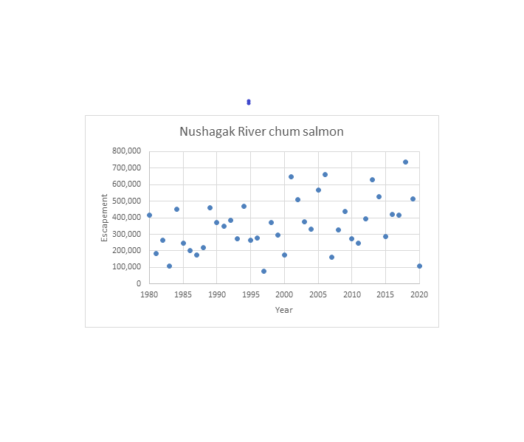

## Pink Salmon (even years)

|  |  |  |  |  |  |
| --- | --- | --- | --- | --- | --- |
| System | Goal | Type | Year | Assessment | Method |
| Nushagak | >165,000 | LB SEG | 2012 | Sonar | Percentile |

**How Current Goal Was Established:**

The current lower bound SEG of 165,000 was established in 2012 using the 4-tier percentile approach (and supported with a risk analysis) and is for even years only. The review in 2006 discontinued an SEG of 600,000–1,100,000 for Nushagak River pink salmon. At that time, sonar operations had been reduced in duration (terminated on July 20) and no longer assessed pink salmon abundance. From 2012 to 2014, the sonar project operated through August 20 to assess pink and coho salmon because both species are actively managed in the Nushagak District. The sonar project was not operated during the month of August since the previous review, therefore no new information was available to update the escapement goals analysis The committee recommends no change to the lower bound SEG of 165,000 for even-year pink salmon . Review of Goal Since Established: The SEG has was not considered for updating in the 2015 or 2018 reviews since only one year of additional data (2014) was available since the goal had been established. Since the last review one additional year of escapement has been added to the time series (2018). Rationale For not updating Goal in 2018: There was no new data available since the 2015 review to include in the analysis.

**New Information since Last review:**

One additional year (2018) is available since the last review cycle. It may be time to update this analysis using the 3-tier approach. However, it is unlikely this goal will be assessed in the near future as a result of a lack of funding to operate the sonar into August.

knitr::include_graphics("pink.png")

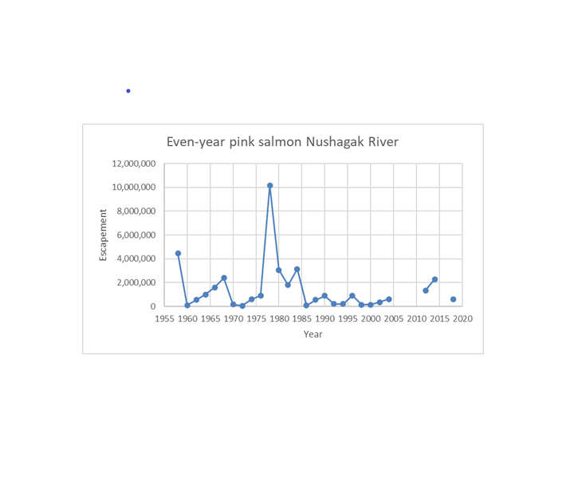

## Coho Salmon:

|  |  |  |  |  |  |
| --- | --- | --- | --- | --- | --- |
| System | Goal | Type | Year | Assessment | Method |
| Nushagak | 60,000 - 120,000 | SEG | 2013 | Sonar | SR analysis |

**How Current Goal Was Established:**

The current SEG of 60,000–120,000 was established in 2013. The review in 2006 discontinued an SEG of 50,000–100,000 for Nushagak River coho salmon At that time, sonar operations had been reduced in duration (terminated on July 20), and no longer assessed coho salmon abundance. Beginning in 2012, the sonar project operated through August 20 to assess coho and pink salmon because both species are actively managed in the Nushagak District. During the 2012 review, the SEG was changed to 60,000– 120,000 to account for the difference between Bendix and DIDSON sonar estimation.

Review of Goal Since Established The Nushagak River sonar has operated after July 20 four times (2013, 2014, 2018, and 2019 ) since the current goals was developed. Since being established in 2013 the goal has been met once (2018), exceeded twice (2013, 2014) and not met once (2019).

**Rational for not updating the goal in 2018:**

During the 2018 review, there was no additional data since the previous review (2015) so the committee elected not to update the analysis.

**New Information since Last review:**

Escapements in 2018 and 2019 were 111k and 52k, respectively. Updating the analysis is not likely to result in a significantly different goal.

knitr::include_graphics("coho.png")

